Dependency Status page

The response choice of “no” is the default. So when users arrive on this page, it’s already defaulted to “no” so they have to make a conscious decision to change the response.

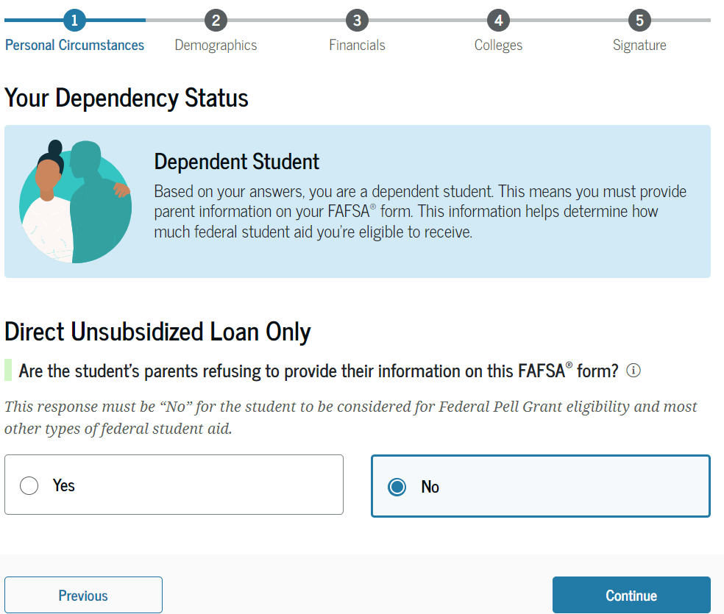

Then, if they *do* change the response to “yes”, they see this modal message pop up:

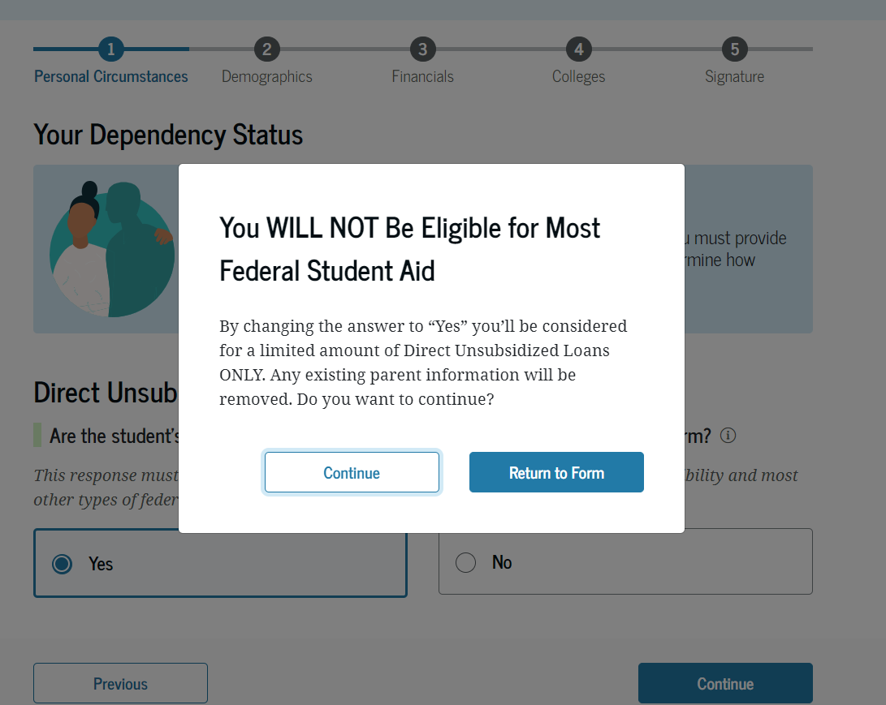

Selecting Continue takes them to the next page in the form. Selecting Return to Form closes the modal and returns them to the unsub only question.