U.S. Environmental Protection Agency

Information Collection Request

**Title:** Revisions to Standards for the Open Burning/Open Detonation (OB/OD) of Waste Explosives

**OMB Control Number:** 2050-NEW

**EPA ICR Number:** 2769.01

**Abstract:** EPA is proposing revisions to the Resource and Recovery Act (RCRA) regulations to

clarify existing requirements for owners/operators of OB/OD units, including how and when to

apply and implement the requirements in the permitting process. Specifically, EPA is proposing

to create new Subparts for OB/OD units in Parts 264 (applicable to permitted facilities) and 265

(applicable to interim status facilities). The new Subparts would contain requirements that apply

to all owners and operators conducting or seeking to conduct OB/OD of waste explosives,

including activities conducted as part of RCRA corrective action. EPA is further proposing

requirements for OB/OD used in non-time sensitive emergencies.

The new provisions would specify how and when owners and operators and permit

authorities are to evaluate alternative treatment technologies for OB/OD, including specific

information that would be required for facilities to demonstrate whether safe alternative modes

of treatment are available for specific waste streams. EPA is proposing an exemption from the

requirement to conduct comprehensive alternative technology evaluations for de minimis

quantities of waste explosives that were generated on site. This rule also proposes new and

revised regulatory provisions on timelines for implementing alternative technologies, permitting

for alternative technologies, waste analysis/characterization, wastes prohibited/restricted from

OB/OD, technical standards for OB/OD units, delay of closure applicability to OB/OD units,

clarifications to emergency provisions at §§ 270.61 and 264.1(g)/270.1(c)(3), and procedures for

permitting mobile treatment units (MTUs).

The overall reporting and recordkeeping requirements for OB/OD facilities are reported

in separate ICRs, including OMB Control No. 2050-0050 (EPA ICR No. 1572.13) and OMB

Control No. 2050-0009 (EPA ICR No. 1573.16). This ICR (EPA ICR No. 2769.01) will be

rolled into the consolidated RCRA ICRs in the next renewal cycle.

**Supporting Statement A**

1. **NEED AND AUTHORITY FOR THE COLLECTION**

*Explain the circumstances that make the collection of information necessary. Identify any legal or administrative requirements that necessitate the collection.*

The reporting and recordkeeping requirements of this ICR are instituted principally under the authority of RCRA Section 3004(n), and supported by authorities under sections 2002, 3004 generally, 3005, and 3006 of the Solid Waste Disposal Act of 1965, as amended by the Resource Conservation and Recovery Act of 1976, as amended by the Hazardous and Solid Waste Amendments of 1984 (HSWA).

To meet its statutory obligations, EPA must obtain sufficient information to assess whether safe alternatives are available in lieu of OB/OD. In addition, for instances where OB/OD remains the only treatment method for waste explosives, the Agency requires sufficient information to ensure that permitting requirements are being met and properly implemented.

1. **PRACTICAL UTILITY/USERS OF THE DATA**

*Indicate how, by whom, and for what purpose the information is to be used. Except for a new collection, indicate the actual use the agency has made of the information received from the current collection.*

The goal of the reporting requirements is to support improved protection of human health and the

environment by reducing the amount of waste explosives currently being open burned and open

detonated and, where OB/OD remains the only available treatment method, by strengthening

protections for OB/OD activities.

EPA will use the collected information to ensure that alternatives to OB/OD of waste explosives

are being identified and implemented, when possible, confirm permitting requirements are being

met, and monitor any potential harms to human health and the environment.

1. **USE OF TECHNOLOGY**

*Describe whether, and to what extent, the collection of information involves the use of automated, electronic, mechanical, or other technological collection techniques or other forms of information technology, e.g., permitting electronic submission of responses, and the basis for the decision for adopting this means of collection. Also describe any consideration of using information technology to reduce burden.*

EPA is proposing an exemption from the requirement to conduct comprehensive alternative

technology evaluations for *de minimis* quantities of waste explosives that were generated on site.

Accordingly, the owner/operator would also be exempt from the requirement to implement an alternative technology with the exception of consideration of any safe available off-site alternative technology treatment options, safe treatment by an existing on-site alternative technology unit, or safe and available treatment by an MTU. EPA does not have sufficient data to estimate how many OB/OD facilities may apply for and potentially qualify for the *de minimis* exemption (because it is a new proposal). This ICR assumes that the de minimis exemption demonstrations will not increase information collection burden and costs on facility owners/operators beyond those estimated for more frequent alternative technology evaluations in (Exhibit 1). Rather, it is likely that the annual burden and costs would decrease for Respondents that qualify for the *de minimis* exemption relative to the information collection burden and costs the Respondent would incur by preparing more frequent alternative technology evaluations. The expected burden and costs for EPA and the States will also be reduced if Respondents qualify for the *de minimis* exemption.

1. **EFFORTS TO IDENTIFY DUPLICATION**

*Describe efforts to identify duplication. Show specifically why any similar information already available cannot be used or modified for use for the purposes described in Item 2 above.*

There are no other Federal agencies with a permit program for hazardous waste facilities. Authorized States must modify their programs only after EPA promulgates Federal standards that are more stringent than the existing Federal standards. Section 3009 of RCRA allows States to impose standards more stringent than, or in addition to, those in the Federal program. To obtain authorization, a State must agree to have reporting requirements that are equivalent to EPA’s requirements. Facilities in authorized States will need to maintain records and submit reports to comply only with the States’ requirements; no parallel information is submitted to EPA.

1. **MINIMIZING BURDEN ON SMALL BUSINESSES AND SMALL ENTITIES**

*If the collection of information impacts small businesses or other small entities, describe any methods used to minimize burden.*

The final rule is not expected to cause a significant impact on small entities. EPA believes that the information to be collected is the minimum amount necessary to fulfill the purpose of the proposed rule.

1. **CONSEQUENCES OF LESS FREQUENT COLLECTION**

*Describe the consequence to Federal program or policy activities if the collection is not conducted or is conducted less frequently, as well as any technical or legal obstacles to reducing burden.*

EPA has sought to reduce the reporting frequency to the minimum that is necessary to ensure compliance with the rule. It would not be possible to collect this information less frequently and still assure that the requirements of permit regulations are met by owner/operators.

1. **GENERAL GUIDELINES**

*Explain any special circumstances that require the collection to be conducted in a manner inconsistent with OMB guidelines.*

The information collection is consistent with the guidelines set forth in 5 CFR 1320.5(d)(2) of the Paperwork Reduction Act Guidelines. There are no known special circumstances that would require reporting on an alternative timeline or methodology.

1. **PUBLIC COMMENT AND CONSULTATIONS**

**8a. Public Comment**

*If applicable, provide a copy and identify the date and page number of publication in the Federal Register of the Agency's notice, required by 5 CFR 1320.8(d), soliciting comments on the information collection prior to submission to OMB. Summarize public comments received in response to that notice and describe actions taken by the Agency in response to these comments. Specifically address comments received on cost and hour burden.*

In compliance with the Paperwork Reduction Act of 1995, EPA issued a public notice in the *Federal Register* on March 20, 2024 (89 FR 19952) and provided a 60-day comment period for this ICR.

**8b. Consultations**

*Describe efforts to consult with persons outside the Agency to obtain their views on the availability of data, frequency of collection, the clarity of instructions and recordkeeping, disclosure, or reporting format (if any), and on the data elements to be recorded, disclosed, or reported. Consultation with representatives of those from whom information is to be obtained or those who must compile records should occur at least once every 3 years - even if the collection of information activity is the same as in prior periods. There may be circumstances that may preclude consultation in a specific situation. These circumstances should be explained.*

EPA conducted outreach to OB/OD facility owners/operators to collect information about the methodologies and costs associated with conducting (or commissioning) alternative technology evaluations.

1. **PAYMENTS OR GIFTS TO RESPONDENTS**

*Explain any decisions to provide payments or gifts to respondents, other than remuneration of contractors or grantees.*

No payment or gift is given to respondents.

1. **ASSURANCE OF CONFIDENTIALITY**

*Describe any assurance of confidentiality provided to respondents and the basis for the assurance in statute, regulation, or Agency policy. If the collection requires a systems of records notice (SORN) or privacy impact assessment (PIA), those should be cited and described here.*

All information submitted to the agency in response to the ICR will be managed in accordance with applicable laws and EPA’s regulations governing treatment of confidential business information at 40 CFR Part 2, Subpart B. Any information determined to constitute a trade secret will be protected under 18 U.S.C. §1905.

1. **JUSTIFICATION FOR SENSITIVE QUESTIONS**

*Provide additional justification for any questions of a sensitive nature, such as sexual behavior and attitudes, religious beliefs, and other matters that are commonly considered private. This justification should include the reasons why the Agency considers the questions necessary, the specific uses to be made of the information, the explanation to be given to persons from whom the information is requested, and any steps to be taken to obtain their consent.*

Sensitive questions are not associated with the information collection activities performed under Public Law 107-118.

1. **RESPONDENT BURDEN HOURS & LABOR COSTS**

*Provide estimates of the hour burden of the collection of information. The statement should:*

* *Indicate the number of respondents, frequency of response, annual hour burden, and an explanation of how the burden was estimated. Generally, estimates should not include burden hours for customary and usual business practices.*
* *If this request for approval covers more than one form, provide separate hour burden estimates for each form and the aggregate the hour burdens.*
* *Provide estimates of annualized cost to respondents for the hour burdens for collections of information, identifying and using appropriate wage rate categories. The cost of contracting out or paying outside parties for information collection activities should not be included here. Instead, this cost should be included as O&M costs under non-labor costs covered under question 13.*

**12a. Respondents/NAICS Codes**

The following is a list of NAICS codes associated with the facilities most likely to be affected by the proposed rule provisions under this ICR:

|  |  |
| --- | --- |
| 213111 | Drilling Oil and Gas Wells |
| 325180 | Other Basic Inorganic Chemical Manufacturing |
| 325199 | All Other Basic Organic Chemical Manufacturing |
| 325920 | Explosives Manufacturing |
| 325998 | All Other Miscellaneous Chemical Product and Preparation Manufacturing |
| 332992 | Small Arms Ammunition Manufacturing |
| 332993 | Ammunition (except Small Arms) Manufacturing |
| 332994 | Small Arms, Ordnance, and Ordnance Accessories Manufacturing |
| 334511 | Search, Detection, Navigation, Guidance, Aeronautical, and Nautical System and  Instrument Manufacturing |
| 336390 | Other Motor Vehicle Parts Manufacturing |
| 541330 | Engineering Services |
| 541910 | Marketing Research and Public Opinion Polling |
| 562211 | Hazardous Waste Treatment and Disposal |

**12b. Information Requested**

(1) More Frequent Alternative Technology Evaluations

(i) Data items:

As outlined in Subpart Y of §264.706 and §264.707 of the proposed rule, facility owners/operators that conduct OB/OD of waste explosives are required to demonstrate and periodically redemonstrate that no safe alternatives exist. The evaluation document must include:

1. description of facility operations;
2. characterization of waste explosives;
3. initial screening of potentially available alternative treatment technologies;
4. identification of alternative technologies according to individual waste streams;
5. identification of selected alternative treatment technologies;
6. identification of individual waste streams requiring OB/OD; and
7. an evaluation of off-site treatment options using alternative treatment technologies and use of MTUs.

Regarding reevaluations for owners or operators conducting OB/OD, EPA is proposing at §264.707(d) to require the facility owner or operator, after conducting an initial evaluation of alternative technologies, to conduct reevaluations at least as frequently as every five years thereafter (instead of every ten years with permit renewal in the baseline scenario). Thus, this more frequent evaluation requirement represents a source of incremental paperwork burden.

(ii) Respondent activities:

To satisfy this new requirement, owner/operators must perform the following activities:

* + - * Read the regulations.
      * Prepare and submit the appropriate alternative technology evaluation every five years, instead of every 10 years.

(iii) *de Minimis* Exemption

EPA is proposing an exemption from the requirement to conduct comprehensive alternative technology evaluations for *de minimis* quantities of waste explosives that were generated on site. Accordingly, the owner/operator would also be exempt from the requirement to implement an alternative technology with the exception of consideration of any safe available off-site alternative technology treatment options, safe treatment by an existing on-site alternative technology unit, or safe and available treatment by an MTU. EPA does not have sufficient data to estimate how many OB/OD facilities may apply for and potentially qualify for the *de minimis* exemption (because it is a new proposal). This ICR assumes that the de minimis exemption demonstrations will not increase information collection burden and costs on facility owners/operators beyond those estimated for more frequent alternative technology evaluations in (Exhibit 1). Rather, it is likely that the annual burden and costs would decrease for Respondents that qualify for the *de minimis* exemption relative to the information collection burden and costs the Respondent would incur by preparing more frequent alternative technology evaluations. The expected burden and costs for EPA and the States will also be reduced if Respondents qualify for the *de minimis* exemption.

(2) New Operating and Monitoring Requirements for OB/OD Units

To become or remain eligible to open burn or open detonate waste explosives, OB/OD facility owners or operators must submit documentation of waste analysis required under §264.706 and an alternative technology evaluation required under §264.707(a) to the regulatory authority, and the regulatory authority must approve the evaluation. Item (1) above, addressing the more frequent alternative technology evaluations, captures the incremental reporting burden of the proposed rulemaking for these components.

In addition, the proposed rulemaking updates the technical standards and permit conditions with which OB/OD users must comply. The operating and monitoring requirements that represent an incremental paperwork burden are outlined below.

Operating Requirements Under §264.708

The proposed rule includes new requirements for the Part B permit application that represent an incremental paperwork burden. Generally, the permit must contain any conditions necessary to protect human health and the environment. In addition, permit conditions and terms for OB/OD units must be established that are specific to the unit and type of explosive waste and which address a number of parameters. The new parameters in the proposed rule to be addressed in the permit conditions include:

* **Noise and Ground Vibration Controls.** This provision requires development of threshold levels and mitigation measures to minimize noise and ground vibration that affects areas outside the facility boundary. To satisfy this requirement owner/operators must develop and include a noise and ground vibration control plan in the permit application.
* **Removal of Excess Material.** This provision requires removal of excess materials (such as foils and casings) if it is possible to do so safely. To satisfy this requirement owner/operators must develop and include an excess material removal plan in the permit application.
* **Surface Water/Storm Water Run-on and Run-off Controls.** These requirements have been added to the required suite of engineering controls and measures. To satisfy this requirement owner/operators must develop and include a plan for surface water/storm water run-on and run-off controls in the permit application.
* **Security.** This provision requires a security plan and controls to ensure the OB/OD units and surrounding kickout area are protected from unauthorized access by the public. Under the proposed rule, this plan must now include implementation of chain link fencing or barbed wire along the unit perimeter. To satisfy this requirement owner/operators must develop and include a plan for appropriate perimeter fencing in the permit application.
* **Public Notice and Outreach Plan.** Under the proposed rule, a public notice and outreach plan must include notice to the surrounding community of planned OB/OD activities and events, the method of notice distribution, the required content of the notice, method(s) for community members to contact the facility with questions or concerns, and a timeframe for notifications. The content of the plan must include how information will be made available to the public regarding contaminants emitted or released from OB/OD operations, environmental monitoring data/results, and locations of off-site contamination including kickout and groundwater contamination. To satisfy this requirement owner/operators must develop and include a public notice and outreach plan in the permit application.

Monitoring Requirements Under §264.710

Owners/operators of OB/OD units must develop monitoring plans for a number of environmental constituents and submit these plans to the Director for approval under §270.23.

Owners/operators must implement the monitoring plans to monitor for releases and contamination from the OB/OD units and the surrounding kickout areas as specified in §264.710(a)(1)-(6). The proposed rule adds certain monitoring requirements, including:

* **Stormwater Monitoring.** Stormwater monitoring is required at and around OB/OD units to detect any potential releases. Stormwater monitoring must be conducted in accordance with an approved RCRA stormwater monitoring plan until the unit completes RCRA closure and is under a post-closure permit as applicable. To satisfy this requirement owner/operators must develop and include a storm water monitoring plan in the permit application. This plan must include sampling plans, the approach for analysis and evaluation of the data, and response procedures for contamination found.
* **Surface Water Monitoring.** Surface water monitoring of nearby surface water bodies is required to detect potential releases from the OB/OD unit. Surface water monitoring must be conducted regularly in accordance with an approved RCRA surface water monitoring plan until the unit completes RCRA closure and is under a post-closure permit as applicable. To satisfy this requirement owner/operators must develop and include a surface water monitoring plan in the permit application. This plan must include sampling plans, the approach for analysis and evaluation of the data, and response procedures for contamination found.
* **Air Monitoring.** Air monitoring is required to detect potential releases from the OB/OD unit boundary. Air monitoring is required downwind of the OB/OD unit boundary and at or near the facility boundary. Air monitoring of OB/OD plumes must be conducted during an OB/OD event, in accordance with an approved air monitoring plan. Air monitoring must also be conducted upwind of the facility to establish background or ambient concentrations. To satisfy this requirement owner/operators must develop and include an air monitoring plan in the permit application. This plan must include sampling plans, the approach for analysis and evaluation of the data, and response procedures for contamination found.
* **Soil Monitoring.** Soil monitoring of the areas around the OB/OD unit is required to detect potential releases from the OB/OD unit. To satisfy this requirement owner/operators must develop and include a soil monitoring plan in the permit application. The owner/operator must test for contamination and if contamination is found at or above the action level specified in the monitoring plan, the owner/operator would take appropriate response actions as required in the monitoring plan.
* **Groundwater Monitoring.** Groundwater monitoring is required to detect potential releases from the OB/OD unit. Monitoring requirements include an upgradient well for background monitoring and that all downgradient wells be located to detect potential releases of contaminants to uppermost flow zones and preferential flow paths. To satisfy this requirement owner/operators must develop and include a groundwater monitoring plan in the permit application.
* **Kickout Monitoring.** Kickout monitoring is required to observe, contain, and retrieve kickout following OB/OD events. To satisfy this requirement owner/operators must develop and include kickout monitoring and retrieval plans in the permit application.

(3) Recordkeeping, Inspections, Training, and Reporting Requirements (§264.712)

All facilities must comply with §264.15 General inspection requirements, §264.16 Personnel Training, Subpart C Preparedness, Subpart D Contingency Plan and Emergency Procedures, and §264.73 Operating record. The proposed rule provides certain clarifications and adds additional provisions applicable to OB/OD units, including:

* **Inspections.** This provision requires that a full inspection schedule and an example inspection sheet be included in the permit application. To satisfy this requirement owner/operators must develop and include a full schedule and example inspection sheet in the permit application.
* **Reports to the Director.** The owner/operator must report the following to the Director electronically: (a) any unit failure event where the unit is damaged or treatment does not occur in the OB/OD unit as intended by the permit within seven (7) days of the initial failure (the unit failure cause and potential correction for the unit must be submitted within 30 days of the initial failure); (b) an annual summary report of all documented treatment residues and untreated waste beyond the OB/OD area from the biannual inspection; (c) all unauthorized releases of hazardous constituents and treatment byproducts to the air, soil, groundwater, or surface water; and (d) any records requested by the Director. To satisfy this requirement owner/operators must develop and submit all reports as identified.

(4) Closure, Time Allowed for Closure for Open Burn and Open Detonation Units (§264.713)

Open burn and open detonation units are subject to the requirements of 264.113, except when the units are used for activities in which military munitions are used as intended or the units continue to receive explosive waste contaminants from adjacent activities. As part of the demonstration to confirm this exception, the proposed rule adds a requirement for the preparation of maps showing all affected open burn and open detonation units, kickout units, and their boundaries. To satisfy this requirement owner/operators must develop and submit such maps.

(5) Mobile Treatment Units (MTUs) for Waste Explosives

As part of this rulemaking, EPA is proposing an optional two-stage permitting process for MTUs under a new Subpart K to 40 CFR Part 270. The proposed framework would create a special form of an individual RCRA permit enabling MTUs to treat waste explosives at multiple locations for a limited duration. In the first stage of the permitting process, EPA would issue a nationwide conditional approval to the MTU owner and operator that would accompany the unit to every job site. This nationwide conditional approval would contain the bulk of the permit terms and conditions [requirements] applicable to the unit. In the second stage, a location specific RCRA permit authorizing treatment of waste explosives at a specific site would be issued by EPA. Prior to issuance of the location specific permit, EPA would provide public notice as required by section 7004(b) and would establish any other requirements specific to that location.

Although the permitting process and application contents for MTUs under the proposed rule are consolidated in the newly established Subpart K, the applicable provisions being proposed for MTUs cite to a variety of other existing RCRA subparts. The list of overlapping information requirements is outlined below. Each of these requirements is subject to, and covered by, existing information collection request documents with formal OMB control numbers. Thus, those paperwork characterizations and burdens are not repeated herein.

Information required for Nationwide Conditional Approval (§ 270.333)

* Prepare the information required by § 270.13, except that the information required by §270.13(b), (f) and (l) is not required;
* Develop sufficient information to demonstrate that design and operation of the MTU will ensure compliance with applicable requirements of part 264 of this Chapter as specified by §264.1(k); (with the exception of the information on arrangements with local authorities required by §264.37 and the information regarding arrangements with local authorities required to be in the MTU’s contingency plan as per §264.52(c));
* Develop and collect information required by § 270.23 (a), (d) and (f); and
* If the application for a nationwide conditional approval relates to a group of identical MTUs, obtain and submit a certification from a registered professional engineer that the units are identical.

Application contents for a RCRA MTU permit (§270.336)

* Collect the information required in §270.13(b) and (f);
* Prepare the information describing the proposed operations (dates, waste types, duration) required by 270.336(a)(3);
* Develop and submit the information required by §270.23(f);
* Prepare information demonstrating compliance with §264.37 regarding arrangements with local authorities;
* Develop an updated contingency plan required by Subpart D of part 264 by including the information required by §264.52(c) reflecting the arrangements with local authorities; and
* Develop evidence of an arrangement between the original generator of the waste explosives and the MTU owner operator as to who will take the actions required to comply with the applicable Part 262 regulations related to any hazardous waste generated by the MTU’s operations.

**12d. Respondent Burden Hours and Labor Costs**

EPA estimates annual respondent burden hours associated with all the information collection requirements covered in this ICR in Exhibits 1 and 2. These exhibits detail the number of hours required to conduct each discrete information collection activity. Exhibit 3 provides the annual bottom-line respondent burden associated with all information collection requirements included in this ICR.

Estimating Labor Costs

The labor wage rates used to estimate costs to respondents were calculated as shown in the following table. The 2022 average wage rates are the average wage rates reported in the Bureau of Labor Statistics, 2020 National Occupational Employment and Wage Estimate, released May 2020, and updated to 2022 levels.

|  |  |  |  |  |
| --- | --- | --- | --- | --- |
| Labor Category | Non-loaded  2022 hourly rate | Fringe benefits  loading multiplier | Overhead loading  multiplier | Loaded  Hourly rate |
| 1. Legal | $71.59 | 1.43 | 1.336 | $136.77 |
| 2. Managerial | $60.45 | 1.43 | 1.336 | $115.49 |
| 3. Technical | $46.58 | 1.43 | 1.336 | $88.99 |
| 4. Clerical | $18.16 | 1.43 | 1.336 | $34.69 |

For the single U.S. Territory entity respondent, this analysis employs the same loaded hourly rates as identified above.

1. **Respondent CAPITAL AND O&m CostS**

*Provide an estimate for the total annual cost burden to respondents or record keepers resulting from the collection of information. (Do not include the cost of any hour burden already reflected on the burden worksheet).*

*The cost estimate should be split into two components: (a) a total capital and start-up cost*

*component (annualized over its expected useful life) and (b) a total operation and maintenance and purchase of services component. The estimates should consider costs associated with generating, maintaining, and disclosing or providing the information. Include descriptions of methods used to estimate major cost factors including system and technology acquisition, expected useful life of capital equipment, the discount rate(s), and the period over which costs will be incurred. Capital and start-up costs include, among other items, preparations for collecting information such as purchasing computers and software; monitoring, sampling, drilling, and testing equipment; and record storage facilities.*

*If cost estimates are expected to vary widely, agencies should present ranges of cost burdens and explain the reasons for the variance. The cost of purchasing or contracting out information collections services should be a part of this cost burden estimate.*

*Generally, estimates should not include purchases of equipment or services, or portions thereof, made: (1) prior to October 1, 1995, (2) to achieve regulatory compliance with requirements not associated with the information collection, (3) for reasons other than to provide information or keep records for the government, or (4) as part of customary and usual business or private practices.*

Estimating Capital Costs

Capital costs usually include any produced physical good needed to provide the needed information, such as machinery, computers, and other equipment. EPA does not anticipate that respondents will incur capital costs in carrying out the information collection requirements of the proposed rule.

Estimating Operations and Maintenance (O&M) Costs

In complying with the proposed requirements, facilities may incur operations and maintenance (O&M) costs associated with some respondent activities. O&M costs include mail submittals, purchased materials costs, and certain lump-sum purchased service costs. Exhibits 1 and 2 detail these costs, if any, for each discrete information collection activity.

Table 1 presents the estimated annual universe of facilities and units subject to the proposed rule’s

new operating, monitoring, and reporting requirements.

**Table 1**

**Estimated Annual Universe of Facilities and Units Affected by Proposed Rule**

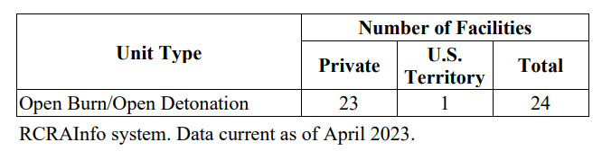

Table 2 presents the estimated annual respondent burden for the proposed rule’s new operating, monitoring, and reporting requirements.

**Table 2**

**Annual Respondent Burden**

|  |  |  |  |  |  |
| --- | --- | --- | --- | --- | --- |
|  | Respondents | Unique Responses | Hours | O&M  Costs | Total Annual  Cost |
| Private Sector | 23 | 2,024 | 26,409 | $198,950 | $2,648,305 |
| U.S. Territory Agencies | 1 | 88 | 1,148 | $8,650 | $115,144 |
| Total | 24 | 2,112 | 27,557 | $207,600 | $2,763,449 |

1. **AGENCY** **COSTS**

*Provide estimates of annualized costs to the Federal government. Also, provide a description of the method used to estimate cost, which should include quantification of hours, operational expenses (such as equipment, overhead, printing, and support staff), and any other expense that would not have been incurred without this collection of information.*

EPA estimates the Agency hour and cost burden associated with all information collection requirements covered in this ICR in Exhibit 4. This exhibit details the number of hours required to conduct each discrete information collection activity. Exhibit 5 provides the annual bottom-line Agency burden associated with all information collection requirements included in this ICR.

EPA estimates an average hourly labor cost (labor plus overhead) of $86.54 for legal staff, $62.27 for managerial staff, $43.68 for technical staff, and $26.56 for clerical staff. To derive these estimates, EPA used the General Schedule (GS) Salary Table 2022. For purposes of this ICR, EPA assigned staff the following government service levels:

* Legal Staff GS-15, Step 1
* Managerial Staff GS-13, Step 1
* Technical Staff GS-11, Step 1
* Clerical Staff GS-6, Step 1

To derive hourly estimates, EPA divided annual compensation estimates by 2,080, which is the number of hours in the Federal work-year. EPA then multiplied hourly rates by the standard government overhead factor of 1.6.

1. **REASONS FOR CHANGE IN BURDEN**

*Explain the reasons for any program changes or adjustments reported in the burden or capital/O&M cost estimates.*

This is a new information collection request, therefore there is no change in burden.

1. **PUBLICATION OF** **DATA**

*For collections of information whose results will be published, outline plans for tabulation and publication. Address any complex analytical techniques that will be used. Provide the time schedule for the entire project, including beginning and ending dates of the collection of information, completion of report, publication dates, and other actions.*

Results from this ICR are not published formally. They are used to calculate agency-level accomplishments and site-specific impacts on publicly available EPA websites.

1. **DISPLAY OF EXPIRATION DATE**

*If seeking approval to not display the expiration date for OMB approval of the information collection, explain the reasons that display would be inappropriate.*

The Agency plans to display the expiration date for OMB approval of the information collection on all instruments.

1. **CERTIFICATION STATEMENT**

*Explain each exception to the topics of the certification statement identified in “Certification for Paperwork Reduction Act Submissions.”*

This information collection complies with all provisions of the Certification for Paperwork Reduction Act Submissions.

Exhibit 1

Part B Permit Application

Estimated Annual Respondent Burden and Cost

Increased Frequency of Alternative Technology Evaluations

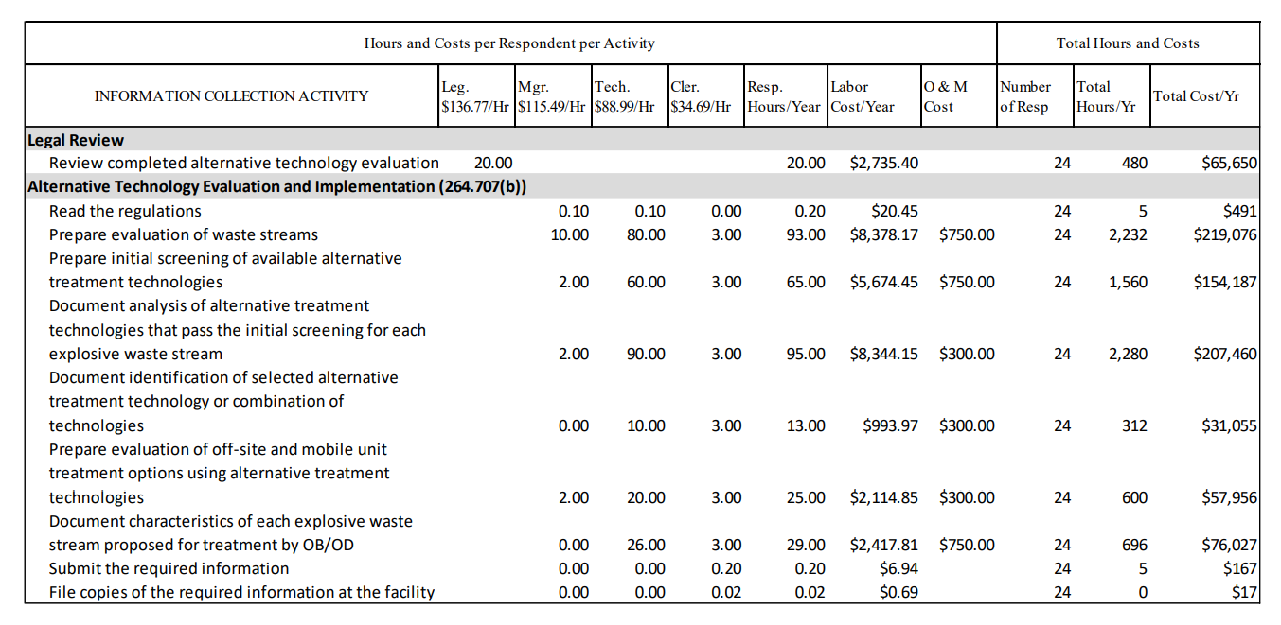

Exhibit 2

Part B Permit Application

Estimation Annual Respondent Burden and Cost

Operating, Monitoring, and Reporting Requirements

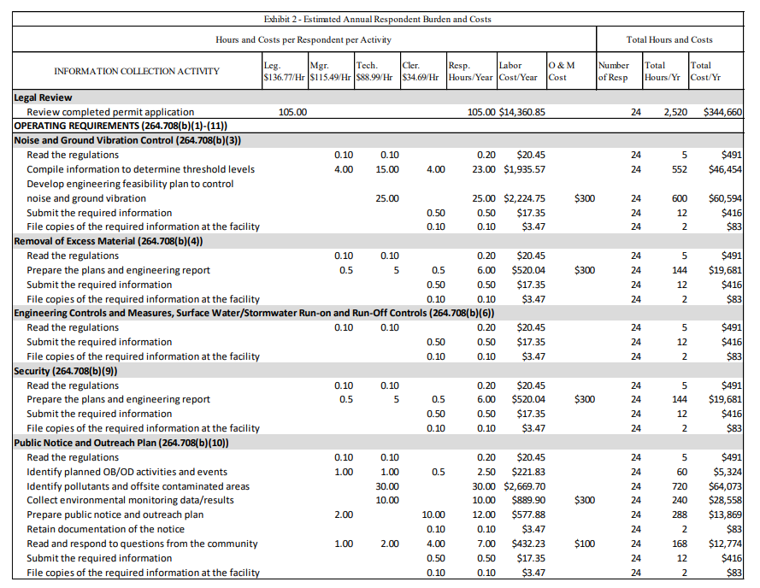

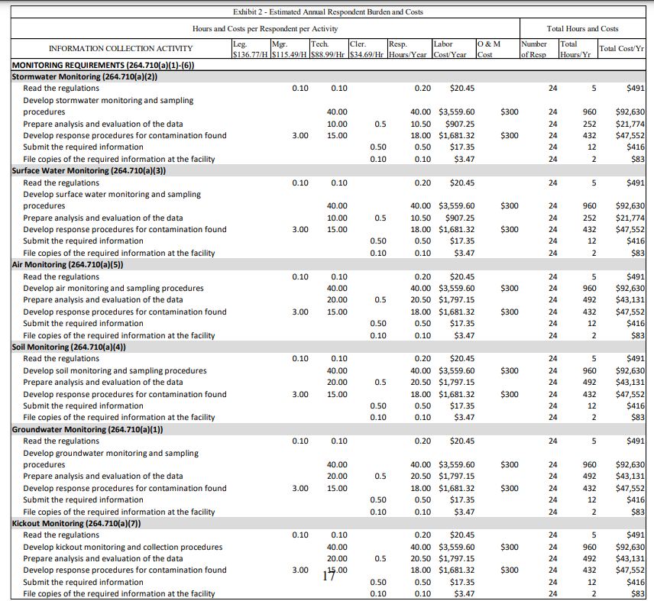

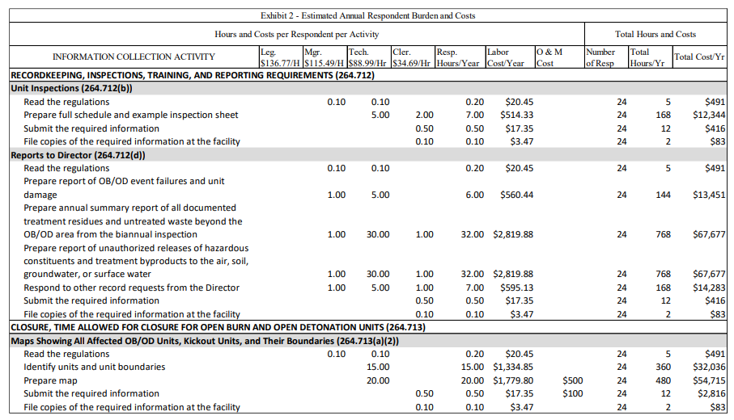

Exhibit 3

Part B Permit Application

Total Estimated Annual Respondent Burden and Cost Summary

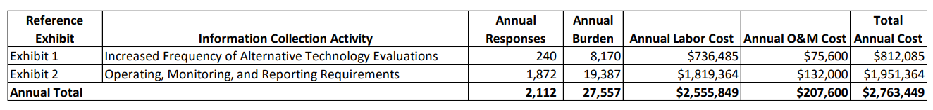

Exhibit 4

Part B Permit Application

Estimated Annual Agency Burden and Cost

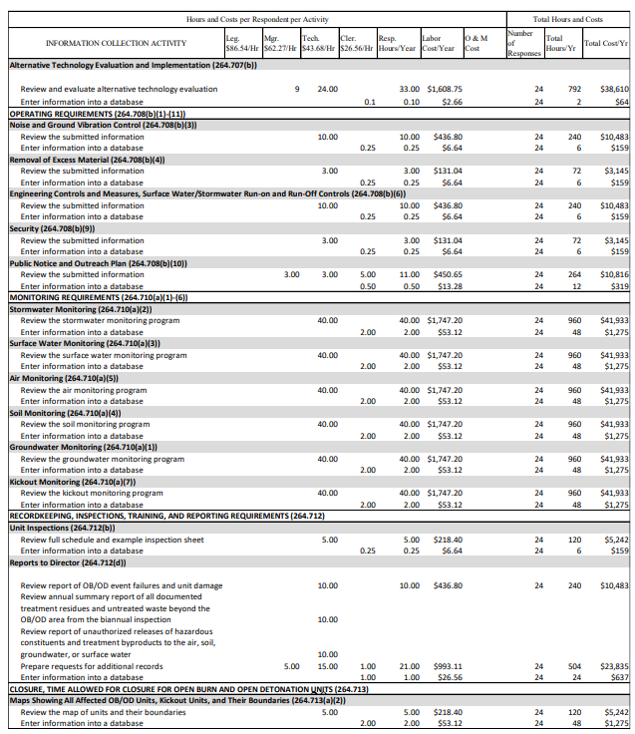

Exhibit 5

Part B Permit Application

Total Estimated Annual Agency Burden and Cost Summary

