U.S. Environmental Protection Agency
Information Collection Request
Title: Disposal of Coal Combustion Residuals from Electric Utilities (Final Rule)
OMB Control Number: 2050-NEW
EPA ICR Number: 2761.02
Abstract: Coal combustion residuals (CCR) are generated from the combustion of coal, including solid fuels classified as anthracite, bituminous, subbituminous, and lignite, for the purpose of generating steam for the purpose of powering a generator to produce electricity or electricity and other thermal energy by electric utilities and independent power producers. CCR includes fly ash, bottom ash, boiler slag, and flue gas desulfurization materials.
CCR are solid wastes that are neither listed nor characteristic hazardous waste and thus, are subject to the requirements of Subtitle D of the Resource Conservation and Recovery Act, as amended (RCRA). RCRA Subtitle D establishes a framework for federal, state, and local government cooperation in controlling the management of non-hazardous solid waste. The federal role in this management structure is to establish the overall regulatory direction, by providing minimum national standards that will protect human health and the environment, and to provide technical assistance to states for planning and developing their own environmentally sound waste management practices. The actual planning and any direct implementation of solid waste programs under RCRA Subtitle D, however, remains a state and local function, and RCRA envisions that states will devise programs to deal with state-specific conditions and needs. 40 CFR Part 257 contains provisions regarding the management of CCR under RCRA Subtitle D.
In 2015, EPA published a final rule to regulate the disposal of CCR from electric utilities as solid waste under RCRA Subtitle D (see 80 FR 21302; April 17, 2015). In the final rule, EPA established national minimum criteria for existing and new CCR landfills and CCR surface impoundments and all lateral expansions to include location restrictions, design and operating criteria, groundwater monitoring and corrective action, closure requirements and post-closure care, and recordkeeping, notification, and internet posting requirements.
The 2015 rule requires any existing unlined CCR surface impoundment that is contaminating groundwater above a regulated constituent’s groundwater protection standard to stop receiving CCR and either retrofit or close, except in limited circumstances. The rule also requires the closure of any CCR landfill or CCR surface impoundment that cannot meet the applicable performance criteria for location restrictions or structural integrity established in this rule. CCR surface impoundments that are no longer receiving CCR as of the effective date of the rule, but still contain water and CCR, will be subject to all applicable regulatory requirements, unless the owner or operator of the facility closes the inactive unit (e.g., the impoundment is closed with a final cover system) no later than three years from the effective date of the rule.
Supporting Statement A
- NEED AND AUTHORITY FOR THE COLLECTION
Explain the circumstances that make the collection of information necessary. Identify any legal or administrative requirements that necessitate the collection.
This rule applies to all CCRs generated by electric utilities and independent power producers that fall within the North American Industry Classification System (NAICS) code 221112 and may affect the following entities: electric utility facilities and independent power producers that fall under the NAICS code 221112. Specifically, the final rule applies to owners and operators of new and existing landfills and new and existing surface impoundments, including all lateral expansions of landfills and surface impoundments that dispose or otherwise engage in solid waste management of CCRs generated from the combustion of coal at electric utilities and independent power producers. These requirements also apply to CCR units located off-site of the electric utilities’ or independent power producers’ facilities that receive CCR for disposal. In addition, the rule applies to certain inactive CCR surface impoundments (i.e., units not receiving CCR after the effective date of the rule) at active electric utilities’ or independent power producers’ facilities, regardless of the fuel currently used at the facility to produce electricity (e.g., coal, natural gas, oil), if the CCR unit still contains CCR and liquids.
Since the 2015 final rule, several Court decisions required accelerated closure timelines for many units and forced closures for many units previously categorized as lined. In addition, in December 2016, the President signed the Water Infrastructure Improvements for the Nation (WIIN) Act. The WIIN Act amended RCRA Subtitle D and established new statutory provisions applicable to CCR landfills and CCR surface impoundments. In particular, the WIIN Act provides that, states may, but are not required to, develop and submit a permit (or other system of prior approval) program for CCR disposal to EPA for approval. Such a program does not have to be identical to the requirements in the CCR rule (40 CFR Part 257, Subpart D), but must be at least as protective as the CCR rule.
In response to the Court decisions and the RCRA Subtitle D amendments, in 2018, EPA published a final rule (see 83 FR 36435; July 30, 2018) that modifies a number of the requirements applicable to CCR landfills and CCR surface impoundments and allows for units to receive variances for unlined surface impoundments. The final rule also incorporates anticipated state applications and programs consistent with the WIIN Act but does not change the scope or focus of the program.
In 2024 EPA published a final rule amending the regulations governing the disposal of CCR in landfills and surface impoundments, codified in subpart D of part 257 of Title 40 of the (CFR). Specifically, the Agency established regulatory requirements for inactive CCR surface impoundments at inactive utilities (“legacy CCR surface impoundment” or “legacy impoundment”). This action was taken in response to the August 21, 2018, opinion by the U.S. Court of Appeals for the District of Columbia Circuit in Utility Solid Waste Activities Group v. EPA, 901 F.3d 414 (D.C. 2018) (“USWAG decision” or “USWAG”) that vacated and remanded the provision exempting legacy impoundments from the CCR regulations. The final rule also established requirements to address the risks from then-currently exempt solid waste management that involves the direct placement of CCR on the land. EPA extended a subset of the existing requirements in 40 CFR part 257, subpart D to CCR surface impoundments and landfills that closed prior to the effective date of the 2015 CCR Rule, inactive CCR landfills, and other areas where CCR is managed directly on the land. In this action, EPA refers to these as CCR management units, or CCRMU.
The 2024 final rule applies to all electric utility facilities and independent power producers that fall under the NAICS code 221112 and may also apply to owners and operators of facilities in NAICS code 22111 that formerly produced coal-fired electricity and disposed of CCRs in legacy impoundments, CCRMUs, and CCRMUs at other active facilities.
EPA merged the burden associated with the information collection requirements related to the disposal of CCR from existing ICR 2050-0053 to this ICR.
EPA regulates the disposal of CCR generated by electric utilities as solid waste under RCRA Subtitle D. In addition, EPA established national minimum criteria for existing and new CCR landfills and existing and new CCR surface impoundments and all lateral expansions. These regulations are established under the authority of Sections 1006(b), 1008(a), 2002(a), 3001, 4004, and 4005(a) of the Solid Waste Disposal Act of 1970, as amended by the Resource Conservation and Recovery Act of 1976 (RCRA), as amended by the Hazardous and Solid Waste Amendments of 1984 (HSWA), 42 U.S.C. Sections 6907(a), 6912(a), 6944, and 6945(a).
At the time the CCR regulations were issued on April 17, 2015, under RCRA Subtitle D, EPA had no formal role in rule implementation, nor could the agency enforce the requirements in the rule. Therefore, the regulations were “self-implementing,” that is, a facility must comply with them without any action by a regulatory agency. As a result, the EPA also encouraged states to revise their Solid Waste Management Plans (SWMPs) and submit these revisions to the EPA for approval. EPA explained that revised SWMPs were the best mechanisms available to show alignment between state and federal requirements, provide the public the opportunity to review and comment on states’ plans for regulating CCR landfills and surface impoundments in their state, and to demonstrate consistency with the federal requirements.
To address concerns about the absence of adequate regulatory oversight under Subtitle D, EPA also sought to enhance the protectiveness of the regulatory requirements by providing for state and public notifications of the third-party certifications, as well as requiring a robust set of other information that documents the decisions made or actions taken to comply with the technical requirements of the rule.
The combined mechanisms of recordkeeping, notifications, and maintaining a publicly accessible internet site under the final rule are needed to provide interested parties with the information necessary to determine whether the owner or operator is operating in accordance with the requirements of the rule. These requirements reduce the danger of owners or operators abusing the self-implementing system established in this rule, through increased transparency that facilitates enforcement by states and private citizens. EPA has consolidated the recordkeeping, notification, and internet posting requirements into a single section of the regulations in an effort to make the regulations easier to follow. See 40 CFR 257.105, 257.106, and 257.107.
- PRACTICAL UTILITY/USERS OF THE DATA
Indicate how, by whom, and for what purpose the information is to be used. Except for a new collection, indicate the actual use the agency has made of the information received from the current collection.
The CCR rule requires owners or operators of CCR units to document how the various provisions of the rule have been met by placing information (e.g., demonstrations, plans, records, notifications, and reports) in the operating record and providing notification of these actions to the state and/or appropriate Tribal authority. The owner or operator also is required to establish and maintain a publicly accessible internet site that posts documentation that has, in many instances, also been entered into the operating record. The owner or operator must place files documenting compliance with the location restrictions; design criteria; operating criteria; groundwater monitoring and corrective action; closure and post-closure care, into the operating record, with the specific documentation requirements found in 40 CFR 257.105. Each file must be maintained in the operating record for a period of at least five years following submittal of the file into the operating record. In certain instances, however, files must be maintained until the CCR unit complete closure.
Owners or operators are required to notify State Directors and/or the appropriate Tribal authority when specific documentation has been placed in the operating record and on the owner or operator’s publicly accessible web site. In most instances these notifications must be certified by a qualified professional engineer and, in certain instances will be accompanied with additional information and or data supporting the notification. Notification requirements have been consolidated in 40 CFR 257.106, and are required for location criteria, design criteria, operating criteria, groundwater monitoring and corrective action and closure and post-closure care.
EPA believes that these requirements will enhance the protectiveness of the rule by providing for state and public notifications of the third-party certifications, as well as requiring a robust set of other information that documents the decisions made or actions taken to comply with the technical requirements of the rule. Further, EPA believes that the establishment and maintenance of this information in both the operating record and on a publicly accessible internet site is appropriate so as to allow states and citizens access to all of the information necessary to show that the rule has been implemented in accordance with the regulatory requirements. EPA has consolidated the recordkeeping and notification requirements into a comprehensive listing in a single section of the regulations. See 40 CFR 257.105 and 257.106, respectively. The Agency anticipates that this will facilitate compliance and will provide other interested parties with an easy-to-read guide to the reporting provisions of the rule.
With the passage of the WIIN Act in December 2016, RCRA Subtitle D was amended to provide new statutory authority pertaining to the management of CCR in landfills and surface impoundments. The WIIN Act allows states to seek CCR permit program approval from EPA. If a state elects to pursue program approval, the information provided by the state will allow EPA to assess and determine whether the state submission meets the statutory requirements.
- USE OF TECHNOLOGY
Describe whether, and to what extent, the collection of information involves the use of automated, electronic, mechanical, or other technological collection techniques or other forms of information technology, e.g., permitting electronic submission of responses, and the basis for the decision for adopting this means of collection. Also describe any consideration of using information technology to reduce burden.
Most information can be maintained in the facility operating record or on a publicly accessible Internet website rather than in submittals to EPA. For the information that is submitted (e.g., liner demonstrations), EPA ensures the accuracy and completeness of the collected information by reviewing each submittal.
- EFFORTS TO IDENTIFY DUPLICATION
Describe efforts to identify duplication. Show specifically why any similar information already available cannot be used or modified for use for the purposes described in Item 2 above.
None of the information required by the regulations covered in this ICR is available from any source but the respondents. None of the regulations are duplicative of any other EPA regulations.
- MINIMIZING BURDEN ON SMALL BUSINESSES AND SMALL ENTITIES
If the collection of information impacts small businesses or other small entities, describe any methods used to minimize burden.
All owner/operators regardless of company size will be treated in the same manner. The information collection requirements do not have a significant economic impact on a substantial number of small entities, EPA nonetheless has tried to reduce the impact of these requirements on small entities.
- CONSEQUENCES OF LESS FREQUENT COLLECTION
Describe the consequence to Federal program or policy activities if the collection is not conducted or is conducted less frequently, as well as any technical or legal obstacles to reducing burden.
EPA has carefully considered the information collection burden imposed upon the regulated community by the requirements covered in this ICR. EPA is confident that those activities required of respondents are necessary to provide sufficient information to state and public users to make informed decisions about policies and actions related to the implementation of the 40 CFR Part 257 information collection requirements related to the disposal of CCR. To the extent possible, the Agency has attempted to minimize the burden imposed by refining existing information requirements and specifying electronic publication of the information on existing web sites. EPA strongly believes that, if the minimum requirements specified under the regulations are not met, EPA cannot ensure that CCR are properly managed and do not pose a serious threat to human health and the environment.
- GENERAL GUIDELINES
Explain any special circumstances that require the collection to be conducted in a manner inconsistent with OMB guidelines.
The information collection is consistent with the guidelines set forth in 5 CFR 1320(d)(2) of the Paperwork Reduction Act .
- PUBLIC COMMENT AND CONSULTATIONS
8a. Public Comment
If applicable, provide a copy and identify the date and page number of publication in the Federal Register of the Agency's notice, required by 5 CFR 1320.8(d), soliciting comments on the information collection prior to submission to OMB. Summarize public comments received in response to that notice and describe actions taken by the Agency in response to these comments. Specifically address comments received on cost and hour burden.
In compliance with the Paperwork Reduction Act of 1995, EPA opened a 60-day public comment period for the collection activities, which was published on May 1, 2023 in the Federal Register (88 FR 26537). EPA received no comments on this ICR in response to the Federal Register notice.
- PAYMENTS OR GIFTS TO RESPONDENTS
Explain any decisions to provide payments or gifts to respondents, other than remuneration of contractors or grantees.
The Agency does not intend to provide payments or gifts to respondents as part of this collection.
- ASSURANCE OF CONFIDENTIALITY
Describe any assurance of confidentiality provided to respondents and the basis for the assurance in statute, regulation, or Agency policy. If the collection requires a systems of records notice (SORN) or privacy impact assessment (PIA), those should be cited and described here.
None of the information collection requirements covered in this ICR require the disclosure of confidential business information. EPA believes that the recordkeeping, notification, and internet posting requirements under the final rule are necessary as a mechanism for States and citizens to monitor the situation of CCR units, such as when groundwater monitoring shows evidence of potential contamination, so that they can determine when intervention is appropriate. The “transparency” requirements under the final rule serve as a key component by ensuring that the entities primarily responsible for enforcing the requirements have access to the information necessary to determine whether enforcement is warranted.
- JUSTIFICATION FOR SENSITIVE QUESTIONS
Provide additional justification for any questions of a sensitive nature, such as sexual behavior and attitudes, religious beliefs, and other matters that are commonly considered private. This justification should include the reasons why the Agency considers the questions necessary, the specific uses to be made of the information, the explanation to be given to persons from whom the information is requested, and any steps to be taken to obtain their consent.
Questions about sensitive issues that are normally considered private (e.g., religious beliefs, sexual attitudes, and behavior) will not be included in the information collections covered by this ICR.
- RESPONDENT BURDEN HOURS & LABOR COSTS
Provide estimates of the hour burden of the collection of information. The statement should:
- Indicate the number of respondents, frequency of response, annual hour burden, and an explanation of how the burden was estimated. Generally, estimates should not include burden hours for customary and usual business practices.
- If this request for approval covers more than one form, provide separate hour burden estimates for each form and the aggregate the hour burdens.
- Provide estimates of annualized cost to respondents for the hour burdens for collections of information, identifying and using appropriate wage rate categories. The cost of contracting out or paying outside parties for information collection activities should not be included here. Instead, this cost should be included as O&M costs under non-labor costs covered under question 13.
Respondent Burden
EPA estimates that 2,083 coal-fired electric utility plants are subject to the information collection requirements covered in this ICR. 302 of these plants are those regulated under the 2015 final CCR rule; an additional 90 plants were not regulated by the 2015 final CCR rule but are regulated under the 2024 final rule, and 1,691 do not have units regulated by the 2024 final rule but will nonetheless need to read the regulations and conduct a facility evaluation to determine that the 2024 final rule does not apply to them.
As shown in Exhibit 9, EPA estimates the annual respondent burden to be 267,123 hours and $33,339,045.
12a. Respondents/NAICS Codes
The information collection requirements covered in this ICR may affect electric utility facilities and independent power producers that fall under the NAICS code 221112 (Fossil Fuel Electric Power Generation) and may also affect electric utilities and independent power producers that fall under the NAICS code 22111 (Electric Power Generation) whose facilities formerly burned coal to produce electricity and disposed of CCRs onsite in legacy surface impoundments, CCRMUs, and CCRMUs at other active facilities.
12b. Information Requested
The information provided varies based on provision and on the timing of the cessation of coal-fired boilers. The requirements outlined in this ICR contain some one-time submissions and some regularly recurring reporting activities, including annual progress reports. The requirements are (voluntary) one-time submissions.
A comprehensive accounting of all respondent activities is detailed in Exhibit 10.
12c. Respondent Burden Hours and Labor Costs
This ICR is a comprehensive presentation of all information collection activities required for disposal of CCR under RCRA Subtitle D. EPA estimated respondent burden hours associated with all 40 CFR Part 257 requirements covered in this ICR in Exhibits 1 through 9. Exhibit 1 addresses the burden for owners and operators of CCR units to read the regulations and adhere to the location restrictions regulations under 40 CFR 257.60. Exhibit 2 addresses the respondent burden to comply with design criteria under 40 CFR 257.70 through 40 CFR 257.74. Exhibit 3 addresses the respondent burden to comply with operating criteria under 40 CFR 257.80 through 40 CFR 257.84. Exhibit 4 addresses provisions related to groundwater monitoring and corrective action covered under 40 CFR 257.90 through 40 CFR 257.98. Exhibit 5 addresses the respondent burden related to closure and post-closure care, as required under 40 CFR 257.101 through 40 CFR 257.104. Exhibit 5 addresses the respondent burden related to recordkeeping, notification, and posting information to the internet, as required under 40 CFR 257.105 through 40 CFR 257.107. Exhibit 7 addresses the state government agency and tribal authority burden related to recordkeeping, notification, and posting information to the internet, as required under 40 CFR 257.106. Exhibit 8a addresses the state government agency and tribal authority burden associated with the preparation of solid waste management plans and CCR permit program applications. Exhibit 8b addresses the Agency burden associated with the review and approval of solid waste management plans and CCR permit program applications. Exhibit 9 provides a summary of the total burden hours and costs for all activities related to the disposal of CCR under Subtitle D of RCRA.
EPA relies on estimates of the universe of affected respondents and estimates of the hourly burden associated with the individual requirements from the prior approved ICR for the CCR program.
Labor Costs
Exhibits 1 through 8 illustrate the labor costs associated with the information collection requirements covered in this ICR.
Owners and Operators of CCR Units
EPA estimates an average hourly respondent labor cost (including fringe and overhead) of $140.50 for legal staff, $112.56 for managerial staff, $54.45 for technical staff, and $35.29 for clerical staff. These hourly labor rates are based on the most current estimates of national cross-industry wages by the U.S. Bureau of Labor Statistics (BLS) for occupational groups SOC 23-1011: Lawyers; SOC 11-0000: Management Occupations; SOC 17-3026: Industrial Engineering Technicians; and SOC 43-9061: Office Clerks, General, respectively, multiplied by a factor of 1.78 to account for fringe benefits and overhead.
The labor rates are displayed in the table below.
Labor Category | US Bureau of Labor Statistics Standard Occupational Code | Non-loaded 2023 average (mean) wage rate  ($ per hour) | Fringe benefits as percent of total employee compensation | Overhead percentage | Loaded 2023 average wage rate ($ per hour)
1. Legal | 23-1011 Lawyers | $78.74 | 33.3% | 12% | $ 140.50
2. Managerial | 11-0000 Management Occupations | $63.08 | 33.3% | 12% | $112.56
3. Technical | 17-3026 Industrial Engineering Technicians | $30.52 | 33.3% | 12% | $54.46
4. Clerical | 43-9061 Office Clerks, General | $19.78 | 33.3% | 12% | $35.29

State Government Agencies and Tribal Authorities
EPA estimates an average hourly labor cost of $97.87 for legal staff, $95.19 for managerial staff, $55.84 for technical staff, and $37.23 for clerical staff. These hourly labor rates are based on the most current estimates of State government wages by BLS for occupational groups SOC 23-1011: Lawyers; SOC 11-0000: Management Occupations; SOC 19-4091: Environmental Science and Protection Technicians; and SOC 43 9061: Office Clerks, General, respectively, multiplied by a factor of 1.97 to account for fringe benefits and overhead.
The labor rates are displayed in the table below.
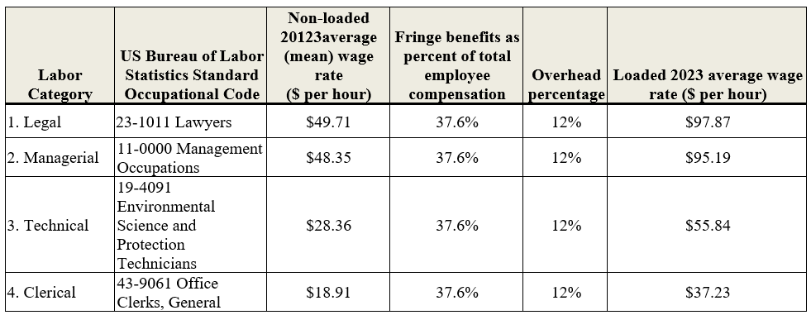
- Respondent CAPITAL AND O&m CostS
Provide an estimate for the total annual cost burden to respondents or record keepers resulting from the collection of information. (Do not include the cost of any hour burden already reflected on the burden worksheet).
The cost estimate should be split into two components: (a) a total capital and start-up cost
component (annualized over its expected useful life) and (b) a total operation and maintenance and purchase of services component. The estimates should consider costs associated with generating, maintaining, and disclosing or providing the information. Include descriptions of methods used to estimate major cost factors including system and technology acquisition, expected useful life of capital equipment, the discount rate(s), and the period over which costs will be incurred. Capital and start-up costs include, among other items, preparations for collecting information such as purchasing computers and software; monitoring, sampling, drilling, and testing equipment; and record storage facilities.
If cost estimates are expected to vary widely, agencies should present ranges of cost burdens and explain the reasons for the variance. The cost of purchasing or contracting out information collections services should be a part of this cost burden estimate.
Generally, estimates should not include purchases of equipment or services, or portions thereof, made: (1) prior to October 1, 1995, (2) to achieve regulatory compliance with requirements not associated with the information collection, (3) for reasons other than to provide information or keep records for the government, or (4) as part of customary and usual business or private practices.
EPA estimates there will be no capital costs incurred under this ICR.
O&M costs are those costs associated with a paperwork requirement incurred continually over the life of the ICR. For this ICR, O&M costs include: mailing costs, certification fees, sampling costs, alternate liner demonstration application, and alternate liner demonstration. O&M costs were obtained from regulatory impact analyses and updated to 2023 levels using Consumer Price Indexes developed by BLS. O&M costs are shown in Exhibits 1 through 8 for all applicable respondent activities. For this collection, the annual O&M cost for private entities is expected to be $17,143,376.
- AGENCY COSTS
Provide estimates of annualized costs to the Federal government. Also, provide a description of the method used to estimate cost, which should include quantification of hours, operational expenses (such as equipment, overhead, printing, and support staff), and any other expense that would not have been incurred without this collection of information.
14a. Agency Activities
Most of the information collection requirements covered in this ICR are maintained in records in the facility’s operating record and therefore are not formally submitted to EPA. For the information that may be submitted – specifically, a revised Solid Waste Management Plan (SWMP) or application for a CCR permit program submitted by a State – the Agency will review and, as appropriate, approve the SWMP or permit program submittal. Early in the development of the waste management infrastructure, a process was created to encourage States to effectively plan for and manage their solid wastes through the development of SWMPs. Currently, many states have SWMPs that have been submitted to and approved by EPA. EPA recommends that States take advantage of this process, already in the regulations, by revising their SWMPs to address the issuance of the revised federal requirements and to submit revisions of these plans to EPA. Currently, no states have approved CCR permit programs as authorized under the WIIN Act of 2016.
14b. Agency Burden and Cost
For Agency burden related to CCR, EPA estimates an average hourly labor cost of $102.11 for legal staff (GS-15, Step 5), $90.10 for managerial staff (GS-15, Step 1), $64.82 for technical staff (GS-13, Step 1), and $27.65 for clerical staff (GS-06, Step 1). To derive these hourly estimates, EPA referred to the General Schedule (GS) Salary Table 2023. This publication summarizes the unloaded (base) hourly rate for various labor categories in the Federal Government. EPA then applied the standard government overhead factor of 1.6 to the unloaded rate to derive loaded hourly rates.
The labor rates are summarized in the table below.
Labor Category | General Schedule (GS) Code | January 2023 Base Rate | Overhead Rate | 2023 Loaded Rate
Legal | GS-15, Step 5 | $63.82 | 1.6 | $102.11
Managerial | GS-15, Step 1 | $56.31 | 1.6 | $90.10
Technical | GS-13, Step 1 | $40.51 | 1.6 | $64.82
Clerical | GS-06, Step 1 | $17.28 | 1.6 | $27.65
Exhibit 8b summarizes the total annual Agency hour or cost burden associated with reviewing and approving State SWMPs and CCR permit program applications. As shown in the exhibit, EPA estimates the annual Agency burden to be 1,599 hours and $121,648.
- REASONS FOR CHANGE IN BURDEN
Explain the reasons for any program changes or adjustments reported in the burden or capital/O&M cost estimates.
This is a new collection. The burden in this new collection has two sources. The first is the transfer of 175,319 hours related to the disposal of CCR from the existing ICR, 2050-0053. The remaining 91,804 hours are a result of the 2024 final rule, which adds requirements to Legacy CCR Surface Impoundments and CCRMUs.
- PUBLICATION OF DATA
For collections of information whose results will be published, outline plans for tabulation and publication. Address any complex analytical techniques that will be used. Provide the time schedule for the entire project, including beginning and ending dates of the collection of information, completion of report, publication dates, and other actions.
Results from this ICR are not published formally. They are used to calculate agency-level accomplishments and site-specific impacts on publicly available EPA websites.
- DISPLAY OF EXPIRATION DATE
If seeking approval to not display the expiration date for OMB approval of the information collection, explain the reasons that display would be inappropriate.
All instruments will display the expiration date for OMB approval of the information collection.
- CERTIFICATION STATEMENT
Explain each exception to the topics of the certification statement identified in “Certification for Paperwork Reduction Act Submissions.”
EPA does not seek any exceptions to the topics for the certification statement identified in the “Certification for Paperwork Reduction Act Submissions.”

Exhibits
Exhibit 1
Beneficial Use of CCR
EPA estimates that, each year, zero users of CCR will demonstrate and keep records of beneficial use, as required under 40 CFR 257.53. This ICR assumes that all beneficial use respondents completed the requirements under 40 CFR 257.53.
Reading the Regulations
EPA estimates that 2,083 coal-fired electric utility plants will be subject to the information collection requirements under CCR regulations. EPA assumes that these respondents will read the regulations once during the three-year life of the ICR. In estimating the annual respondent hour and cost burden over the three-year period covered by this ICR, EPA annualized the hour and cost burden of this one-time activity by dividing the number of respondents by three. Thus, EPA estimates that 694 respondents (i.e., 2,083 respondents / 3 years), on average, will read the regulations each year.
Location Restrictions
(c1) Placement above the Uppermost Aquifer
EPA assumes that owners and operators of new CCR units (i.e., 26 new landfills + 11 new impoundments = 37 units) will demonstrate that each of their CCR units meet the minimum requirements for placement above the uppermost aquifer. EPA further assumes that these demonstrations, which include a certification from a qualified professional engineer, will be prepared once during the three-year life of the ICR. In estimating the annual respondent hour and cost burden over the three-year period covered by this ICR, EPA annualized the hour and cost burden of this one-time activity by dividing the number of CCR units by three. Thus, EPA estimates that 13 units (i.e., 37 units / 3 years), on average, will be subject to this requirement each year.
(c2) Wetlands
EPA assumes that owners and operators of new CCR units (i.e., 26 new landfills + 11 new impoundments = 37 units) will prepare the wetland location restriction demonstration required under 40 CFR 257.61. EPA further assumes that these demonstrations, which include a certification from a qualified professional engineer, will be prepared once during the three-year life of the ICR. In estimating the annual respondent hour and cost burden over the three-year period covered by this ICR, EPA annualized the hour and cost burden of this one-time activity by dividing the number of CCR units by three. Thus, EPA estimates that 13 units (i.e., 37 units / 3 years), on average, will be subject to this requirement each year.
(c3) Fault Areas
EPA assumes that owners and operators of new CCR units (i.e., 26 new landfills + 11 new impoundments = 37 units) will prepare the fault area location restriction demonstration required under 40 CFR 257.62. EPA further assumes that these demonstrations, which include a certification from a qualified professional engineer, will be prepared once during the three-year life of the ICR. In estimating the annual respondent hour and cost burden over the three-year period covered by this ICR, EPA annualized the hour and cost burden of this one-time activity by dividing the number of CCR units by three. Thus, EPA estimates that 13 units (i.e., 37 units / 3 years), on average, will be subject to this requirement each year.
(c4) Seismic Impact Zones
EPA assumes that owners and operators of new CCR units (i.e., 26 new landfills + 11 new impoundments = 37 unitsi.e., 26 new landfills + 11 new impoundments = 37 units will prepare the seismic impact zone location restriction demonstration required under 40 CFR 257.63. EPA further assumes that these demonstrations, which include a certification from a qualified professional engineer, will be prepared once during the three-year life of the ICR. In estimating the annual respondent hour and cost burden over the three-year period covered by this ICR, EPA annualized the hour and cost burden of this one-time activity by dividing the number of CCR units by three. Thus, EPA estimates that 13 units (i.e., 37 units / 3 years), on average, will be subject to this requirement each year.
(c5) Unstable Areas
EPA assumes that owners and operators of new CCR units (i.e., 26 new landfills + 11 new impoundments = 37 units) will prepare the unstable areas location restriction demonstration required under 40 CFR 257.64. EPA further assumes that these demonstrations, which include a certification from a qualified professional engineer, will be prepared once during the three-year life of the ICR. In estimating the annual respondent hour and cost burden over the three-year period covered by this ICR, EPA annualized the hour and cost burden of this one-time activity by dividing the number of CCR units by three. Thus, EPA estimates that 13 units (i.e., 37 units / 3 years), on average, will be subject to this requirement each year.
Applicability and Evaluation Reports
EPA assumes that all 194 Legacy CCR Surface Impoundments will need to complete the Applicability Report required at 40 CFR 257.100(f)(1), including any attendant extensions to complete the report. EPA annualized the hour and cost burden of this one-time activity by dividing the number of CCR units by three. Thus, EPA estimates that 65 units (i.e., 194 units / 3 years), on average, will be subject to this requirement each year.
EPA assumes that all 195 CCR Management Units (CCRMUs), and all 15 CCRMUs at Other Active Facilities (OAFUs) will need to complete the Facility Evaluation Report required at 40 CFR 257.73(c) and (d). In addition, EPA assumes that 1,691 facilities without units regulated by the 2024 final rule will need to complete a Facility Evaluation Report to determine that the rule does not apply to them, for a total of 1,901 completed Reports. EPA annualized the hour and cost burden of this one-time activity by dividing the number of completed reports by three. Thus, EPA estimates that 634 reports (i.e., 1,901 reports / 3 years), on average, will be subject to this requirement each year.
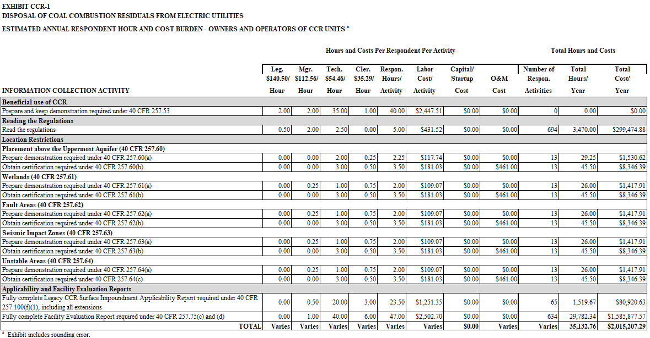

Exhibit 2
Design Criteria
(d1) Liner Design Criteria for New CCR Landfills and Any Lateral Expansion of a CCR Landfill
EPA assumes that 7 of the new CCR landfills will have an alternative composite liner. As a result, 7 of the new CCR landfills will be subject to the certification requirement at 40 CFR 257.70(c)(2).
EPA assumes that owners and operators of all new CCR landfills will obtain a certification from a qualified professional engineer that the composite liner and the leachate collection and removal system meet the requirements of 40 CFR 257.70. One certification will be obtained prior to the construction of the CCR landfill pursuant to 40 CFR 257.70(e) and one certification will be obtained upon completion of the construction pursuant to 40 CFR 257.70(f). EPA further assumes that each of these certifications will be obtained once during the three-year life of the ICR. In estimating the annual respondent hour and cost burden over the three-year period covered by this ICR, EPA annualized the hour and cost burden of this one-time activity by dividing the number of new CCR landfills by three. Thus, EPA estimates that 9 units (i.e., 21 units / 3 years), on average, will be subject to these certification requirements each year.
(d2) Liner Design Criteria for Existing CCR Surface Impoundments
EPA assumes that owners and operators of all existing CCR surface impoundments have already documented the liner type as required under 40 CFR 257.71(a) and obtained the certification required under 40 CFR 257.71(b) are unaffected during this ICR.
(d3) Liner Design Criteria for New CCR Surface Impoundments and Any Lateral Expansion of a CCR Surface Impoundment
EPA assumes that owners and operators of all new CCR surface impoundments will obtain a certification from a qualified professional engineer that the composite liner complies with the requirements of 40 CFR 257.72. One certification will be obtained prior to the construction of the CCR surface impoundment pursuant to 40 CFR 257.72(c) and one certification will be obtained upon completion of the construction pursuant to 40 CFR 257.72(d). EPA further assumes that each of these certifications will be obtained once during the three-year life of the ICR. In estimating the annual respondent hour and cost burden over the three-year period covered by this ICR, EPA annualized the hour and cost burden of this one-time activity by dividing the number of new CCR surface impoundments by three. Thus, EPA estimates that 4 units (i.e., 11 units / 3 years), on average, will be subject to these certification requirements each year.
.
(d4) Structural Integrity Criteria for Existing CCR Surface Impoundments
Requirements at 40 CFR 257.73(a)
EPA estimates that 83 percent of existing CCR surface impoundments are not incised CCR units. EPA assumes that owners and operators of these CCR surface impoundments will comply with the requirements at 40 CFR 257.73(a).
EPA assumes that several one-time activities under 40 CFR 257.73(a) were already completed by units regulated under the 2015 CCR rule but will need to be completed by Legacy CCR Surface Impoundments. These activities include placing a permanent identification marker showing the identification number of the CCR unit (40 CFR 257.73(a)(1)) and preparing the Emergency Action Plan (EAP) under 40 CFR 257.73(a)(3). EPA also assumes that several additional activities required under 40 CFR 257.73 every five years were completed such that their five-year recurrence is outside the scope of this ICR. These activities include documenting the initial hazard potential classification assessment of the CCR unit (40 CFR 257.73(a)(2)) and obtaining the certification required under 40 CFR 257.73(a)(2)(ii), though Legacy CCR surface impoundments will need to conduct these activities.
EPA assumes that two requirements under 40 CFR 257.73(a) will be completed annually. EPA assumes that the requirement to prepare documentation on an annual face-to-face meeting or exercise between representatives of the owner/operator of the CCR unit and the local emergency responders (40 CFR 257.73(a)(3)(i)(E)) will be conducted by the percentage of all units that present a high or significant hazard. EPA assumes that 43 percent of all units present a high or significant hazard. Thus, EPA assumes that 188 units (i.e., 523 units, of which 43 percent are high or significant hazard, and 83 percent are not incised) will need to complete the documentation under (40 CFR 257.73(a)(3)(i)(E)) annually. EPA also assumes that preparing documentation required under 40 CFR 257.73(a)(3)(v) will be completed by 47 units (i.e., 523 units × 10% of units activating EAPs x 83% non-incised units= 47 units).
EPA also assumes that the remaining requirements under 40 CFR 257.73(a) will not be completed during this ICR: amend the EAP (40 CFR 257.73(a)(3)(ii)) and obtain certification (40 CFR 257.73(a)(3)(iv)). EPA assumes that it will not be necessary to amend the EAP during this ICR.
Requirements at 40 CFR 257.73(c) through (e)
EPA assumes that no units will be subject to the requirements at 40 CFR 257.73(c) through (e) during this ICR, except Legacy CCR surface impoundments. Several requirements have been completed, including: compiling history of construction (40 CFR 257.73(c)), conducting and documenting the initial structural stability assessment (40 CFR 257.73(d)), obtaining the certification required under 40 CFR 257.73(d)(3), conducting and documenting the initial safety factor assessment (40 CFR 257.73(e)) , and obtaining the certification required under 40 CFR 257.73(e)(2). In addition, any action plans for structural stability that would have been required under 257.73(d)(2) would have been completed at the time of the initial assessment (which has already been completed).
(d5) Structural Integrity Criteria for New CCR Surface Impoundments and Any Lateral Expansion of a CCR Surface Impoundment
Requirements at 40 CFR 257.74(a)
EPA estimates that 83 percent of new CCR surface impoundments are not incised CCR units. EPA assumes that owners and operators of these CCR surface impoundments will comply with the requirements at 40 CFR 257.74(a).
EPA also assumes that certain activities under 40 CFR 257.74(a) will be conducted once during the three-year life of the ICR. These activities include: placing a permanent identification marker showing the identification number of the CCR unit (40 CFR 257.74(a)(1)), documenting the initial hazard potential classification assessment of the CCR unit (40 CFR 257.74(a)(2)), obtaining the certification required under 40 CFR 257.74(a)(2)(ii), and preparing a written EAP (40 CFR 257.74(a)(3)). In estimating the annual respondent hour and cost burden over the three-year period covered by this ICR, EPA annualized the hour and cost burden of these one-time activities by dividing the number of CCR surface impoundments by three. Thus, EPA estimates that 3 units (i.e., 11 units / 3 years), on average, will be subject to these requirements each year.
EPA further assumes that owners and operators of CCR units subject to the requirements of 40 CFR 257.74(a) will conduct the following activity on an annual basis: prepare documentation on an annual face-to-face meeting or exercise between representatives of the owner/operator of the CCR unit and the local emergency responders (40 CFR 257.74(a)(3)(i)(E)). EPA assumes that only those units that have a high or significant hazard (assumed to be 43%) will be required to complete the documentation.
EPA assumes that no units will amend the EAP (40 CFR 257.74(a)(3)(ii)) during the ICR period. EPA assumes that the average number of new units will obtain the certification required under 40 CFR 257.74(a)(3)(iv) annually (3), and that one percent of units (i.e., 3 units × 0.01 = 0 units) will need to implement the EAP and prepare the documentation required under 40 CFR 257.74(a)(3)(v).
Requirements at 40 CFR 257.74(c) through (e)
EPA estimates that 73 percent of new CCR surface impoundments have a height of five feet or more and a storage volume of 20 acre-feet or more or have a height of 20 feet or more (i.e., 4 units x 0.73 = 3 units). EPA assumes that owners and operators of these CCR surface impoundments will comply with the requirements at 40 CFR 257.74 (c) through (e).
EPA also assumes that certain activities under 40 CFR 257.74(c) through (e) will be conducted once during the three-year life of the ICR. These activities include: compiling the design and construction plans for the CCR unit (40 CFR 257.74(c)), conducting and documenting the initial structural stability assessment (40 CFR 257.74(d)), obtaining the certification required under 40 CFR 257.74(d)(3), conducting and documenting the initial safety factor assessment (40 CFR 257.74(e)) , and obtaining the certification required under 40 CFR 257.74(e)(2). In estimating the annual respondent hour and cost burden over the three-year period covered by this ICR, EPA annualized the hour and cost burden of these one-time activities by dividing the number of CCR surface impoundments by three. Thus, EPA estimates that 3 units (i.e., 11 units / 3 years), on average, will be subject to these requirements each year.
In addition, EPA assumes that no units will be required to prepare the action plan required under 40 CFR 257.74(d)(2).
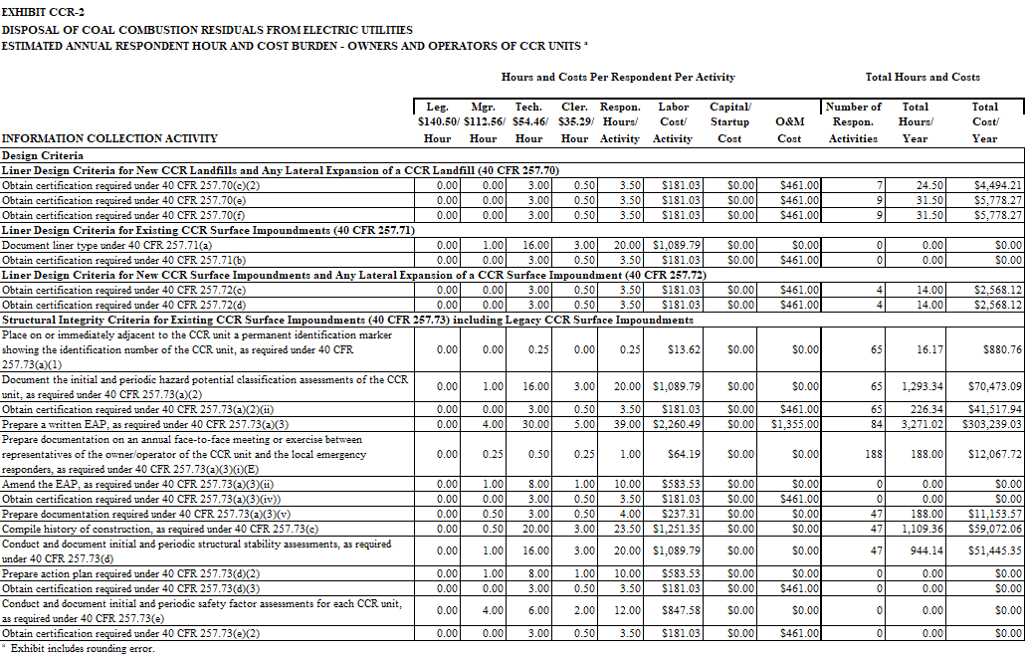
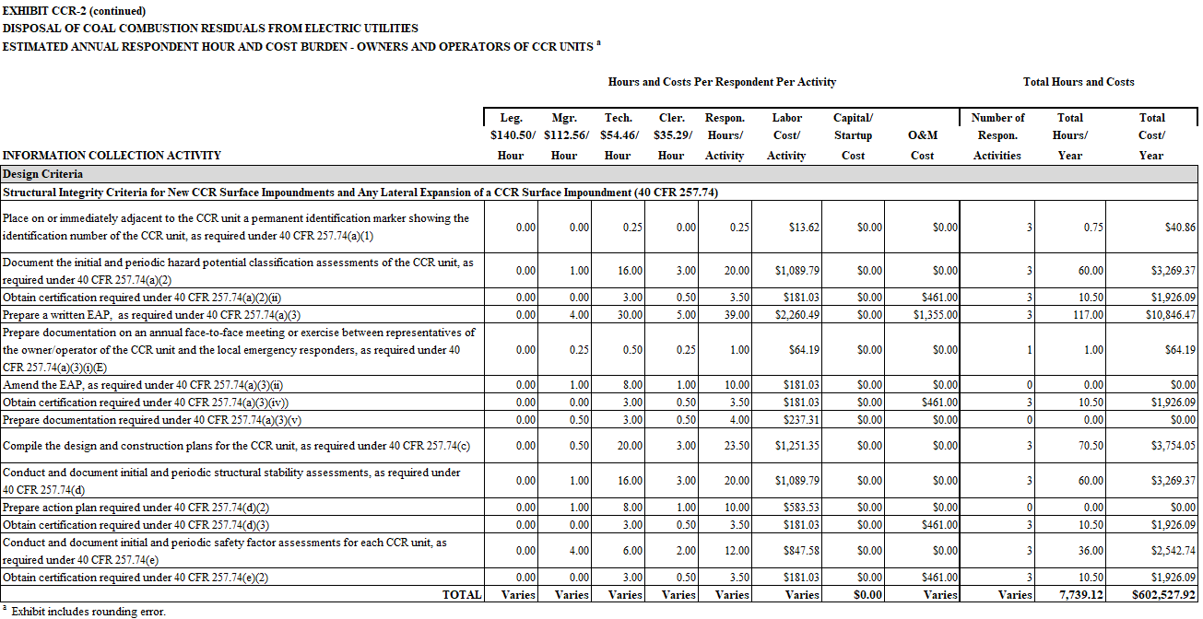

Exhibit 3
Operating Criteria
(e1) Air Criteria
EPA assumes that all owners and operators of existing and new CCR units will comply with the air criteria requirements at 40 CFR 257.80. EPA also assumes that owners and operators of new units and Legacy CCR surface impoundments will prepare the CCR fugitive dust control plan once during the three-year life of the ICR. EPA assumes that existing units and CCRMUs have already prepared the dust control plan. In estimating the annual respondent hour and cost burden over the three-year period covered by this ICR, EPA annualized the hour and cost burden of this one-time activity by dividing the number of new CCR units by three. Thus, EPA estimates that 78 units (i.e., 231 units / 3 years), on average, will prepare the CCR fugitive dust control plan each year.
EPA assumes that none of the owners and operators will amend their CCR fugitive dust control plan during the three-year period covered by this ICR.
Based on the above, owners and operators of 78 CCR units will need to obtain a certification from a qualified professional engineer that the initial CCR fugitive dust control plan, or any subsequent amendment of it, meets the requirements of 40 CFR 257.80 (40 CFR 257.80(b)(7)).
EPA assumes that owners and operators of 964 CCR units will prepare the annual CCR fugitive dust control report required under 40 CFR 257.80(c).
(e2) Run-On and Run-Off Controls for CCR Landfills
EPA assumes that all owners and operators of new CCR landfills will prepare the initial run-on and run-off control system plan required under 40 CFR 257.81(c) once during the three-year life of the ICR. EPA assumes that existing units have already prepared the initial run-on and run-off control system plans. In estimating the annual respondent hour and cost burden over the three-year period covered by this ICR, EPA annualized the hour and cost burden of this one-time activity by dividing the number of new CCR units by three. Thus, EPA estimates that 9 units (i.e., 26 units / 3 years), on average, will prepare the run-on and run-off control plan each year.
EPA assumes that none of the owners and operators will amend their run-on and run-off control system plan during the three-year period covered by this ICR.
Based on the above, owners and operators of 9 CCR units will need to obtain a certification from a qualified professional engineer that the initial and periodic run-on and run-off control system plans meet the requirements of 40 CFR 257.81 (40 CFR 257.81(c)(5)).
(e3) Hydrologic and Hydraulic Capacity Requirements for CCR Surface Impoundments
EPA assumes that all owners and operators of new CCR surface impoundments and Legacy CCR Surface Impoundments will prepare the initial inflow design flood control system plans required under 40 CFR 257.82(c) once during the three-year life of the ICR. EPA assumes that existing units have already prepared the initial inflow design flood control system plans. In estimating the annual respondent hour and cost burden over the three-year period covered by this ICR, EPA annualized the hour and cost burden of this one-time activity by dividing the number of CCR units by three. Thus, EPA estimates that 69 units (i.e., 205 units / 3 years), on average, will be subject to this requirement each year.
Based on the above, owners and operators of 69 CCR units will need to obtain a certification from a qualified professional engineer that the initial inflow design flood control system plans meet the requirements of 40 CFR 257.82 (40 CFR 257.82(c)(5)).
(e4) Inspection Requirements for CCR Surface Impoundments
EPA assumes that owners and operators of all 523 existing and new CCR surface impoundments and all 194 Legacy CCR Surface Impoundments will comply with the inspection requirements at 40 CFR 257.83(a) each year.
EPA estimates that 73 percent of existing and new CCR surface impoundments are subject to the periodic structural stability assessment requirements under 40 CFR 257.73(d) or 40 CFR 257.74(d) (i.e., 721 units x 0.73 = 326 units). EPA assumes that all of these CCR units will be inspected annually by a qualified professional engineer to ensure that the design, construction, operation, and maintenance of the CCR unit are consistent with recognized and generally accepted good engineering standards, as required under 40 CFR 257.83(b)(1). EPA also assumes that the qualified professional engineer will develop an inspection report, as required under 40 CFR 257.83(b)(2).
Finally, EPA assumes that owners and operators of 1 percent of the existing and new CCR surface impoundments (i.e., 721 units x 0.01 = 7 units) will develop and implement an action plan to remedy structural weakness or disrupting condition each year.
(e5) Inspection Requirements for CCR Landfills
EPA assumes that owners and operators of all 235 existing and new CCR landfills will comply with the inspection requirements at 40 CFR 257.84(a) and (b) each year.
EPA also assumes that owners and operators of 1 percent of the existing and new CCR landfills (i.e., 235 units x 0.01 = 2 units) will develop and implement an action plan to remedy structural weakness or disrupting condition each year.
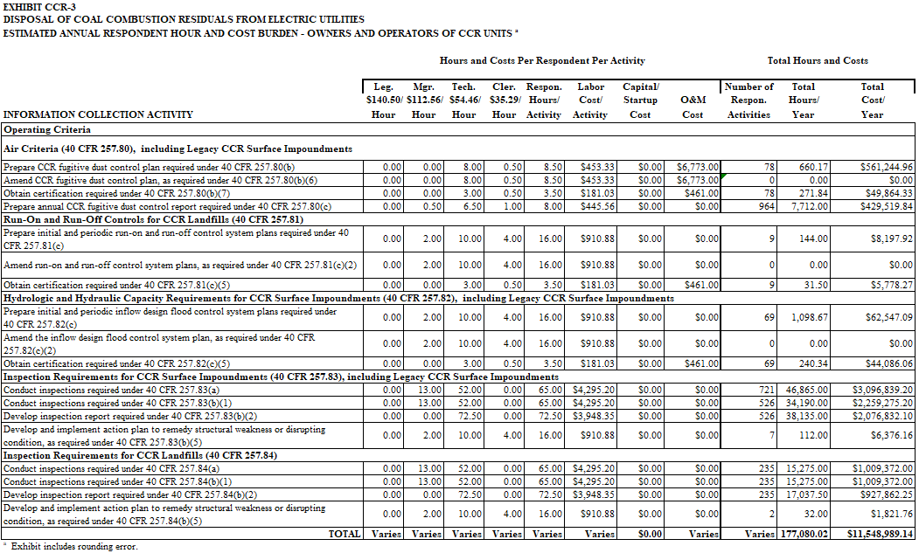

Exhibit 4
Groundwater Monitoring and Corrective Action
(f1) Applicability
EPA assumes that owners and operators of all 770 existing and new CCR units will develop the annual groundwater monitoring and corrective action report required under 40 CFR 257.90(e). Note that for Legacy CCR Surface Impoundments and CCRMUs, the requirements of the 2024 final rule to conduct groundwater monitoring and corrective action activities do not phase in until after the three-year period covered by this ICR.
(f2) Groundwater Monitoring Systems
EPA assumes that owners and operators of all 37 new CCR units will document and include in the operating record the design, installation, development, and decommissioning of any monitoring wells, piezometers and other measurement, sampling, and analytical devices. EPA assumes that existing units have already completed this requirement. Owners and operators of these units also will obtain a certification from a qualified professional engineer stating that the groundwater monitoring system has been designed and constructed to meet the requirements of 40 CFR 257.91. EPA also assumes that these activities will be conducted once during the three-year life of the ICR. In estimating the annual respondent hour and cost burden over the three-year period covered by this ICR, EPA annualized the hour and cost burden of these one-time activities by dividing the number of CCR units by three. Thus, EPA estimates that 13 units (i.e., 37 units / 3 years), on average, will be subject to these requirements each year.
(f3) Groundwater Sampling and Analysis Requirements
EPA assumes that owners and operators of all 37 new CCR units will develop a sampling and analysis program. EPA also assumes that owners and operators of these units will obtain a certification from a qualified professional engineer stating that the selected statistical method is appropriate for evaluating the groundwater monitoring data for the CCR management area. EPA further assumes that these activities will be conducted once during the three-year life of the ICR. In estimating the annual respondent hour and cost burden over the three-year period covered by this ICR, EPA annualized the hour and cost burden of this one-time activity by dividing the number of CCR units by three. Thus, EPA estimates that 13 units (i.e., 37 units / 3 years), on average, will be subject to this requirement each year.
(f4) Detection Monitoring Program
EPA assumes that owners and operators of 5 percent of existing and new CCR units (i.e., 761 units x 0.05 = 38 units) will demonstrate the need for an alternative monitoring frequency for repeated sampling and analysis for constituents listed in Appendix III during the active life and the post-closure care period based on the availability of groundwater. EPA also assumes that these owners and operators will obtain a certification from a qualified professional engineer stating that the demonstration for an alternative groundwater sampling and analysis frequency meets the requirements of 40 CFR 257.94. EPA further assumes that these activities will be conducted once during the three-year life of the ICR. In estimating the annual respondent hour and cost burden over the three-year period covered by this ICR, EPA annualized the hour and cost burden of these one-time activities by dividing the number of CCR units by three. Thus, EPA estimates that 13 units (i.e., 38 units / 3 years), on average, will be subject to these requirements each year.
EPA assumes that, each year, owners and operators of 0.32 percent of existing and new CCR units (i.e., 761 units x 0.32 = 241 units) will determine that there is a statistically significant increase over background levels for one or more of the constituents listed in Appendix III at any monitoring well at the waste boundary specified under 40 CFR 257.91(a)(2) and will be required to prepared the demonstration and the certification required under 40 CFR 257.94(e)(2).
Finally, EPA assumes that owners and operators of 62 percent of CCR units will detect a statistically significant increase over background levels for one or more of the constituents listed in Appendix III at any monitoring well at the waste boundary specified under 40 CFR 257.91(a)(2). EPA assumes that 472 units (i.e., 0.62 × 761 units = 472 units) will prepare a notification stating that an assessment monitoring program has been established in the first year, and that an additional 62 percent of the remaining units that have not yet established an assessment monitoring program will also establish a program in each of the remaining two years of the ICR. Specifically, EPA assumes that 717 units will establish an assessment monitoring program over the three years. On an annual basis, this ICR assumes that 239 units (i.e., 717 units / 3 years) will be required to prepare the notification under 40 CFR 257.94(e)(3).
(f5) Assessment Monitoring Program
EPA assumes that owners and operators of 5 percent of the CCR units subject to the assessment monitoring requirements (i.e., 717 units x 0.05 = 36 units) will demonstrate the need for an alternative monitoring frequency for repeated sampling and analysis for constituents listed in Appendix IV during the active life and the post-closure care period based on the availability of groundwater (40 CFR 257.95(c)(1)-(2)). EPA also assumes that these owners and operators will obtain a certification from a qualified professional engineer stating that the demonstration for an alternative groundwater sampling and analysis frequency meets the requirements of 40 CFR 257.95 (40 CFR 257.95(c)(3)). EPA further assumes that these activities will be conducted once during the three-year life of the ICR. In estimating the annual respondent hour and cost burden over the three-year period covered by this ICR, EPA annualized the hour and cost burden of these one-time activities by dividing the number of CCR units by three. Thus, EPA estimates that 12 units (i.e., 36 units / 3 years), on average, will be subject to these requirements each year.
EPA assumes that, during the three-year period covered by this ICR, the concentrations of all constituents listed in Appendix IV will be shown to be at or below background values for two consecutive sampling events for 5 percent of the CCR units (i.e., 717 units x 0.05 = 36 units). EPA further assumes that these owners and operators will prepare a notification stating that detection monitoring is resuming for the CCR unit (40 CFR 257.95(e)). In estimating the annual respondent hour and cost burden over the three-year period covered by this ICR, EPA annualized the hour and cost burden of this one-time activity by dividing the number of CCR units by three. Thus, EPA estimates that 12 units (i.e., 36 units / 3 years), on average, will be subject to this requirement each year. EPA assumes that, during the three-year period covered by this ICR, one or more constituents in Appendix IV will be detected at statistically significant levels above the groundwater protection standard established under 40 CFR 257.95(h) for 5 percent of the CCR units (i.e., 717 units x 0.05 = 36 units). These owners and operators will need to prepare a notification identifying the constituents in Appendix IV that have exceeded the groundwater protection standard (40 CFR 257.95(g)). In estimating the annual respondent hour and cost burden over the three-year period covered by this ICR, EPA annualized the hour and cost burden of these one-time activities by dividing the number of CCR units by three. Thus, EPA estimates that 12 units (i.e., 36 units / 3 years), on average, will be subject to this requirement each year.
This ICR assumes that 6 units will be required to notify all persons who own the land or reside on the land that directly overlies any part of the plume of contamination if contaminants have migrated off-site if indicated by sampling of wells in accordance with 40 CFR 257.95(g)(2) and 1 unit will demonstrate that a source other than the CCR unit caused the contamination, or that the statistically significant increase resulted from error in sampling, analysis, statistical evaluation, or natural variation in groundwater quality (40 CFR 257.95(g)(3)(ii).
This ICR assumes that 45 percent of all units will initiate corrective action, and will prepare a notification stating that an assessment of corrective measures has been initiated under 40 CFR 257.95(g)(5). EPA estimates that 342 units will be required to prepare this notification (i.e., 761 × 0.45 = 342 units). In estimating the annual respondent hour and cost burden over the three-year period covered by this ICR, EPA annualized the hour and cost burden of these one-time activities by dividing the number of CCR units by three. Thus, EPA estimates that 115 units (i.e., 342 units / 3 years), on average, will be subject to this requirement each year.
(f6) Assessment of Corrective Measures
EPA assumes that 11 CC5R units will be subject to the assessment of corrective measures requirements under 40 CFR 257.96 each year. This includes the requirements to prepare the demonstration under 40 CFR 257.96(a), obtain the certification under 40 CFR 257.96(a), complete the assessment of corrective measures required under 40 CFR 257.96(d), and discuss the results of the corrective measures assessment prior to the selection of remedy in a public meeting with interested and affected parties, under 40 CFR 257.96(e).
(f7) Selection of Remedy
EPA assumes that 115 of the existing and new CCR units will be affected by the requirements under 40 CFR 257.97 during the three-year period covered by this ICR. This includes the requirements to prepare a semi-annual report describing the progress in selecting and designing the remedy, prepare a report on the selected remedy, and obtain the certification required under 40 CFR 257.97(a).
(f8) Implementation of the Corrective Action Program
EPA assumes that none of the existing and new CCR units will be affected by the requirements under 40 CFR 257.98 during the three-year period covered by this ICR.
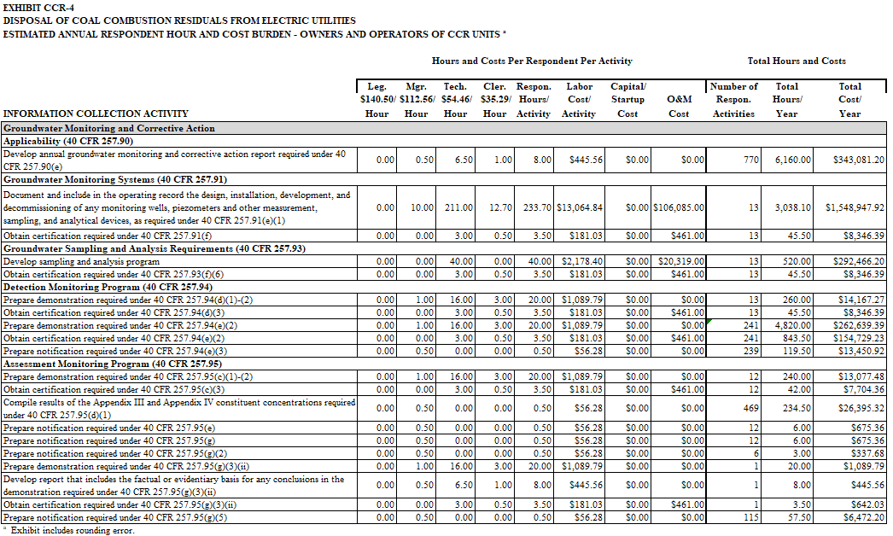
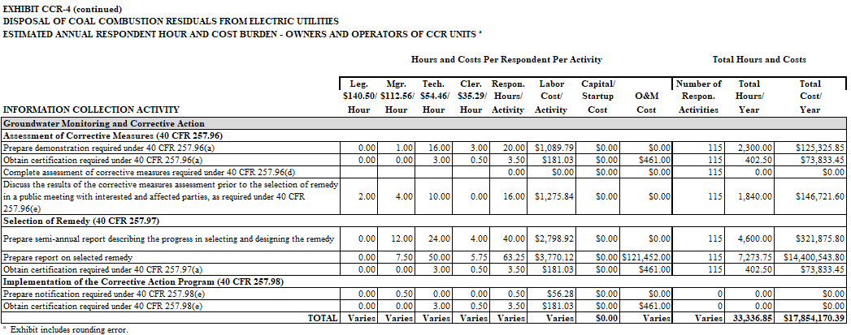

Exhibit 5
Closure and Post-Closure Care
(g1) Closure of CCR Landfills and CCR Surface Impoundments
The burden associated with inclusion of the specified statements in the notifications required under 40 CFR 257.102(g) has been considered under the corresponding regulatory requirements. The timelines of the 2024 final rule corresponding to closure of Legacy CCR Surface Impoundments and CCRMUs fall outside the three-year period covered by this ICR.
(g2) Criteria for Conducting Closure or Retrofit of CCR Landfills and CCR Surface Impoundments
EPA assumes that all owners and operators of new CCR units will prepare a written closure plan or written retrofit plan that describes the steps necessary to close or retrofit the CCR unit at any point during the active life of the CCR unit consistent with recognized and generally accepted good engineering practices (40 CFR 257.102(b) and (k)). EPA assumes that existing units completed this requirement. EPA also assumes that owners and operators will obtain a written certification from a qualified professional engineer that the written closure or retrofit plan meets the requirements of 40 CFR 257.102 (40 CFR 257.102(b)(4) and (k)(2)(iv)). EPA assumes that these activities will be conducted once during the three-year life of the ICR. In estimating the annual respondent hour and cost burden over the three-year period covered by this ICR, EPA annualized the hour and cost burden of these one-time activities by dividing the number of CCR units by three. Thus, EPA estimates that 13 units (i.e., 26landfills + 11 surface impoundments), on average, will be subject to these requirements each year.
EPA assumes that none of the owners and operators will amend their closure or retrofit plan during the three-year period covered by this ICR.
EPA estimates that 9 CCR landfills and 88 CCR surface impoundments units will undergo closure on average each year. EPA assumes that owners and operators of these CCR units will conduct the following activities: obtain a written certification from a qualified professional engineer that the design of the final cover system meets the requirements of 40 CFR 257.102, if the unit is closing (40 CFR 257.102(d)(3)(iii)); obtain a certification from a qualified professional engineer verifying that closure or retrofit has been completed in accordance with the closure or retrofit plan specified in 40 CFR 257.102(b) or (k)(2) and the requirements of 40 CFR 257.102(f)(3) and (k)(4); prepare a notification of intent to close or retrofit a CCR unit (40 CFR 257.102(g) and (k)(5)); prepare a notification of closure of a CCR unit, if the unit is closing (40 CFR 257.102(h)); and prepare a notification stating that the notation on the deed to the property (or some other instrument that is normally examined during title search) has been recorded (40 CFR 257.102(i)). This ICR assumes that 17 units complete the preceding activities annually, apart from the notification of intent to close or retrofit a CCR unit required under 40 CFR 257.102(g), which is assumed to be zero.
(g3) Alternative Closure Requirement
EPA assumes that none of the CCR units will be affected by the alternative closure requirements (units undergoing retrofit are also eligible for these alternatives as specified under 40 CFR 257.102(k)(3)) under 40 CFR 257.103 during the three-year period covered by this ICR.
(g4) Post-Closure Care Requirements
EPA assumes that all owners and operators of new CCR units will prepare a written post-closure plan (40 CFR 257.104(d)). EPA also assumes that owners and operators will obtain a written certification from a qualified professional engineer that the written post-closure plan meets the requirements of 40 CFR 257.104 (40 CFR 257.104(d)(4)). EPA assumes that these activities will be conducted once during the three-year life of the ICR. In estimating the annual respondent hour and cost burden over the three-year period covered by this ICR, EPA annualized the hour and cost burden of these one-time activities by using the average number of new CCR units. Thus, EPA estimates that 13 units (i.e., 11 new surface impoundments + 26 CCR landfills, divided by three years), on average, will be subject to this requirement each year.
EPA assumes that none of the owners and operators will amend their post-closure plan during the three-year period covered by this ICR.
Finally, EPA assumes that none of the owners and operators of the CCR units will prepare a notification verifying that post-closure care has been completed (40 CFR 257.104(e)).
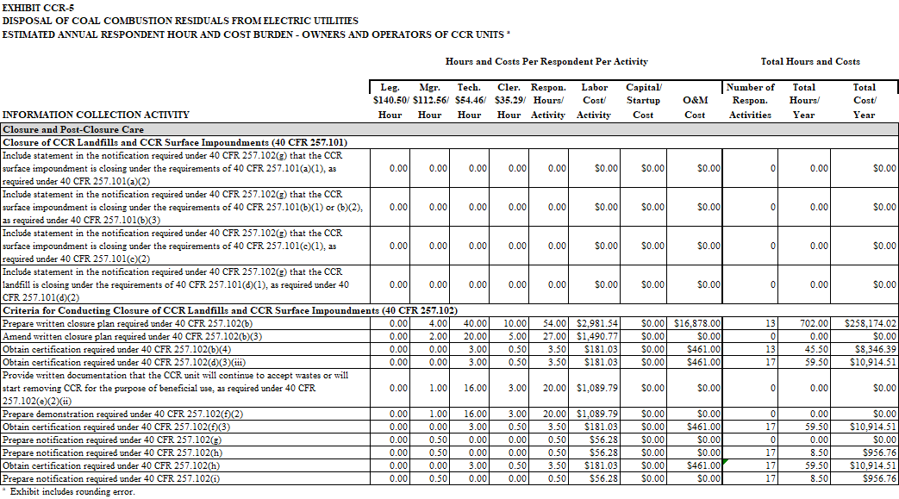
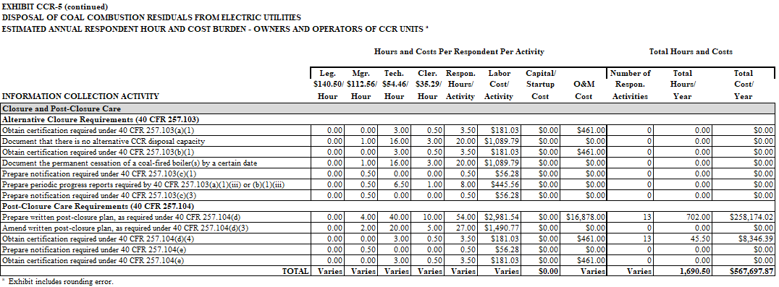

Exhibit 6
Recordkeeping, Notification, and Posting of Information to the Internet - Owners and Operators of CCR Units
EPA assumes that each year, the 302 owners and operator of the 779 existing and new CCR units will comply with the recordkeeping, notification, and posting requirements of the final rule.
EPA also assumes that the owners and operators of Legacy CCR Surface Impoundments, CCRMUs, and OAFUs will develop a publicly accessible internet site (CCR website) or website section containing the information specified at 40 CFR 257.107 during the three-year life of the ICR, totaling 404 total websites or website sections, or an average of 135 internet sites per year.
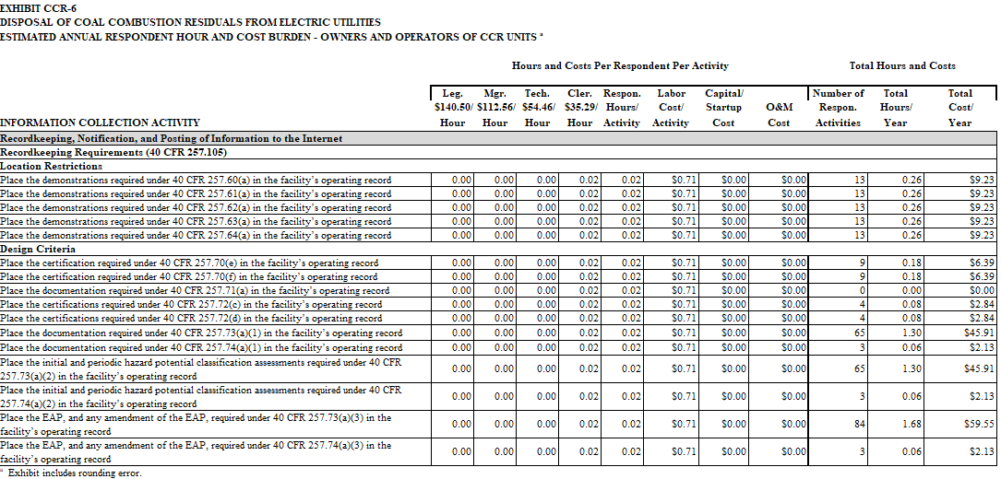
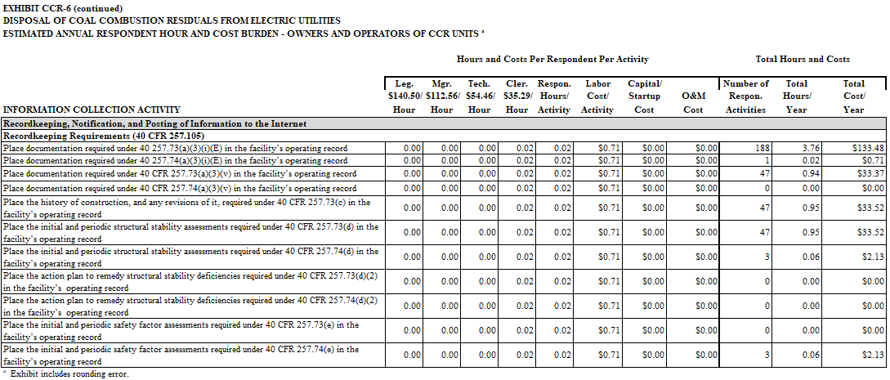
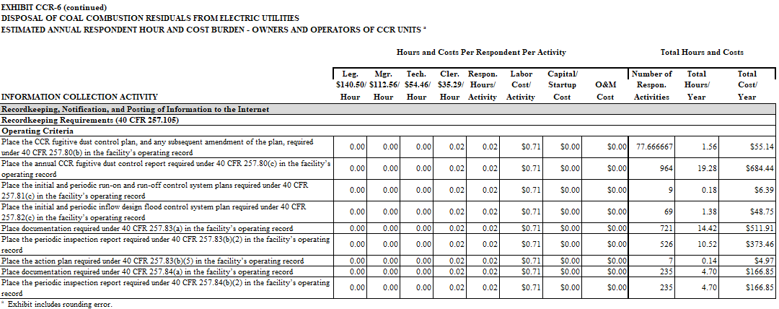
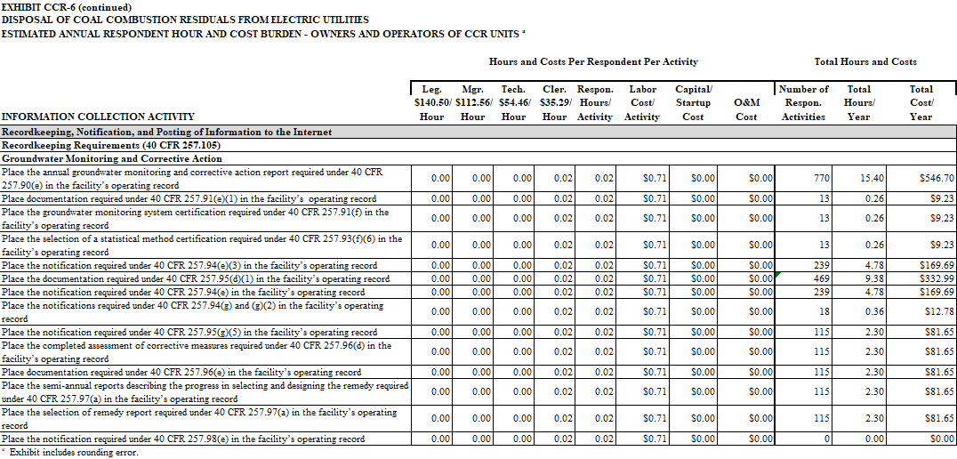
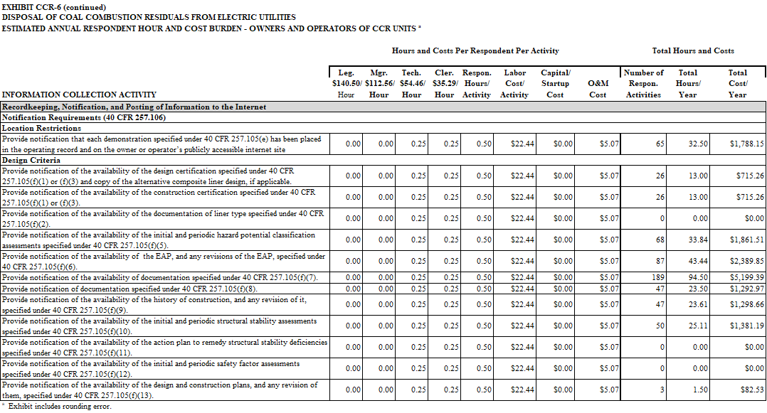
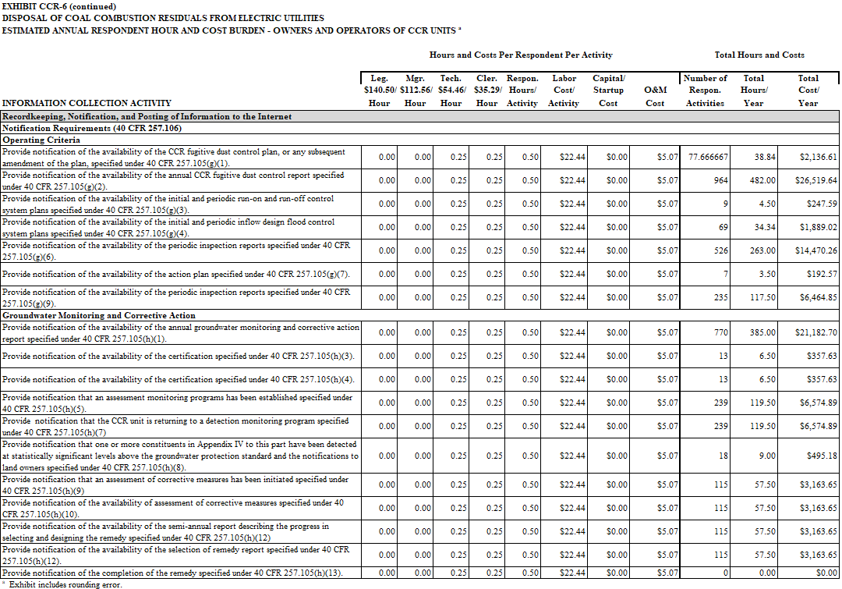
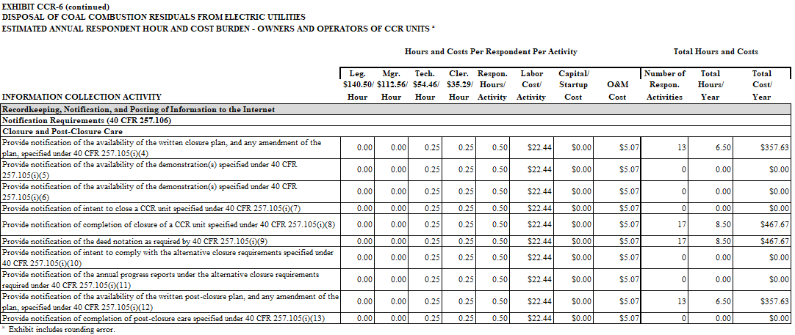
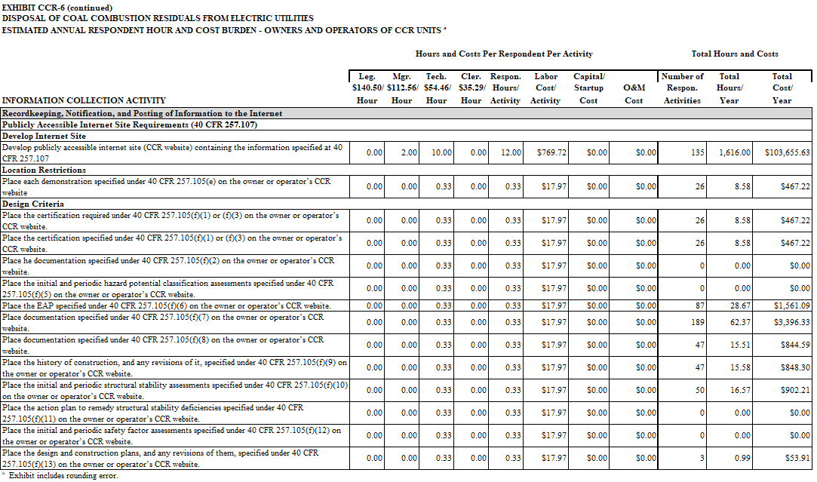
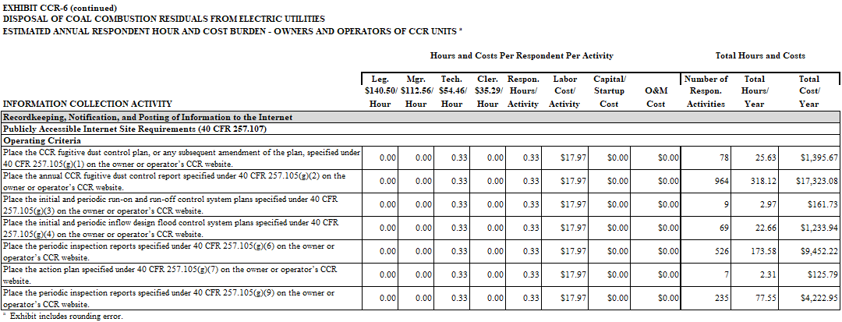
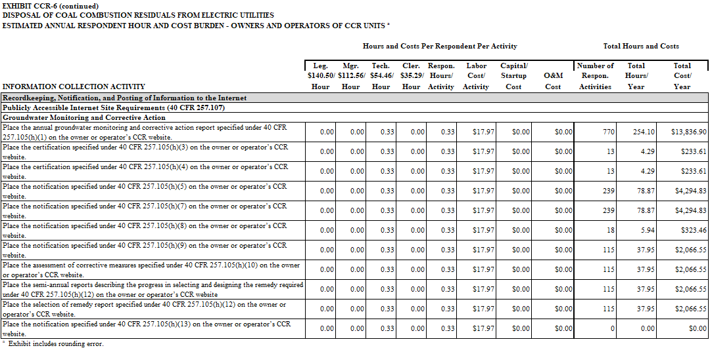
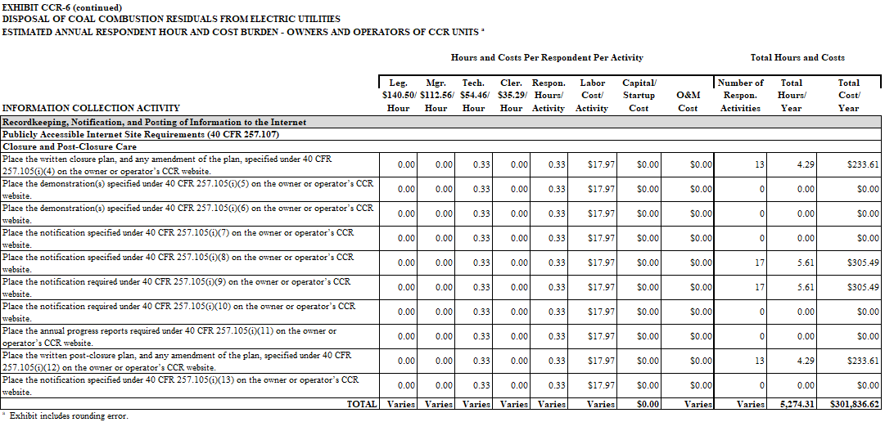

Exhibit 7
Recordkeeping, Notification, and Posting of Information to the Internet – State Government Agencies and Tribal Authorities
Owners and operators of CCR units must send the notifications required under 40 CFR 257.106(e) through (i) to the relevant State Director and/or appropriate Tribal authority. EPA assumes that State government agencies and Tribal authorities will review these notifications once received.
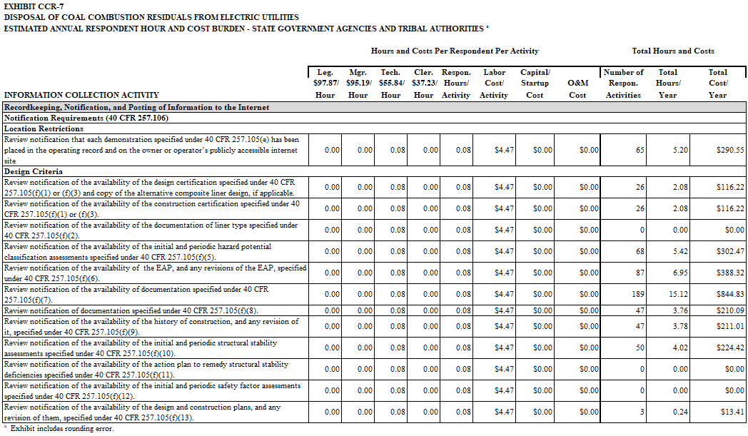
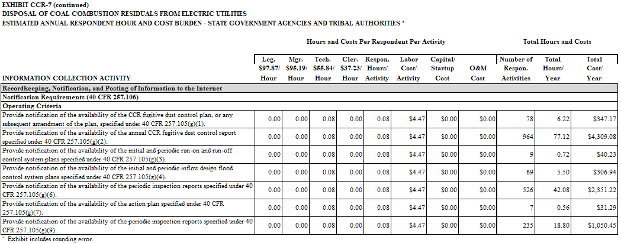
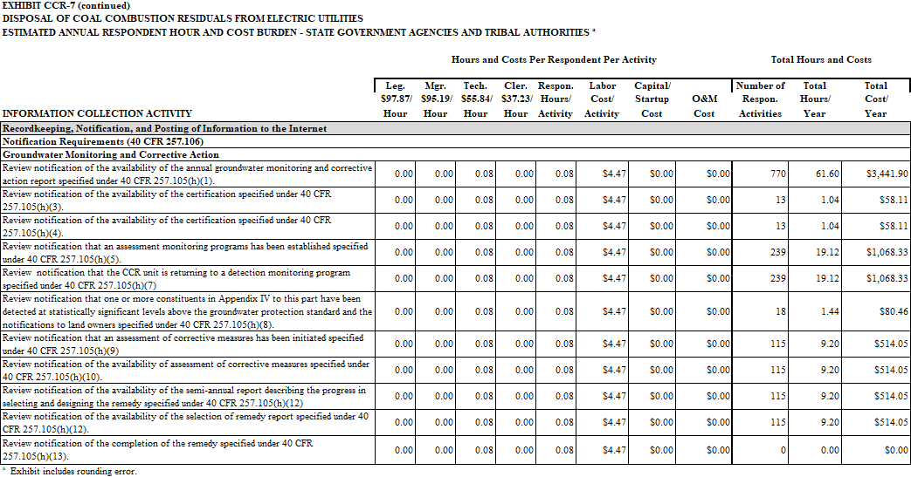
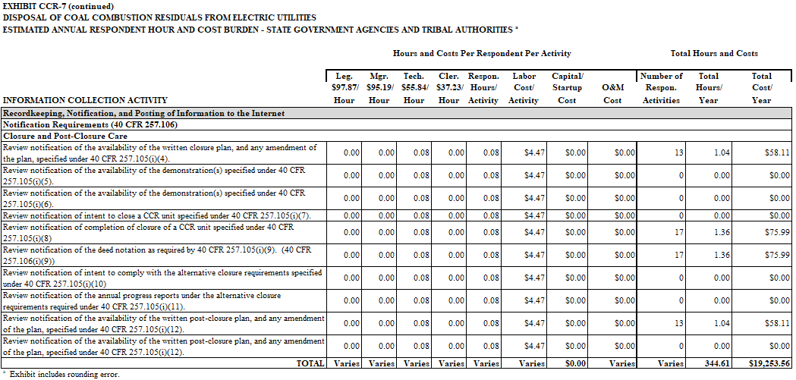

Exhibits 8a & 8b
Solid Waste Management Plans
In the currently approved ICR, EPA assumed that 48 States (i.e., 47 States and Puerto Rico) would prepare a solid waste management plan (SWMP) during the three-year life of the ICR. Under the SWMP approval process, a State with an approved SWMP can grant an extension to the compliance dates in the CCR rule to an entity unable to comply. Interest in this authority did not materialize as EPA believed it would at the time the CCR rule was issued. In fact, only three States have approved SWMPs at this time and EPA is not aware of any other States that will seek such approval from EPA. As a result, with this ICR revision, EPA is revising the number of respondents for this voluntary activity from 48 to 3. In estimating the annual respondent hour and cost burden over the three-year period covered by this ICR, EPA annualized the hour and cost burden of this one-time activity by dividing the number of respondents by three. Thus, EPA estimates that one respondent (i.e., 3 respondents / 3 years), on average, will prepare a solid waste management plan each year.
State Applications for CCR Permit Programs
EPA is aware of 44 States (43 States and Puerto Rico) that have one or more facilities with a CCR website (a requirement of the CCR rule). Of these 44 States, 8 States have only one facility with a CCR website; 2 States have two facilities; 4 States have three facilities; 3 States have four facilities, and 27 States have five or more facilities with a CCR website. EPA believes that those States with few facilities subject to the CCR rule (i.e., States with fewer than four facilities with a CCR website) will not invest the resources necessary to prepare and submit an application for a CCR permit program. In addition, based on information EPA has learned through its interactions with the States, EPA believes approximately 75 percent of States with five or more facilities with a CCR website will submit a state program application to the Agency. Thus, EPA estimates that 21 States will seek permit program approval (e.g., 75 percent of 27 States) during the three-year life of the ICR. In estimating the annual respondent hour and cost burden over the three-year period covered by this ICR, EPA annualized the hour and cost burden of this one-time activity by dividing the number of respondents by three. Thus, EPA estimates that 7 respondents (i.e., 21 respondents / 3 years), on average, will prepare an application for State CCR permit program each year.
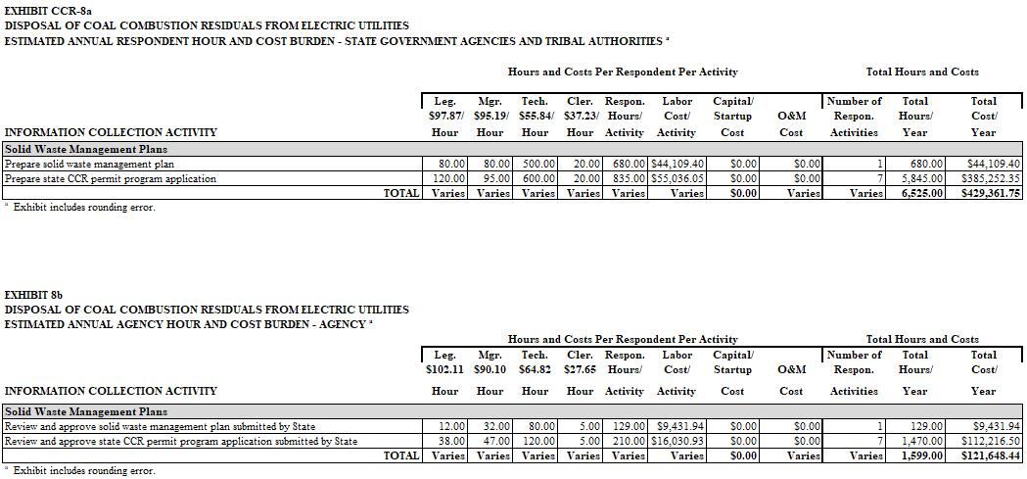

Exhibit 9
Total Estimated Respondent Hour and Cost Burden Summary
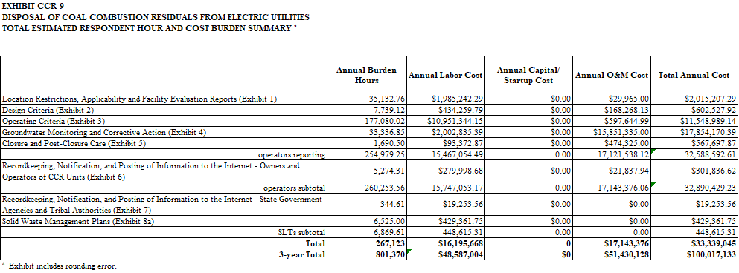

Exhibit 10

- Beneficial Use of CCR
Under 40 CFR 257.53, beneficial use of CCR means the CCR meet all the following conditions:
      - the CCR must provide a functional benefit;
      - the CCR must substitute for the use of a virgin material, conserving natural resources that would otherwise need to be obtained through practices, such as extraction;
      - the use of the CCR must meet relevant product specifications, regulatory standards or design standards when available, and when such standards are not available, CCR are not used in excess quantities; and
      - when unencapsulated use of CCR involving placement on the land of 12,400 tons or more in non-roadway applications, the user must demonstrate and keep records, and provide such documentation upon request, that environmental releases to ground water, surface water, soil and air are comparable to or lower than those from analogous products made without CCR, or that environmental releases to ground water, surface water, soil and air will be at or below relevant regulatory and health-based benchmarks for human and ecological receptors during use.
- Data Item:
Demonstration required under 40 CFR 257.53.

- Respondent Activities:
Beneficial users of CCR must perform the following activities:
- Prepare and keep demonstration required under 40 CFR 257.53.

- Location Restrictions
- Placement above the Uppermost Aquifer
Under 40 CFR 257.60, new CCR landfills, existing and new CCR surface impoundments, and all lateral expansions of CCR landfills and CCR surface impoundments must be constructed with a base that is located no less than 1.52 meters (five feet) above the upper limit of the uppermost aquifer, or to demonstrate that there will not be an intermittent, recurring, or sustained hydraulic connection between any portion of the base of the CCR unit and the uppermost aquifer due to normal fluctuations in groundwater elevations (including the seasonal high water table). The owner or operator must demonstrate by the dates specified in 40 CFR 257.60(c) that the CCR unit meets the minimum requirements for placement above the uppermost aquifer.
In addition, the owner or operator of the CCR unit must comply with the recordkeeping requirements specified in 40 CFR 257.105(e), the notification requirements specified in 40 CFR 257.106(e), and the internet requirements specified in 40 CFR 257.107(e). These requirements are covered under “Recordkeeping, Notification, and Posting of Information to the Internet.”
- Data Items:
- Demonstration required under 40 CFR 257.60(a).
- Certification required under 40 CFR 257.60(b).

- Respondent Activities:
Owners and operators must perform the following activities:
- Prepare demonstration required under 40 CFR 257.60(a).
- Obtain certification required under 40 CFR 257.60(b).

- Wetlands
Under 40 CFR 257.61, new CCR landfills, existing and new CCR surface impoundments, and all lateral expansions of CCR landfills and CCR surface impoundments must not be located in wetlands, as defined in 40 CFR 232.2, unless the owner or operator demonstrates by the dates specified in 40 CFR 257.61(c) that the CCR unit meets the requirements of 40 CFR 257.61(a)(1) through (a)(5).
In addition, the owner or operator must comply with the recordkeeping requirements specified in 40 CFR 257.105(e), the notification requirements specified in 40 CFR 257.106(e), and the internet requirements specified in 40 CFR 257.107(e). These requirements are covered under “Recordkeeping, Notification, and Posting of Information to the Internet.”
- Data Items:
- Demonstration required under 40 CFR 257.61(a).
- Certification required under 40 CFR 257.61(b).

- Respondent Activities:
Owners and operators must perform the following activities:
Prepare demonstration required under 40 CFR 257.61(a).
Obtain certification required under 40 CFR 257.61(b).

- Fault Areas
Under 40 CFR 257.62, new CCR landfills, existing and new CCR surface impoundments, and all lateral expansions of CCR landfills and CCR surface impoundments must not be located within 60 meters (200 feet) of the outermost damage zone of a fault that has had displacement in Holocene time unless the owner or operator demonstrates by the dates specified in 40 CFR 257.62(c) that an alternative setback distance of less than 60 meters (200 feet) will prevent damage to the structural integrity of the CCR unit.
In addition, the owner or operator of the CCR unit must comply with the recordkeeping requirements specified in 40 CFR 257.105(e), the notification requirements specified in 40 CFR 257.106(e), and the internet requirements specified in 40 CFR 257.107(e). These requirements are covered under “Recordkeeping, Notification, and Posting of Information to the Internet.”
- Data Items:
- Demonstration required under 40 CFR 257.62(a).
- Certification required under 40 CFR 257.62(b).

- Respondent Activities:
Owners and operators must perform the following activities:
- Prepare demonstration required under 40 CFR 257.62(a).
- Obtain certification required under 40 CFR 257.62(b).

- Seismic Impact Zones
Under 40 CFR 257.63, new CCR landfills, existing and new CCR surface impoundments, and all lateral expansions of CCR landfills and CCR surface impoundments must not be located in seismic impact zones unless the owner or operator demonstrates by the dates specified in 40 CFR 257.63(c) that all structural components including liners, leachate collection and removal systems, and surface water control systems, are designed to resist the maximum horizontal acceleration in lithified earth material for the site.
In addition, the owner or operator of the CCR unit must comply with the recordkeeping requirements specified in 40 CFR 257.105(e), the notification requirements specified in 40 CFR 257.106(e), and the internet requirements specified in 40 CFR 257.107(e). These requirements are covered under “Recordkeeping, Notification, and Posting of Information to the Internet.”
- Data Items:
- Demonstration required under 40 CFR 257.63(a).
- Certification required under 40 CFR 257.63(b).

- Respondent Activities:
Owners and operators must perform the following activities:
- Prepare demonstration required under 40 CFR 257.63(a).
- Obtain certification required under 40 CFR 257.63(b).

- Unstable Areas
Under 40 CFR 257.64, an existing or new CCR landfill, existing or new CCR surface impoundment, or any lateral expansion of a CCR landfill or CCR surface impoundment must not be located in an unstable area unless the owner or operator demonstrates by the dates specified in 40 CFR 257.64(d) that recognized and generally accepted good engineering practices have been incorporated into the design of the CCR unit to ensure that the integrity of the structural components of the CCR unit will not be disrupted. The owner or operator must consider all of the factors at 40 CFR 257.64(b), at a minimum, when determining whether an area is unstable.
In addition, the owner or operator of the CCR unit must comply with the recordkeeping requirements specified in 40 CFR 257.105(e), the notification requirements specified in 40 CFR 257.106(e), and the internet requirements specified in 40 CFR 257.107(e). These requirements are covered under “Recordkeeping, Notification, and Posting of Information to the Internet.”
- Data Items:
- Demonstration required under 40 CFR 257.64(a).
- Certification required under 40 CFR 257.64(c).

- Respondent Activities:
Owners and operators must perform the following activities:
- Prepare demonstration required under 40 CFR 257.64(a).
- Obtain certification required under 40 CFR 257.64(c).

- Design Criteria
- Liner Design Criteria for New CCR Landfills and Any Lateral Expansion of a CCR Landfill
Under 40 CFR 257.70, new CCR landfills and any lateral expansion of a CCR landfill must be designed, constructed, operated, and maintained with either a composite liner that meets the requirements of 40 CFR 257.70(b) or an alternative composite liner that meets the requirements in 40 CFR 257.70(c), and a leachate collection and removal system that meets the requirements of 40 CFR 257.70(d).
In addition, the owner or operator of the CCR unit must comply with the recordkeeping requirements specified in 40 CFR 257.105(f), the notification requirements specified in 40 CFR 257.106(f), and the internet requirements specified in 40 CFR 257.107(f). These requirements are covered under “Recordkeeping, Notification, and Posting of Information to the Internet.”
- Data Items:
- Certification required under 40 CFR 257.70(c)(2).
- Certification required under 40 CFR 257.70(e).
- Certification required under 40 CFR 257.70(f).

- Respondent Activities:
Owners and operators must perform the following activities:
- Obtain certification required under 40 CFR 257.70(c)(2).
- Obtain certification required under 40 CFR 257.70(e).
- Obtain certification required under 40 CFR 257.70(f).

- Liner Design Criteria for Existing CCR Surface Impoundments
Under 40 CFR 257.71, the owner or operator of an existing CCR surface impoundment must document whether or not such unit was constructed with any one of the following: (i) a liner consisting of a minimum of two feet of compacted soil with a hydraulic conductivity of no more than 1x10-7 cm/sec; (ii) a composite liner that meets the requirements of 40 CFR 257.70(b); or (iii) an alternative liner that meets the requirements of 40 CFR 257.70(c)
In addition, the owner or operator of the CCR unit must comply with the recordkeeping requirements specified in 40 CFR 257.105(f), the notification requirements specified in 40 CFR 257.106(f), and the internet requirements specified in 40 CFR 257.107(f). These requirements are covered under “Recordkeeping, Notification, and Posting of Information to the Internet.”
- Data Items:
- Documentation of liner type under 40 CFR 257.71(a).
- Certification required under 40 CFR 257.71(b).

- Respondent Activities:
Owners and operators must perform the following activities:
- Document liner type under 40 CFR 257.71(a).
- Obtain certification required under 40 CFR 257.71(b).

- Liner Design Criteria for New CCR Surface Impoundments and Any Lateral Expansion of a CCR Surface Impoundment
Under 40 CFR 257.72, new CCR surface impoundments and lateral expansions of existing and new CCR surface impoundments must be designed, constructed, operated, and maintained with either a composite liner or an alternative composite liner that meets the requirements of 40 CFR 257.70(b) or (c).
In addition, the owner or operator of the CCR unit must comply with the recordkeeping requirements specified in 40 CFR 257.105(f), the notification requirements specified in 40 CFR 257.106(f), and the internet requirements specified in 40 CFR 257.107(f). These requirements are covered under “Recordkeeping, Notification, and Posting of Information to the Internet.
- Data Items:
- Certification required under 40 CFR 257.72(c).
- Certification required under 40 CFR 257.72(d).

- Respondent Activities:
Owners and operators must perform the following activities:
- Obtain certification required under 40 CFR 257.72(c).
- Obtain certification required under 40 CFR 257.72(d).

- Alternate Liner Demonstrations
For each CCR unit, owners/operators must demonstrate that the surface impoundment’s clay liner meets the Section 4004(a) standard for sanitary landfill classification, and therefore that the unit should be classified as “lined.”
This provision is voluntary; owners/operators of CCR impoundments are not required to submit the application, or to submit the demonstration if their application is approved.
  - Data Item:
- Alternate liner demonstration application.
- Alternate liner demonstration.

(ii) Respondent Activities:
Owners/operators of a CCR surface impoundment are expected to perform the following activities:
- For each unit, submit an application to EPA expressing their interest to pursue a liner demonstration.
- If the demonstration for a given unit is approved by EPA, proceed to complete the demonstration.

- Structural Integrity Criteria for Existing CCR Surface Impoundments
40 CFR 257.73 provides structural integrity criteria requirements for existing CCR surface impoundments. These requirements include: periodic hazard potential classification assessments, a written Emergency Action Plan (EAP), changes to the history of construction, periodic structural stability assessments, and periodic safety factor assessments
The requirements of 40 CFR 257.73(a) apply to all existing CCR surface impoundments, except for those existing CCR surface impoundments that are incised CCR units. If an incised CCR surface impoundment is subsequently modified (e.g., a dike is constructed) such that the CCR unit no longer meets the definition of an incised CCR unit, the CCR unit is subject to the requirements of 40 CFR 257.73(a)
Owners and operators of CCR units must comply with the recordkeeping requirements specified in 40 CFR 257.105(f), the notification requirements specified in 40 CFR 257.106(f), and the internet requirements specified in 40 CFR 257.107(f). These requirements are covered under “Recordkeeping, Notification, and Posting of Information to the Internet.”
- Data Items:
- A permanent identification marker showing the identification number of the CCR unit, as required under 40 CFR 257.73(a)(1).
- Documentation of the initial and periodic hazard potential classification assessments of the CCR unit, as required under 40 CFR 257.73(a)(2).
- Certification required under 40 CFR 257.73(a)(2)(ii).
- A written EAP, as required under 40 CFR 257.73(a)(3).
- Documentation on an annual face-to-face meeting or exercise between representatives of the owner/operator of the CCR unit and the local emergency responders, as required under 40 CFR 257.73(a)(3)(i)(E).
- Amended EAP, as required under 40 CFR 257.73(a)(3)(ii).
- Certification required under 40 CFR 257.73(a)(3)(iv)).
- Documentation required under 40 CFR 257.73(a)(3)(v).
- History of construction required under 40 CFR 257.73(c).
- Documentation of initial and periodic structural stability assessments, as required under 40 CFR 257.73(d).
- Action plan required under 40 CFR 257.73(d)(2).
- Certification required under 40 CFR 257.73(d)(3).
- Documentation of initial and periodic safety factor assessments for each CCR unit, as required under 40 CFR 257.73(e).
- Certification required under 40 CFR 257.73(e)(2).
- Respondent Activities:
Owners and operators must perform the following activities:
- Place on or immediately adjacent to the CCR unit a permanent identification marker showing the identification number of the CCR unit, as required under 40 CFR 257.73(a)(1).
- Document the initial and periodic hazard potential classification assessments of the CCR unit, as required under 40 CFR 257.73(a)(2).
- Obtain certification required under 40 CFR 257.73(a)(2)(ii).
- Prepare a written EAP, as required under 40 CFR 257.73(a)(3).
- Prepare documentation on an annual face-to-face meeting or exercise between representatives of the owner/operator of the CCR unit and the local emergency responders, as required under 40 CFR 257.73(a)(3)(i)(E).
- Amend the EAP, as required under 40 CFR 257.73(a)(3)(ii).
- Obtain certification required under 40 CFR 257.73(a)(3)(iv)).
- Prepare documentation required under 40 CFR 257.73(a)(3)(v).
- Compile history of construction required under 40 CFR 257.73(c).
- Conduct and document initial and periodic structural stability assessments, s required under 40 CFR 257.73(d).
- Prepare action plan required under 40 CFR 257.73(d)(2).
- Obtain certification required under 40 CFR 257.73(d)(3).
- Conduct and document initial and periodic safety factor assessments for each CCR unit, as required under 40 CFR 257.73(e).
- Obtain certification required under 40 CFR 257.73(e)(2).
- Structural Integrity Criteria for New CCR Surface Impoundments and Any Lateral Expansion of a CCR Surface Impoundment
40 CFR 257.74 provides structural integrity criteria requirements for new CCR surface impoundments and any lateral expansion of a CCR surface impoundment. These requirements include: periodic hazard potential classification assessments, a written Emergency Action Plan (EAP), design and construction plans, periodic structural stability assessments, and periodic safety factor assessments
Owners and operators of the CCR unit must comply with the recordkeeping requirements specified in 40 CFR 257.105(f), the notification requirements specified in 40 CFR 257.106(f), and the internet requirements specified in 40 CFR 257.107(f). These requirements are covered under “Recordkeeping, Notification, and Posting of Information to the Internet.
- Data Items:
- A permanent identification marker showing the identification number of the CCR unit, as required under 40 CFR 257.74(a)(1).
- Documentation of the initial and periodic hazard potential classification assessments of the CCR unit, as required under 40 CFR 257.74(a)(2). .
- Certification required under 40 CFR 257.74(a)(2)(ii).
- A written EAP, as required under 40 CFR 257.74(a)(3).
- Documentation on an annual face-to-face meeting or exercise between representatives of the owner/operator of the CCR unit and the local emergency responders, as required under 40 CFR 257.74(a)(3)(i)(E)
- Amended EAP, as required under 40 CFR 257.74(a)(3)(ii)
- Certification required under 40 CFR 257.74(a)(3)(iv).
- Documentation required under 40 CFR 257.74(a)(3)(v).
- Design and construction plans for the CCR unit, as required under 40 CFR 257.74(c).
- Documentation of initial and periodic structural stability assessments, as required under 40 CFR 257.74(d).
- Action plan required under 40 CFR 257.74(d)(2).
- Certification required under 40 CFR 257.74(d)(3).
- Documentation of initial and periodic safety factor assessments for each CCR unit, as required under 40 CFR 257.74(e).
- Certification required under 40 CFR 257.74(e)(2).
- Respondent Activities:
  - Owners and operators must perform the following activities:
  - Place on or immediately adjacent to the CCR unit a permanent identification marker showing the identification number of the CCR unit, as required under 40 CFR 257.74(a)(1).
  - Document the initial and periodic hazard potential classification assessments of the CCR unit, as required under 40 CFR 257.74(a)(2). .
  - Obtain certification required under 40 CFR 257.74(a)(2)(ii).
  - Prepare a written EAP, as required under 40 CFR 257.74(a)(3).
  - Prepare documentation on an annual face-to-face meeting or exercise between representatives of the owner/operator of the CCR unit and the local emergency responders, as required under 40 CFR 257.74(a)(3)(i)(E)
  - Amend the EAP, as required under 40 CFR 257.74(a)(3)(ii)
  - Obtain certification required under 40 CFR 257.74(a)(3)(iv).
  - Prepare documentation required under 40 CFR 257.74(a)(3)(v).
  - Compile the design and construction plans for the CCR unit, as required under 40 CFR 257.74(c).
  - Conduct and document initial and periodic structural stability assessments, as required under 40 CFR 257.74(d).
  - Prepare action plan required under 40 CFR 257.74(d)(2).
  - Obtain certification required under 40 CFR 257.74(d)(3).
  - Conduct and document initial and periodic safety factor assessments for each CCR unit, as required under 40 CFR 257.74(e).
  - Obtain certification required under 40 CFR 257.74(e)(2).
- Operating Criteria
- Air Criteria
Under 40 CFR 257.80, the owner or operator of a CCR landfill, CCR surface impoundment, or any lateral expansion of a CCR unit must adopt measures that will effectively minimize CCR from becoming airborne at the facility, including CCR fugitive dust originating from CCR units, roads, and other CCR management and material handling activities
The owner or operator of the CCR unit must comply with the recordkeeping requirements specified in 40 CFR 257.105(g), the notification requirements specified in 40 CFR 257.106(g), and the internet requirements specified in 40 CFR 257.107(g). These requirements are covered under “Recordkeeping, Notification, and Posting of Information to the Internet.”
- Data Items:
- CCR fugitive dust control plan required under 40 CFR 257.80(b).
- Amended CCR fugitive dust control plan, as required under 40 CFR 257.80(b)(6).
- Certification required under 40 CFR 257.80(b)(7)
- Annual CCR fugitive dust control report required under 40 CFR 257.80(c).
- Respondent Activities:
Owners and operators must perform the following activities:
- Prepare CCR fugitive dust control plan required under 40 CFR 257.80(b).
- Amend CCR fugitive dust control plan, as required under 40 CFR 257.80(b)(6).
- Obtain certification required under 40 CFR 257.80(b)(7)
- Prepare annual CCR fugitive dust control report required under 40 CFR 257.80(c).
- Run-On and Run-Off Controls for CCR Landfills
Under 40 CFR 257.81, the owner or operator of an existing or new CCR landfill or any lateral expansion of a CCR landfill must design, construct, operate, and maintain: (1) a run-on control system to prevent flow onto the active portion of the CCR unit during the peak discharge from a 24-hour, 25-year storm; and (2) a run-off control system from the active portion of the CCR unit to collect and control at least the water volume resulting from a 24-hour, 25-year storm. Run-off from the active portion of the CCR unit must be handled in accordance with the surface water requirements under 40 CFR 257.3-3
The owner or operator of the CCR unit must comply with the recordkeeping requirements specified in 40 CFR 257.105(g), the notification requirements specified in 40 CFR 257.106(g), and the internet requirements specified in 40 CFR 257.107(g). These requirements are covered under “Recordkeeping, Notification, and Posting of Information to the Internet.
- Data Items:
- Initial and periodic run-on and run-off control system plans required under 40 CFR 257.81(c).
- Amended run-on and run-off control system plans, as required under 40 CFR 257.81(c)(2).
- Certification required under 40 CFR 257.81(c)(5).
- Respondent Activities:
Owners and operators must perform the following activities:
- Prepare initial and periodic run-on and run-off control system plans required under 40 CFR 257.81(c).
- Amend run-on and run-off control system plans, as required under 40 CFR 257.81(c)(2).
- Obtain certification required under 40 CFR 257.81(c)(5).
- Hydrologic and Hydraulic Capacity Requirements for CCR Surface Impoundments
Under 40 CFR 257.82, the owner or operator of an existing or new CCR surface impoundment or any expansion of a CCR surface impoundment must design, construct, operate, and maintain an inflow design flood control system as specified in 40 CFR 257.82(a)(1) and (a)(2).
The owner or operator of the CCR unit must comply with the recordkeeping requirements specified in 40 CFR 257.105(g), the notification requirements specified in 40 CFR 257.106(g), and the internet requirements specified in CFR 257.107(g). These requirements are covered under “Recordkeeping, Notification, and Posting of Information to the Internet.”
- Data Items:
- Initial and periodic inflow design flood control system plans required under 40 CFR 257.82(c).
- Amended inflow design flood control system plan, as required under 40 CFR 257.82(c)(2).
- Certification required under 40 CFR 257.82(c)(5).
- Respondent Activities:
Owners and operators must perform the following activities:
- Prepare initial and periodic inflow design flood control system plans required under 40 CFR 257.82(c).
- Amend the inflow design flood control system plan, as required under 40 CFR 257.82(c)(2).
- Obtain certification required under 40 CFR 257.82(c)(5).
- Inspection Requirements for CCR Surface Impoundments
Under 40 CFR 257.83, all CCR surface impoundments and any lateral expansion of a CCR surface impoundment must be inspected.
The owner or operator of the CCR unit must comply with the recordkeeping requirements specified in 40 CFR 257.105(g), the notification requirements specified in 40 CFR 257.106(g), and the internet requirements specified in 40 CFR 257.107(g). These requirements are covered under “Recordkeeping, Notification, and Posting of Information to the Internet.”
- Data Items:
- Inspections required under 40 CFR 257.83(a).
- Inspections required under 40 CFR 257.83(b)(1)).
- Inspection report required under 40 CFR 257.83(b)(2).
- Action plan to remedy structural weakness or disrupting condition, as required under 40 CFR 257.83(b)(5).
- Respondent Activities:
Owners and operators must perform the following activities:
- Conduct inspections required under 40 CFR 257.83(a).
- Conduct inspections required under 40 CFR 257.83(b)(1)).
- Develop inspection report required under 40 CFR 257.83(b)(2).
- Develop and implement action plan to remedy structural weakness or disrupting condition, as required under 40 CFR 257.83(b)(5).
- Inspection Requirements for CCR Landfills
Under 40 CFR 257.84, all CCR landfills must be inspected.
The owner or operator of the CCR unit must comply with the recordkeeping requirements specified in 40 CFR 257.105(g), the notification requirements specified in 40 CFR 257.106(g), and the internet requirements specified in 40 CFR 257.107(g). These requirements are covered under “Recordkeeping, Notification, and Posting of Information to the Internet.”
- Data Items:
- Inspections required under 40 CFR 257.84(a).
- Inspections required under 40 CFR 257.84(b)(1).
- Inspection report required under 40 CFR 257.84(b)(2).
- Action plan to remedy structural weakness or disrupting condition, as required under 40 CFR 257.84(b)(5).
- Respondent Activities:
Owners and operators must perform the following activities:
- Conduct inspections required under 40 CFR 257.84(a).
- Conduct inspections required under 40 CFR 257.84(b)(1).
- Develop inspection report required under 40 CFR 257.84(b)(2).
- Develop and implement action plan to remedy structural weakness or disrupting condition, as required under 40 CFR 257.84(b)(5).
- Groundwater Monitoring and Corrective Action
- Applicability
Except as provided for in 40 CFR 257.100 for inactive CCR surface impoundments, all CCR landfills, CCR surface impoundments, and lateral expansions of CCR units are subject to the groundwater monitoring and corrective action requirements under 40 CFR 257.90 through 257.98.
The owner or operator of the CCR unit must comply with the recordkeeping requirements specified in 40 CFR 257.105(h), the notification requirements specified in 40 CFR 257.106(h), and the internet requirements specified in 40 CFR 257.107(h). These requirements are covered under “Recordkeeping, Notification, and Posting of Information to the Internet.”
- Data Item:
- Annual groundwater monitoring and corrective action report required under 40 CFR 257.90(e).
- Respondent Activities:
Owners and operators must perform the following activities:
- Develop annual groundwater monitoring and corrective action report required under 40 CFR 257.90(e).
- Groundwater Monitoring Systems
Owners and operators of CCR units must install a groundwater monitoring system.
The owner or operator of the CCR unit must comply with the recordkeeping requirements specified in 40 CFR 257.105(h), the notification requirements specified in 40 CFR 257.106(h), and the internet requirements specified in 40 CFR 257.107(h). These requirements are covered under “Recordkeeping, Notification, and Posting of Information to the Internet.”
- Data Items:
- Documentation in the operating record of the design, installation, development, and decommissioning of any monitoring wells, piezometers and other measurement, sampling, and analytical devices, as required under 40 CFR 257.91(e)(1).
- Certification required under 40 CFR 257.91(f).
- Respondent Activities:
Owners and operators must perform the following activities:
- Document and include in the operating record the design, installation, development, and decommissioning of any monitoring wells, piezometers and other measurement, sampling, and analytical devices, as required under 40 CFR 257.91(e)(1).
- Obtain certification required under 40 CFR 257.91(f).
- Groundwater Sampling and Analysis Requirements
Under 40 CFR 257.93, the groundwater monitoring program must include consistent sampling and analysis procedures that are designed to ensure monitoring results that provide an accurate representation of groundwater quality at the background and downgradient wells required by 40 CFR 257.91.
The owner or operator of the CCR unit must comply with the recordkeeping requirements specified in 40 CFR 257.105(h), the notification requirements specified in 40 CFR 257.106(h), and the internet requirements specified in 40 CFR 257.107(h). These requirements are covered under “Recordkeeping, Notification, and Posting of Information to the Internet.”
- Data Items:
- Sampling and analysis program.
- Certification required under 40 CFR 257.93(f)(6).
- Respondent Activities:
Owners and operators must perform the following activities:
- Develop sampling and analysis program.
- Obtain certification required under 40 CFR 257.93(f)(6).
- Detection Monitoring Program
Owners and operators of a CCR unit must conduct detection monitoring at all groundwater monitoring wells consistent with 40 CFR 257.94.
The owner or operator of the CCR unit must comply with the recordkeeping requirements specified in 40 CFR 257.105(h), the notification requirements specified in 40 CFR 257.106(h), and the internet requirements specified in 40 CFR 257.107(h). These requirements are covered under “Recordkeeping, Notification, and Posting of Information to the Internet.”
- Data Items:
- Demonstration required under 40 CFR 257.94(d)(1)-(2).
- Certification required under 40 CFR 257.94(d)(3).
- Demonstration required under 40 CFR 257.94(e)(2).
- Notification required under 40 CFR 257.94(e)(3).
- Respondent Activities:
Owners and operators must perform the following activities:
- Prepare demonstration required under 40 CFR 257.94(d)(1)-(2).
- Obtain certification required under 40 CFR 257.94(d)(3).
- Prepare demonstration required under 40 CFR 257.94(e)(2).
- Prepare notification required under 40 CFR 257.94(e)(3).
- Assessment Monitoring Program
Pursuant to 40 CFR 257.95, assessment monitoring is required whenever a statistically significant increase over background levels has been detected for one or more of the constituents listed in Appendix III to 40 CFR Part 257.
The owner or operator of the CCR unit must comply with the recordkeeping requirements specified in 40 CFR 257.105(h), the notification requirements specified in 40 CFR 257.106(h), and the internet requirements specified in 40 CFR 257.107(h). These requirements are covered under “Recordkeeping, Notification, and Posting of Information to the Internet.”
- Data Items:
- Demonstration required under 40 CFR 257.95(c)(1)-(2).
- Certification required under 40 CFR 257.95(c)(3).
- Results of the Appendix III and Appendix IV constituent concentrations required under 40 CFR 257.95(d)(1).
- Notification required under 40 CFR 257.95(e).
- Notification required under 40 CFR 257.95(g).
- Notification required under 40 CFR 257.95(g)(2).
- Demonstration required under 40 CFR 257.95(g)(3)(ii).
- Report that includes the factual or evidentiary basis for any conclusions in the demonstration required under 40 CFR 257.95(g)(3)(ii).
- Certification required under 40 CFR 257.95(g)(3)(ii).
- Notification required under 40 CFR 257.95(g)(5).
- Respondent Activities:
Owners and operators must perform the following activities:
- Prepare demonstration required under 40 CFR 257.95(c)(1)-(2).
- Obtain certification required under 40 CFR 257.95(c)(3).
- Compile results of the Appendix III and Appendix IV constituent concentrations required under 40 CFR 257.95(d)(1).
- Prepare notification required under 40 CFR 257.95(e).
- Prepare notification required under 40 CFR 257.95(g).
- Prepare notification required under 40 CFR 257.95(g)(2).
- Prepare demonstration required under 40 CFR 257.95(g)(3)(ii).
- Develop report that includes the factual or evidentiary basis for any conclusions in the demonstration required under 40 CFR 257.95(g)(3)(ii).
- Obtain certification required under 40 CFR 257.95(g)(3)(ii).
- Prepare notification required under 40 CFR 257.95(g)(5).
- Assessment of Corrective Measures
40 CFR 257.96 identifies the requirements for the assessment of corrective measures.
The owner or operator of the CCR unit must comply with the recordkeeping requirements specified in 40 CFR 257.105(h), the notification requirements specified in 40 CFR 257.106(h), and the internet requirements specified in 40 CFR 257.107(h). These requirements are covered under “Recordkeeping, Notification, and Posting of Information to the Internet.”
- Data Items:
- Demonstration required under 40 CFR 257.96(a).
- Certification required under 40 CFR 257.96(a).
- Assessment of corrective measures required under 40 CFR 257.96(d).
- Results of the corrective measures assessment prior to the selection of remedy in a public meeting with interested and affected parties, as required under 40 CFR 257.96(e).
- Respondent Activities:
Owners and operators must perform the following activities:
- Prepare demonstration required under 40 CFR 257.96(a).
- Obtain certification required under 40 CFR 257.96(a).
- Complete assessment of corrective measures required under 40 CFR 257.96(d).
- Discuss the results of the corrective measures assessment prior to the selection of remedy in a public meeting with interested and affected parties, as required under 40 CFR 257.96(e).
- Selection of Remedy
Based on the results of the corrective measures assessment conducted under 40 CFR 257.96, the owner or operator of the CCR unit must select a remedy that, at a minimum, meets the standards listed in 40 CFR 257.97(b).
The owner or operator of the CCR unit must comply with the recordkeeping requirements specified in 40 CFR 257.105(h), the notification requirements specified in 40 CFR 257.106(h), and the internet requirements specified in 40 CFR 257.107(h). These requirements are covered under “Recordkeeping, Notification, and Posting of Information to the Internet.”
- Data Items:
- Semi-annual report describing the progress in selecting and designing the remedy.
- Report on selected remedy.
- Certification required under 40 CFR 257.97(a).
- Respondent Activities:
Owners and operators must perform the following activities:
- Prepare semi-annual report describing the progress in selecting and designing the remedy.
- Prepare report on selected remedy.
- Obtain certification required under 40 CFR 257.97(a).
- Implementation of the Corrective Action Program
40 CFR 257.98 identifies the requirements for implementation of the Corrective Action Program.
The owner or operator of the CCR unit must comply with the recordkeeping requirements specified in 40 CFR 257.105(h), the notification requirements specified in 40 CFR 257.106(h), and the internet requirements specified in 40 CFR 257.107(h). These requirements are covered under “Recordkeeping, Notification, and Posting of Information to the Internet.”
- Data Items:
- Notification required under 40 CFR 257.98(e).
- Certification required under 40 CFR 257.98(e).
- Respondent Activities:
Owners and operators must perform the following activities:
- Prepare notification required under 40 CFR 257.98(e).
- Obtain certification required under 40 CFR 257.98(e).
- Closure and Post-Closure Care
- Closure or Retrofit of CCR Landfills and CCR Surface Impoundments
40 CFR 257.101 identifies the requirements for the closure or retrofit of CCR landfills and CCR surface impoundments for cause.
- Data Items:
- Statement in the notification required under 40 CFR 257.102(g) that the CCR surface impoundment is closing or retrofitting under the requirements of 40 CFR 257.101(a)(1), as required under 40 CFR 257.101(a)(2).
- Statement in the notification required under 40 CFR 257.102(g) that the CCR surface impoundment is closing under the requirements of 40 CFR 257.101(b)(1) or (b)(2), as required under 40 CFR 257.101(b)(3).
- Statement in the notification required under 40 CFR 257.102(g) that the CCR surface impoundment is closing under the requirements of 40 CFR 257.101(c)(1), as required under 40 CFR 257.101(c)(2).
- Statement in the notification required under 40 CFR 257.102(g) that the CCR landfill is closing under the requirements of 40 CFR 257.101(d)(1), as required under 40 CFR 257.101(d)(2).
- Respondent Activities:
Owners and operators must perform the following activities:
- Include statement in the notification required under 40 CFR 257.102(g) that the CCR surface impoundment is closing or retrofitting under the requirements of 40 CFR 257.101(a)(1), as required under 40 CFR 257.101(a)(2).
- Include statement in the notification required under 40 CFR 257.102(g) that the CCR surface impoundment is closing under the requirements of 40 CFR 257.101(b)(1) or (b)(2), as required under 40 CFR 257.101(b)(3).
- Include statement in the notification required under 40 CFR 257.102(g) that the CCR surface impoundment is closing under the requirements of 40 CFR 257.101(c)(1), as required under 40 CFR 257.101(c)(2).
- Include statement in the notification required under 40 CFR 257.102(g) that the CCR landfill is closing under the requirements of 40 CFR 257.101(d)(1), as required under 40 CFR 257.101(d)(2).
- Criteria for Conducting Closure or Retrofit of CCR Landfills and CCR Surface Impoundments
40 CFR 257.102 identifies the requirements for conducting closure of CCR landfills and CCR surface impoundments.
The owner or operator of the CCR unit must comply with the recordkeeping requirements specified in 40 CFR 257.105(i), the notification requirements specified in 40 CFR 257.106(i), and the internet requirements specified in 40 CFR 257.107(i). These requirements are covered under “Recordkeeping, Notification, and Posting of Information to the Internet.”
- Data Items:
- Written closure plan required under 40 CFR 257.102(b).
- Amended written closure plan required under 40 CFR 257.102(b)(3).
- Certification required under 40 CFR 257.102(b)(4).
- Certification required under 40 CFR 257.102(d)(3)(iii).
- Written documentation that the CCR unit will continue to accept wastes or will start removing CCR for the purpose of beneficial use, as required under 40 CFR 257.102(e)(2)(ii).
- Demonstration required under 40 CFR 257.102(f)(2).
- Certification required under 40 CFR 257.102(f)(3).
- Notification required under 40 CFR 257.102(g).
- Notification required under 40 CFR 257.102(h).
- Certification required under 40 CFR 257.102(h).
- Notification required under 40 CFR 257.102(i).
- Written retrofit plan required under 40 CFR 257.102(k)(2).
- Notification required under 40 CFR 257.102(k)(5).
- Notification required under 40 CFR 257.102(k)(6).
- Respondent Activities:
Owners and operators must perform the following activities:
- Prepare written closure plan required under 40 CFR 257.102(b).
- Amend written closure plan required under 40 CFR 257.102(b)(3).
- Obtain certification required under 40 CFR 257.102(b)(4).
- Obtain certification required under 40 CFR 257.102(d)(3)(iii).
- Provide written documentation that the CCR unit will continue to accept wastes or will start removing CCR for the purpose of beneficial use, as required under 40 CFR 257.102(e)(2)(ii).
- Prepare demonstration required under 40 CFR 257.102(f)(2).
- Obtain certification required under 40 CFR 257.102(f)(3).
- Prepare notification required under 40 CFR 257.102(g).
- Prepare notification required under 40 CFR 257.102(h).
- Obtain certification required under 40 CFR 257.102(h).
- Prepare notification required under 40 CFR 257.102(i).
- Prepare written retrofit plan required under 40 CFR 257.102(k)(2).
- Prepare notification required under 40 CFR 257.102(k)(5).
- Prepare notification required under 40 CFR 257.102(k)(6).
- Alternative Closure Requirements
Per 40 CFR 257.103, the owner or operator of a CCR landfill, CCR surface impoundment, or any lateral expansion of a CCR landfill or CCR surface impoundment that is subject to closure or retrofit pursuant to 40 CFR 257.101(a), (b)(1), or (d) may continue to receive CCR in the unit provided the owner or operator meets the requirements of either 40 CFR 257.103(a) or (b).
The owner or operator of the CCR unit must comply with the recordkeeping requirements specified in 40 CFR 257.105(i), the notification requirements specified in 40 CFR 257.106(i), and the internet requirements specified in 40 CFR 257.107(i). These requirements are covered under “Recordkeeping, Notification, and Posting of Information to the Internet.”
- Data Items:
- Certification required under 40 CFR 257.103(a)(1).
- Documentation that there is no alternative CCR disposal capacity.
- Certification required under 40 CFR 257.103(b)(1).
- Documentation of the permanent cessation of a coal-fired boiler(s) by a certain date.
- Notification required under 40 CFR 257.103(c)(1).
- Periodic progress reports required by 40 CFR 257.103(a)(1)(iii) or (b)(1)(iii),
- Notification required under 40 CFR 257.103(c)(3).
- Respondent Activities:
Owners and operators must perform the following activities:
- Obtain certification required under 40 CFR 257.103(a)(1).
- Document that there is no alternative CCR disposal capacity.
- Obtain certification required under 40 CFR 257.103(b)(1).
- Document the permanent cessation of a coal-fired boiler(s) by a certain date.
- Prepare notification required under 40 CFR 257.103(c)(1).
- Prepare periodic progress reports required by 40 CFR 257.103(a)(1)(iii) or (b)(1)(iii),
- Prepare notification required under 40 CFR 257.103(c)(3).
- Post-Closure Care Requirements
Except as provided by either 40 CFR 257.104(a)(2) or (a)(3), 40 CFR 257.104 applies to the owners or operators of CCR landfills, CCR surface impoundments, and all lateral expansions of CCR landfills and CCR surface impoundments that are subject to the closure criteria under 40 CFR 257.102.
An owner or operator of a CCR unit that elects to close a CCR unit by removing CCR as provided by 40 CFR 257.102(c) is not subject to the post-closure care criteria under this section. An owner or operator of an inactive CCR surface impoundment that elects to close a CCR unit pursuant to the requirements under 40 CFR 257.100(b) is not subject to the post-closure care criteria under this section.
In addition, the owner or operator of the CCR unit must comply with the recordkeeping requirements specified in 40 CFR 257.105(i), the notification requirements specified in 40 CFR 257.106(i), and the internet requirements specified in 40 CFR 257.107(i). These requirements are covered under “Recordkeeping, Notification, and Posting of Information to the Internet.”
- Data Items:
- Written post-closure plan required under 40 CFR 257.104(d).
- Amended written post-closure plan, as required under 40 CFR 257.104(d)(3).
- Certification required under 40 CFR 257.104(d)(4).
- Notification required under 40 CFR 257.104(e).
- Certification required under 40 CFR 257.104(e).
- Respondent Activities:
Owners and operators must perform the following activities:
- Prepare written post-closure plan required under 40 CFR 257.104(d).
- Amend written post-closure plan, as required under 40 CFR 257.104(d)(3).
- Obtain certification required under 40 CFR 257.104(d)(4).
- Prepare notification required under 40 CFR 257.104(e).
- Obtain certification required under 40 CFR 257.104(e).
- Recordkeeping, Notification, and Posting of Information to the Internet
- Recordkeeping Requirements
40 CFR 257.105 identifies the recordkeeping requirements applicable to owners and operator of CCR units subject to 40 CFR Part 257, Subpart D. Owners and operators must maintain files of all information required by this section in a written operating record at their facility. Unless specified otherwise, each file must be retained for at least five years following the date of each occurrence, measurement, maintenance, corrective action, report, record, or study.
An owner or operator of more than one CCR unit subject to the provisions of 40 CFR Part 257, Subpart D may comply with the requirements of 40 CFR 257.105 in one recordkeeping system provided the system identifies each file by the name of each CCR unit. The files may be maintained on microfilm, on a computer, on computer disks, on a storage system accessible by a computer, on magnetic tape disks, or on microfiche.
The owner or operator of a CCR unit must submit to the State Director and/or appropriate Tribal authority any demonstration or documentation required by 40 CFR Part 257, Subpart D, if requested, when such information is not otherwise available on the owner or operator’s publicly accessible internet site.
- Data Items:
Location restrictions
- Demonstrations documenting whether or not the CCR unit is in compliance with the requirements under 40 CFR 257.60(a), 257.61(a), 257.62(a), 257.63(a), and 257.64(a). (40 CFR 257.105(e))
Design criteria
- The design and construction certifications as required by 40 CFR 257.70(e) and (f). (40 CFR 257.105(f)(1))
- The documentation of liner type as required by 40 CFR 257.71(a). (40 CFR 257.105(f)(2))
- The design and construction certifications as required by 40 CFR 257.72(c) and (d). (40 CFR 257.105(f)(3))
- Documentation prepared by the owner or operator stating that the permanent identification marker was installed as required by 40 CFR 257.73(a)(1) and 257.74(a)(1). (40 CFR 257.105(f)(4))
- The initial and periodic hazard potential classification assessments as required by 40 CFR 257.73(a)(2) and 257.74(a)(2). (40 CFR 257.105(f)(5))
- The emergency action plan (EAP), and any amendment of the EAP, as required by 40 CFR 257.73(a)(3) and 257.74(a)(3), except that the most recent EAP must be maintained in the facility’s operating record irrespective of the time requirement specified in 40 CFR 257.105(b). (40 CFR 257.105(f)(6))
- Documentation prepared by the owner or operator recording the annual face-to-face meeting or exercise between representatives of the owner or operator of the CCR unit and the local emergency responders as required by 40 257.73(a)(3)(i)(E) and 257.74(a)(3)(i)(E). (40 CFR 257.105(f)(7))
- Documentation prepared by the owner or operator recording all activations of the emergency action plan as required by 40 CFR 257.73(a)(3)(v) and 257.74(a)(3)(v). (40 CFR 257.105(f)(8))
- The history of construction, and any revisions of it, as required by 40 CFR 257.73(c), except that these files must be maintained until the CCR unit completes closure of the unit in accordance with 40 CFR 257.102. (40 CFR 257.105(f)(9))
- The initial and periodic structural stability assessments as required by 40 CFR 257.73(d) and 257.74(d). (40 CFR 257.105(f)(10))
- The action plan to remedy structural stability deficiencies as required by 40 CFR 257.73(d)(2) and 257.74(d)(2). (40 CFR 257.105(f)(11))
- The initial and periodic safety factor assessments as required by 40 CFR 257.73(e) and 257.74(e). (40 CFR 257.105(f)(12))
- The design and construction plans, and any revisions of it, as required by 40 CFR 257.74(c), except that these files must be maintained until the CCR unit completes closure of the unit in accordance with 40 CFR 257.102. (40 CFR 257.105(f)(13))

Operating criteria
- The CCR fugitive dust control plan, and any subsequent amendment of the plan, required by 40 CFR 257.80(b), except that the most recent control plan must be maintained in the facility’s operating record irrespective of the time requirement specified in 40 CFR 257.105(b). (40 CFR 257.105(g)(1))
- The annual CCR fugitive dust control report required by 40 CFR 257.80(c). (40 CFR 257.105(g)(2))
- The initial and periodic run-on and run-off control system plans as required by 40 CFR 257.81(c). (40 CFR 257.105(g)(3))
- The initial and periodic inflow design flood control system plan as required by 40 CFR 257.82(c). (40 CFR 257.105(g)(4))
- Documentation recording the results of each inspection and instrumentation monitoring by a qualified person as required by 40 CFR 257.83(a). (40 CFR 257.105(g)(5))
- The periodic inspection report as required by 40 CFR 257.83(b)(2). (40 CFR 257.105(g)(6))
- The action plan as required by 40 CFR 257.83(b)(5). (40 CFR 257.105(g)(7))
- Documentation recording the results of the weekly inspection by a qualified person as required by 40 CFR 257.84(a). (40 CFR 257.105(g)(8))
- The periodic inspection report as required by 40 CFR 257.84(b)(2). (40 CFR 257.105(g)(9))

Groundwater monitoring and corrective action
- The annual groundwater monitoring and corrective action report as required by 40 CFR 257.90(e). (40 CFR 257.105(h)(1))
- Documentation of the design, installation, development, and decommissioning of any monitoring wells, piezometers and other measurement, sampling, and analytical devices as required by 40 CFR 257.91(e)(1). (40 CFR 257.105(h)(2))
- The groundwater monitoring system certification as required by 40 CFR 257.91(f). (40 CFR 257.105(h)(3))
- The selection of a statistical method certification as required by 40 CFR 257.93(f)(6). (40 CFR 257.105(h)(4))
- Within 30 days of establishing an assessment monitoring program, the notification as required by 40 CFR 257.94(e)(3). (40 CFR 257.105(h)(5))
- The results of the Appendix III to this part and Appendix IV to this part constituent concentrations as required by 40 CFR 257.95(d)(1). (40 CFR 257.105(h)(6))
- Within 30 days of returning to a detection monitoring program, the notification as required by 40 CFR 257.94(e). (40 CFR 257.105(h)(7))
- Within 30 days of detecting one or more constituents in Appendix IV to this part at statistically significant levels above the groundwater protection standard, the notifications as required by 40 CFR 257.94(g) and (g)(2). (40 CFR 257.105(h)(8))
- Within 30 days of initiating the assessment of corrective measures requirements, the notification as required by 40 CFR 257.95(g)(5). (40 CFR 257.105(h)(9))
- The completed assessment of corrective measures as required by 40 CFR 257.96(d). (40 CFR 257.105(h)(10))
- Documentation prepared by the owner or operator recording the public meeting for the corrective measures assessment as required by 40 CFR 257.96(e). (40 CFR 257.105(h)(11))
- The semi-annual reports describing the progress in selecting and designing the remedy and the selection of remedy report as required by 40 CFR 257.97(a), except that the selection of remedy report must be maintained until the remedy has been completed. (40 CFR 257.105(h)(12))
- Within 30 days of completing the remedy, the notification as required by 40 CFR 257.98(e). (40 CFR 257.105(h)(13))

Closure and post-closure care
- The notification of intent to initiate closure of the CCR unit as required by 40 CFR 257.100(c)(1). (40 CFR 257.105(i)(1))
- The annual progress reports of closure implementation as required by 40 CFR 257.100(c)(2)(i) and (c)(2)(ii). (40 CFR 257.105(i)(2))
- The notification of closure completion as required by 40 CFR 257.100(c)(3). (40 CFR 257.105(i)(3))
- The written closure plan, and any amendment of the plan, as required by 40 CFR 257.102(b). (40 CFR 257.105(i)(4))
- The written demonstration(s), including the certification required by 40 CFR 257.102(e)(2)(iii), for a time extension for initiating closure as required by 40 CFR 257.102(e)(2)(ii). (40 CFR 257.105(i)(5))
- The written demonstration(s), including the certification required by 40 CFR 257.102(f)(2)(iii), for a time extension for completing closure or retrofit as required by 40 CFR 257.102(f)(2)(i). (40 CFR 257.105(i)(6) and (j)(4))
- The notification of intent to close a CCR unit as required by 40 CFR 257.102(g). (40 CFR 257.105(i)(7))
- The notification of completion of closure of a CCR unit as required by 40 CFR 257.102(h). (40 CFR 257.105(i)(8))
- The notification recording a notation on the deed as required by 40 CFR 257.102(i). (40 CFR 257.105(i)(9))
- The notification of intent to comply with the alternative closure requirements as required by 40 CFR 257.103(c)(1). (40 CFR 257.105(i)(10))
- The annual progress reports under the alternative closure requirements as required by 40 CFR 257.103(c)(2). (40 CFR 257.105(i)(11))
- The written post-closure plan, and any amendment of the plan, as required by 40 CFR 257.104(d). (40 CFR 257.105(i)(12))
- The notification of completion of post-closure care period as required by 40 CFR 257.104(e). (40 CFR 257.105(i)(13))
- The written retrofit plan, and any amendment of the plan, as required by 40 CFR 257.102(k)(2). (40 CFR 257.105(j)(1))
- The notification of intent to retrofit a CCR unit as required by 40 CFR 257.102(k)(5). (40 CFR 257.105(j)(5))
- The notification of completion of retrofit of a CCR unit as required by 40 CFR 257.102(k)(6). (40 CFR 257.105(j)(6))

- Respondent Activities:
Owners and operators must perform the following activities:
Location restrictions
- Place the demonstrations required under 40 CFR 257.60(a) in the facility’s operating record.
- Place the demonstrations required under 40 CFR 257.61(a) in the facility’s operating record.
- Place the demonstrations required under 40 CFR 257.62(a) in the facility’s operating record.
- Place the demonstrations required under 40 CFR 257.63(a) in the facility’s operating record.
- Place the demonstrations required under 40 CFR 257.64(a) in the facility’s operating record.

Design criteria
- Place the certification required under 40 CFR 257.70(e) in the facility’s operating record.
- Place the certification required under 40 CFR 257.70(f) in the facility’s operating record.
- Place the documentation required under 40 CFR 257.71(a) in the facility’s operating record.
- Place the certifications required under 40 CFR 257.72(c) in the facility’s operating record.
- Place the certifications required under 40 CFR 257.72(d) in the facility’s operating record.
- Place the documentation required under 40 CFR 257.73(a)(1) in the facility’s operating record.
- Place the documentation required under 40 CFR 257.74(a)(1) in the facility’s operating record.
- Place the initial and periodic hazard potential classification assessments required under 40 CFR 257.73(a)(2) in the facility’s operating record.
- Place the initial and periodic hazard potential classification assessments required under 40 CFR 257.74(a)(2) in the facility’s operating record.
- Place the EAP, and any amendment of the EAP, required under 40 CFR 257.73(a)(3) in the facility’s operating record.
- Place the EAP, and any amendment of the EAP, required under 40 CFR 257.74(a)(3) in the facility’s operating record.
- Place documentation required under 40 257.73(a)(3)(i)(E) in the facility’s operating record.
- Place documentation required under 40 257.74(a)(3)(i)(E) in the facility’s operating record.
- Place documentation required under 40 CFR 257.73(a)(3)(v) in the facility’s operating record.
- Place documentation required under 40 CFR 257.74(a)(3)(v) in the facility’s operating record.
- Place the history of construction, and any revisions of it, required under 40 CFR257.73(c) in the facility’s operating record.
- Place the initial and periodic structural stability assessments required under 40 CFR 257.73(d) in the facility’s operating record.
- Place the initial and periodic structural stability assessments required under 40 CFR 257.74(d) in the facility’s operating record.
- Place the action plan to remedy structural stability deficiencies required under 40 CFR 257.73(d)(2) in the facility’s operating record.
- Place the action plan to remedy structural stability deficiencies required under 40 CFR 257.74(d)(2) in the facility’s operating record.
- Place the initial and periodic safety factor assessments required under 40 CFR 257.73(e) in the facility’s operating record.
- Place the initial and periodic safety factor assessments required under 40 CFR 257.74(e) in the facility’s operating record.
- Place the design and construction plans, and any revisions of it, required under 40 CFR 257.74(c) in the facility’s operating record.

Operating criteria
- Place the CCR fugitive dust control plan, and any subsequent amendment of the plan, required under 40 CFR 257.80(b) in the facility’s operating record.
- Place the annual CCR fugitive dust control report required under 40 CFR 257.80(c) in the facility’s operating record.
- Place the initial and periodic run-on and run-off control system plans required under 40 CFR 257.81(c) in the facility’s operating record.
- Place the initial and periodic inflow design flood control system plan required under 40 CFR 257.82(c) in the facility’s operating record.
- Place documentation required under 40 CFR 257.83(a) in the facility’s operating record.
- Place the periodic inspection report required under 40 CFR 257.83(b)(2) in the facility’s operating record.
- Place the action plan required under 40 CFR 257.83(b)(5) in the facility’s operating record.
- Place documentation required under 40 CFR 257.84(a) in the facility’s operating record.
- Place the periodic inspection report required under 40 CFR 257.84(b)(2) in the facility’s operating record.

Groundwater monitoring and corrective action
- Place the annual groundwater monitoring and corrective action report required under 40 CFR 257.90(e) in the facility’s operating record.
- Place documentation required under 40 CFR 257.91(e)(1) in the facility’s operating record.
- Place the groundwater monitoring system certification required under 40 CFR 257.91(f) in the facility’s operating record.
- Place the selection of a statistical method certification required under 40 CFR 257.93(f)(6) in the facility’s operating record.
- Place the notification required under 40 CFR 257.94(e)(3) in the facility’s operating record.
- Place the documentation required under 40 CFR 257.95(d)(1) in the facility’s operating record.
- Place the notification required under 40 CFR 257.94(e) in the facility’s operating record.
- Place the notifications required under 40 CFR 257.94(g) and (g)(2) in the facility’s operating record.
- Place the notification required under 40 CFR 257.95(g)(5) in the facility’s operating record.
- Place the completed assessment of corrective measures required under 40 CFR 257.96(d) in the facility’s operating record.
- Place documentation required under 40 CFR 257.96(e) in the facility’s operating record.
- Place the semi-annual reports describing the progress in selecting and designing the remedy required under 40 CFR 257.97(a) in the facility’s operating record.
- Place the selection of remedy report required under 40 CFR 257.97(a) in the facility’s operating record.
- Place the notification required under 40 CFR 257.98(e) in the facility’s operating record.

Closure and post-closure care
- Place the notification required under 40 CFR 257.100(c)(1) in the facility’s operating record.
- Place the annual progress reports of closure implementation required under 40 CFR 257.100(c)(2)(i) and (c)(2)(ii) in the facility’s operating record.
- Place the notification required under 40 CFR 257.100(c)(3) in the facility’s operating record.
- Place the written closure plan, and any amendment of the plan, required under 40 CFR 257.102(b) in the facility’s operating record.
- Place the written demonstration(s) required under 40 CFR 257.102(e)(2)(ii) in the facility’s operating record.
- Place the certification required under 40 CFR 257.102(e)(2)(iii) in the facility’s operating record.
- Place the written demonstration(s) required under 40 CFR 257.102(f)(2)(i) in the facility’s operating record.
- Place the certification required under 40 CFR 257.102(f)(2)(iii) in the facility’s operating record.
- Place the notification required under 40 CFR 257.102(g) in the facility’s operating record.
- Place the notification required under 40 CFR 257.102(h) in the facility’s operating record.
- Place the notification required under 40 CFR 257.102(i) in the facility’s operating record.
- Place the notification required under 40 CFR 257.103(c)(1) in the facility’s operating record.
- Place the annual progress reports required under 40 CFR 257.103(c)(2) in the facility’s operating record.
- Place the written post-closure plan, and any amendment of the plan, required under 40 CFR 257.104(d) in the facility’s operating record.
- Place the notification required under 40 CFR 257.104(e) in the facility’s operating record.
- Place the written retrofit plan, and any amendment of the plan, required under 40 CFR 257.102(k)(2) in the facility’s operating record.
- Place the notification required under 40 CFR 257.102(k)(5) in the facility’s operating record.
- Place the notification required under 40 CFR 257.102(k)(6) in the facility’s operating record.

- Notification Requirements
40 CFR 257.106 identifies the notification requirements applicable to owners and operator of CCR units subject to 40 CFR Part 257, Subpart D. Owners and operators must notify the State Director and/or appropriate Tribal authority when information has been placed in the operating record and on the owner or operator’s publicly accessible internet site.
The notifications required 40 CFR 257.106(e) through (i) must be sent to the relevant State Director and/or appropriate Tribal authority before the close of business on the day the notification is required to be completed. For purposes of 40 CFR 257.106, before the close of business means the notification must be postmarked or sent by electronic mail (e-mail). If a notification deadline falls on a weekend or federal holiday, the notification deadline is automatically extended to the next business day.
If any CCR unit is located in its entirety within Indian Country, the notifications of this section must be sent to the appropriate Tribal authority. If any CCR unit is located in part within Indian Country, the notifications of this section must be sent both to the appropriate State Director and Tribal authority.
Notifications may be combined as long as the deadline requirement for each notification is met. Unless otherwise required in 40 CFR 257.106, the notifications specified in this section must be sent to the State Director and/or appropriate Tribal authority within 30 days of placing in the operating record the information required by 40 CFR 257.105.
- Data Items:
Location restrictions
- Notification to the State Director and/or appropriate Tribal authority that each demonstration specified under 40 CFR 257.105(e) has been placed in the operating record and on the owner or operator’s publicly accessible internet site). (40 CFR 257.106(e))

Design criteria
- Notification of the availability of the design certification specified under 40 CFR 257.105(f)(1) or (f)(3) and copy of the alternative composite liner design, if applicable. (40 CFR 257.106(f)(1))
- Notification of the availability of the construction certification specified under 40 CFR 257.105(f)(1) or (f)(3). (40 CFR 257.106(f)(2))
- Notification of the availability of the documentation of liner type specified under 40 CFR 257.105(f)(2). (40 CFR 257.106(f)(3))
- Notification of the availability of the initial and periodic hazard potential classification assessments specified under 40 CFR 257.105(f)(5). (40 CFR 257.106(f)(4))
- Notification of the availability of emergency action plan (EAP), and any revisions of the EAP, specified under 40 CFR 257.105(f)(6). (40 CFR 257.106(f)(5))
- Notification of the availability of documentation prepared by the owner or operator recording the annual face-to-face meeting or exercise between representatives of the owner or operator of the CCR unit and the local emergency responders specified under 40 CFR 257.105(f)(7). (40 CFR 257.106(f)(6))
- Notification of documentation prepared by the owner or operator recording all activations of the emergency action plan specified under 40 CFR 257.105(f)(8). (40 CFR 257.106(f)(7))
- Notification of the availability of the history of construction, and any revision of it, specified under 40 CFR 257.105(f)(9). (40 CFR 257.106(f)(8))
- Notification of the availability of the initial and periodic structural stability assessments specified under 40 CFR 257.105(f)(10). (40 CFR 257.106(f)(9))
- Notification of the availability of the action plan to remedy structural stability deficiencies specified under 40 CFR 257.105(f)(11). (40 CFR 257.106(f)(10))
- Notification of the availability of the initial and periodic safety factor assessments specified under 40 CFR 257.105(f)(12). (40 CFR 257.106(f)(11))
- Notification of the availability of the design and construction plans, and any revision of them, specified under 40 CFR 257.105(f)(13). (40 CFR 257.106(f)(12))

Operating criteria
- Notification of the availability of the CCR fugitive dust control plan, or any subsequent amendment of the plan, specified under 40 CFR 257.105(g)(1). (40 CFR 257.106(g)(1))
- Notification of the availability of the annual CCR fugitive dust control report specified under 40 CFR 257.105(g)(2). (40 CFR 257.106(g)(2))
- Notification of the availability of the initial and periodic run-on and run-off control system plans specified under 40 CFR 257.105(g)(3). (40 CFR 257.106(g)(3))
- Notification of the availability of the initial and periodic inflow design flood control system plans specified under 40 CFR 257.105(g)(4). (40 CFR 257.106(g)(4))
- Notification of the availability of the periodic inspection reports specified under 40 CFR 257.105(g)(6). (40 CFR 257.106(g)(5))
- Notification of the availability of the action plan specified under 40 CFR 257.105(g)(7). (40 CFR 257.106(g)(6))
- Notification of the availability of the periodic inspection reports specified under 40 CFR 257.105(g)(9). (40 CFR 257.106(g)(7))

Groundwater monitoring and corrective action
- Notification of the availability of the annual groundwater monitoring and corrective action report specified under 40 CFR 257.105(h)(1). (40 CFR 257.106(h)(1))
- Notification of the availability of the groundwater monitoring system certification specified under 40 CFR 257.105(h)(3). (40 CFR 257.106(h)(2))
- Notification of the availability of the selection of a statistical method certification specified under 40 CFR 257.105(h)(4). (40 CFR 257.106(h)(3))
- Notification that an assessment monitoring programs has been established specified under 40 CFR 257.105(h)(5). (40 CFR 257.106(h)(4))
- Notification that the CCR unit is returning to a detection monitoring program specified under 40 CFR 257.105(h)(7). (40 CFR 257.106(h)(5))
- Notification that one or more constituents in Appendix IV to this part have been detected at statistically significant levels above the groundwater protection standard and the notifications to landowners specified under 40 CFR 257.105(h)(8). (40 CFR 257.106(h)(6))
- Notification that an assessment of corrective measures has been initiated specified under 40 CFR 257.105(h)(9). (40 CFR 257.106(h)(7))
- Notification of the availability of assessment of corrective measures specified under 40 CFR 257.105(h)(10). (40 CFR 257.106(h)(8))
- Notification of the availability of the semi-annual report describing the progress in selecting and designing the remedy under 40 CFR 257.105(h)(12). (40 CFR 257.106(h)(9))
- Notification of the availability of the selection of remedy report specified under 40 CFR 257.105(h)(12). (40 CFR 257.106(h)(9))
- Notification of the completion of the remedy specified under 40 CFR 257.105(h)(13). (40 CFR 257.106(h)(10))

Closure and post-closure care
- Notification of the intent to initiate closure of the CCR unit specified under 40 CFR 257.105(i)(1). (40 CFR 257.106(i)(1))
- Notification of the availability of the annual progress reports of closure implementation specified under 40 CFR 257.105(i)(2). (40 CFR 257.106(i)(2))
- Notification of closure completion specified under 40 CFR 257.105(i)(3). (40 CFR 257.106(i)(3))
- Notification of the availability of the written closure plan, and any amendment of the plan, specified under 40 CFR 257.105(i)(4). (40 CFR 257.106(i)(4))
- Notification of the availability of the demonstration(s) for a time extension for initiating closure specified under 40 CFR 257.105(i)(5). (40 CFR 257.106(i)(5))
- Notification of the availability of the demonstration(s) for a time extension for completing closure specified under 40 CFR 257.105(i)(6). (40 CFR 257.106(i)(6)
- Notification of intent to close a CCR unit specified under 40 CFR 257.105(i)(7). (40 CFR 257.106(i)(7))
- Notification of completion of closure of a CCR unit specified under 40 CFR 257.105(i)(8). (40 CFR 257.106(i)(8))
- Notification of the deed notation as required by 40 CFR 257.105(i)(9). (40 CFR 257.106(i)(9))
- Notification of intent to comply with the alternative closure requirements specified under 40 CFR 257.105(i)(10). (40 CFR 257.106(i)(10))
- The annual progress reports under the alternative closure requirements as required by 40 CFR 257.105(i)(11). (40 CFR 257.106(i)(11))
- Notification of the availability of the written post-closure plan, and any amendment of the plan, specified under 40 CFR 257.105(i)(12). (40 CFR 257.106(i)(12))
- Notification of completion of post-closure care specified under 40 CFR 257.105(i)(13). (40 CFR 257.106(i)(13))
- Notification of the availability of the written retrofit plan, and any amendment of the plan, specified under 40 CFR 257.105(j)(1). (40 CFR 257.106(j)(1))
- Notification of intent to retrofit a CCR unit specified under 40 CFR 257.105(j)(5). (40 CFR 257.106(j)(5))
- Notification of completion of retrofit of a CCR unit specified under 40 CFR 257.105(j)(6). (40 CFR 257.106(j)(6))

- Respondent Activities:
Owners and operators must perform the following activities:
Location restrictions
- Provide notification that each demonstration specified under 40 CFR 257.105(e) has been placed in the operating record and on the owner or operator’s publicly accessible internet site.

Design criteria
- Provide notification of the availability of the design certification specified under 40 CFR 257.105(f)(1) or (f)(3) and copy of the alternative composite liner design, if applicable.
- Provide notification of the availability of the construction certification specified under 40 CFR 257.105(f)(1) or (f)(3).
- Provide notification of the availability of the documentation of liner type specified under 40 CFR 257.105(f)(2).
- Provide notification of the availability of the initial and periodic hazard potential classification assessments specified under 40 CFR 257.105(f)(5).
- Provide notification of the availability of the EAP, and any revisions of the EAP, specified under 40 CFR 257.105(f)(6).
- Provide notification of the availability of documentation specified under 40 CFR 257.105(f)(7).
- Provide notification of documentation specified under 40 CFR 257.105(f)(8).
- Provide notification of the availability of the history of construction, and any revision of it, specified under 40 CFR 257.105(f)(9).
- Provide notification of the availability of the initial and periodic structural stability assessments specified under 40 CFR 257.105(f)(10).
- Provide notification of the availability of the action plan to remedy structural stability deficiencies specified under 40 CFR 257.105(f)(11).
- Provide notification of the availability of the initial and periodic safety factor assessments specified under 40 CFR 257.105(f)(12).
- Provide notification of the availability of the design and construction plans, and any revision of them, specified under 40 CFR 257.105(f)(13).

Operating criteria
- Provide notification of the availability of the CCR fugitive dust control plan, or any subsequent amendment of the plan, specified under 40 CFR 257.105(g)(1).
- Provide notification of the availability of the annual CCR fugitive dust control report specified under 40 CFR 257.105(g)(2).
- Provide notification of the availability of the initial and periodic run-on and run-off control system plans specified under 40 CFR 257.105(g)(3).
- Provide notification of the availability of the initial and periodic inflow design flood control system plans specified under 40 CFR 257.105(g)(4).
- Provide notification of the availability of the periodic inspection reports specified under 40 CFR 257.105(g)(6).
- Provide notification of the availability of the action plan specified under 40 CFR 257.105(g)(7).
- Provide notification of the availability of the periodic inspection reports specified under 40 CFR 257.105(g)(9).

Groundwater monitoring and corrective action
- Provide notification of the availability of the annual groundwater monitoring and corrective action report specified under 40 CFR 257.105(h)(1).
- Provide notification of the availability of the certification specified under 40 CFR 257.105(h)(3).
- Provide notification of the availability of the certification specified under 40 CFR 257.105(h)(4).
- Provide notification that an assessment monitoring programs has been established specified under 40 CFR 257.105(h)(5).
- Provide notification that the CCR unit is returning to a detection monitoring program specified under 40 CFR 257.105(h)(7)
- Provide notification that one or more constituents in Appendix IV to 40 CFR Part 257 have been detected at statistically significant levels above the groundwater protection standard and the notifications to landowners specified under 40 CFR 257.105(h)(8).
- Provide notification that an assessment of corrective measures has been initiated specified under 40 CFR 257.105(h)(9)
- Provide notification of the availability of assessment of corrective measures specified under 40 CFR 257.105(h)(10).
- Provide notification of the availability of the semi-annual report describing the progress in selecting and designing the remedy specified under 40 CFR 257.105(h)(12).
- Provide notification of the availability of the selection of remedy report specified under 40 CFR 257.105(h)(12).
- Provide notification of the completion of the remedy specified under 40 CFR 257.105(h)(13).

Closure and post-closure care
- Provide notification of the intent to initiate closure of the CCR unit specified under 40 CFR 257.105(i)(1).
- Provide notification of the availability of the annual progress reports of closure implementation specified under 40 CFR 257.105(i)(2).
- Provide notification of closure completion specified under 40 CFR 257.105(i)(3).
- Provide notification of the availability of the written closure plan, and any amendment of the plan, specified under 40 CFR 257.105(i)(4).
- Provide notification of the availability of the demonstration(s) specified under 40 CFR 257.105(i)(5).
- Provide notification of the availability of the demonstration(s) specified under 40 CFR 257.105(i)(6).
- Provide notification of intent to close a CCR unit specified under 40 CFR 257.105(i)(7).
- Provide notification of completion of closure of a CCR unit specified under 40 CFR 257.105(i)(8).
- Provide notification of the deed notation as required by 40 CFR 257.105(i)(9).
- Provide notification of intent to comply with the alternative closure requirements specified under 40 CFR 257.105(i)(10
- Provide notification of the annual progress reports under the alternative closure requirements required under 40 CFR 257.105(i)(11).
- Provide notification of the availability of the written post-closure plan, and any amendment of the plan, specified under 40 CFR 257.105(i)(12).
- Provide notification of completion of post-closure care specified under 40 CFR 257.105(i)(13).
- Provide notification of the availability of the written retrofit plan, and any amendment of the plan, specified under 40 CFR 257.105(j)(1).
- Provide notification of intent to retrofit a CCR unit specified under 40 CFR 257.105(j)(5).
- Provide notification of completion of retrofit of a CCR unit specified under 40 CFR 257.105(j)(6).

- Publicly Accessible Internet Site Requirements
40 CFR 257.107 identifies the publicly accessible internet site requirements applicable to owners and operator of CCR units subject to 40 CFR Part 257, Subpart D. Owners and operators must maintain a publicly accessible internet site (CCR website) containing the information specified in this section. The owner or operator’s website must be titled “CCR Rule Compliance Data and Information.”
An owner or operator of more than one CCR unit subject to the provisions of 40 CFR Part 257, Subpart D may comply with the requirements of 40 CFR 257.107 by using the same internet site for multiple CCR units provided the CCR website clearly delineates information by the name of each unit.
Unless otherwise required in 40 CFR 257.107, the information required to be posted to the CCR website must be made available to the public for at least five years following the date on which the information was first posted to the CCR website.
Unless otherwise required in 40 CFR 257.107, the information must be posted to the CCR website within 30 days of placing the pertinent information required by 40 CFR 257.105 in the operating record.
- Data Items:
Location restrictions
- Each demonstration specified under 40 CFR 257.105(e) on the owner or operator’s CCR website. (40 CFR 257.107(e))

Design criteria
- Design certification specified under 40 CFR 257.105(f)(1) or (f)(3). (40 CFR 257.107(f)(1))
- The construction certification specified under 40 CFR 257.105(f)(1) or (f)(3). (40 CFR 257.107(f)(2))
- The documentation of liner type specified under 40 CFR 257.105(f)(2). (40 CFR 257.107(f)(3))
- The initial and periodic hazard potential classification assessments specified under 40 CFR 257.105(f)(5). (40 CFR 257.107(f)(4))
- The emergency action plan (EAP) specified under 40 CFR 257.105(f)(6), except that only the most recent EAP must be maintained on the CCR website. (40 CFR 257.107(f)(5))
- Documentation prepared by the owner or operator recording the annual face-to-face meeting or exercise between representatives of the owner or operator of the CCR unit and the local emergency responders specified under 40 CFR 257.105(f)(7). (40 CFR 257.107(f)(6))
- Documentation prepared by the owner or operator recording any activation of the emergency action plan specified under 40 CFR 257.105(f)(8). (40 CFR 257.107(f)(7))
- The history of construction, and any revisions of it, specified under 40 CFR 257.105(f)(9). (40 CFR 257.107(f)(8))
- The initial and periodic structural stability assessments specified under 40 CFR 257.105(f)(10). (40 CFR 257.107(f)(9))
- The action plan to remedy structural stability deficiencies specified under 40 CFR 257.105(f)(11). (40 CFR 257.107(f)(10))
- The initial and periodic safety factor assessments specified under 40 CFR 257.105(f)(12). (40 CFR 257.107(f)(11))
- The design and construction plans, and any revisions of them, specified under 40 CFR 257.105(f)(13). (40 CFR 257.107(f)(12))

Operating criteria
- The CCR fugitive dust control plan, or any subsequent amendment of the plan, specified under 40 CFR 257.105(g)(1). (40 CFR 257.107(g)(1))
- The annual CCR fugitive dust control report specified under 40 CFR 257.105(g)(2). (40 CFR 257.107(g)(2))
- The initial and periodic run-on and run-off control system plans specified under 40 CFR 257.105(g)(3). (40 CFR 257.107(g)(3))
- The initial and periodic inflow design flood control system plans specified under 40 CFR 257.105(g)(4). (40 CFR 257.107(g)(4))
- The periodic inspection reports specified under 40 CFR 257.105(g)(6). (40 CFR 257.107(g)(5))
- The action plan specified under 40 CFR 257.105(g)(7). (40 CFR 257.107(g)(6))
- The periodic inspection reports specified under 40 CFR 257.105(g)(9). (40 CFR 257.107(g)(7))

Groundwater monitoring and corrective action
- The annual groundwater monitoring and corrective action report specified under 40 CFR 257.105(h)(1). (40 CFR 257.107(h)(1))
- The groundwater monitoring system certification specified under 40 CFR 257.105(h)(3). (40 CFR 257.107(h)(2))
- The selection of a statistical method certification specified under 40 CFR 257.105(h)(4). (40 CFR 257.107(h)(3))
- The notification that an assessment monitoring programs has been established specified under 40 CFR 257.105(h)(5). (40 CFR 257.107(h)(4))
- The notification that the CCR unit is returning to a detection monitoring program specified under 40 CFR 257.105(h)(7). (40 CFR 257.107(h)(5))
- The notification that one or more constituents in Appendix IV to this part have been detected at statistically significant levels above the groundwater protection standard and the notifications to landowners specified under 40 CFR 257.105(h)(8). (40 CFR 257.107(h)(6))
- The notification that an assessment of corrective measures has been initiated specified under 40 CFR 257.105(h)(9). (40 CFR 257.107(h)(7))
- The assessment of corrective measures specified under 40 CFR 257.105(h)(10). (40 CFR 257.107(h)(8))
- The semi-annual reports describing the progress in selecting and designing the remedy. (40 CFR 257.107(h)(9))
- The selection of remedy report specified under 40 CFR 257.105(h)(12), except that the selection of remedy report must be maintained until the remedy has been completed. (40 CFR 257.107(h)(9))
- The notification that the remedy has been completed specified under 40 CFR 257.105(h)(13). (40 CFR 257.107(h)(10))

Closure and post-closure care
- The notification of intent to initiate closure of the CCR unit specified under 40 CFR 257.105(i)(1). (40 CFR 257.107(i)(1))
- The annual progress reports of closure implementation specified under 40 CFR 257.105(i)(2). (40 CFR 257.107(i)(2))
- The notification of closure completion specified under 40 CFR 257.105(i)(3). (40 CFR 257.107(i)(3))
- The written closure plan, and any amendment of the plan, specified under 40 CFR 257.105(i)(4). (40 CFR 257.107(i)(4))
- The demonstration(s) for a time extension for initiating closure specified under 40 CFR 257.105(i)(5). (40 CFR 257.107(i)(5))
- The demonstration(s) for a time extension for completing closure specified under 40 CFR 257.105(i)(6). (40 CFR 257.107(i)(6))
- The notification of intent to close a CCR unit specified under 40 CFR 257.105(i)(7). (40 CFR 257.107(i)(7))
- The notification of completion of closure of a CCR unit specified under 40 CFR 257.105(i)(8). (40 CFR 257.107(i)(8))
- The notification recording a notation on the deed as required by 40 CFR 257.105(i)(9). (40 CFR 257.107(i)(9))
- The notification of intent to comply with the alternative closure requirements as required by 40 CFR 257.105(i)(10). (40 CFR 257.107(i)(10))
- The annual progress reports under the alternative closure requirements as required by 40 CFR 257.105(i)(11). (40 CFR 257.107(i)(11))
- The written post-closure plan, and any amendment of the plan, specified under 40 CFR 257.105(i)(12). (40 CFR 257.107(i)(12))
- The notification of completion of post-closure care specified under 40 CFR 257.105(i)(13). (40 CFR 257.107(i)(13))
- The written retrofit plan, and any amendment of the plan, specified under 40 CFR 257.105(j)(1). (40 CFR 257.107(j)(2))
- The notification of intent to retrofit a CCR unit specified under 40 CFR 257.105(j)(5). (40 CFR 257.107(j)(5))
- The notification of completion of retrofit of a CCR unit specified under 40 CFR 257.105(j)(6). (40 CFR 257.107(j)(6))

- Respondent Activities:
Owners and operators must perform the following activities:
Location restrictions
- Place each demonstration specified under 40 CFR 257.105(e) on the owner or operator’s CCR website.

Design criteria
- Place the certification required under 40 CFR 257.105(f)(1) or (f)(3) on the owner or operator’s CCR website.
- Place the certification specified under 40 CFR 257.105(f)(1) or (f)(3) on the owner or operator’s CCR website.
- Place the documentation specified under 40 CFR 257.105(f)(2) on the owner or operator’s CCR website.
- Place the initial and periodic hazard potential classification assessments specified under 40 CFR 257.105(f)(5) on the owner or operator’s CCR website.
- Place the EAP specified under 40 CFR 257.105(f)(6) on the owner or operator’s CCR website.
- Place documentation specified under 40 CFR 257.105(f)(7) on the owner or operator’s CCR website.
- Place documentation specified under 40 CFR 257.105(f)(8) on the owner or operator’s CCR website.
- Place the history of construction, and any revisions of it, specified under 40 CFR 257.105(f)(9) on the owner or operator’s CCR website.
- Place the initial and periodic structural stability assessments specified under 40 CFR 257.105(f)(10) on the owner or operator’s CCR website.
- Place the action plan to remedy structural stability deficiencies specified under 40 CFR 257.105(f)(11) on the owner or operator’s CCR website.
- Place the initial and periodic safety factor assessments specified under 40 CFR 257.105(f)(12) on the owner or operator’s CCR website.
- Place the design and construction plans, and any revisions of them, specified under 40 CFR 257.105(f)(13) on the owner or operator’s CCR website.

Operating criteria
- Place the CCR fugitive dust control plan, or any subsequent amendment of the plan, specified under 40 CFR 257.105(g)(1) on the owner or operator’s CCR website.
- Place the annual CCR fugitive dust control report specified under 40 CFR 257.105(g)(2) on the owner or operator’s CCR website.
- Place the initial and periodic run-on and run-off control system plans specified under 40 CFR 257.105(g)(3) on the owner or operator’s CCR website.
- Place the initial and periodic inflow design flood control system plans specified under 40 CFR 257.105(g)(4) on the owner or operator’s CCR website.
- Place the periodic inspection reports specified under 40 CFR 257.105(g)(6) on the owner or operator’s CCR website.
- Place the action plan specified under 40 CFR 257.105(g)(7) on the owner or operator’s CCR website.
- Place the periodic inspection reports specified under 40 CFR 257.105(g)(9) on the owner or operator’s CCR website.

Groundwater monitoring and corrective action
- Place the annual groundwater monitoring and corrective action report specified under 40 CFR 257.105(h)(1) on the owner or operator’s CCR website.
- Place the certification specified under 40 CFR 257.105(h)(3) on the owner or operator’s CCR website.
- Place the certification specified under 40 CFR 257.105(h)(4) on the owner or operator’s CCR website.
- Place the notification specified under 40 CFR 257.105(h)(5) on the owner or operator’s CCR website.
- Place the notification specified under 40 CFR 257.105(h)(7) on the owner or operator’s CCR website.
- Place the notification specified under 40 CFR 257.105(h)(8) on the owner or operator’s CCR website.
- Place the notification specified under 40 CFR 257.105(h)(9) on the owner or operator’s CCR website.
- Place the assessment of corrective measures specified under 40 CFR 257.105(h)(10) on the owner or operator’s CCR website.
- Place the semi-annual reports describing the progress in selecting and designing the remedy required under 40 CFR 257.105(h)(12) on the owner or operator’s CCR website.
- Place the selection of remedy report specified under 40 CFR 257.105(h)(12) on the owner or operator’s CCR website.
- Place the notification specified under 40 CFR 257.105(h)(13) on the owner or operator’s CCR website.

Closure and post-closure care
- Place the notification specified under 40 CFR 257.105(i)(1) on the owner or operator’s CCR website.
- Place the annual progress reports of closure implementation specified under 40 CFR 257.105(i)(2) on the owner or operator’s CCR website.
- Place the notification specified under 40 CFR 257.105(i)(3) on the owner or operator’s CCR website.
- Place the written closure plan, and any amendment of the plan, specified under 40 CFR 257.105(i)(4) on the owner or operator’s CCR website.
- Place the demonstration(s) specified under 40 CFR 257.105(i)(5) on the owner or operator’s CCR website.
- Place the demonstration(s) specified under 40 CFR 257.105(i)(6) on the owner or operator’s CCR website.
- Place the notification specified under 40 CFR 257.105(i)(7) on the owner or operator’s CCR website.
- Place the notification specified under 40 CFR 257.105(i)(8) on the owner or operator’s CCR website.
- Place the notification required under 40 CFR 257.105(i)(9) on the owner or operator’s CCR website.
- Place the notification required under 40 CFR 257.105(i)(10) on the owner or operator’s CCR website.
- Place the annual progress reports required under 40 CFR 257.105(i)(11) on the owner or operator’s CCR website.
- Place the written post-closure plan, and any amendment of the plan, specified under 40 CFR 257.105(i)(12) on the owner or operator’s CCR website.
- Place the notification specified under 40 CFR 257.105(i)(13) on the owner or operator’s CCR website.
- Place the written retrofit plan, and any amendment of the plan, specified under 40 CFR 257.105(j)(1) on the owner or operator’s CCR website.
- Place the notification specified under 40 CFR 257.105(j)(5) on the owner or operator’s CCR website.
- Place the notification required under 40 CFR 257.105(j)(6) on the owner or operator’s CCR website.

- Solid Waste Management Plans
States and territories where the CCR units will be regulated under the final rule may prepare a solid waste management plan to address the issuance of the revised federal requirements in the CCR rule. This would be a voluntary activity.
- Data Item:
- Solid waste management plan.
- Respondent Activity:
State government agencies and Tribal authorities are expected to perform the following activity:
- Prepare solid waste management plan.
- State CCR Permit Program Applications
With the passage of the WIIN Act in December 2016, RCRA Subtitle D was amended to provide new statutory authority pertaining to the management of CCR in landfills and surface impoundments. The WIIN Act allows states to seek CCR permit program approval from EPA. Such a program does not have to be identical to the requirements in the CCR rule (40 CFR Part 257, Subpart D), but must be at least as protective as the CCR rule. EPA is developing a Guidance document to provide states with the information needed to apply for permit program approval. States and territories where the CCR units will be regulated under the final rule may prepare and submit program approval from EPA. This would be a voluntary activity.
- Data Item:
- Application for a state CCR permit program consistent with EPA’s guidance document.
- Respondent Activity:
  - State government agencies and Tribal authorities are expected to perform the following activity:
  - Prepare application for a state CCR permit program consistent with EPA’s guidance document.
- Facility Evaluation for Identifying CCR Management Units
Under 40 CFR 257.75, the owner or operator of a covered facility will need to identify and delineate the extent, laterally and vertically, of any CCRMU containing one ton or more at the facility. To begin, the owner or operator reviews all existing records and documents reasonably and readily available to (including information that is readily and reasonably attainable by) the facility, that contain information regarding any past and present CCR management that resulted in the accumulation of CCR on the ground. During this first step, the facility is required to gather and review reasonably and readily available information to identify potential locations of CCR placement at, and to determine preliminary boundaries, lateral and vertical dimensions, and estimates of volume of any CCRMU. Then, at the second step, the facility evaluation requires physical inspection of the facility. Where necessary, the physical inspection must include field investigation activities, such as conducting exploratory soil borings, geophysical assessments, or any other similar physical investigation confirmation activities to establish the location and boundaries of identified CCRMU, and to affirmatively rule out other areas of potential CCR placement at the facility that were identified during the information review.
- Data Item:
- Facility Evaluation report required under 40 CFR 257.75.
- Respondent Activities:
Owners and operators must perform the following activities:
- Complete the Facility Evaluation Report Part 1 required under 40 CFR 257.75(c).
- Complete the Facility Evaluation Report Part 2 required under 40 CFR 257.75(d).
- Applicability Report for Legacy CCR Surface Impoundments
Under 40 CFR 257.100(f)(1), the owner or operator of a legacy CCR surface impoundment must prepare a report that includes information needed to identify the unit, a figure of the facility and where the unit is located at the facility, and the current site conditions. The applicability documentation must also include the facility address, latitude and longitude, and contact information of the owner and/or operator of the legacy CCR surface impoundment with their phone number and email address.
- Data Item:
- Applicability report required under 40 CFR 257.100(f)(1).
- Respondent Activities:
Owners and operators must perform the following activities:
- Complete the Applicability report required under 40 CFR 257.100(f)(1).

See Utility Solid Waste Activities Group, et al v EPA, No. 15-1219 (D.C. Circuit) and Waterkeeper Alliance Inc. et al. v. EPA No. 18-1289 (D.C. Circuit)
See EPA ICR Number1189.29.
U.S. Bureau of Labor Statistics (BLS)’s May 2023 National Industry-Specific Occupational Employment and Wage Estimates cross all industry sectors, at: http://www.bls.gov/oes/current/oes_nat.htm.
= [1+ (Fringe Benefits %)] / [(100% - Fringe Benefits %) x (1+ Overhead %)].
Applied “All goods-producing” industry group fringe benefits percentage of 33.3% from “Table 6. Private industry, by major industry group” of the US Bureau of Labor Statistics (BLS) “Employer Costs for Employee Compensation” (ECEC), at https://www.bls.gov/news.release/ecec.t06.htm.
In absence of data specific to industry, applied 12% Federal civilian overhead cost factor from Figure C1 of the REVISED February 2008 OMB Circular A-76.
= [1+ (Fringe Benefits %)] / [(100% - Fringe Benefits %) x (1+ Overhead %)].
Applied 37.6% fringe benefits percentage from “Table 3. State and local government, by major occupational and industry group” of the US Bureau of Labor Statistics (BLS) “Employer Costs for Employee Compensation” (ECEC), at https://www.bls.gov/news.release/ecec.t03.htm.
In absence of data specific to state governments, applied 12% Federal civilian overhead cost factor from Figure C1 of the REVISED February 2008 OMB Circular A-76.
Office of Policy and Management (OPM) 2023 General Schedule (Base) Hourly Rate Pay Table.
Note that under the WIIN Act a participating State director (i.e., for a state which has an EPA-approved CCR permitting under the WIIN Act) may issue technical certification in lieu of the current requirements to have professional engineers issue the certifications. This does not affect total burden.
According to the data collected by EPA ORCR from postings made to publicly accessible internet sites required under 40 CFR 257.107, 230 out of 532 units with posted hazard classification assessments had hazard classifications of “high” or “significant.”
40 CFR 257.73(f)(3) indicates that the frequency for conducting periodic assessments is every five years. The date of completing the initial assessment is the basis for establishing the deadline to complete the first subsequent assessment. As a result, the initial assessment was conducted in 2016, and the next assessment will be conducted in 2021, which is outside of the scope of this ICR.
Ibid.
40 CFR 257.74(f)(2) indicates that the frequency for conducting periodic assessments is every five years. The date of completing the initial assessment is the basis for establishing the deadline to complete the first subsequent assessment. As a result, only the initial assessment will be conducted during the three-year period covered by this ICR.
This assumption is consistent with the assumption applied to existing units as described under 40 CFR 257.73(a).
This assumption is consistent with the assumption applied to existing units as described under 40 CFR 257.73(a)(3)(v).
40 CFR 257.74(f)(2) indicates that the frequency for conducting periodic assessments is every five years. The date of completing the initial assessment is the basis for establishing the deadline to complete the first subsequent assessment. As a result, only the initial assessment will be conducted during the three-year period covered by this ICR.
Ibid.
The RIA for the final rule assumes that each dust control plan would be modified once over its lifespan. The RIA also assumes a 40-year CCR management unit lifespan. (p. 4-22)
EPA assumes that the annual dust control report will be prepared for existing units annually, and for new units the year after they come online.
EPA assumes that the annual groundwater monitoring and corrective action report will be prepared for existing units annually, and for new units the year after they come online.
This assumption reflects data collected by EPA ORCR from postings made to publicly accessible internet sites required under 40 CFR 257.107. These data indicate that of 762 CCR management units, six have posted alternative source demonstrations following a determination of statistically significant increases (SSIs) resulting from detection monitoring activities.
This ICR assumes that the number of new CCR units is equal to one-half of the number of CCR unit closures in every year. According to the data collected on postings made to publicly accessible internet sites required by the 2015 CCR final rule (“CCR compliance websites”) required under 40 CFR 257, the median number of impoundments per facility is 2. This ICR assumes that facilities consolidate impoundments after closures, rather than replacing all closing impoundments with the same number of new impoundments.

