MARAD requests approval to make the following changes to OMB 2133-0018 (Title XI Obligation Guarantees—46 CFR Part 298):

* **Form MA-163 (Instructions and Application for Ship Financing)**: The application instructions were modernized to include electronic submission procedures. Additionally, terminology was clarified to better convey the electronic submission process.

**Previous Instructions:**

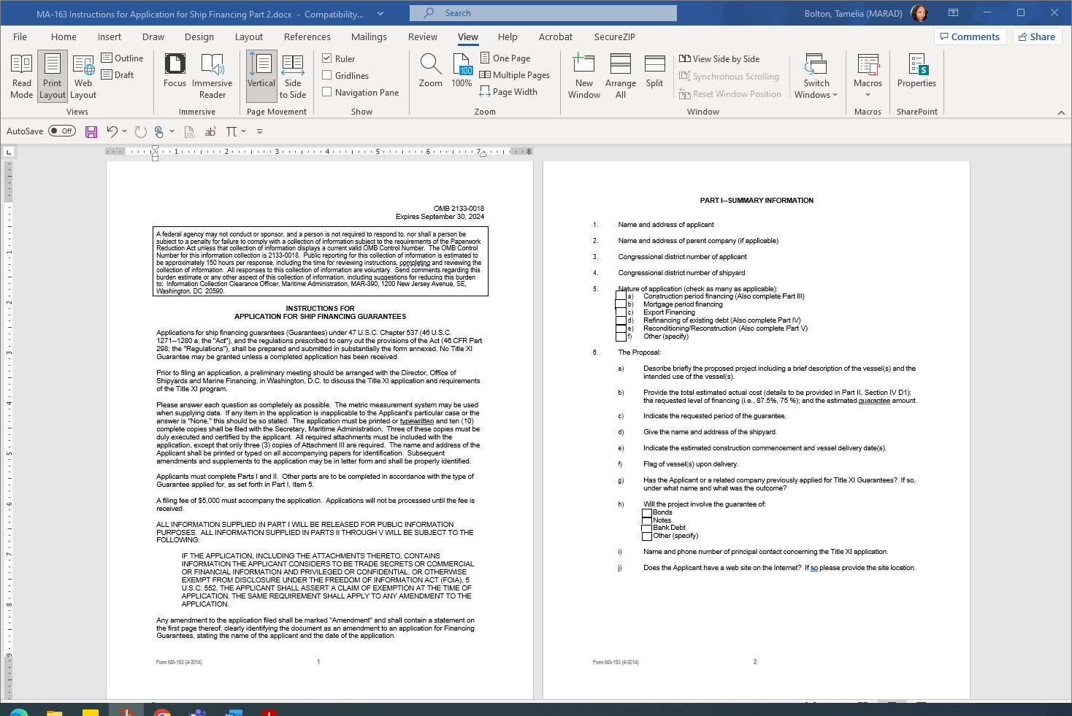

**Updated Instructions:**

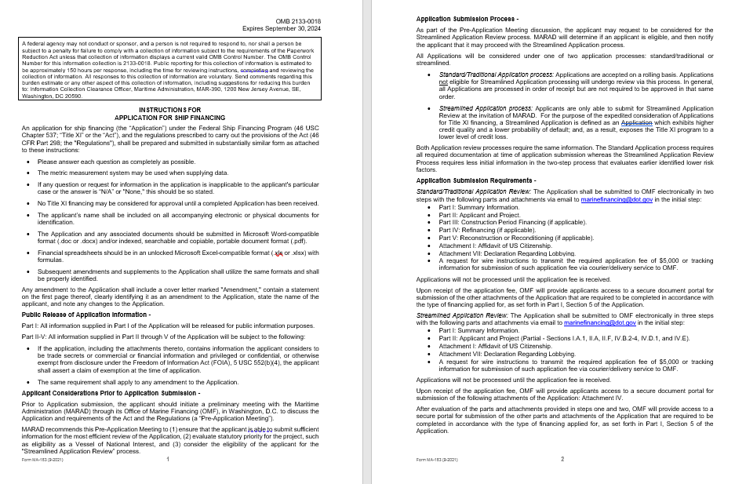

* **Form MA-163A** **(Instructions and Application for Shipyard Financing)**: The application instructions were modernized to include electronic submission procedures. Additionally, terminology was clarified to better convey the electronic submission process.

**Previous Instructions:**

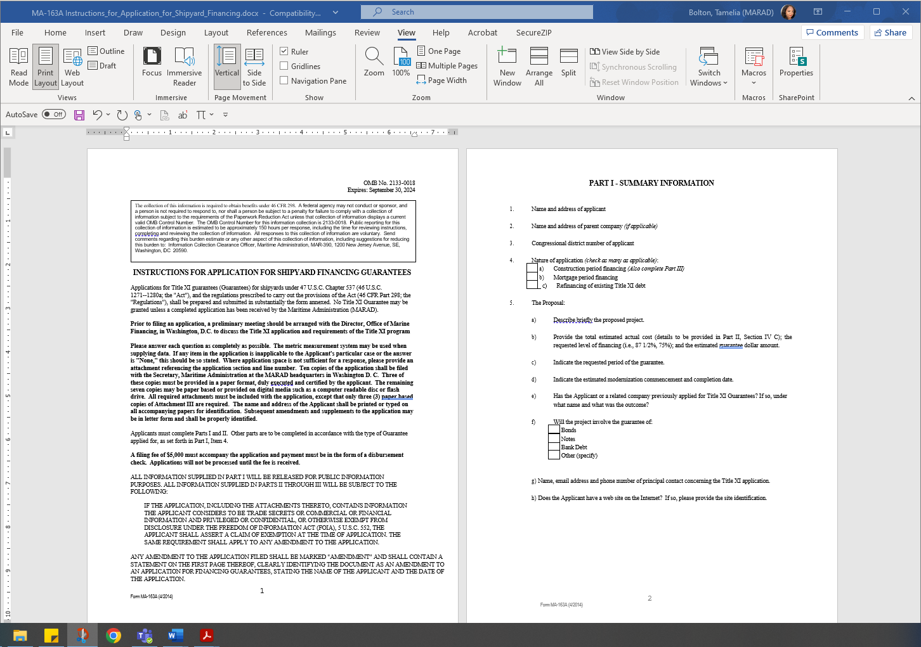

**Updated Instructions:**

