2022 NASA SBIR/STTR Solicitation Request for Information
Paperwork Reduction Act Statement:
This information collection meets the requirements of 44 U.S.C 3507, as amended by section 2 of the Paperwork Reduction Act of 1995. You do not need to answer these questions unless we display a valid Office of Management and Budget control number. The OMB control number for this information collection is 2700-0153 and it expires on 07/31/2024. We estimate that it will take about 5 minutes to read the instructions, gather the facts, and answer the questions. You may send comments on our time estimate above to cale.m.rubenstein@nasa.gov. Send only comments relating to our time estimate to this address.

The purpose of this Request for Information is to engage industry and small businesses early on to build awareness, gain insights, and obtain feedback to shape the Program Year (PY) 22 NASA SBIR/STTR Solicitation and identify process improvements to elevate the customer experience.

- Name of Small Business Concern (SBC)?
- Does your firm belong to a Certified Socio-economic Category (check all that apply)?
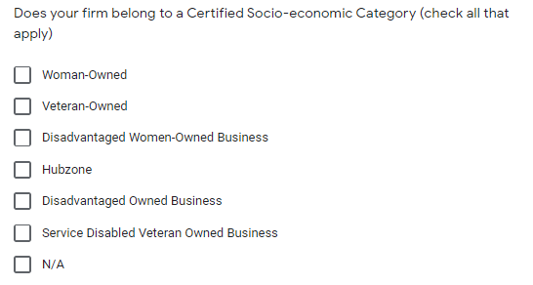
- Are you new to the SBIR/STTR program?
- Did you successfully submit a proposal to the 2022 Solicitation?
Yes | No
2) Which program(s) did you submit a proposal for?  a) SBIR  b) STTR  c) Both SBIR & STTR | 2) What prevented you from submitting a Proposal? (Check all that apply)  - Time constraints  - Technical problems with submittal  - Help Desk Responsiveness  - Unclear Instructions  - Confusing Requirements  - Submission portal interface  - Commercialization Metrics Survey  - Narrow focused subtopics  - Availability of subtopics recurring from past to present solicitations  - Unrealistic deliverables within timeframe given  - Other: ________________________  Additional Comments:________________
QUESTIONS ON THE OVERALL SOLICITATION  - Were the requirements of the solicitation easy to understand?  - Yes  - No  If No, why not and how can it be improved?_________________________ | - Did you attend our “Dissecting the Solicitations” webinar or watched the recording?  - Yes  - No  If no, why?  _______________________________________
4) Were the instructions helpful in drafting your proposal?  - Yes  - No  If No, why not and how can it be improved?_________________________ | - Do you have any suggestions that would help you in submitting to next year’s solicitation?
5) Were the references supplied in the solicitation helpful to submit a proposal?  - Yes  - No  If No, why not and how can it be improved?_________________________ | - What type of help or assistance would you need to be successful in next year’s solicitation?
SUBTOPIC SPECIFIC QUESTIONS  6. Was it easy to find the subtopic(s) of interest your firm proposed to?  - Yes  - No  If No, why not and how can it be improved?_________________________ | After last question in this column, we would thank the user and end survey.
7) Rate these factors in order of importance for your firm to submit a proposal?
- Subtopics with broad NASA needs and/or broad capability goals
- Subtopics with clear requirements and/or metrics
- Subtopics with multiple “scopes” or separate stated technology needs within a broader program area
- Subtopics with clearly stated NASA program/project/mission stakeholders
- Subtopics with content that supports the broader aerospace industrial base and/or new commercial aerospace markets beyond NASA program/projects/missions
- The predictability of subtopic recurrence in future solicitations important

For this use a numerical rating scale from 1 to 5 with 5 being most important and 1 being the Least important. Example below:

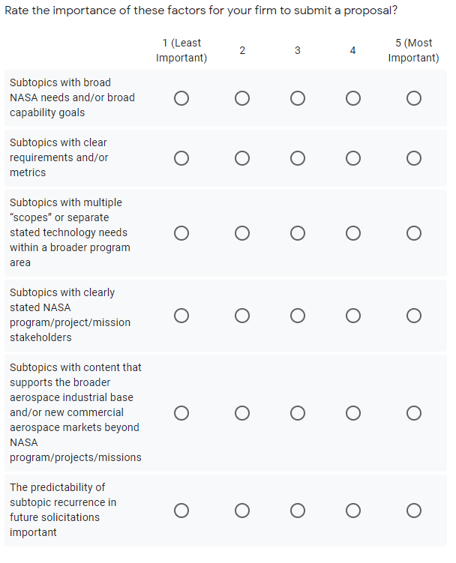
Limit on response per column and add comments box that respondent can explain answer

SUBTOPIC POINTERS AND TRANSITION OPPORTUNITIES
- Related subtopic pointers were identified in the subtopic headers of the solicitation, when applicable, to assist proposers with identifying related subtopics that also potentially seek related technologies for different customers or applications. Were they useful in the decision of which subtopic to propose to?
- Yes
- No
If not, what other information would you have liked to see?
_______________________________________________________

9) The solicitation identified several potential transition and infusion opportunities (Moon to Mars, Commercial Lunar Payload Services, Flight Opportunities, International Space Station Utilization) for technologies developed under identified subtopics. Did you apply for any of these opportunities?
- Yes
- No
If not, why not?
_______________________________________________________

SUBTOPIC DESIRED DELIVERABLES
10) Did the desired deliverables and expected Technology Readiness Levels (TRL) range at completion align with your expectation of what could be achieved given the period of performance and award value of Phase I and Phase II?
- Yes
- No
If not, what other information would you have liked to see?
_______________________________________________________

NASA ASSISTANCE
11) Was the “Dissecting the Solicitations” webinar or the recording helpful in completing your proposal?
- Yes
- No
If no, not why?
_______________________________________

12) Did you take advantage of NASA’s Innovation Corps (i-Corps) with your proposal?
- Yes
- No
If no, not why?
_______________________________________

13) Did you take advantage of the Technical and Business Assistance (TABA) program with your proposal?

- Yes
- No
If no, not why?
_______________________________________

14) If you used the Help Desk, were they helpful in addressing your concerns regarding your proposal?

- Yes
- No
- N/A
If no, not why?
_______________________________________

General Comments:
_______________________________________
_______________________________________

