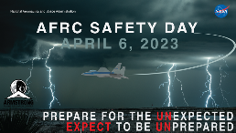

Paperwork Reduction Act Statement:

This information collection meets the requirements of 44 U.S.C 3507, as amended by section 2 of the Paperwork Reduction Act of 1995. You do not need to answer these questions unless we display a valid Office of Management and Budget control number. The OMB control number for this information collection is 2700-0153 and it expires on 07/31/2024. We estimate that it will take about 5 minutes to read the instructions, gather the facts, and answer the questions. You may send comments on our time estimate above to [carol-ann.thomas@nasa.gov](mailto:__________@nasa.gov). Send only comments relating to our time estimate to this address.

Safety Day 2023 Feedback Survey

1.Safety Day 2023 was of value to me.

Agree

Neutral

Disagree

2.I attended Safety Day...

In Person

Online

Neither

Both

3.A hybrid (online/in-person) event works well for Safety Day (audio/visual/seating).

Agree

Neutral

Disagree

4.Safety Day 2023 had excellent speakers that held my interest.

Agree

Neutral

Disagree

5.The Safety Day 2023 speaker topics were applicable to me/my life.

Agree

Neutral

Disagree

6.Future Safety Day topics I would like to hear about are:

Enter your answer

7.Things I would change to make Safety Day better next year are:

Enter your answer