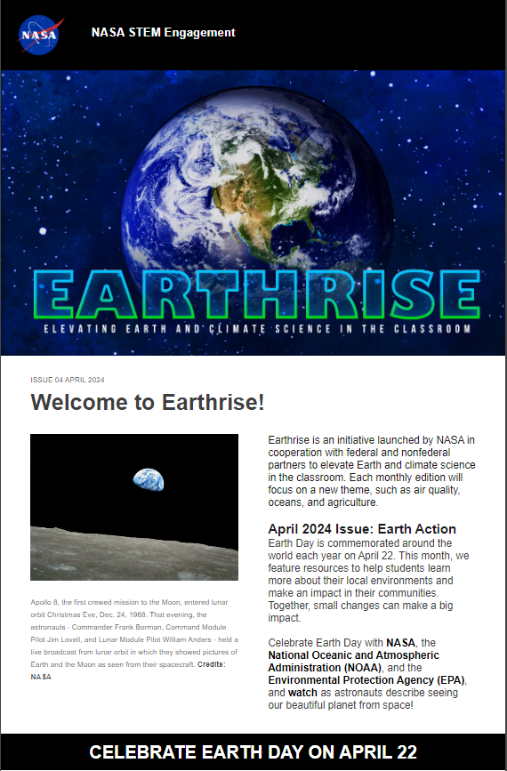

We’d love your feedback! Please click the hyperlink or use the QR Code to complete the 5 minute [Earthrise Feedback Questionnaire](https://www.surveymonkey.com/r/SYCZTZJ).

We’d love your feedback! Please use the link (<https://www.surveymonkey.com/r/SYCZTZJ>) or the QR Code to complete the 5 minute Earthrise Feedback Questionnaire.