Online Materials - NASA/NMNH EIC Exit Survey
Anonymous Link for Distribution:
https://pacificresearch.qualtrics.com/jfe/form/SV_57SePKbS35aO6Wi

QR Code generated in Qualtrics:
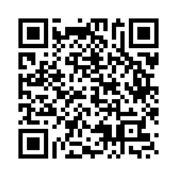
Screenshots of the programmed survey:

Page 1
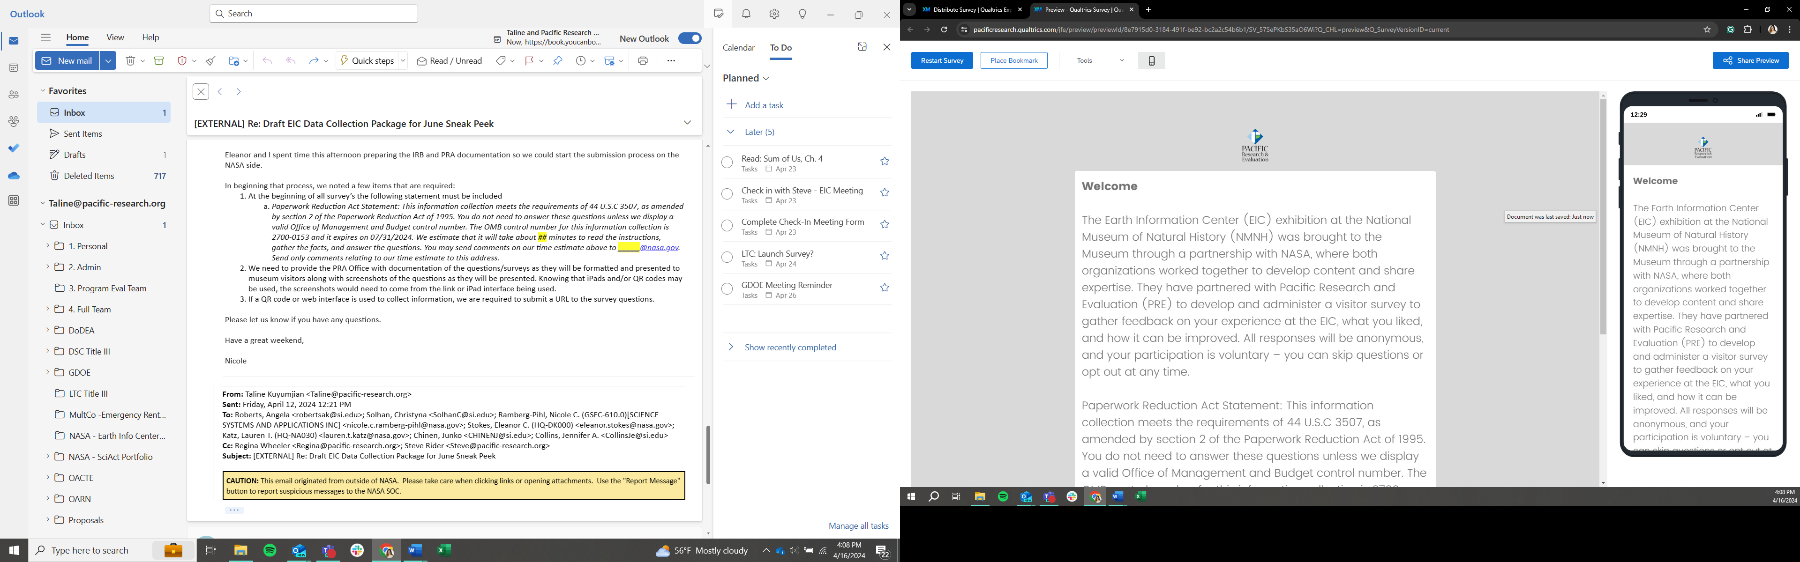

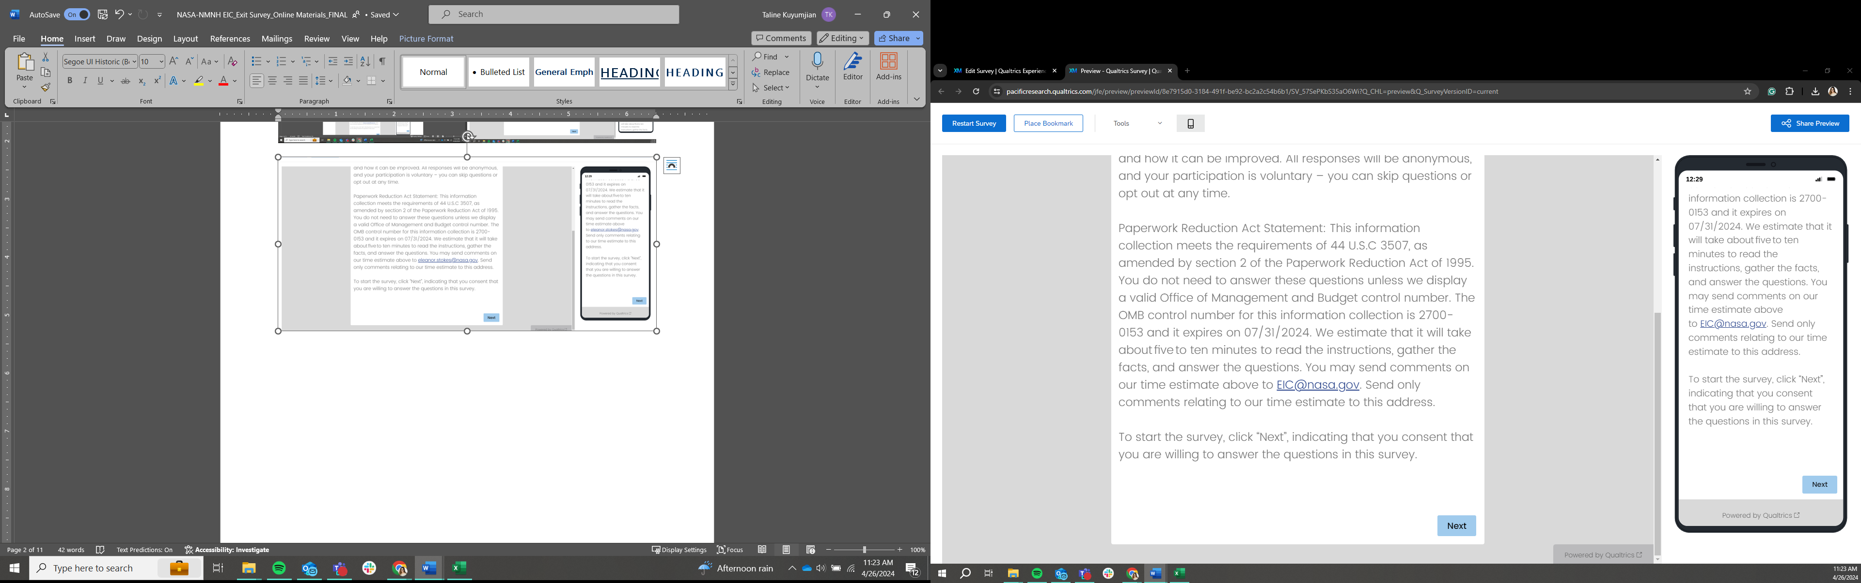

Page 2
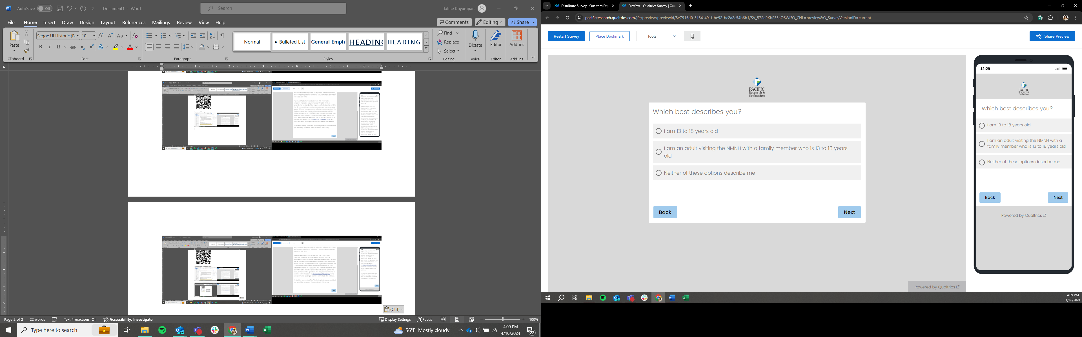

Page 3
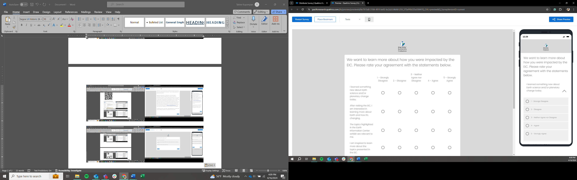

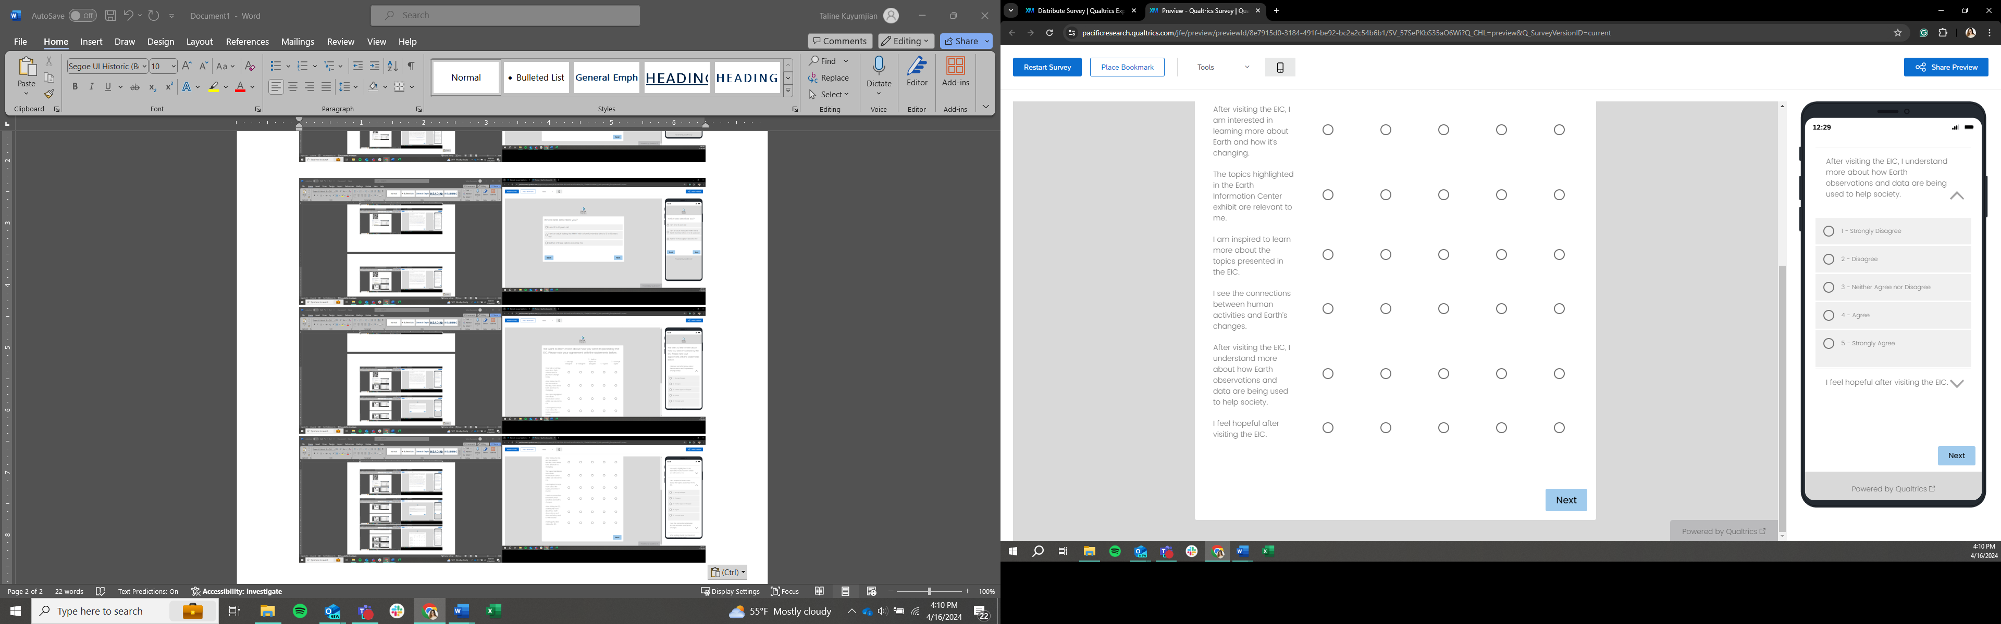

Page 4
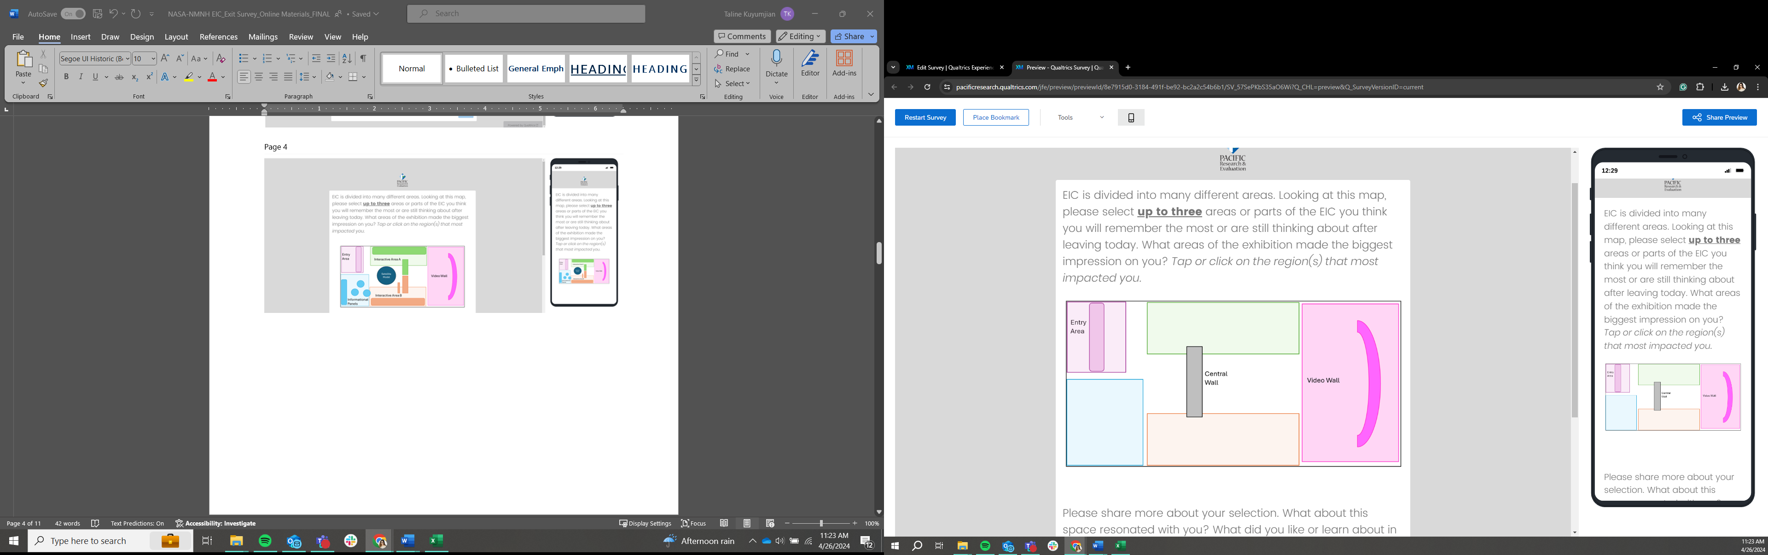
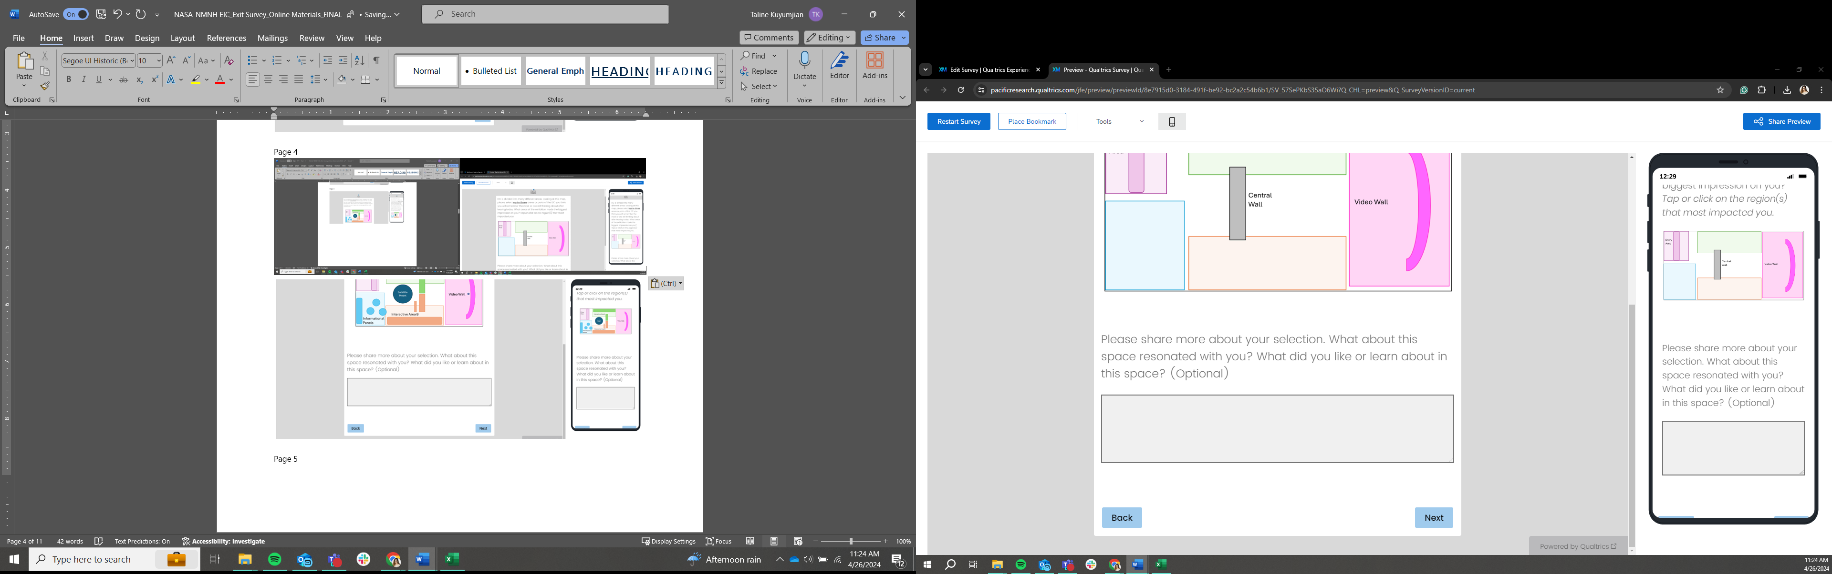

Page 5
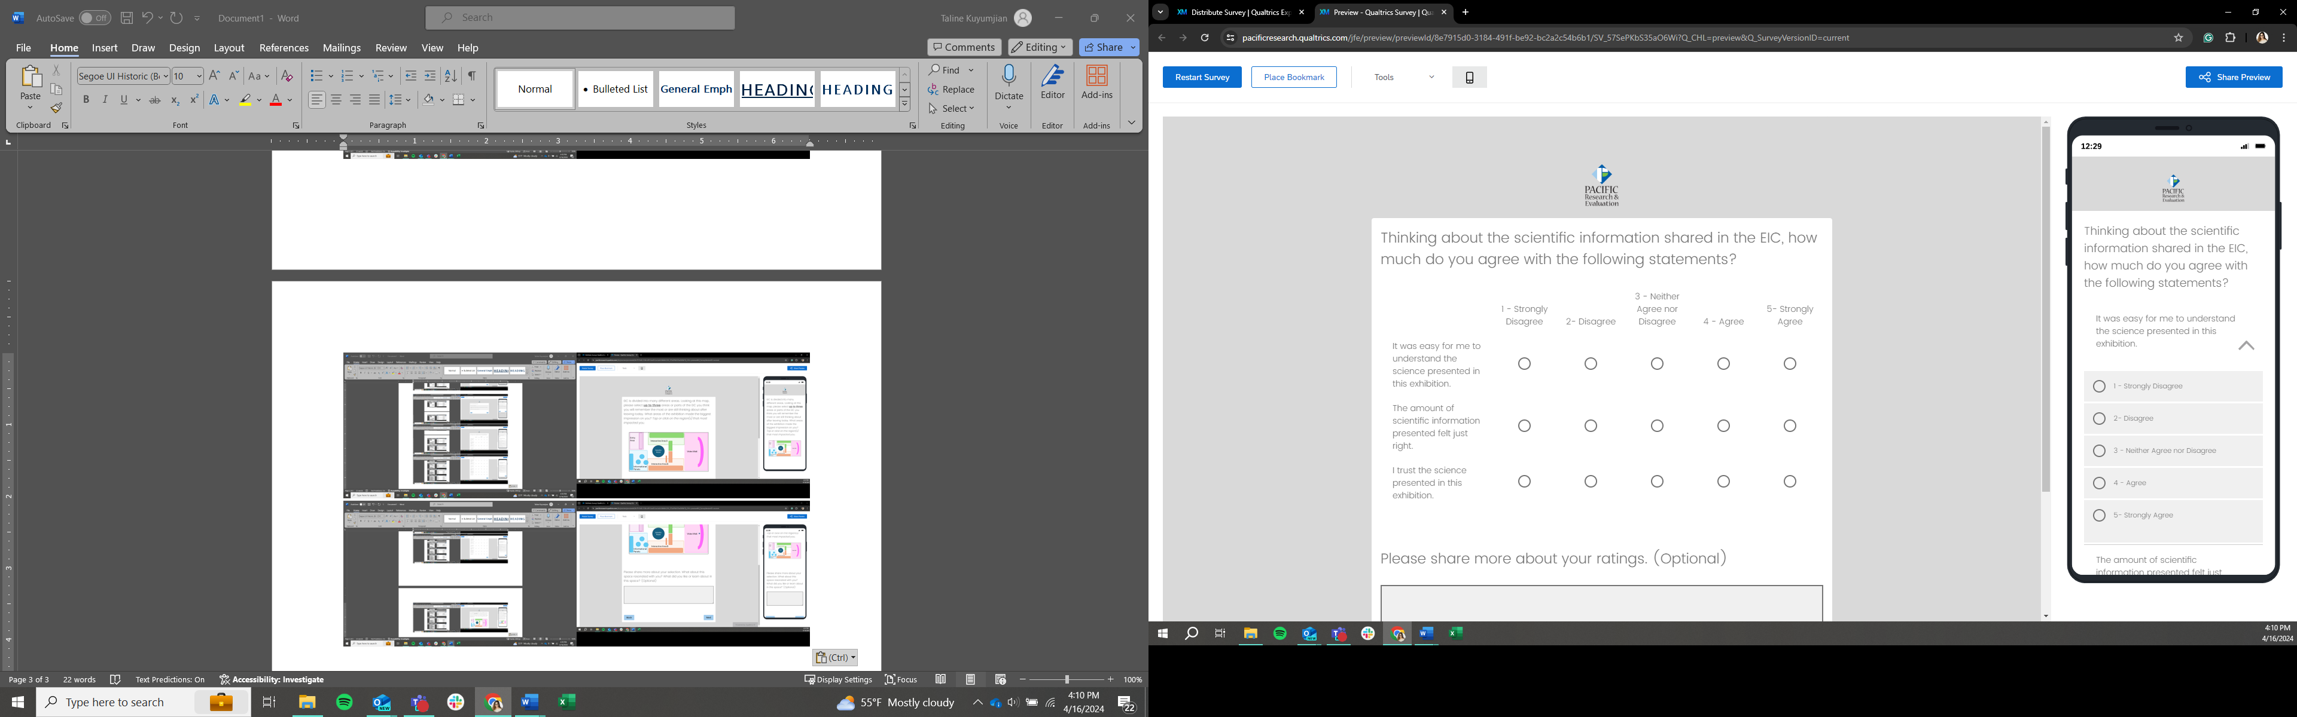
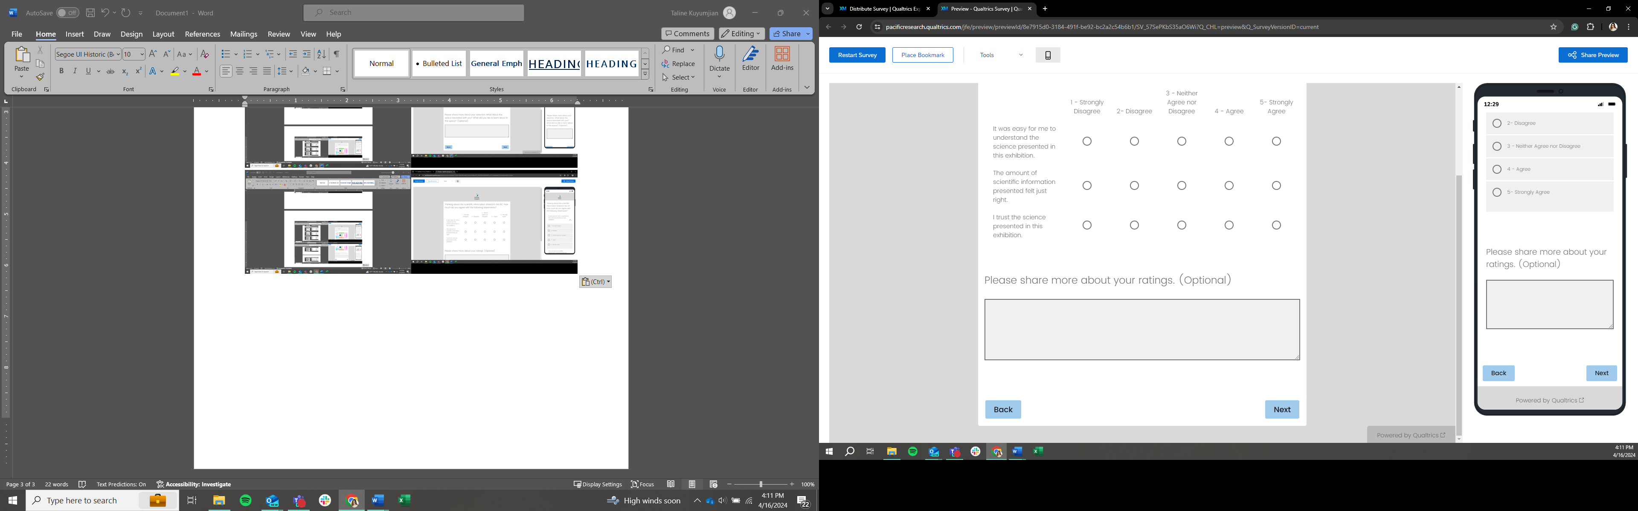

Page 6
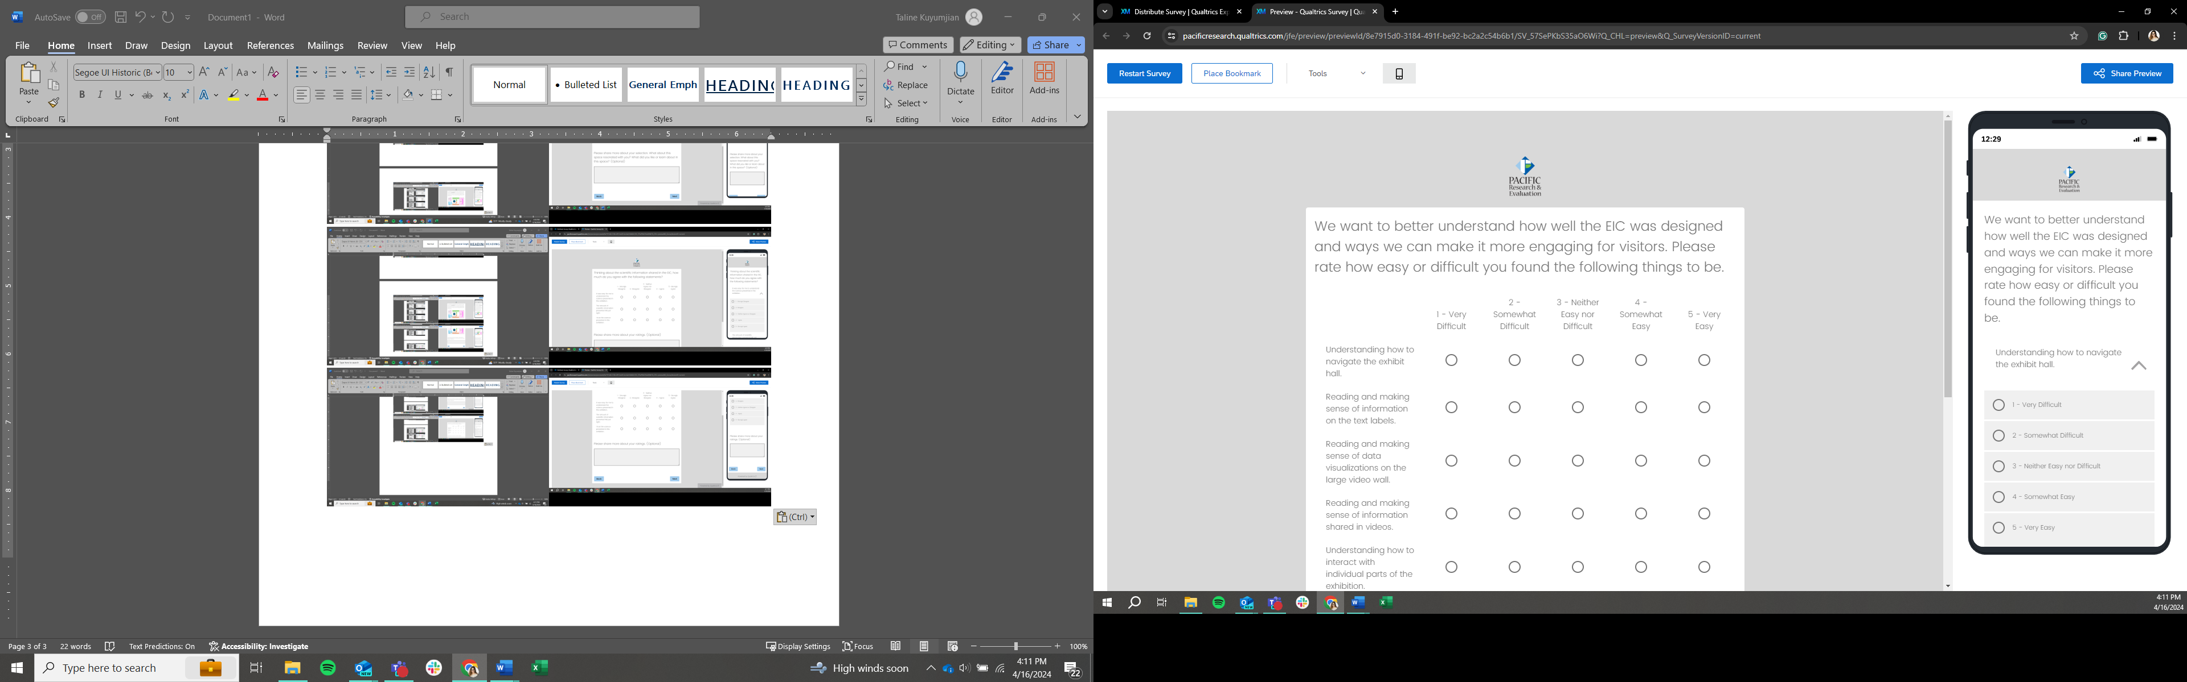
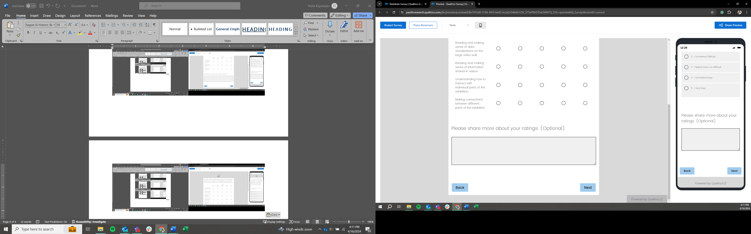

Page 7
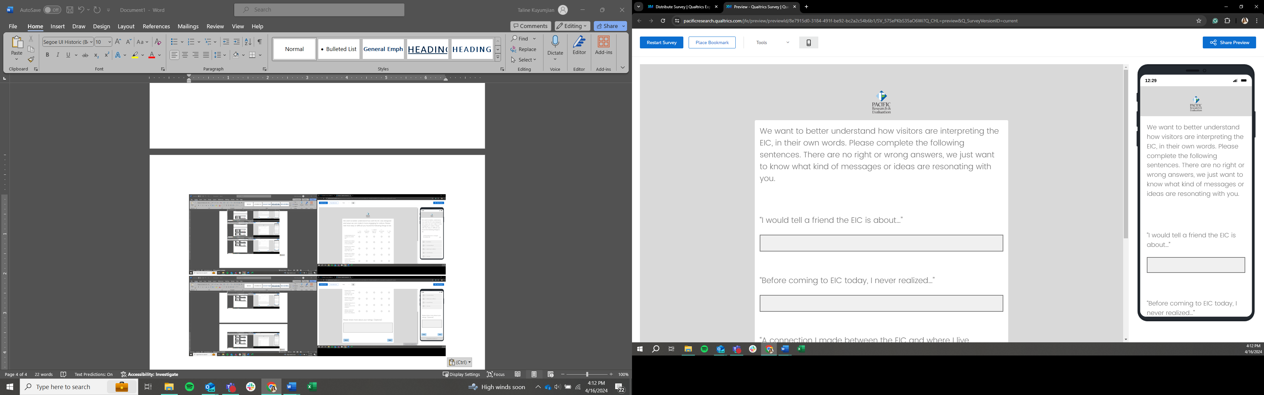
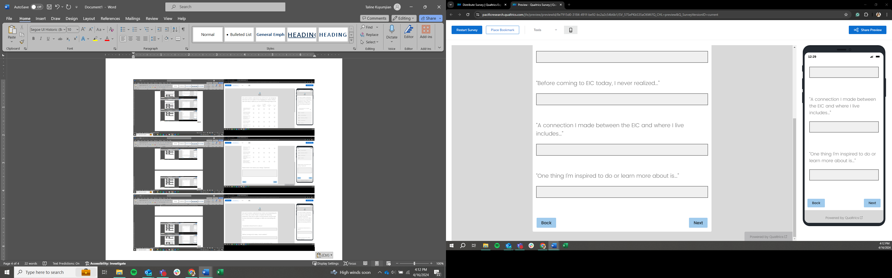

Page 8
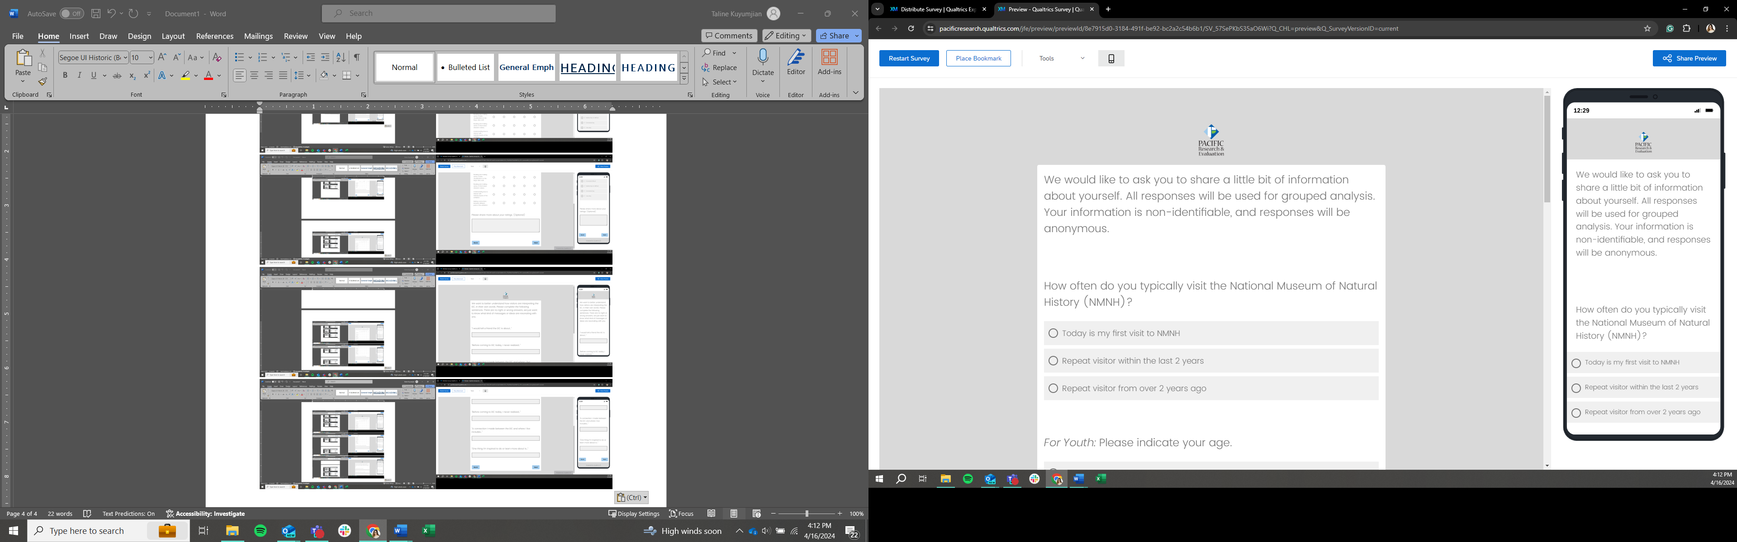
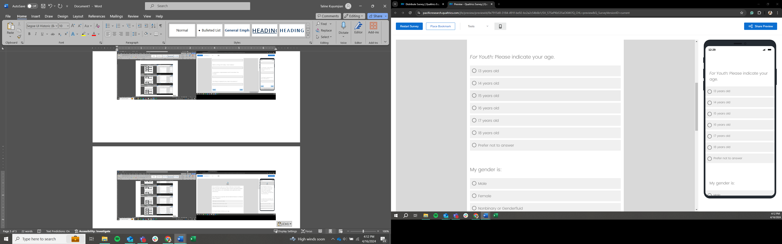
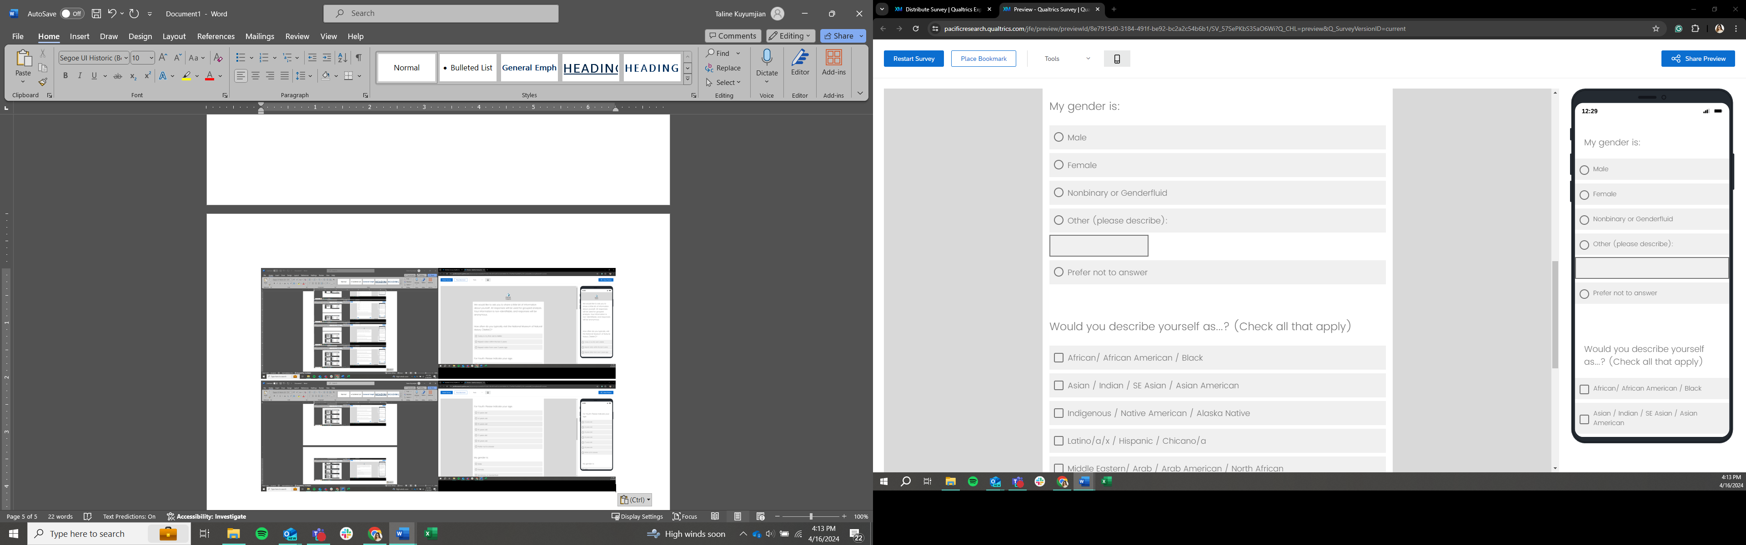
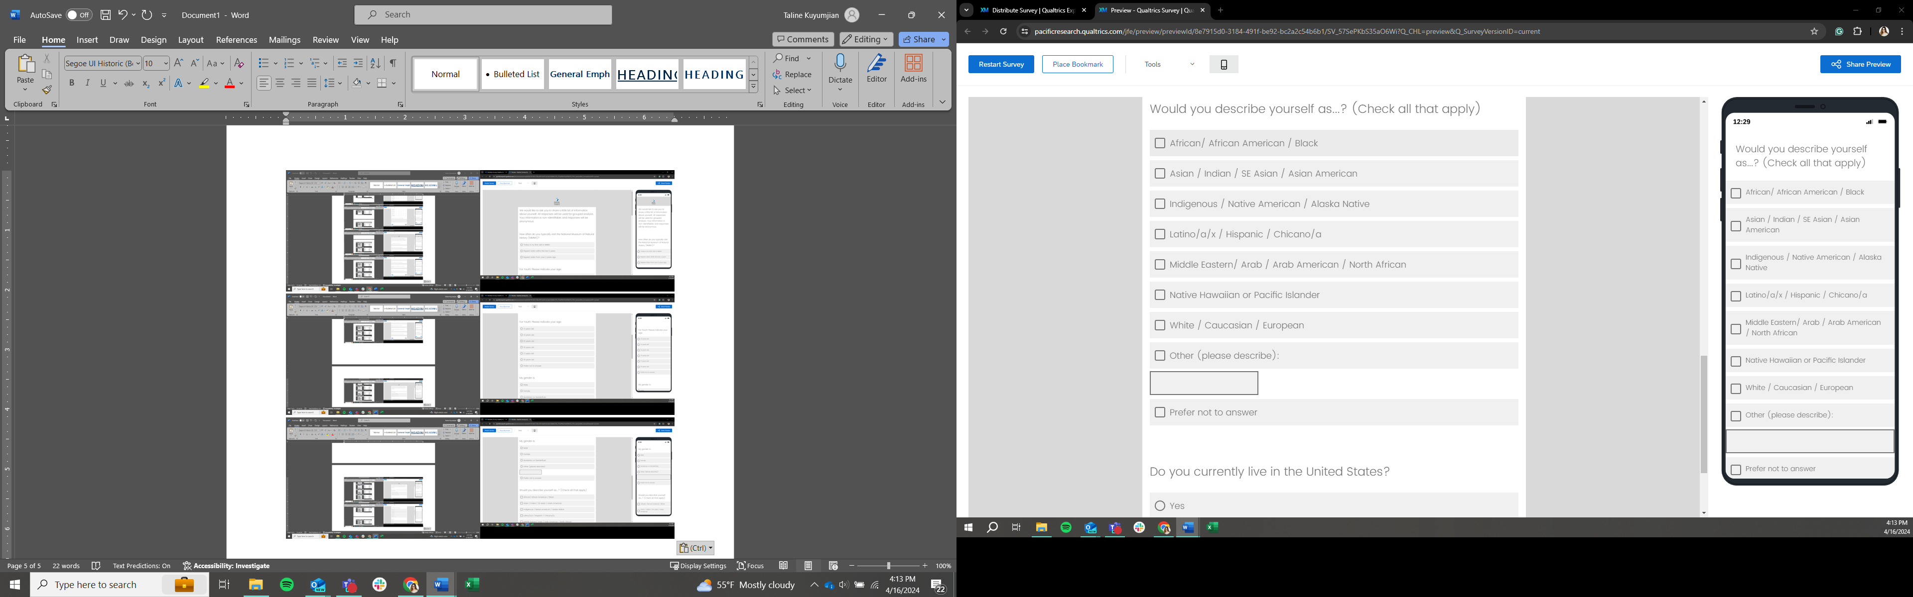
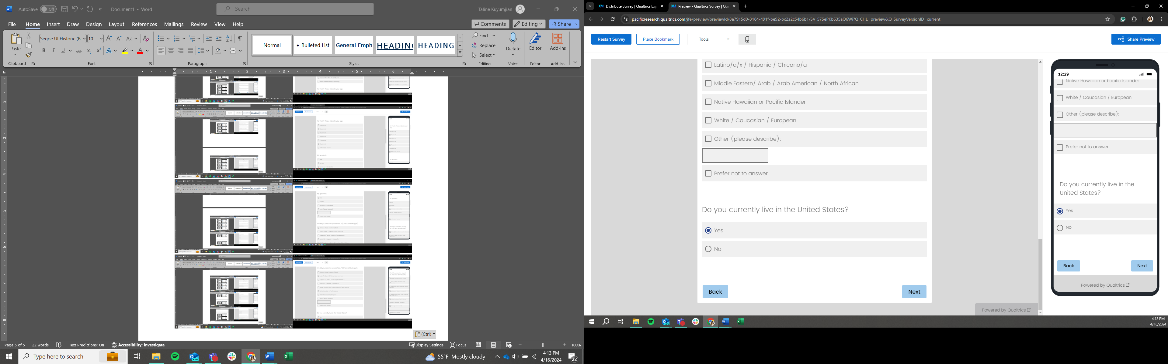

Page 9
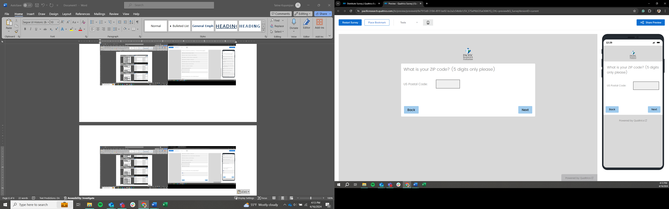

Page 10
