# NASA/NMNH EIC Exit Survey

The Earth Information Center (EIC) exhibition at the National Museum of Natural History (NMNH) was brought to the Museum through a partnership with NASA, where both organizations worked together to develop content and share expertise. They have partnered with Pacific Research and Evaluation (PRE) to develop and administer a visitor survey to gather feedback on your experience at the EIC, what you liked, and how it can be improved. All responses will be anonymous, and your participation is voluntary – you can skip questions or opt out at any time.

*Paperwork Reduction Act Statement: This information collection meets the requirements of 44 U.S.C 3507, as amended by section 2 of the Paperwork Reduction Act of 1995. You do not need to answer these questions unless we display a valid Office of Management and Budget control number. The OMB control number for this information collection is 2700-0153 and it expires on 07/31/2024. We estimate that it will take about five to ten minutes to read the instructions, gather the facts, and answer the questions. You may send comments on our time estimate above to* [*EIC@nasa.gov*](mailto:EIC@nasa.gov) *Send only comments relating to our time estimate to this address.*

1. How often do you typically visit the National Museum of Natural History (NMNH)?
   * Today is my first visit to NMNH
   * Repeat visitor within the last 2 years
   * Repeat visitor from over 2 years ago
2. We want to learn more about how you were impacted by the EIC. Please rate your agreement with the statements below.

|  | **1**  **Strongly Disagree** | **2**  **Disagree** | **3**  **Neither Agree nor Disagree** | **4**  **Agree** | **5**  **Strongly Agree** |
| --- | --- | --- | --- | --- | --- |
| *I learned something new about Earth science and/or planetary change today.* |  |  |  |  |  |
| *After visiting the EIC, I am interested in learning more about Earth and how it’s changing.* |  |  |  |  |  |
| *The topics highlighted in the Earth Information Center exhibit are relevant to me.* |  |  |  |  |  |
| *I am inspired to learn more about the topics presented in the EIC.* |  |  |  |  |  |
| *I see the connections between human activities and Earth’s changes.* |  |  |  |  |  |
| *After visiting the EIC, I understand more about how Earth observations and data are being used to help society.* |  |  |  |  |  |
| *I feel hopeful after visiting the EIC.* |  |  |  |  |  |

1. EIC is divided into many different areas. Looking at this map, please select up to three areas or parts of the EIC you think you will remember the most or are still thinking about after leaving today. What areas of the exhibition made the biggest impression on you? *Circle up to three areas.*

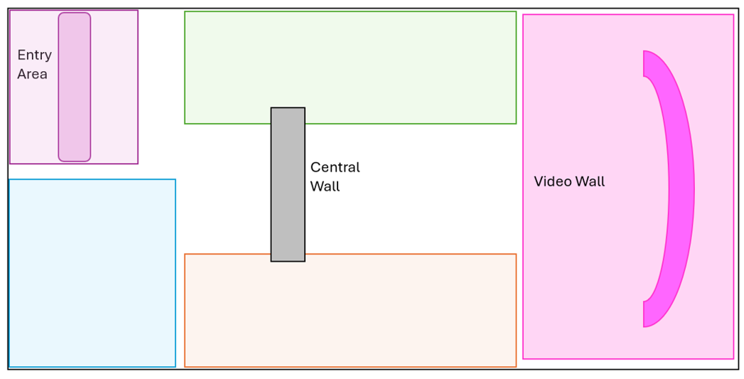

Please share more about your selection. What about this space resonated with you? What did you like or learn about in this space? (Optional)

1. Thinking about the scientific information shared in the EIC, how much do you agree with the following statements?

|  | **1**  **Strongly Disagree** | **2**  **Disagree** | **3**  **Neither Agree nor Disagree** | **4**  **Agree** | **5**  **Strongly Agree** |
| --- | --- | --- | --- | --- | --- |
| *It was easy for me to understand the science presented in this exhibition.* |  |  |  |  |  |
| *The amount of scientific information presented felt just right.* |  |  |  |  |  |
| *I trust the science presented in this exhibition.* |  |  |  |  |  |

Please share more about your ratings. (Optional)

1. We want to better understand how well the EIC was designed and ways we can make it more engaging for visitors. Please rate how easy or difficult you found the following things to be.

|  | **1**  **Very Difficult** | **2**  **Somewhat Difficult** | **3**  **Neither Easy nor Difficult** | **4**  **Somewhat Easy** | **5**  **Very Easy** |
| --- | --- | --- | --- | --- | --- |
| *Understanding how to navigate the exhibit hall.* |  |  |  |  |  |
| *Reading and making sense of information on the text panels/labels.* |  |  |  |  |  |
| *Reading and making sense of data visualizations on the large video wall.* |  |  |  |  |  |
| *Reading and making sense of information shared in videos.* |  |  |  |  |  |
| *Understanding how to interact with individual parts of the exhibition.* |  |  |  |  |  |
| *Making connections between different parts of the exhibition.* |  |  |  |  |  |

Please share more about your ratings. (Optional)

1. We want to better understand how visitors are interpreting the EIC, in their own words. Please complete the following sentences. There are no right or wrong answers, we just want to know what kind of messages or ideas are resonating with you.

“I would tell a friend the EIC is about…”

“Before coming to EIC today, I never realized…”

“A connection I made between the EIC and where I live includes…”

“One thing I’m inspired to do or learn more about is…”

## Demographics (Optional)

We would like to ask you to share a little bit of information about yourself. All responses will be used for grouped analysis. Your information is non-identifiable, and responses will be anonymous.

1. Please indicate your age.
   * 13 years old
   * 14 years old
   * 15 years old
   * 16 years old
   * 17 years old
   * 18 years old
   * 19 to 24
   * 25 to 34
   * 35 to 44
   * 45 to 54
   * 55 to 64
   * 65 or older
   * Prefer not to answer
2. Do you currently live in the United States?
   * Yes
   * No

If “yes”, what is your ZIP code? (5 digits only please) _______________

**Thank You!**

*Please return this clipboard to the data collectors to receive your NASA or NMNH pin.*