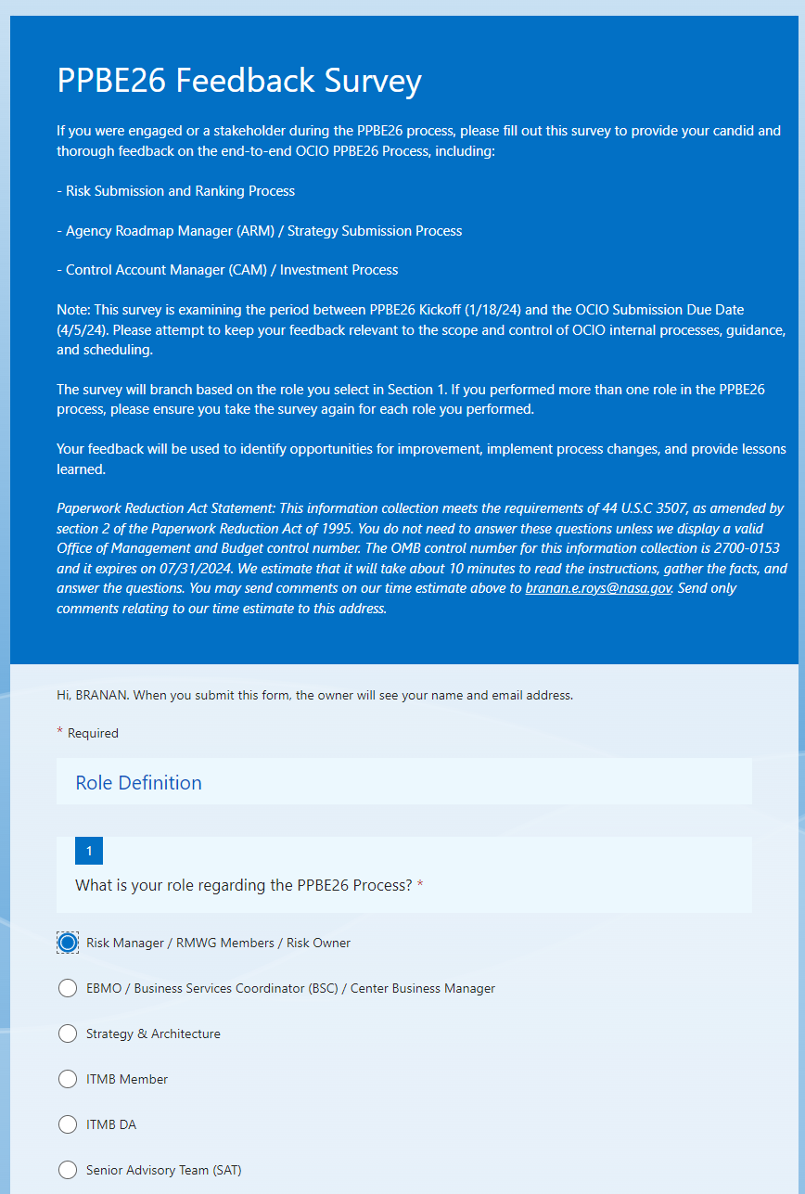

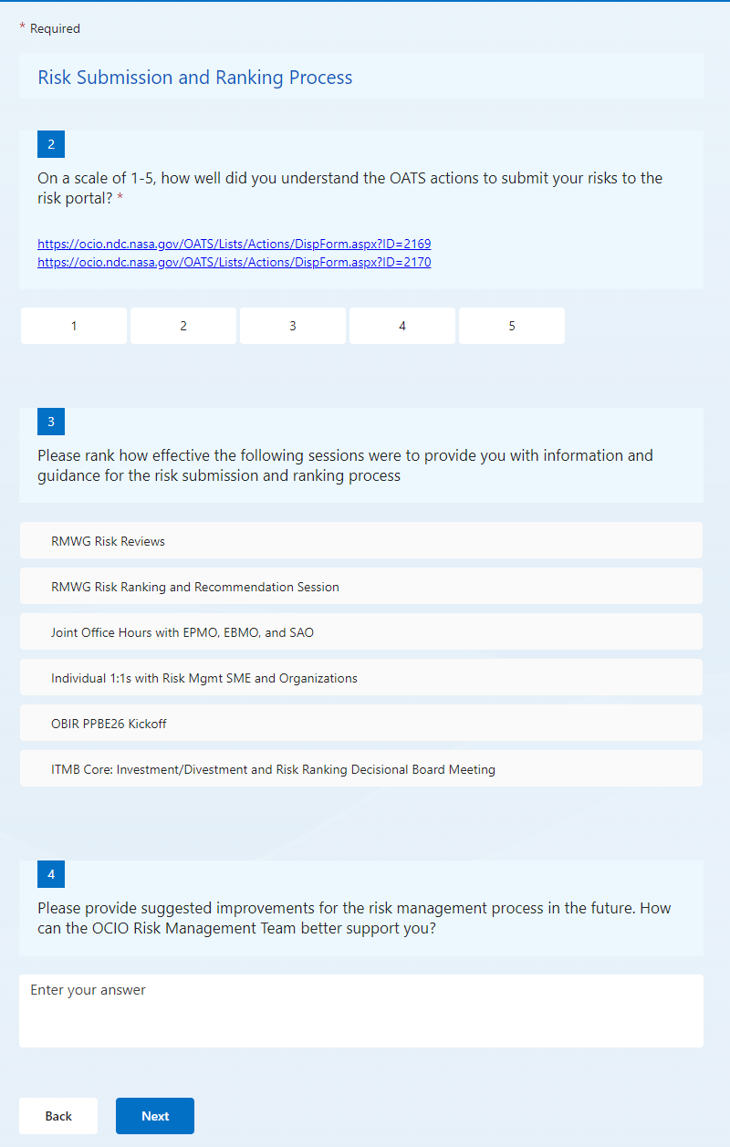

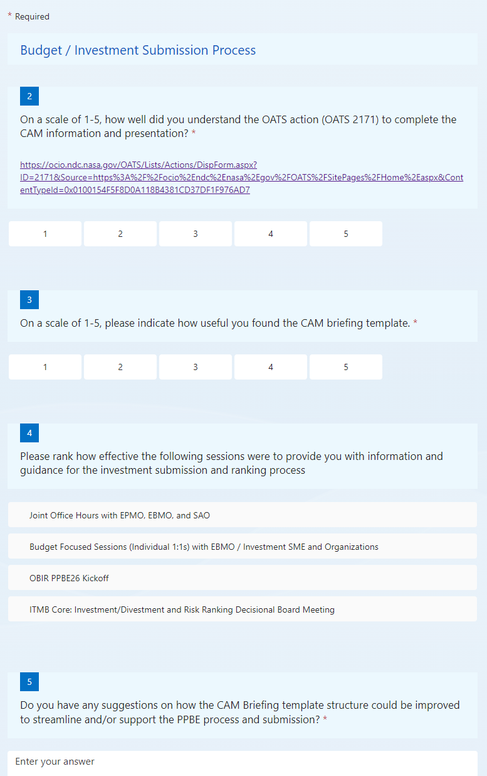

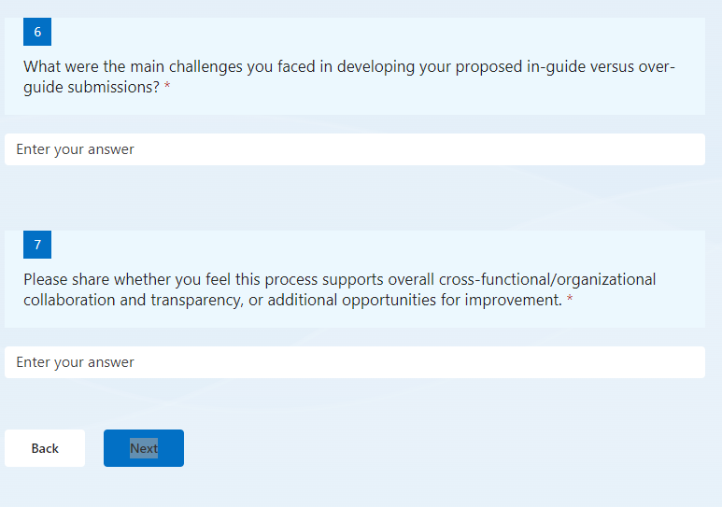

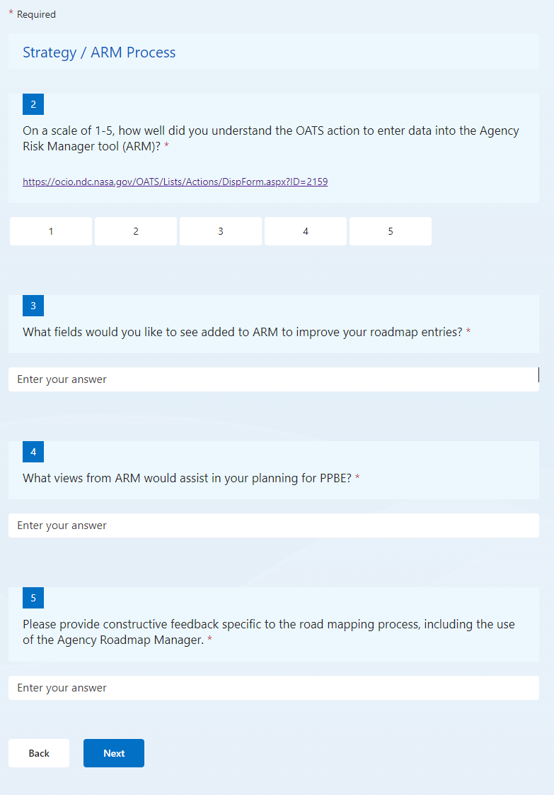

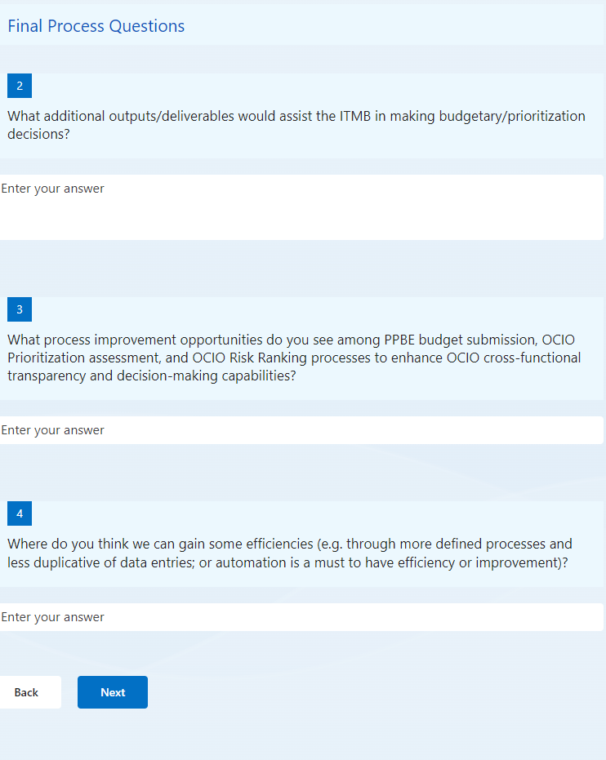

PPBE26 Feedback Survey

If you were engaged or a stakeholder during the PPBE26 process, please fill out this survey to provide your candid and thorough feedback on the end-to-end OCIO PPBE26 Process, including:  
  
- Risk Submission and Ranking Process  
  
- Agency Roadmap Manager (ARM) / Strategy Submission Process  
  
- Control Account Manager (CAM) / Investment Process  
  
Note: This survey is examining the period between PPBE26 Kickoff (1/18/24) and the OCIO Submission Due Date (4/5/24). Please attempt to keep your feedback relevant to the scope and control of OCIO internal processes, guidance, and scheduling.   
  
The survey will branch based on the role you select in Section 1. If you performed more than one role in the PPBE26 process, please ensure you take the survey again for each role you performed.  
  
Your feedback will be used to identify opportunities for improvement, implement process changes, and provide lessons learned.

*Paperwork Reduction Act Statement: This information collection meets the requirements of 44 U.S.C 3507, as amended by section 2 of the Paperwork Reduction Act of 1995. You do not need to answer these questions unless we display a valid Office of Management and Budget control number. The OMB control number for this information collection is 2700-0153 and it expires on 07/31/2024. We estimate that it will take about 10 minutes to read the instructions, gather the facts, and answer the questions. You may send comments on our time estimate above to*[*branan.e.roys@nasa.gov*](mailto:branan.e.roys@nasa.gov)*. Send only comments relating to our time estimate to this address.*

Hi, BRANAN. When you submit this form, the owner will see your name and email address.

Required

Role Definition

1

What is your role regarding the PPBE26 Process?

Risk Manager / RMWG Members / Risk Owner

EBMO / Business Services Coordinator (BSC) / Center Business Manager

Strategy & Architecture

ITMB Member

ITMB DA

Senior Advisory Team (SAT)





Required

Risk Submission and Ranking Process

2

On a scale of 1-5, how well did you understand the OATS actions to submit your risks to the risk portal?

<https://ocio.ndc.nasa.gov/OATS/Lists/Actions/DispForm.aspx?ID=2169>  
<https://ocio.ndc.nasa.gov/OATS/Lists/Actions/DispForm.aspx?ID=2170>

1

2

3

4

5

3

Please rank how effective the following sessions were to provide you with information and guidance for the risk submission and ranking process

RMWG Risk Reviews

RMWG Risk Ranking and Recommendation Session

Joint Office Hours with EPMO, EBMO, and SAO

Individual 1:1s with Risk Mgmt SME and Organizations

OBIR PPBE26 Kickoff

ITMB Core: Investment/Divestment and Risk Ranking Decisional Board Meeting

4

Please provide suggested improvements for the risk management process in the future. How can the OCIO Risk Management Team better support you?



BackNext

Required

Budget / Investment Submission Process

2

On a scale of 1-5, how well did you understand the OATS action (OATS 2171) to complete the CAM information and presentation?

<https://ocio.ndc.nasa.gov/OATS/Lists/Actions/DispForm.aspx?ID=2171&Source=https%3A%2F%2Focio%2Endc%2Enasa%2Egov%2FOATS%2FSitePages%2FHome%2Easpx&ContentTypeId=0x0100154F5F8D0A118B4381CD37DF1F976AD7>

1

2

3

4

5

3

On a scale of 1-5, please indicate how useful you found the CAM briefing template.

1

2

3

4

5

4

Please rank how effective the following sessions were to provide you with information and guidance for the investment submission and ranking process

Joint Office Hours with EPMO, EBMO, and SAO

Budget Focused Sessions (Individual 1:1s) with EBMO / Investment SME and Organizations

OBIR PPBE26 Kickoff

ITMB Core: Investment/Divestment and Risk Ranking Decisional Board Meeting

5

Do you have any suggestions on how the CAM Briefing template structure could be improved to streamline and/or support the PPBE process and submission?



6

What were the main challenges you faced in developing your proposed in-guide versus over-guide submissions?



7

Please share whether you feel this process supports overall cross-functional/organizational collaboration and transparency, or additional opportunities for improvement.



BackNext

equired

Strategy / ARM Process

2

On a scale of 1-5, how well did you understand the OATS action to enter data into the Agency Risk Manager tool (ARM)?

<https://ocio.ndc.nasa.gov/OATS/Lists/Actions/DispForm.aspx?ID=2159>

1

2

3

4

5

3

What fields would you like to see added to ARM to improve your roadmap entries?



4

What views from ARM would assist in your planning for PPBE?



5

Please provide constructive feedback specific to the road mapping process, including the use of the Agency Roadmap Manager.



BackNext

Final Process Questions

2

What additional outputs/deliverables would assist the ITMB in making budgetary/prioritization decisions?



3

What process improvement opportunities do you see among PPBE budget submission, OCIO Prioritization assessment, and OCIO Risk Ranking processes to enhance OCIO cross-functional transparency and decision-making capabilities?



4

Where do you think we can gain some efficiencies (e.g. through more defined processes and less duplicative of data entries; or automation is a must to have efficiency or improvement)?



BackNext