2024 transmittal email will be like this, only the graphic will be updated to reflect this year’s events, and text and link will be updated to reflect new year.

The separately attached agenda from 2023 (PDF), will also be repurposed for 2024 with updated text and new link to survey once approved.

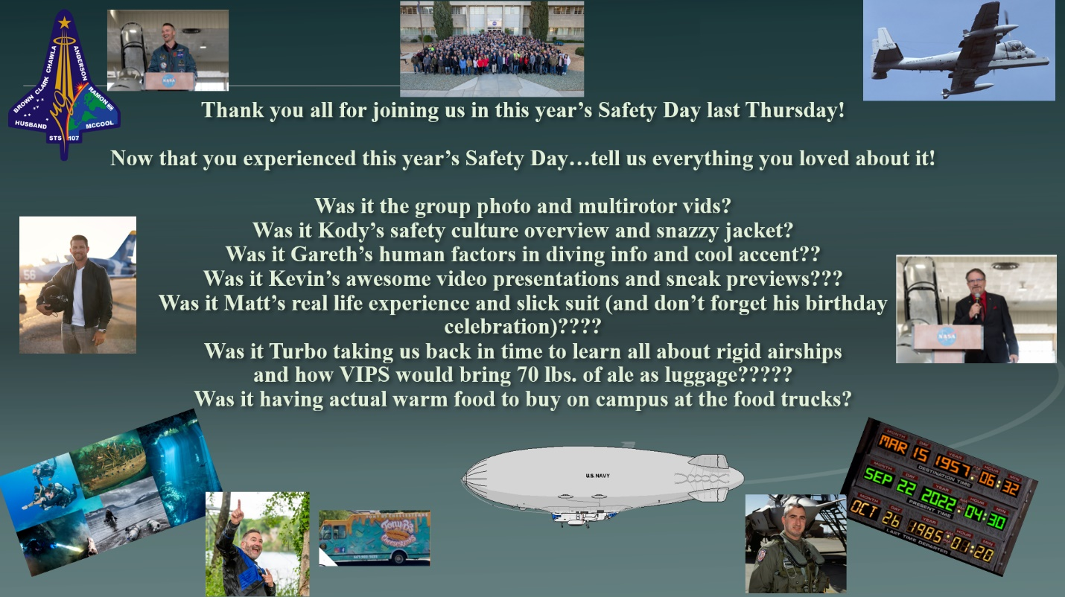

**(Or I *guess* you could tell us what you would like to change for next year 😊)**

**How can we make 2024 even better??**

**Complete the SAFETY DAY SURVEY HERE:**

[**Safety Day 2023 Feedback Survey (office.com)**](https://gcc02.safelinks.protection.outlook.com/?url=https%3A%2F%2Fforms.office.com%2Fpages%2Fresponsepage.aspx%3Fid%3DWNQFcL5FrkiBQNQ9qW3Re5Kx2-_0xlpElZsKkVcsCzpUOUdFUTQ0QTZNVVpITzVESFBQRVkyWkZCVS4u&data=05%7C02%7Cb.edwards-bodmer%40nasa.gov%7C7e77ff9494844acd814308dc4f2da526%7C7005d45845be48ae8140d43da96dd17b%7C0%7C0%7C638472304668091791%7CUnknown%7CTWFpbGZsb3d8eyJWIjoiMC4wLjAwMDAiLCJQIjoiV2luMzIiLCJBTiI6Ik1haWwiLCJXVCI6Mn0%3D%7C0%7C%7C%7C&sdata=5BVzEg4t9LjcZO%2BVcrm7RbLY1yHHg%2FEt5GSLVhNswO4%3D&reserved=0)