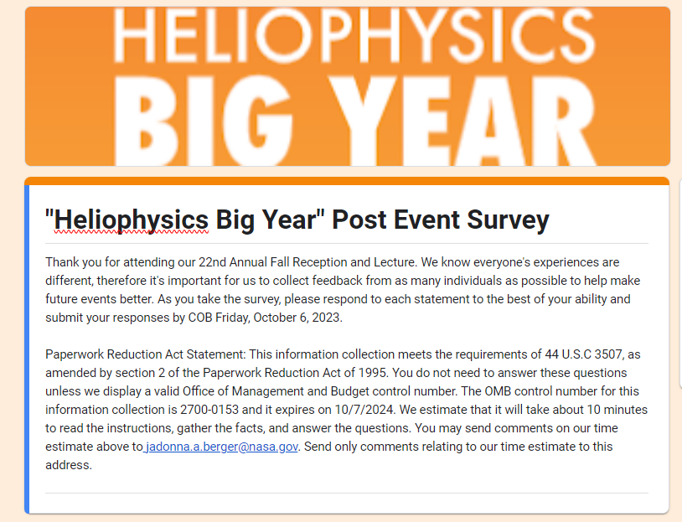 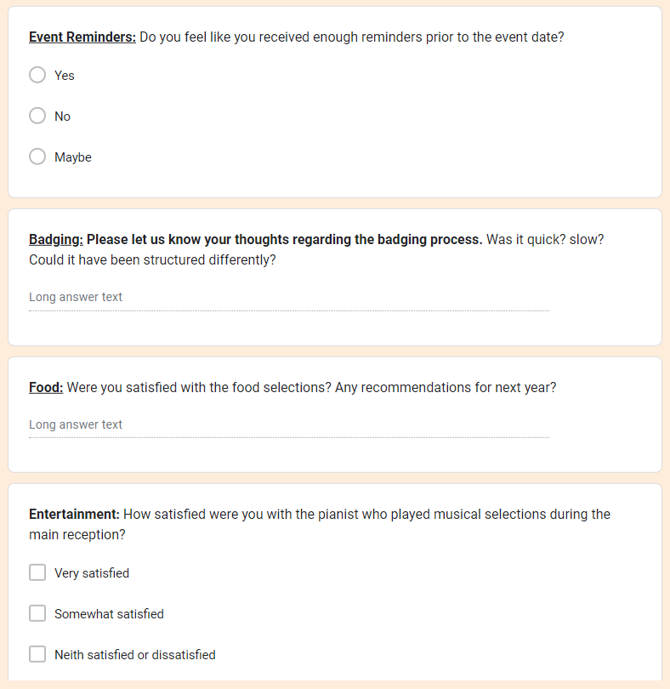

**Heliophysics Sample Survey Screenshot**