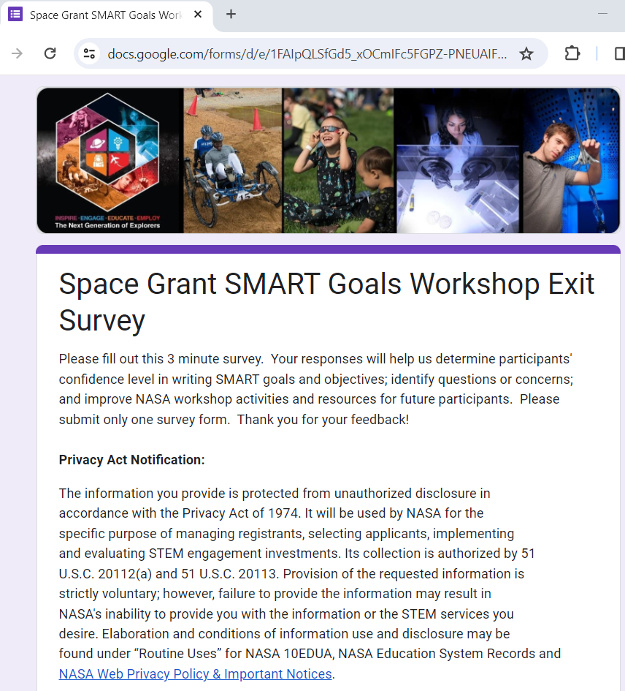

Space Grant SMART Goals Workshop Exit Survey

Please fill out this 3 minute survey.  Your responses will help us determine participants' confidence level in writing SMART goals and objectives; identify questions or concerns; and improve NASA workshop activities and resources for future participants.  Please submit only one survey form.  Thank you for your feedback!

**Privacy Act Notification:**

The information you provide is protected from unauthorized disclosure in accordance with the Privacy Act of 1974. It will be used by NASA for the specific purpose of managing registrants, selecting applicants, implementing and evaluating STEM engagement investments. Its collection is authorized by 51 U.S.C. 20112(a) and 51 U.S.C. 20113. Provision of the requested information is strictly voluntary; however, failure to provide the information may result in NASA's inability to provide you with the information or the STEM services you desire. Elaboration and conditions of information use and disclosure may be found under “Routine Uses” for NASA 10EDUA, [NASA Education System Records](https://www.federalregister.gov/documents/2023/05/10/2023-09932/privacy-act-of-1974-system-of-records) and [NASA Web Privacy Policy & Important Notices](https://www.nasa.gov/privacy/).

**Paperwork Reduction Act Statement:**

This information collection meets the requirements of 44 U.S.C 3507, as amended by section 2 of the Paperwork Reduction Act of 1995. You do not need to answer these questions unless we display a valid Office of Management and Budget control number. The OMB control number for this information collection is 2700-0153 and it expires on 7/31/2024. We estimate that it will take about 3 minutes to read the instructions, gather the facts, and answer the questions. You may send comments on our time estimate above to richard.l.gilmore@nasa.gov. Send only comments relating to our time estimate to this address.

1. Please rate your overall **confidence**in writing your Space Grant consortium’s SMART goals and objectives for the upcoming release of the Multi-Year Solicitation (select your rating).

* Completely confident
* Fairly confident
* Somewhat confident
* Slightly confident
* Not confident at all

1. This workshop helped me better understand how to write quality SMART goals and objectives and the support resources available to me (rate your agreement with statement).

* Strongly Agree
* Agree
* Neither disagree or agree
* Disagree
* Strongly Disagree

1. What questions or concerns do you have regarding SMART goals and objectives?
2. Please provide any general comments you’d like to share regarding this workshop (*Was there something you really liked or do you have suggestions for improvement?*)