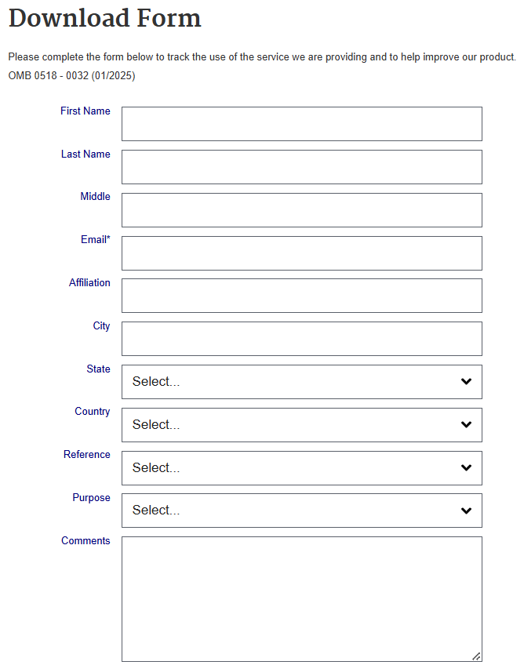Screenshot of ARS Web Form



OMB 0518 – 0032  
Expiration Date xx-xx-xxxx

According to the Paperwork Reduction Act of 1985, an agency cannot conduct or sponsor, and a person is not required to collection of information unless it displays a valid OMB control number. The valid OMB control number for the collection is 0518-0032. The estimated time to complete the forms is 3 minutes. This includes time for reviewing instructions and filling in the information. Send comments regarding this burden estimate or any other aspect of this collection of information, including suggestions for reducing this burden, to the following address: U.S. Department of Agriculture, Agricultural Research Service, Research, Education, Economics, Administrative Financial Management, Information Technology Services Division, 5601 Sunnyside Ave., Beltsville, MD 20705.