NAL PRA Artifacts:

* NAL Document Delivery Login Form:

https://docdel.nal.usda.gov/user/login.html?group=patron&LS=AGL

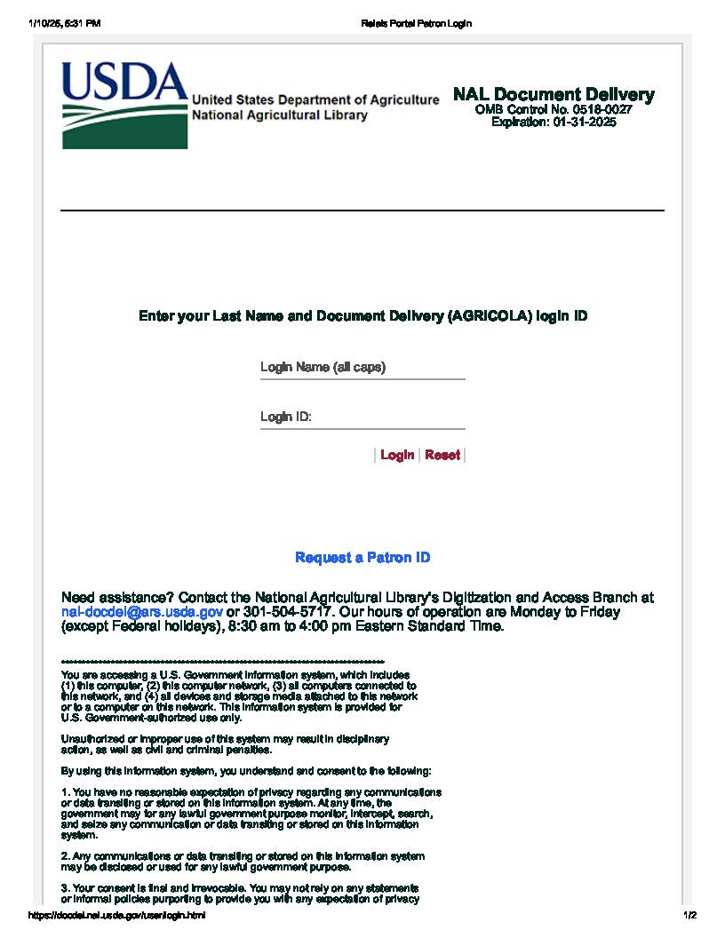

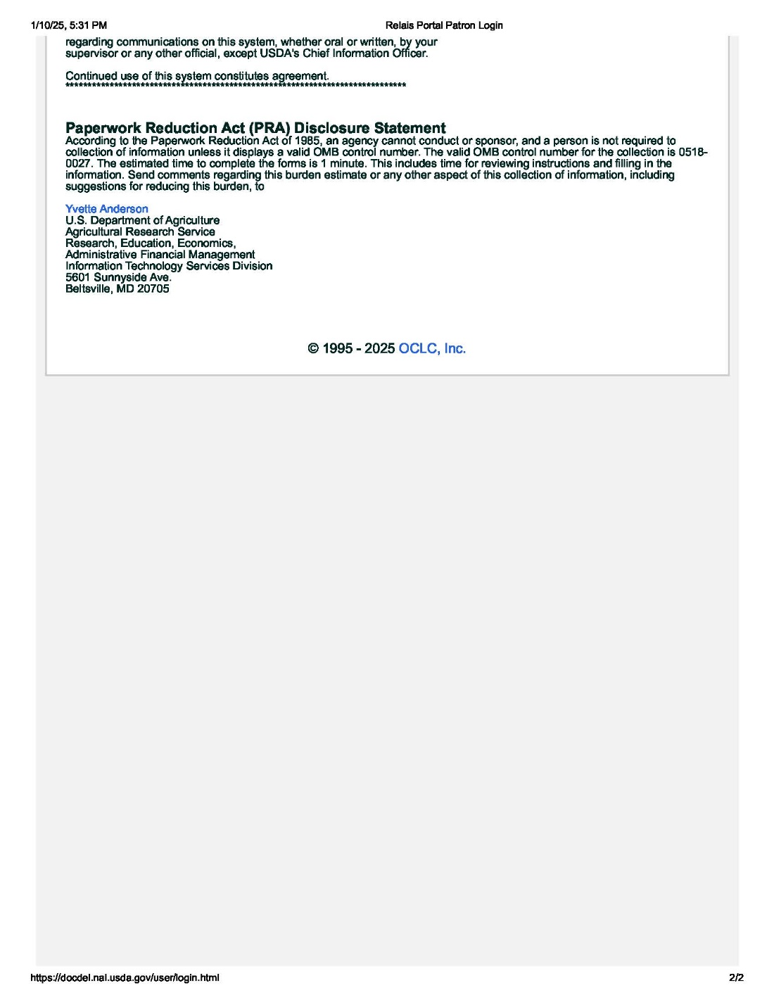

* NAL Document Delivery Patron Registration:

https://www.nal.usda.gov/borrow-materials/register-for-a-patron-id

