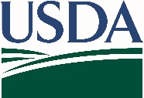
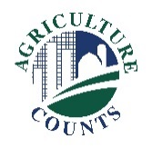
United States Department of Agriculture
National Agricultural Statistics Service

What do I do next?
Complete your survey in one of the following ways:
Online at agcounts.usda.gov through the Respondent Portal. Online reporting is fast and secure. All you need is the unique survey code on the enclosed form to begin.

By mail or fax. Complete the questionnaire and mail it back in the prepaid return envelope provided or fax it to 855-415-3687.

April 22, 2024

Why am I getting this letter?

Enclosed is your 2024 Mink Survey. Your participation is important. Your information will help to provide the current climate of the mink industry.

Please complete the questionnaire at your earliest convenience. You may receive an email reminder. If we do not receive your completed questionnaire by Friday, May 17, 2024, we may contact you for an interview.

How will the data be used?

The data will:

- Help inform policy decisions that directly affect
your mink operation.

- Be used by mink producers and processors to make informed business decisions based on the average marketing price per pelt and value of pelts produced by major states.

This national survey includes information on the number of pelts produced in 2023, the number of females bred to produce kits in 2024, the price per pelt or total value sold, and the value of pelt production and marketing prices by color class.

The information you provide will be used for statistical purposes only. In accordance with federal law, your responses will be kept confidential and will not be disclosed in identifiable form. We will publish the data on the NASS website in the Mink report on July 12, 2024.

Thank you for your participation and support of U.S. agriculture. For more information, visit www.nass.usda.gov/Surveys/go/Mink. If you have questions or need assistance completing your survey, please call 888-424-7828.

Sincerely,
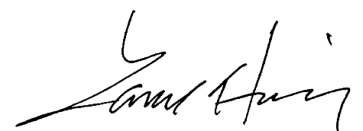
Lance Honig
Chair, Agricultural Statistics Board
National Agricultural Statistics Service
U.S. Department of Agriculture

Enclosure

