**United States Department of Agriculture**

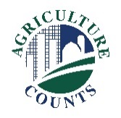

National Agricultural Statistics Service

December 22, 2023

**What should I do next?**

Complete your survey in one of the following ways:

**Online** at [agcounts.usda.gov](http://www.agcounts.usda.gov) through the Respondent Portal. **Online reporting is fast and secure.**You just need your unique survey code on the enclosed form to begin.

By **mail or fax**. Complete the questionnaire and mail it back in the prepaid envelope provided or fax it to 855- 415-3687.

**Why am I getting this letter?**

You have been selected to participate in the 2024 Commercial Floriculture Survey (2023 production year). Your information will help document changes in the floriculture industry and enable us to develop up-to-date industry data.

You may receive an email reminder to complete your questionnaire. If we do not receive your completed questionnaire by December 29, we may contact you for an interview.

**How will the data be used?**

Growers, buyers, government agencies and others can use the data to identify state and national trends, make plans, and determine the industry’s impact on farm income and the economy.

We recommend you respond online through the Respondent Portal. On the portal, you can complete your surveys, track upcoming surveys, access data visualizations and reports of interest, link to other USDA agencies, and more.

The information you provide will be used for statistical purposes only. **In accordance with federal law, your responses will be kept confidential and will not be disclosed in identifiable form.** We will publish survey data May 16, 2024, in USDA’s National Agricultural Statistics Service Quick Stats database at quickstats.nass.usda.gov.

Thank you for your participation and support of our programs and U.S. agriculture. If you have any questions or need assistance completing your survey, please contact us at 888-424-7828. For more information on this survey, visit nass.usda.gov/go/floriculture.

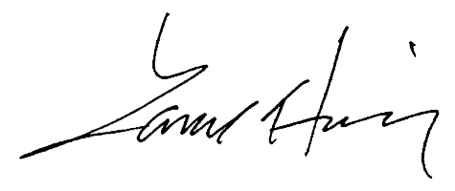Sincerely,

Lance Honig

Acting Chair, Agricultural Statistics Board

Enclosure