**Request for Nonsubstantive Change to the**

**2025 American Community Survey**

**Group Quarters Internet Data Collection Respondent Materials**

**OMB Control No. 0607-0810**

**U.S. Department of Commerce**

**U.S. Census Bureau**

Purpose

The American Community Survey (ACS) Office is requesting the implementation of new respondent materials for group quarters internet data collection (GQ IDC). This package was created based on feedback received from ACS Group Quarters (GQ) field staff after several months of implementing a new internet response mode for some group quarters facilities. The new materials should increase internet response, improve data quality, and reduce additional follow-up visits from field staff.

Group Quarters Internet Data Collection Respondent Package

Currently, the ACS uses the ACS-17(L)(GQ) introductory letter to notify GQ respondents of the option to complete the survey online. The letter is part of a package that includes a paper questionnaire, appointment card, and other materials. This package is used for both institutional and non-institutional GQs. The letter mentions that internet response is available but only if a User ID is on the label on the envelope (as institutional GQs are not eligible to respond online). Field Representatives (FRs) are reporting that many residents cannot find the UserID to respond online.

To remedy this issue, a new package called the GQ IDC Respondent Package was developed. This new package includes a new ACS-40 envelope and a new letter focused on internet response, the ACS-17INET(L)(GQ). This letter resembles the ACS-17INET(L) used for ACS housing units. The new internet letter will inform residents that they have been selected to participate in the ACS and that they can complete the survey online. The ACS-17INET(L)(GQ) will allow the FR to write the internet user ID in a prominent position on the letter. The FR may also include their appointment card with the letter. The FR will hand the new GQ IDC Respondent Package to respondents or leave it with the GQ point of contact.

Note that institutional GQs, such as jails and nursing homes, will continue to use the GQ paper questionnaire package.

Group Quarters Facility Administrators FAQ Brochure – Remote Alaska

The GQ informational brochures were updated with a new look and feel, new pictures, and clearer language in DY2023. However, the Remote Alaska brochure did not reflect the new GQ online response option. The GQ Facility Administrators FAQ Remote Alaska brochure has been updated for DY2025 to include information on how to complete the GQ IDC online. In addition, some minor aesthetic changes were made to the brochure.

**Attachments**

1. **ACS-17INET(L)(GQ) Introductory Internet Letter**
2. **ACS-40 Letter-size Envelope**
3. **ACS-50 Group Quarters Facility Administrators FAQ Brochure – Remote Alaska**

**Attachment A - ACS-17INET(L)(GQ) Introductory Internet Letter**

*Front*

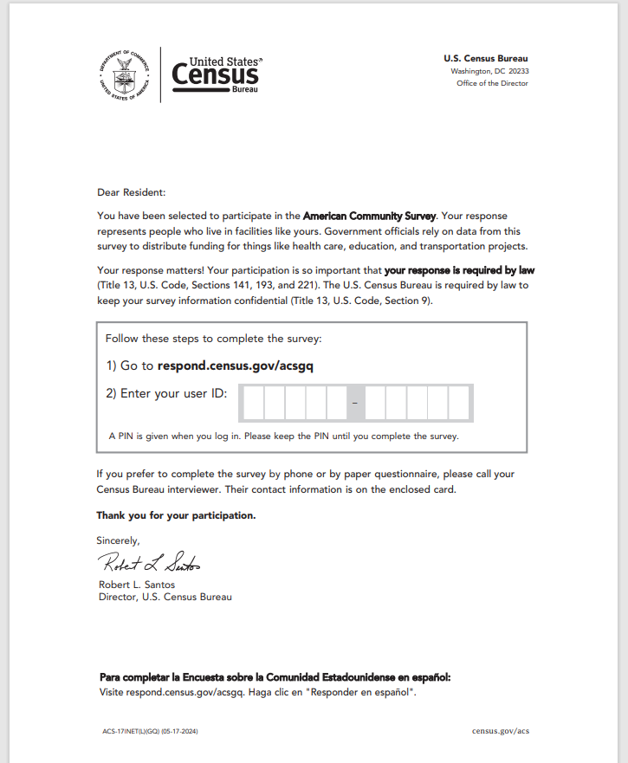

**Attachment A - ACS-17INET(L)(GQ) Introductory Internet Letter**

*Back*

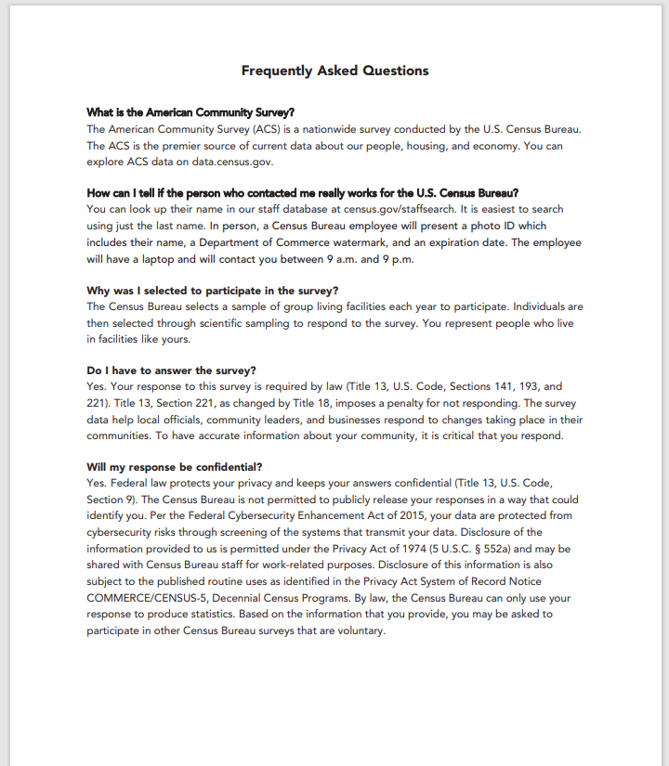

**Attachment B - ACS-40 Letter size Envelope**

*Front*

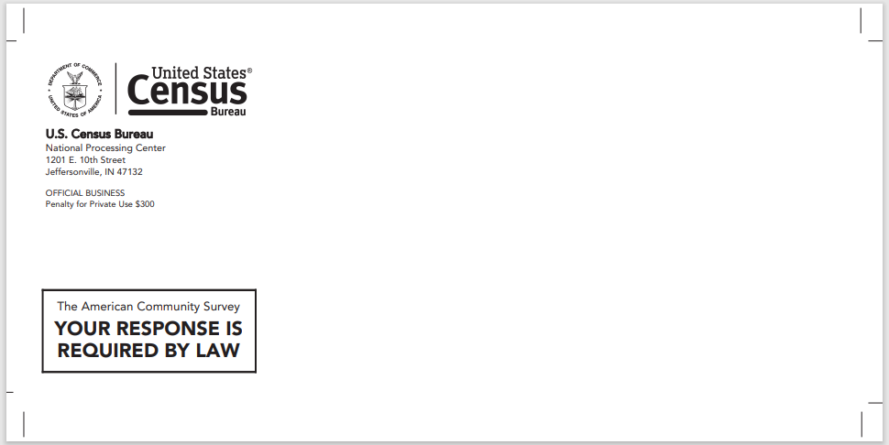

*Back*

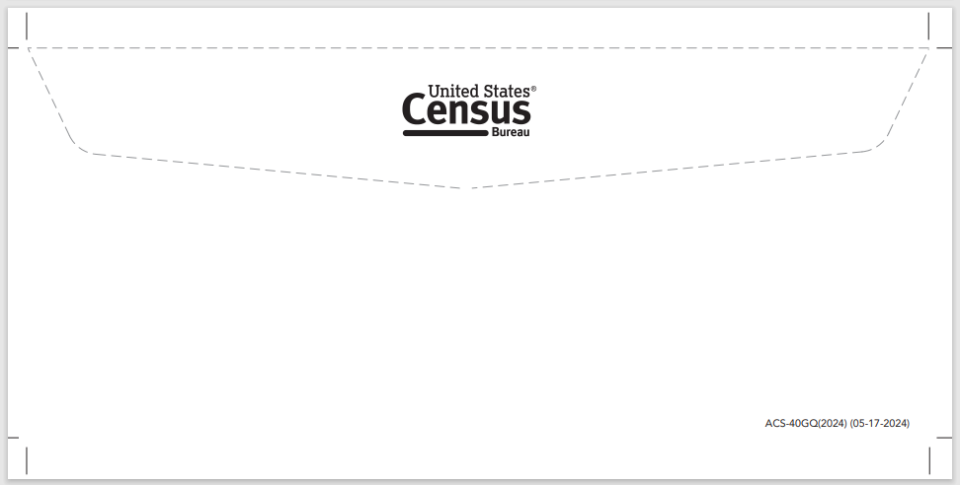

**Attachment C - ACS-50 Group Quarters Facility Administrators FAQ Brochure – Remote Alaska**

*Outside*

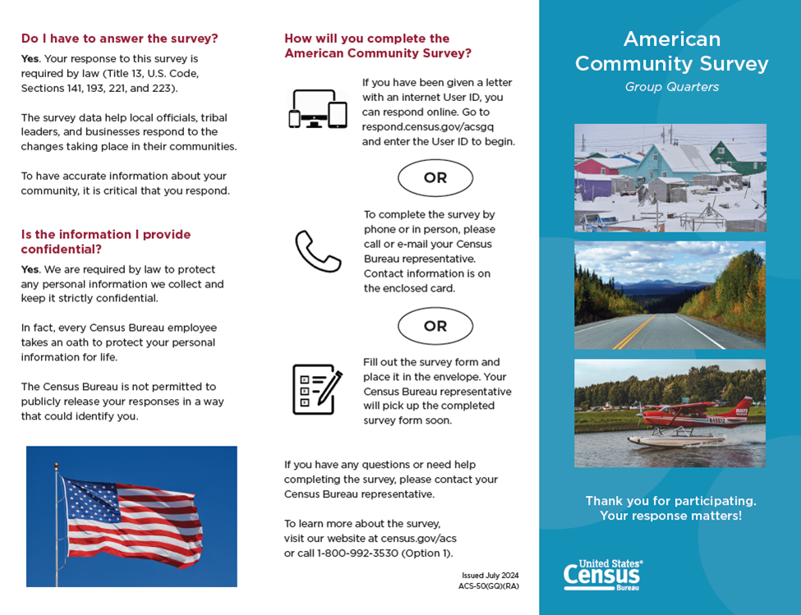

**Attachment C - ACS-50 Group Quarters Facility Administrators FAQ Brochure – Remote Alaska**

*Inside*

