**OMB Control Number 0651-0080**

**Expiration Date: XX/XX/XXXX**

**System Usability Scale**

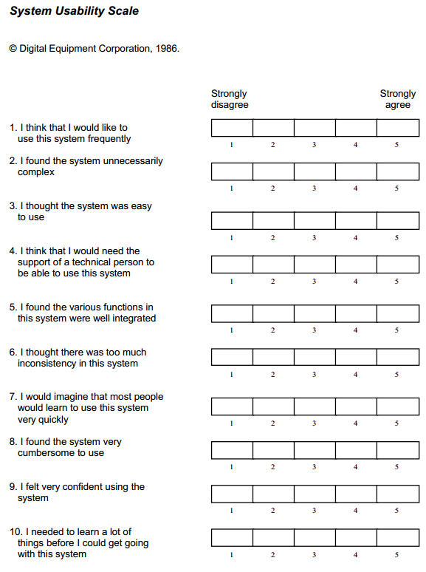

*Additional information, including scoring, may be retrieved from:* [*http://hell.meiert.org/core/pdf/sus.pdf*](http://hell.meiert.org/core/pdf/sus.pdf)

A Federal agency may not conduct or sponsor, and a person is not required to respond to, nor shall a person be subject to a penalty for failure to comply with an information collection subject to the requirements of the Paperwork Reduction Act of 1995, unless the information collection has a valid OMB Control Number. The OMB Control Number for this information collection is 0651-0080. Public burden for this usability testing is estimated to average 2 hours per response, including the time for reviewing instructions, searching existing data sources, gathering and maintaining the data needed, and completing and reviewing the information collection. Send comments regarding this burden estimate or any other aspect of this information collection, including suggestions for reducing this burden to the Office of the Chief Administrative Officer, United States Patent and Trademark Office, P.O. Box 1450, Alexandria, VA 22313-1450 or email [InformationCollection@uspto.gov](mailto:InformationCollection@uspto.gov).