A Federal agency may not conduct or sponsor, and a person is not required to respond to, nor shall a person be subject to a penalty for failure to comply with an information collection subject to the requirements of the Paperwork Reduction Act of 1995, unless the information collection has a valid OMB Control Number. The OMB Control Number for this information collection is 0651-0080. Public burden for this survey is estimated to average 10 minutes per response, including the time for reviewing instructions, searching existing data sources, gathering and maintaining the data needed, and completing and reviewing the information collection. Send comments regarding this burden estimate or any other aspect of this information collection, including suggestions for reducing this burden to the Office of the Chief Administrative Officer, United States Patent and Trademark Office, P.O. Box 1450, Alexandria, VA 22313-1450 or email InformationCollection@uspto.gov.

Introduction:
The IP5 Statistics Report contains patenting activities and recent developments at the IP5 Offices, namely the European Patent Office (EPO), the Japan Patent Office (JPO), the Korean Intellectual Property Office (KIPO), the China National Intellectual Property Administration (CNIPA), and the United States Patent and Trademark Office (USPTO). The goal of this survey is to learn more about the IP5 Statistics Report readers, their use of the information presented in the report and its annexes, and to identify possible improvements to better match reader needs. The survey should take less than 10 minutes to complete.
1. Demographics section:
- My primary affiliation is the following:
  - Government agency
  - University or college
  - Research Organization or individual researcher
  - Law firm or practitioner (not corporate)
  - Industry group
  - Business or corporation (excluding small business)
  - Independent inventor or small business
  - Other (specify)
- If they answer b or c, ask: My research focus is the following:
  - Science
  - Technology
  - Economics/Trade
  - Legal
  - Other (specify)
- I currently reside in the following country:
  - Open ended or drop down
- I most commonly interact with the following intellectual property office: (select all that apply)
  - European Patent Office (EPO)
  - Japan Patent Office (JPO)
  - Korean Intellectual Property Office (KIPO)
  - China National Intellectual Property Administration (CNIPA)
  - United States Patent and Trademark Office (USPTO)
  - World Intellectual Property Organization (WIPO)
  - National Patent Offices in Europe (specify)
  - None of the above
  - Other (Please specify)
  - NA
- I most commonly file patent applications at the following office first:
  - EPO
  - JPO
  - KIPO
  - CNIPA
  - USPTO
  - WIPO (PCT)
  - National Patent Offices in Europe (specify)
  - Other (specify)
  - NA
- I am interested in obtaining information from the current report about the following offices: (select all that apply)
  - EPO
  - JPO
  - KIPO
  - CNIPA
  - USPTO
  - WIPO
  - National Patent Offices in Europe
- I found out about the availability of the IP5 Statistics Report from the following:
  - Internet search
  - Note and/or link on an IP5 office website
  - Report was referenced in an article/blog/etc.
  - Communication from an IP5 office (e.g., email, etc.)
  - Aware of report from past usage
  - Notified by a colleague
  - Other (specify)
- How often do I read/consult the IP5 Statistics Report?
  - This is my first time reading any IP5 Statistics Report
  - I read the report once a year
  - I consult the report multiple times per year
  - Other (specify)
2. Section on interest from the IP5 SR:
- I consult the IP5 Statistics Report for the following reason(s): (Check all that apply)
- The IP5 Statistics Report is of general interest to me
- As a general assessment of IP activity as a whole
- To create analyses, talking points, create own report
- To compare IP activity with other economic information for some region or regions
- To find statistical input for academic research
- To obtain statistics about a specific office
- To make assessments about the performance of each office
- To compare the various offices against each other
- To better inform filing strategies (e.g., forecasting/predicting the timing of events around patent applications in some regions, etc.)
- Other (specify)
- Of the above list, the most important reason for consulting the IP5 Statistics Report was:
  - Drop down list

3. Section on Report Understanding:
- I reference the following chapters from the report: (Select all that apply)
  - Chapter 1: Introduction
  - Chapter 2: The IP5 Offices
  - Chapter 3: Worldwide Patenting Activity
  - Chapter 4: Patent Activity at the IP5 Offices
  - Chapter 5: The IP5 Offices and the Patent Cooperation Treaty (PCT)
  - Chapter 6: Other Work
  - Annexes
- Of the chapters I referenced in the report, I had a difficult time understanding information from the following: (Strongly Agree to Strongly Disagree)
  - Chapter 1: Introduction
  - Chapter 2: The IP5 Offices
  - Chapter 3: Worldwide Patenting Activity
  - Chapter 4: Patent Activity at the IP5 Offices
  - Chapter 5: The IP5 Offices and the Patent Cooperation Treaty (PCT)
  - Chapter 6: Other Work
  - Annexes
  - None
- I had a difficult time understanding the metrics relating to the following as provided in the IP5 Statistics Report: (Strongly Agree to Strongly Disagree)
  - Quality metrics (e.g., allowance rates, appeal rates, etc.)
  - Pendency metrics (Pendency for First Office Action (FA) or Final Office Action, etc.)
  - Cross Filings
  - Filing trends
  - Inter-bloc activity
  - Patent families
  - Sectors and fields of technology
  - Maintenance on granted patents
  - Examination rates
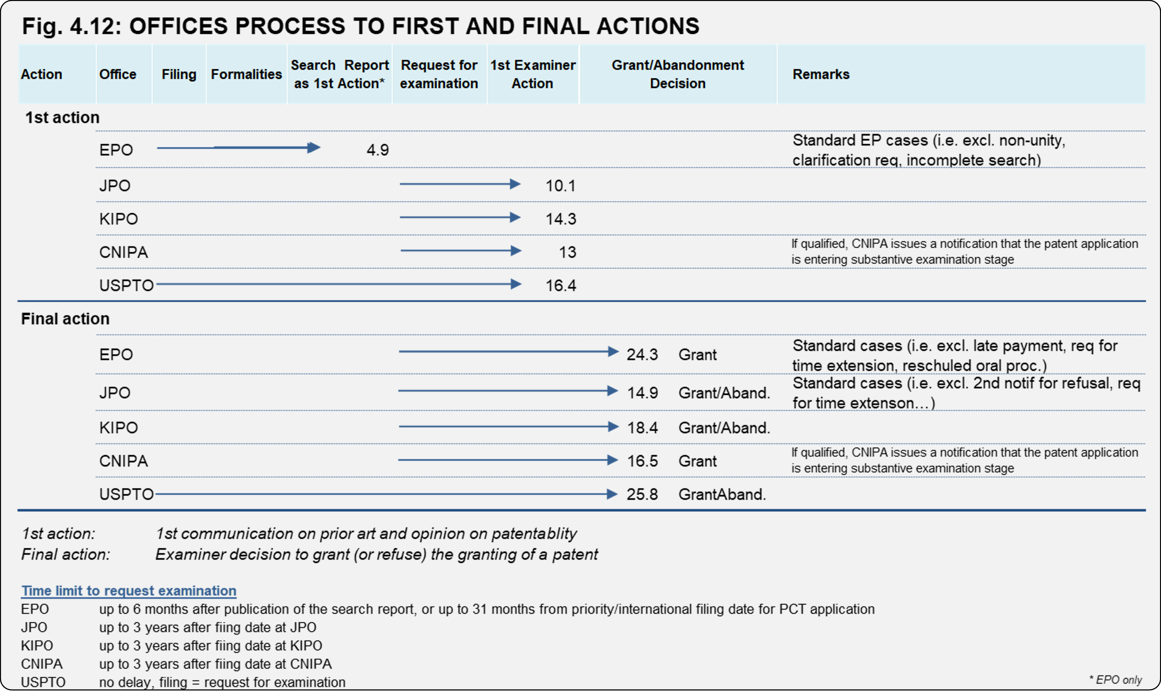
For questions 4 and 5, please refer to the image above from chapter 4 of the report.
- At each IP5 Office, it is clear how long it will take on average to reach the following: (Matrix style question: along the columns would be the offices: EPO, JPO, KIPO, CNIPA, USPTO. Select all that apply)
  - An initial opinion on patentability for a patent application
  - A final opinion on patentability that results in either the grant of a patent or the abandonment/withdrawal/refusal of a patent application
- To understand how long the patent process takes, it would be helpful (e.g., for the purpose of forecasting/predicting the timing of events around patent applications in various regions) if the following metrics were shared from each of the IP5 offices: (grid question format, check boxes for each office (EPO, JPO, KIPO, CNIPA, USPTO) and check all that apply)
  - Average time between filing and first examiner action
  - Average time between filing and final decision
  - Average time between filing and request for examination
  - Average time between request for examination and first action
  - Average time between request for examination and final decision
  - Patent Term Adjustment (PTA) Compliance rate
  - Others (specify)
4. Customer Experience:
- Upon consulting the IP5 Statistics Report:
  - I found what I was looking for
  - I downloaded data from the statistical annex on the IP5 Statistics webpage
  - My filing strategy was influenced
  - I was able to provide well-informed information to a client
- Please provide additional feedback on how the IP5 Statistics Report could be improved. What do you appreciate most about the report? Are important topics missing? What do you consider superfluous?

