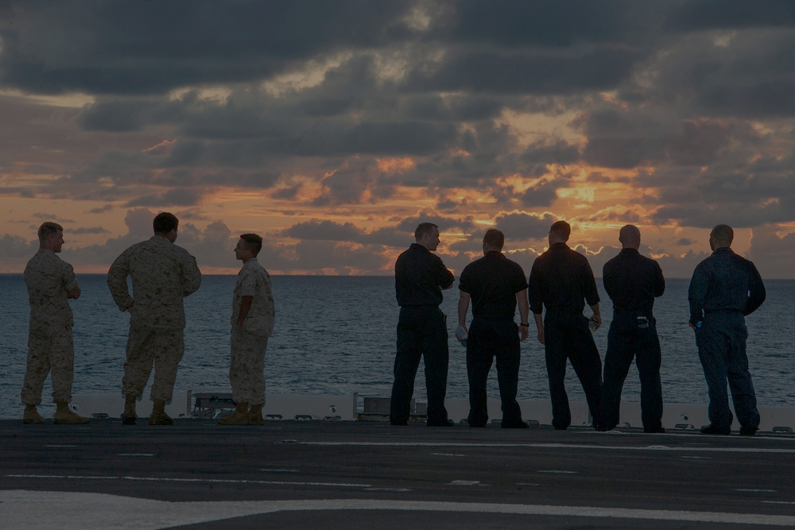

**THE NAVAL HEALTH RESEARCH CENTER IS CONDUCTING A STUDY ON MEN’S HELP-SEEKING EXPERIENCES DURING MILITARY SERVICE**

If you are a male active duty sailor, you may be eligible to participate!

**Participation involves completing a confidential**

**60-minute phone interview.**

**Volunteers will receive a $40**

**Amazon gift card for their time.**

**If you have questions or would like to learn more about this research,**

**please reach us at mosaicstudy@health.mil**

Study Coordinator: [lauren.m.hurtado2.ctr@health.mil](mailto:lauren.m.hurtado2.ctr@health.mil) Study Principal Investigator: [kristen.h.walter.civ@health.mil](mailto:kristen.h.walter.civ@health.mil)

Please use this QR code to see if you are eligible and to sign up for the study!

**LOOKING FOR RESEARCH PARTICIPANTS**