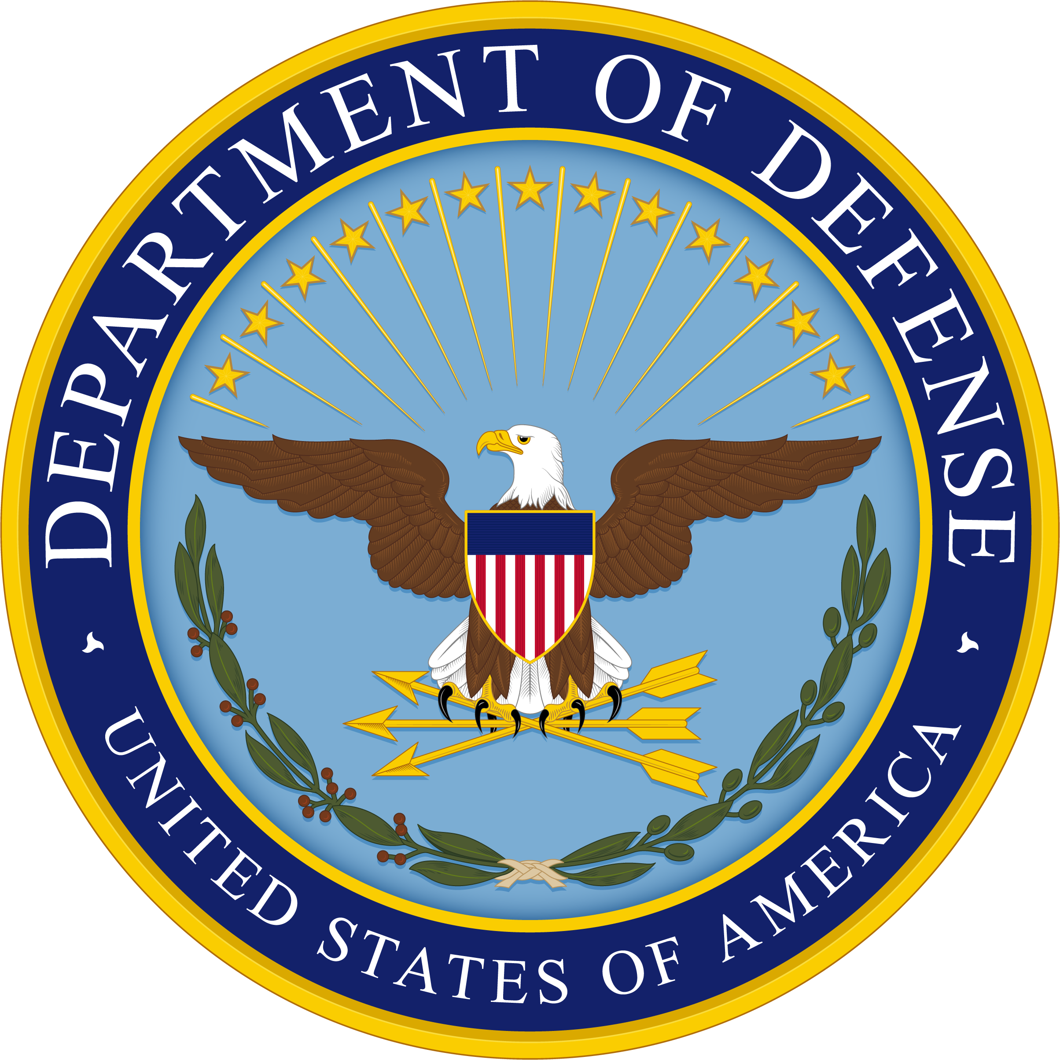
2024 DoD Patient Safety Culture Survey
LEADERSHIP FACT SHEET

DHA and MTF leadership play an integral role in promoting survey participation as response rates increase when leaders communicate the survey’s importance. Your endorsement and support are crucial to the success of the survey, the validity of the results, and the usefulness of the data for patient safety improvements.
Background
Information

Survey Objective | Assess the culture of patient safety, including workforce burnout, within DHA (Direct Care) facilities worldwide
Survey Sponsor | Department of Defense Patient Safety Program
Survey History | Conducted within the DHA in 2005-2006, 2008, 2011, 2016, 2019, and 2022; Developed by the Agency for Healthcare Research and Quality (AHRQ). All staff working in ambulatory clinics will take the AHRQ medical office survey and all staff working in a hospital setting will take the AHRQ 2.0 hospital survey.
Target Audience | Staff at all DHA facilities worldwide working in DHA hospitals, outpatient medical clinics, and dental facilities  - Clinical and house staff (including interns, residents, fellows)  - Non-clinical staff  - Active duty and reservist military  - Civilian GS employees, contractors, and volunteers
Survey Topics
Survey Topics
- Organizational learning/Staff training
- Patient tracking/Handoffs/Information
exchange
- Teamwork
- Reporting PS events
- Staff burnout and well-being
- Staffing/Work pace and pressures

- Communication about error
- Communication openness
- Leadership/Management support for patient safety
- Leadership support for well-being
- Processes and standardization
- Other areas including space for open-ended comments
Survey results will be provided at overall DHA, Network, and MTF levels (if at least 5 responses are received from MTFs, for anonymity) and will:
Survey Results
- Identify actionable strengths and improvement areas across DHA
- Provide comparisons across work areas, staff positions, and facilities
- Provide comparisons and changes in the culture of patient safety and burnout rates
- Benchmark against AHRQ measures
- Assist facilities to meet TJC accreditation standards and establish safe practices assessed by Leapfrog surveys
Survey
Deployment
Method | E-mail notification containing a link to the survey web page
Completion Time | Approximately 10 minutes
Confidentiality | Survey is anonymous and voluntary. Individual responses will not be tracked, and only aggregated statistics will be reported.
Survey Timeline
Spring 2024 | MTF leadership announce survey throughout chain of command
June - July 2024 | Beta testing of survey website to resolve any access issues
August 2024 | Respondents receive email notifying them of survey
Summer 2025 | Survey results available
Contacts
MTF Point of Contact | [Name], [Email], [Phone]
Leadership Point of Contact | [Name], [Email], [Phone]
Patient Safety Website https://www.health.mil/Military-Health-Topics/Access-Cost-Quality-and-Safety/Quality-And-Safety-of-Healthcare/Patient-Safety/Patient-Safety-Culture-Survey

