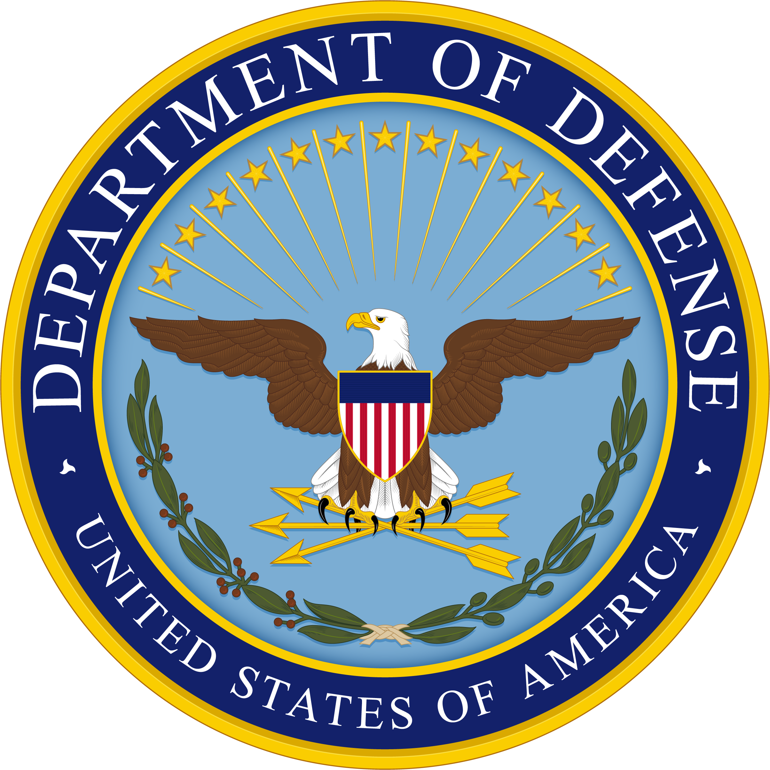
2024 DoD PATIENT SAFETY
CULTURE SURVEY

Your voice matters
Please take 10 minutes for patient safety

Who | Staff at all DHA military medical facilities worldwide
What | - Voluntary and anonymous web-based survey about patient safety and staff well-being at your facility  - Sponsored by the Department of Defense Patient Safety Program
Why | - To learn from staff perceptions  - To assess the culture of patient safety within military medical treatment facilities worldwide  - To assess staff burnout, wellbeing, and other factors impacting patient safety  - To identify strengths and actionable improvement areas  - Assist your facility meet TJC accreditation standards and establish safe practices assessed by Leapfrog surveys
When | August 2024
How | Staff will be notified through e-mail and provided a hyperlink to the survey

For additional details, please contact the MTF Point of Contact [NAME] [PHONE NUMBER] [EMAIL ADDRESS].

https://www.health.mil/Military-Health-Topics/Access-Cost-Quality-and-Safety/Quality-And-Safety-of-Healthcare/Patient-Safety/Patient-Safety-Culture-Survey

