**TO:** CDRH New, CDRH Industry, In Vitro Diagnostics, CDRH Science, Radiological Health Program, Laser, CDRH Premarket Online

**SUBJECT:** FDA to accept FY 2025 Small Business Determination requests online (65/65 characters max)

**PREHEADER:** Beginning xxx, 2024, the Small Business Determination (SBD) Program will transition to electronic submissions to help improve efficiency. (140/140 characters max)

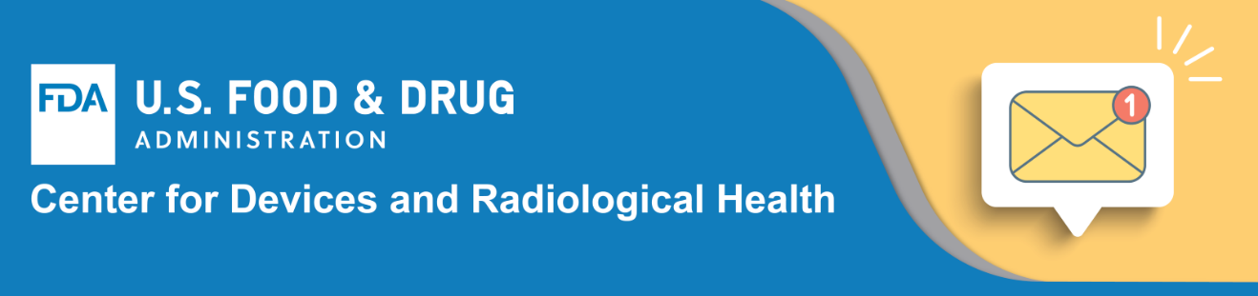

**New Electronic Submission Process Will Make It Easier to Submit and Track Fiscal Year 2025 and Future Small Business Determination Requests**

Are you a domestic or foreign business seeking to qualify as a small business? If so, the application process is getting easier.

Starting on xxx, 2024, the U.S. Food and Drug Administration’s (FDA) Center for Devices and Radiological Health (CDRH) will only accept FY 2025 and future Small Business Determination (SBD) requests (Form 3602 and Form 3602A, and other related documents) electronically through [CDRH’s Customer Collaboration Portal](https://www.fda.gov/medical-devices/industry-medical-devices/send-and-track-medical-device-premarket-submissions-online-cdrh-portal), commonly referred to as the CDRH Portal. The transition to an electronic submission system streamlines the SBD application process and provides submitters with a real-time review status.

The SBD Program’s transition to accepting electronic submissions is an example of how CDRH is using technology to enhance efficiency and transparency in reviewing industry submissions while also continuing to fulfill commitments outlined in the Medical Device User Fee Amendments 2022 (MDUFA V).

**Learn about the SBD Program**

**Access the CDRH Portal**

**Questions?**

Please contact the [Division of Industry and Consumer Education](https://www.fda.gov/medical-devices/device-advice-comprehensive-regulatory-assistance/contact-us-division-industry-and-consumer-education-dice).



U.S. Food and Drug Administration  
10903 New Hampshire Avenue, Silver Spring, MD 20993  
1-888-INFO-FDA (1-888-463-6332)  
[Privacy Policy](https://www.fda.gov/AboutFDA/AboutThisWebsite/WebsitePolicies/default.htm?utm_campaign=Alcon%20CyPass%20Micro-Stent%20Safety%20Communication&utm_medium=email&utm_source=Eloqua&elqTrackId=97465b0f8e0047fa991a1d069a1619aa&elq=1435abe63e974b239a45b81698f951fb&elqaid=5095&elqat=1&elqCampaignId=4070#privacy) | [www.fda.gov](https://www.fda.gov/?utm_campaign=Alcon%20CyPass%20Micro-Stent%20Safety%20Communication&utm_medium=email&utm_source=Eloqua&elqTrackId=23294b99d9404d5b81de0b3a0999c2af&elq=1435abe63e974b239a45b81698f951fb&elqaid=5095&elqat=1&elqCampaignId=4070)  
[Manage Preferences or Unsubscribe from this List](http://go.fda.gov/SubscriptionManagement?utm_campaign=Alcon%20CyPass%20Micro-Stent%20Safety%20Communication&utm_medium=email&utm_source=Eloqua&elqTrackId=9d380944364b4855b9f03bb296655905&elq=1435abe63e974b239a45b81698f951fb&elqaid=5095&elqat=1&elqCampaignId=4070) | [Unsubscribe from all Email Lists](http://app.info.fda.gov/e/u?s=2027422842&elq=1435abe63e974b239a45b81698f951fb)

**Social Media for This Rollout**

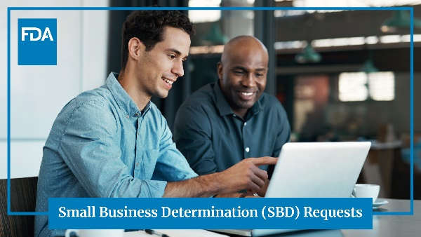**ALT Text:** Two men are discussing what is on a computer screen during a business meeting.

**X (formerly Twitter)   
Main post: 179/280 characters, plus link**

Get ready. Starting xxx, 2024, businesses will be able to submit their FY 2025 and any future Small Business Determination (SBD) requests electronically. Learn more about the new process: [Insert link here]

**Thread:** **274/280 characters**

The new online SBD submission process aims to enhance efficiency and transparency in reviewing certification requests, and fulfills commitments outlined in the Medical Device User Fee Amendments 2022 (MDUFA V).

**LinkedIn**

Are you a domestic or foreign business seeking to submit a small business certification application? If so, beginning xxx, 2024, check out our new electronic submission process for FY 2025 Small Business Determination (SBD) requests. Launched by our Center for Devices and Radiological Health (CDRH), the new submission process replaces the current paper-based process, for FY 2025 and forward, and allows businesses to track their SBD requests online. The new electronic process aims to enhance efficiency and transparency in reviewing certification applications, and it fulfills commitments outlined in the Medical Device User Fee Amendments 2022 (MDUFA V). Learn more: [Insert link here]