OMB control number: 0938-1415 Expiration Date: XX/XX/20XX

ECP Screenshots

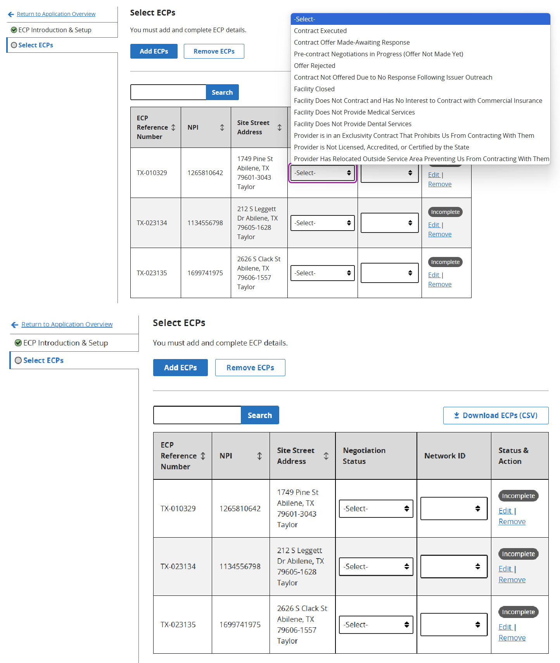

According to the Paperwork Reduction Act of 1995, no persons are required to respond to a collection of information unless it displays a valid OMB control number. The valid OMB control number for this information collection is 0938-1415. This information collection requires QHP issuers, including SADP issuers, to ensure access to a sufficient number and geographic distribution of essential community providers (ECPs), where available, that serve predominantly low-income, medically underserved individuals. The time required to complete this information collection is estimated to average less than 1,458 hours per response, including the time to review instructions, search existing data resources, gather the data needed, to review and complete the information collection. This information collection is mandatory under 2702(c) of the Public Health Service Act and will be kept private in accordance with regulations at 45 CFR 155.260, Privacy and Security of Personally Identiﬁable Information. If you have comments concerning the accuracy of the time estimate(s) or suggestions for improving this form, please write to: CMS, 7500 Security Boulevard, Attn: PRA Reports Clearance Officer, Mail Stop C4-26-05, Baltimore, Maryland 21244-1850 and [Elizabeth.Hechtman@cms.hhs.gov,](mailto:Elizabeth.Hechtman@cms.hhs.gov) Attention: Information Collections Clearance Officer.



**Edit Details: TX-010329**

**GIIID**

**ECP Details**

ECP Reference Number TX-010329

National Provider Identifier (NPI)

1265810642

Provider Site Name

Abilene Community Health Center

Organization Name

TEXASTECH UNIVERSITY HEALTH SCIENCES CENTER

Site Street Address 1749 Pine St

Abilene, TX 79601-3043 Taylor

ECP Categories

* Federally Qualified Health Centers - Medical Services

**Provider contract Details**

All fields are required.

Negotiation Status

Once you select a negotiation status, addition.al required fields will display.

I-Select-

Network ID

Save

Save and Duplicate

Cancel

**Edit Details: TX-010329**

■IIIUl::iW

**ECP Details**

**ECP Reference Number**

TX-010329

**National Provider Identifier (NP[)**

1265810642

**Provider Site Name**

Abilene Community Health Center

Organization Name

TEXASTECH UNIVERSITYHEALTH

Contract Executed

Contract Offer Made-Awaiting Response

Pre-contract Negotiations in Progress (Offer Not Made Yet) Offer Rejected

Contract Not Offered Due to No Response Following Issuer Outreach Facility Closed

Facility Does Not Contract and Has No Interest to Contract with Commercial Insurance Facility Does Not Provide Medical ServJCes

Facility Does Not Provide Dental Services

Provider IS in an Exclusivity Contract That Prohibit5 Us From Contracting With Them Provider IS Not Licensed, Accredited, or Certified by the State

I Select

Provider Has Relocated Outside ServJCe Area Preventing Us From Contracting With Them

II

**Network** ID

**Save**

**Save and Duplicate**

**Cancel**