**Post-Release Services (PRS) Referral (Form S-19)**

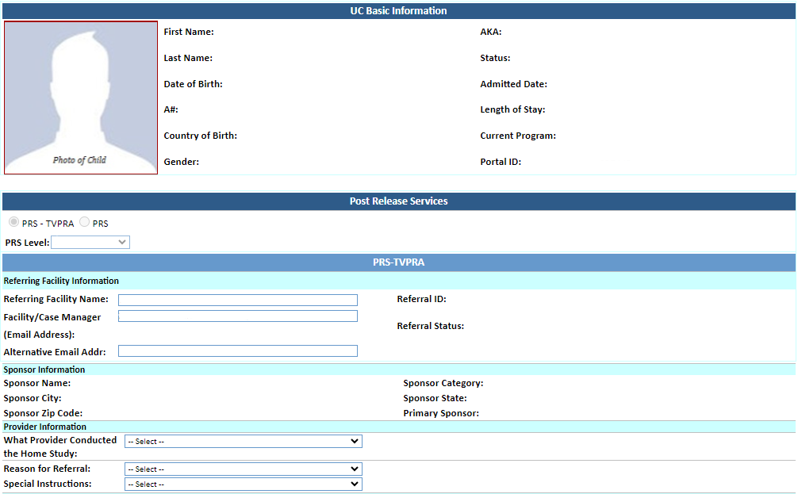

auto-populated

system-generated

system-generated

system-generated

* Level 1
* Level 2
* Level 3

auto-populated

auto-populated

auto-populated

auto-populated

auto-populated

auto-populated

auto-populated

auto-populated

***Populates when “PRS-TVPRA” is selected***

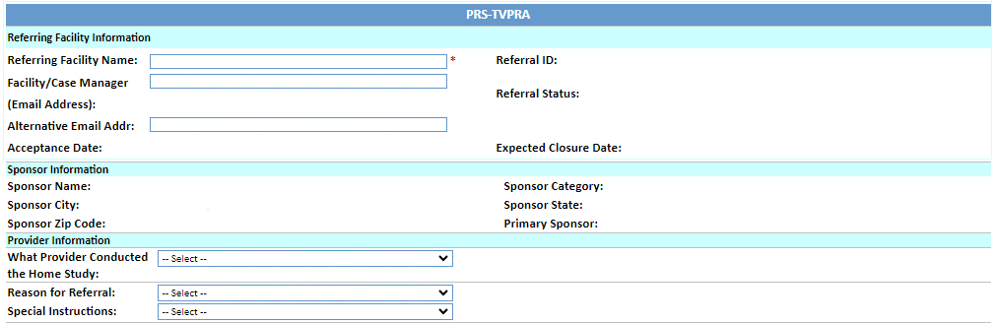

auto-populated

auto-populated

auto-populated

auto-populated

auto-populated

auto-populated

auto-populated

auto-populated

system-generated

system-generated

system-generated

system-generated

* Victims of Trafficking (TVPRA)
* American Disability Act (TVPRA)
* Physical or Sexual Abuse by Caregiver (TVPRA)
* Sponsor Risk (TVPRA)
* 12 and Under Going to Non-Relative Sponsor (ORR Mandated)
* Non-Relative Sponsor Multiple Sponsorship (ORR Mandated)
* ORR Discretionary
* RTC Placement
* Medically Fragile
* Pregnant
* Parenting
* Tender Age
* Sibling Group
* Related

List of all home study providers

***Populates when “PRS” is selected***

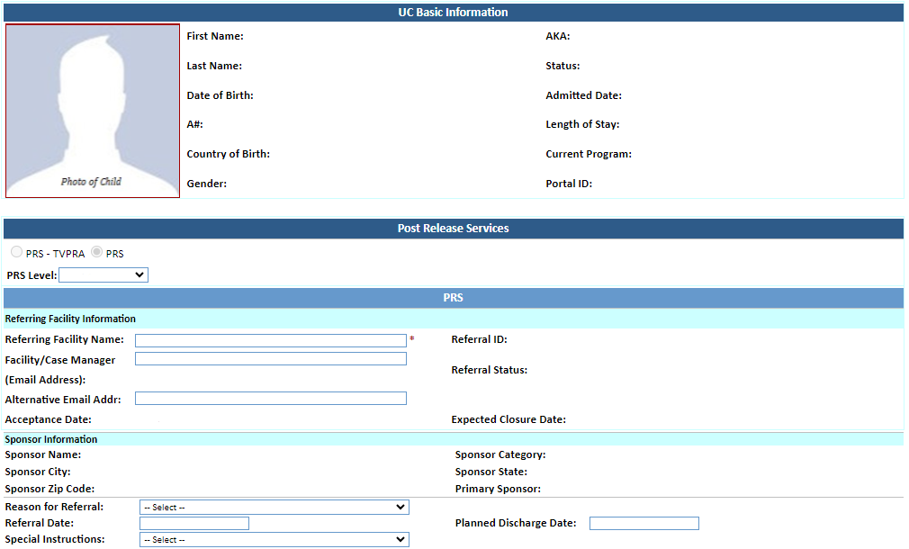

auto-populated

auto-populated

system-generated

system-generated

system-generated

* 12 and Under Going to Non-Relative Sponsor - ORR Mandated Home Study
* Non-Relative Sponsor Multiple Sponsorship - ORR Mandated Home Study
* ORR Discretionary Home Study
* UC Going to Non-Relative Sponsor - ORR Mandated No Home Study
* Other - No Home Study

system-generated

* RTC Placement
* Medically Fragile
* Pregnant
* Parenting
* Tender Age
* Sibling Group
* Related

***Populates when either “PRS-TVPRA” or “PRS” is selected***

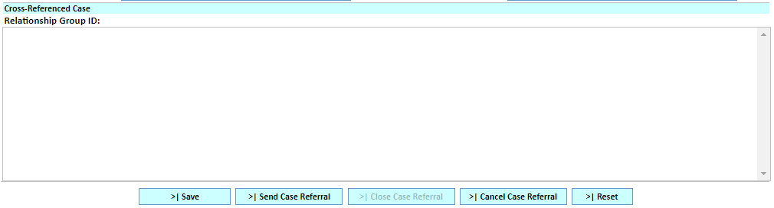

system-generated



