**Home Study (HS) Referral (Form S-26)**

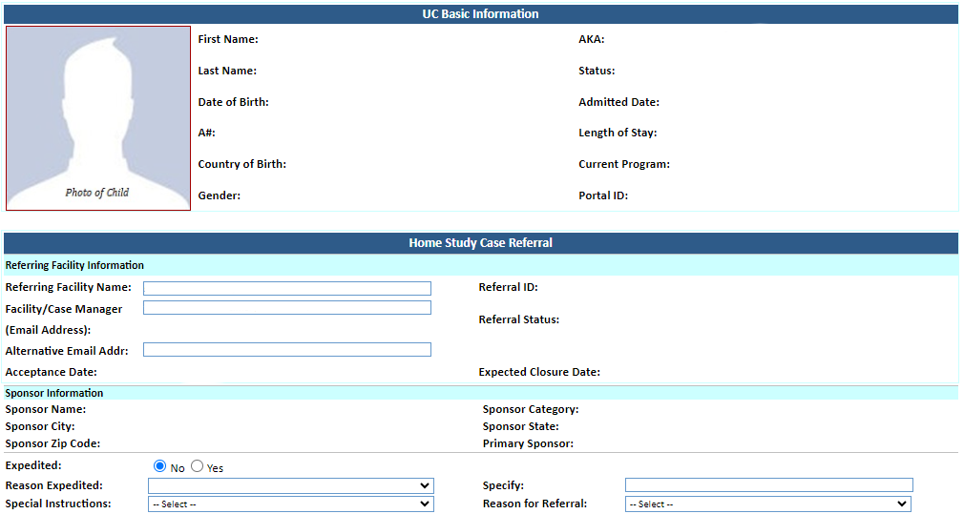

system-generated

system-generated

system-generated

system-generated

auto-populated

auto-populated

system-generated

system-generated

* Victims of Trafficking (TVPRA)
* American Disability Act (TVPRA)
* Physical or Sexual Abuse by Caregiver (TVPRA)
* Sponsor Risk (TVPRA)
* 12 and Under Going to Non-Relative Sponsor (ORR Mandated)
* Non-Relative Sponsor Multiple Sponsorship (ORR Mandated)
* ORR Discretionary
* RTC Placement
* Medically Fragile
* Pregnant
* Parenting
* Tender Age
* Sibling Group
* Related
* High Length of Care
* Age Out
* Other

system-generated

auto-populated

auto-populated

auto-populated

auto-populated

auto-populated

auto-populated

auto-populated

auto-populated

auto-populated

auto-populated

auto-populated

auto-populated

auto-populated

auto-populated

auto-populated

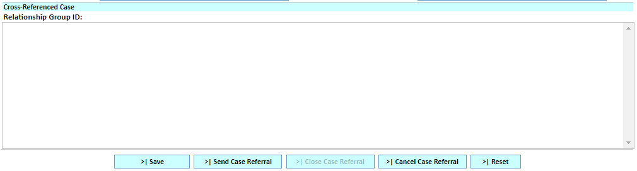

system-generated



