Home Study (HS) Referral (Form S-26)

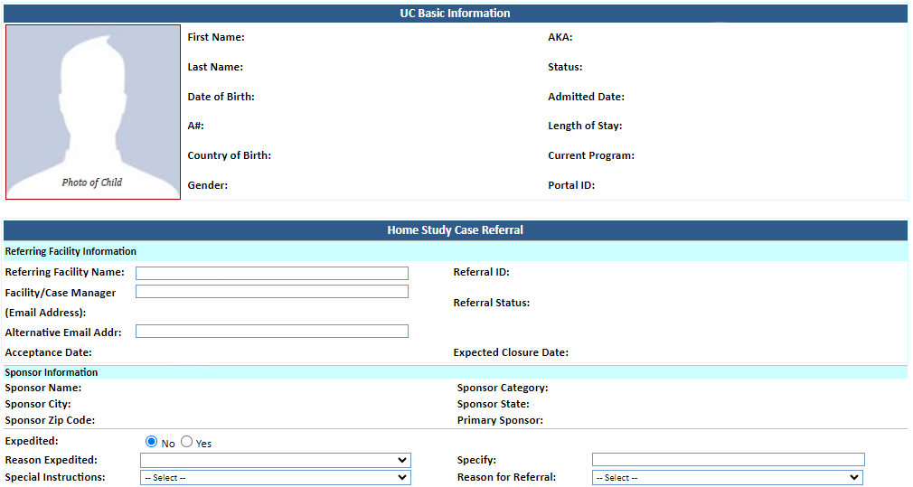
system-generated
system-generated
system-generated
system-generated
auto-populated
auto-populated
system-generated
system-generated
- Victims of Trafficking (TVPRA)
- American Disability Act (TVPRA)
- Physical or Sexual Abuse by Caregiver (TVPRA)
- Sponsor Risk (TVPRA)
- 12 and Under Going to Non-Relative Sponsor (ORR Mandated)
- Non-Relative Sponsor Multiple Sponsorship (ORR Mandated)
- ORR Discretionary
- RTC Placement
- Medically Fragile
- Pregnant
- Parenting
- Tender Age
- Sibling Group
- Related
- High Length of Care
- Age Out
- Other
system-generated
auto-populated
auto-populated
auto-populated
auto-populated
auto-populated
auto-populated
auto-populated
auto-populated
auto-populated
auto-populated
auto-populated
auto-populated
auto-populated
auto-populated
auto-populated
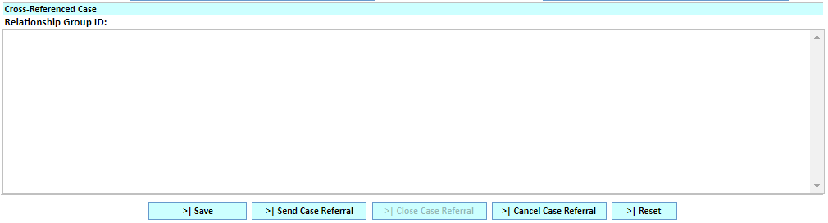
system-generated



