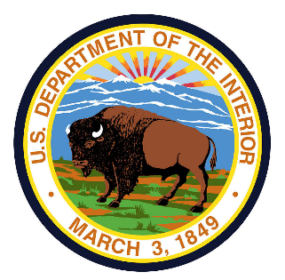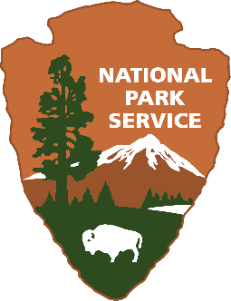**United States Department of the Interior**

**NATIONAL PARK SERVICE**

**1869 C Street, N.W.**

**Washington, DC 20240**

**[Season, Year]**

**Dear National Park Visitor:**

Thank you for participating in this study. Our goal is to learn about the expectations, opinions, and interests of visitors to the National Park System. This information will assist us in our efforts to better manage this park and to serve you.

The questionnaire is only being given to a select number of visitors, so your participation is very important. It should take about 20 minutes to complete after your visit.

When your trip is over, the same individual in your group who completed the onsite survey in the park should complete this follow-up questionnaire. Seal it in the postage-paid envelope provided and drop it in any U.S. Postal Service mailbox. You can also participate online by visiting the following website and entering your unique ID:

www.NPSsurvey.org/XXXX (Park Acronym)

Unique ID: 4-digit number found on the top right corner of your survey

If you have any questions, please contact the Social Science Program Manager, National Park Service, 1201 Oakridge Drive, Fort Collins, CO, 80525-5596; nps_nrss_social_science@nps.gov (email).

We appreciate your help.

**Sincerely,**

**The National Park Service**

**United States Department of the Interior**

**NATIONAL PARK SERVICE**

**1869 C Street, N.W.**

**Washington, DC 20240**

**[Season, Year]**

**Dear National Park Visitor:**

About a month ago, on your recent trip to one of the many National Park Service units, we asked you to participate in a visitor survey for the National Park Service. The National Park Service would like to thank you for agreeing to participate in this visitor study. We selected only a small number of visitors to participate in this study; therefore, the return of each questionnaire in the postage-paid envelope provided is very important. You may also participate by visiting the website below and entering the provided password. The information you provide will help us better manage the National Park Service, and better serve you, our visitor.

To participate online, visit the following website and enter your unique ID:

www.NPSsurvey.org/XXXX (Park Acronym)

ID: 4-digit number found on the top right corner of your survey

If you have any questions, please contact the Social Science Program Manager, National Park Service, 1201 Oakridge Drive, Fort Collins, CO, 80525-5596; nps_nrss_social_science@nps.gov (email).

Thank you for your help with this important study. Your opinions matter, and we appreciate you sharing them with us. They will help us improve the management of the National Park Service.

**Sincerely,**

**The National Park Service**

