The Electronic Code of Federal Regulations
Displaying title 29, up to date as of 8/20/2024. Title 29 was last amended 8/01/2024.
Nomenclature changes to part 1910 appear at 84 FR 21597, May 14, 2019. Appendix B-I to § 1910.1043—Respiratory Questionnaire
§1910.1043 Cotton Dust.

PAPERWORK REDUCTION ACT BURDEN DISCLOSURE STATEMENT
Under the cotton dust standard, this medical questionnaire must be administered to all employees who are exposed to cotton dust, and who will therefore be included in their employer's medical surveillance program. (29 CFR 1910.1043(h)(1)(i)). Under the Paperwork Reduction Act, a Federal agency generally cannot conduct or sponsor, and the public is generally not required to respond to, an information collection, unless it is approved by OMB and displays a valid OMB Control Number. Use of this questionnaire is mandatory. The questionnaire assists both physicians and employers to ensure that the physician obtains compliant employee medical documentation. OSHA estimates employer burden for the completion of this collection of information ranges from one hour and five minutes (1.08 hours) to one hour and thirty-five minutes (1.58 hours). This estimate includes the time for reviewing instructions, searching existing data sources, gathering and maintaining the data needed, and, completing and reviewing the collection of information. The time estimate includes employer time for compliance with the underlying information collection requirements in 29 CFR 1910.1043(h), including employee time for completion of the questionnaire and medical examination and providing information to the physician. The employer shall retain this record for at least 20 years. Send comments regarding this burden estimate or any other aspect of this collection of information, including suggestions for reducing this burden to OSHAPRA@dol.gov or to OSHA’s Directorate of Standards and Guidance, Department of Labor, Room N-3718, 200 Constitution Ave., NW, Washington, DC 20210; Attn: Paperwork Reduction Act Comment; 1218-0061. (This address is for comments regarding this form only; DO NOT SEND ANY COMPLETED SAMPLE FORM TO THIS OFFICE.)
OMB Control #1218-0061; Expires: 9-30-2024
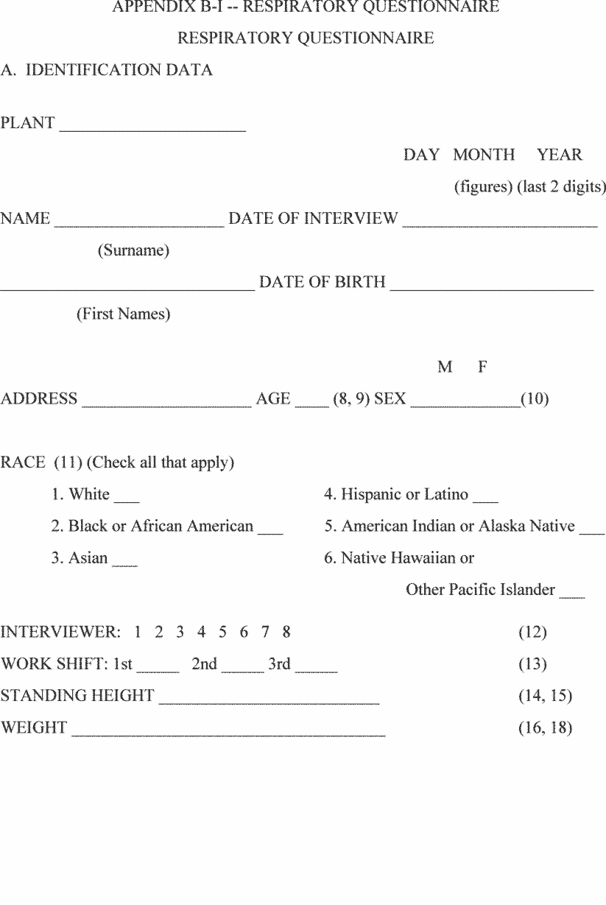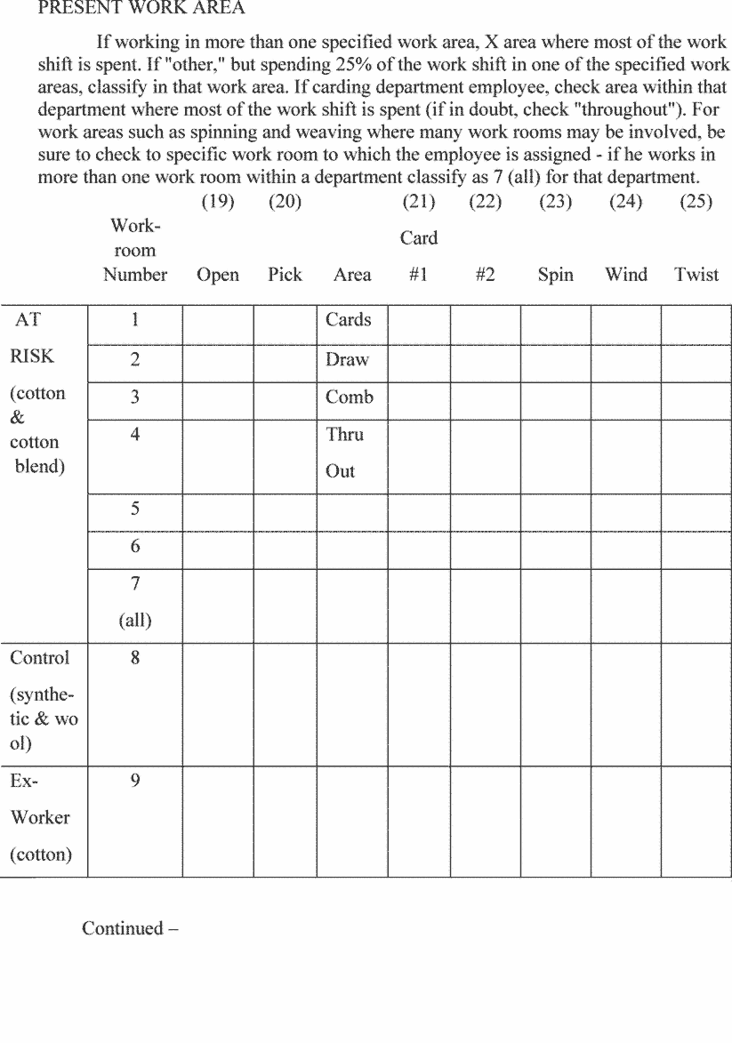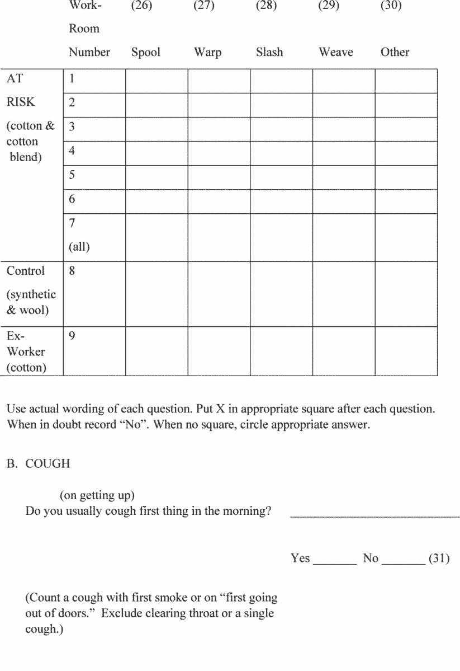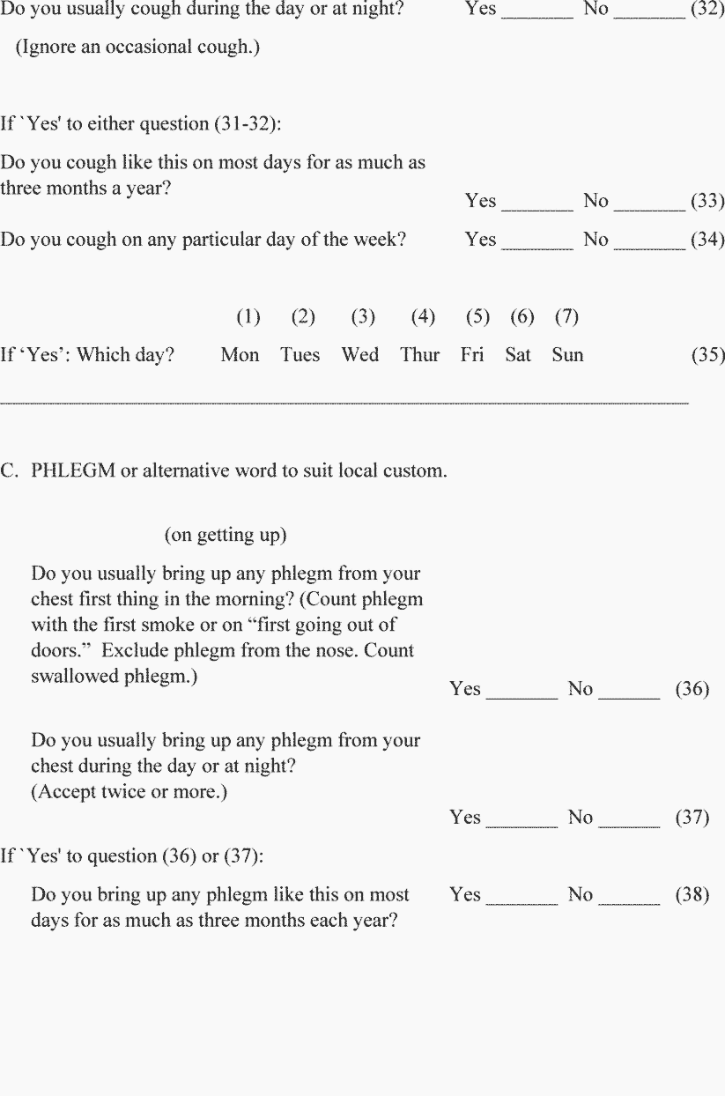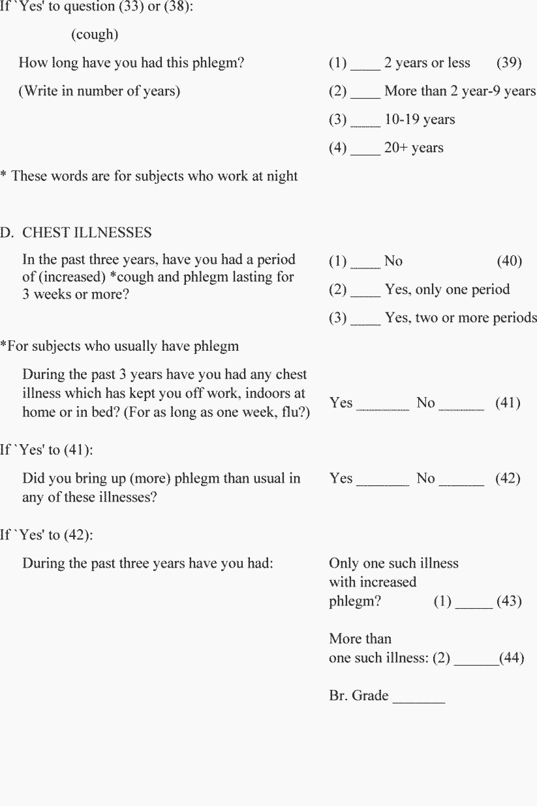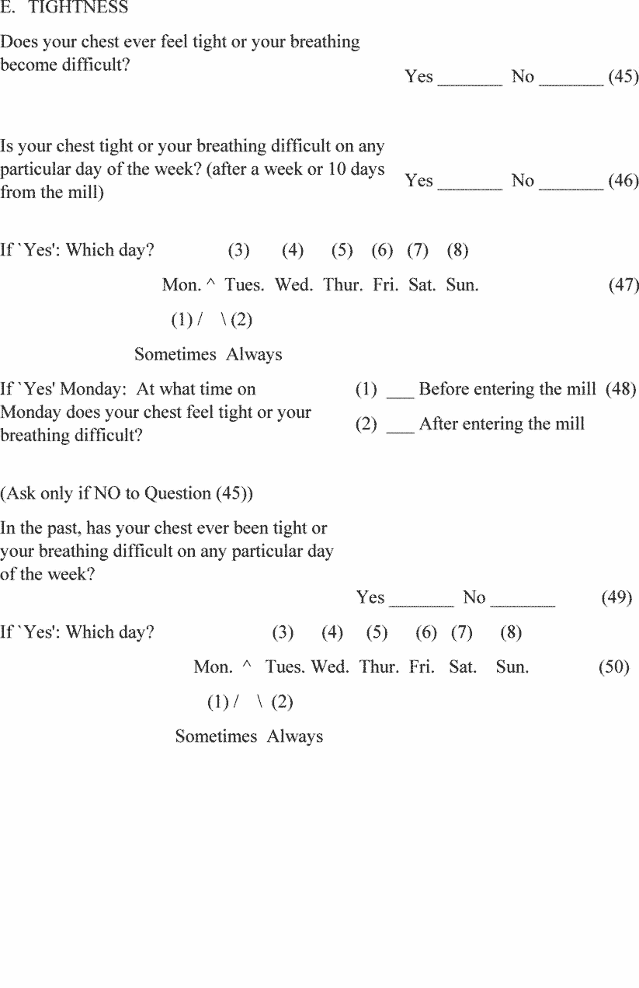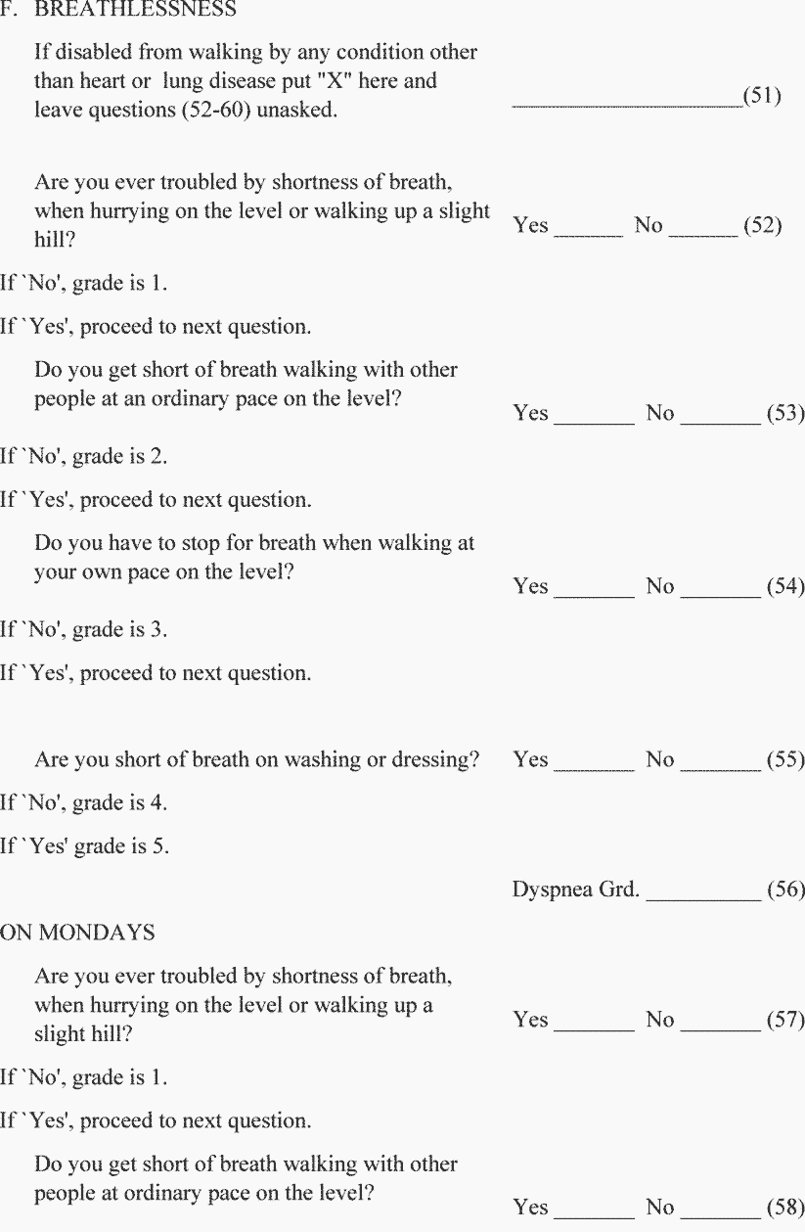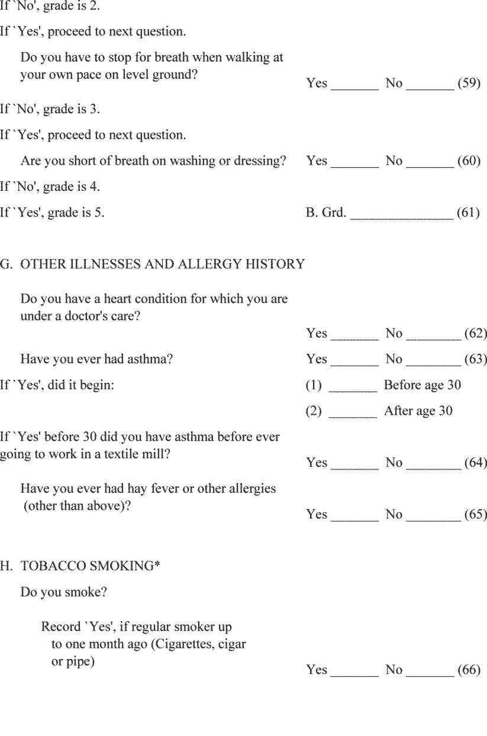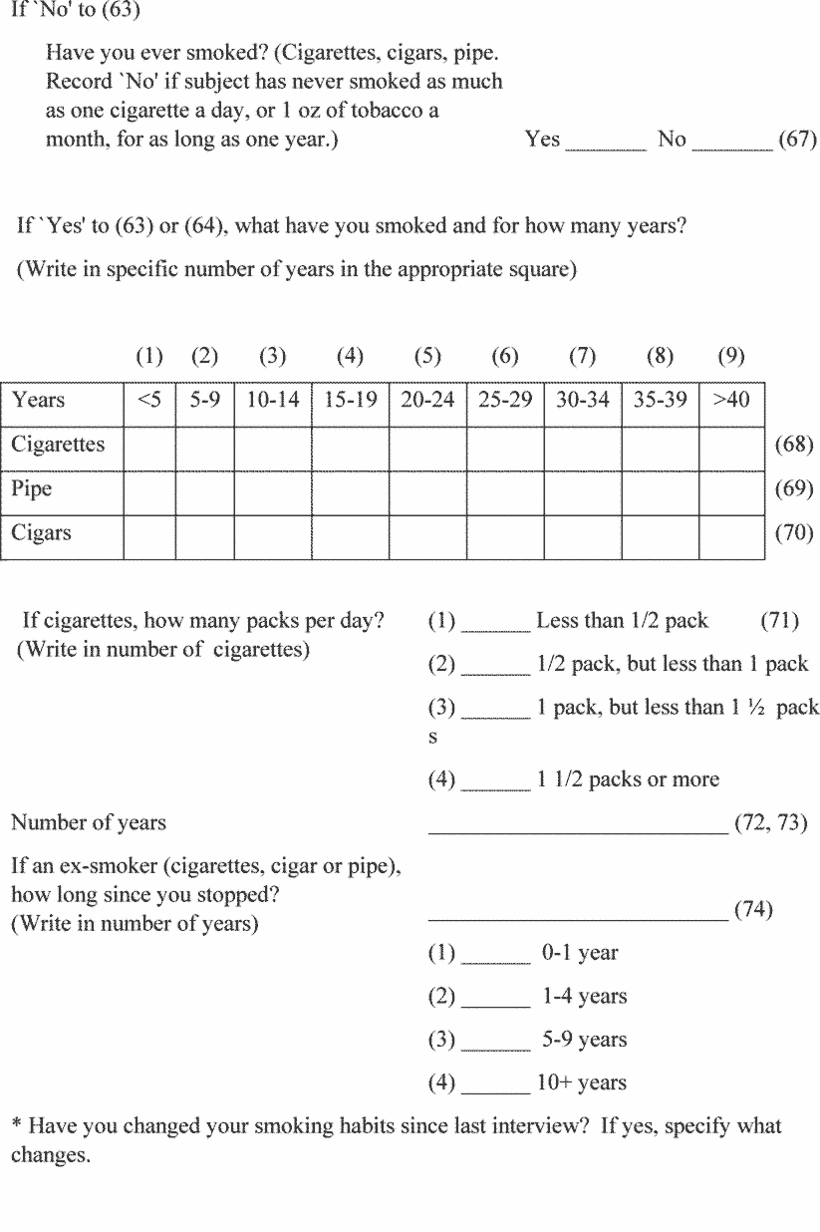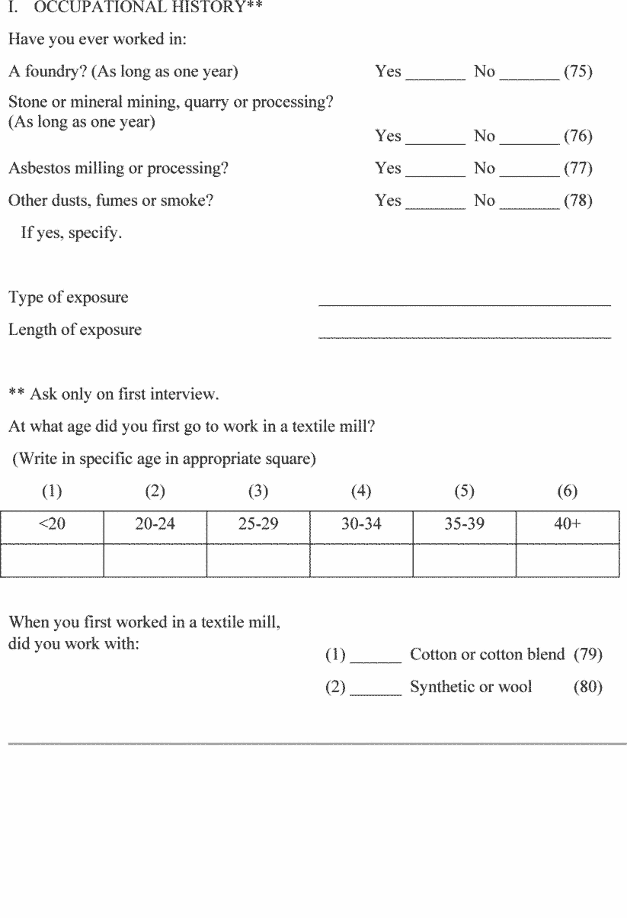
Appendix B-II to § 1910.1043—Respiratory Questionnaire for Non-Textile Workers for the Cotton Industry
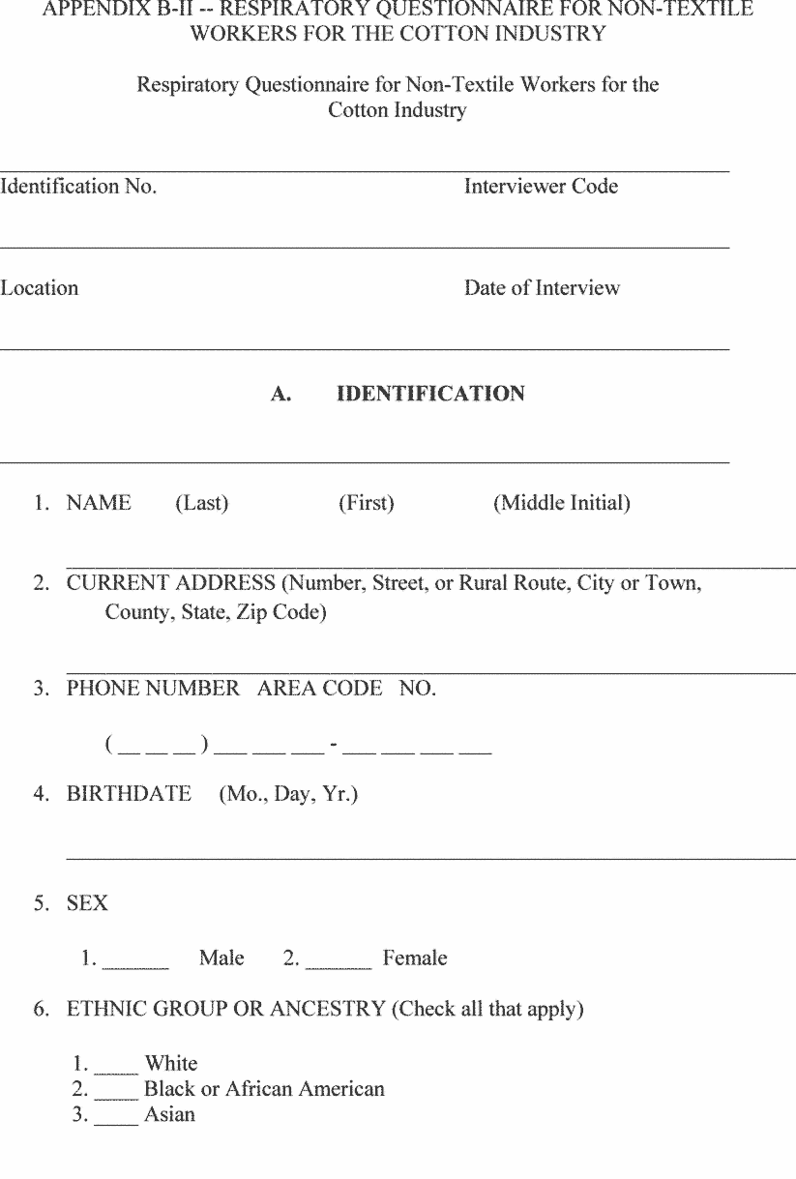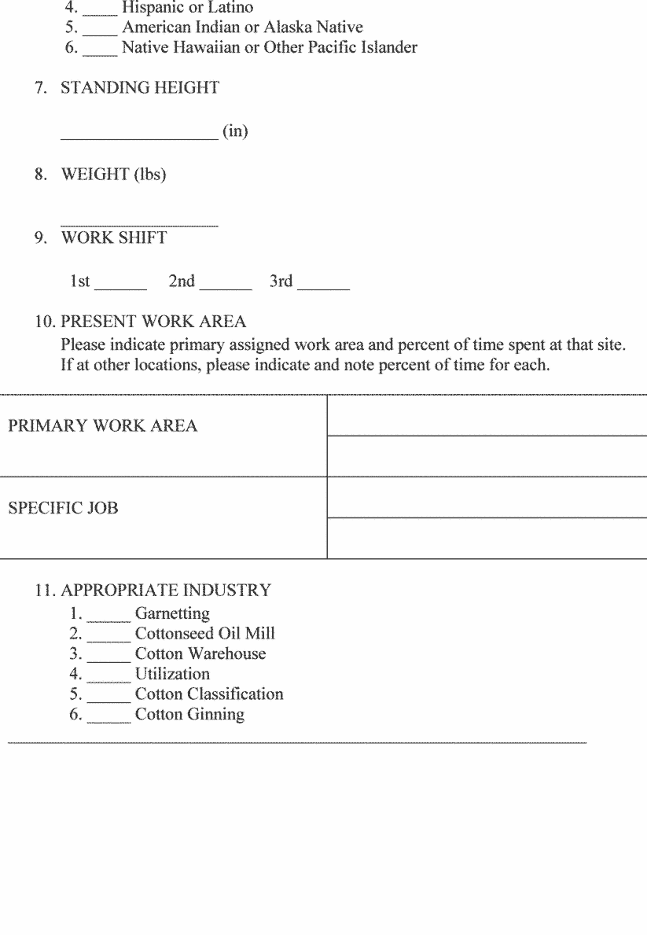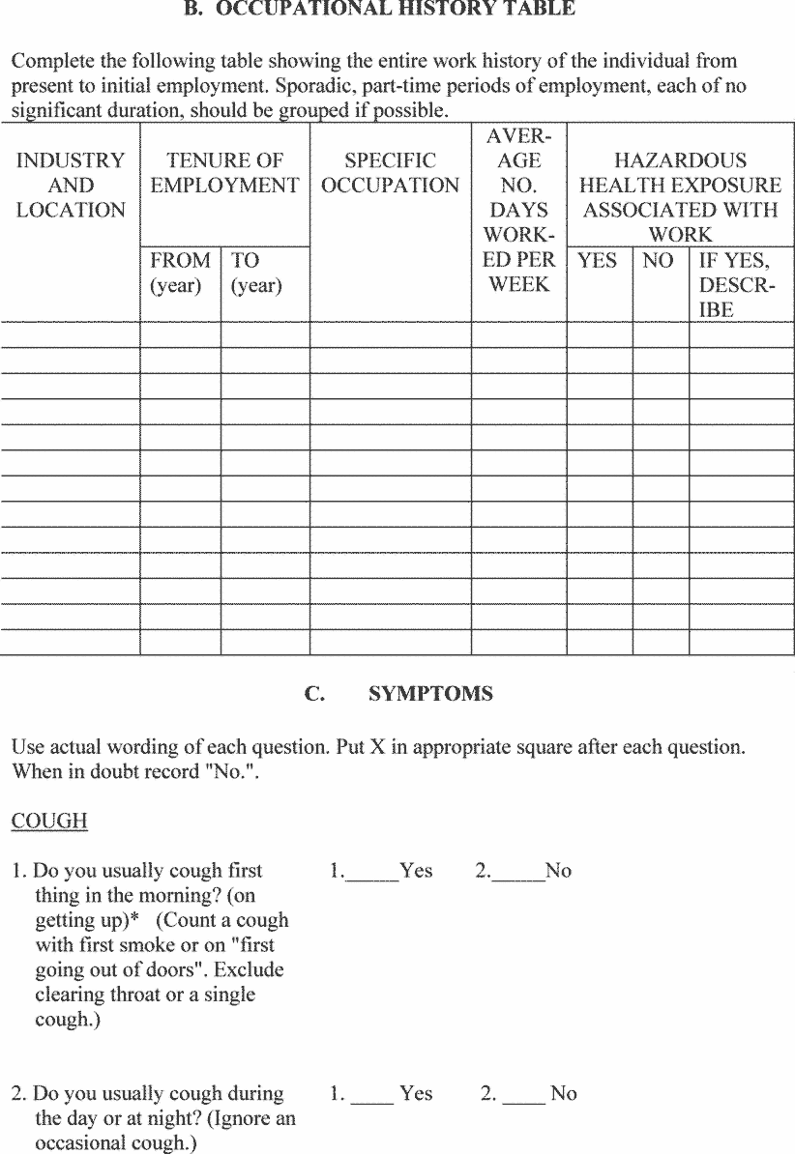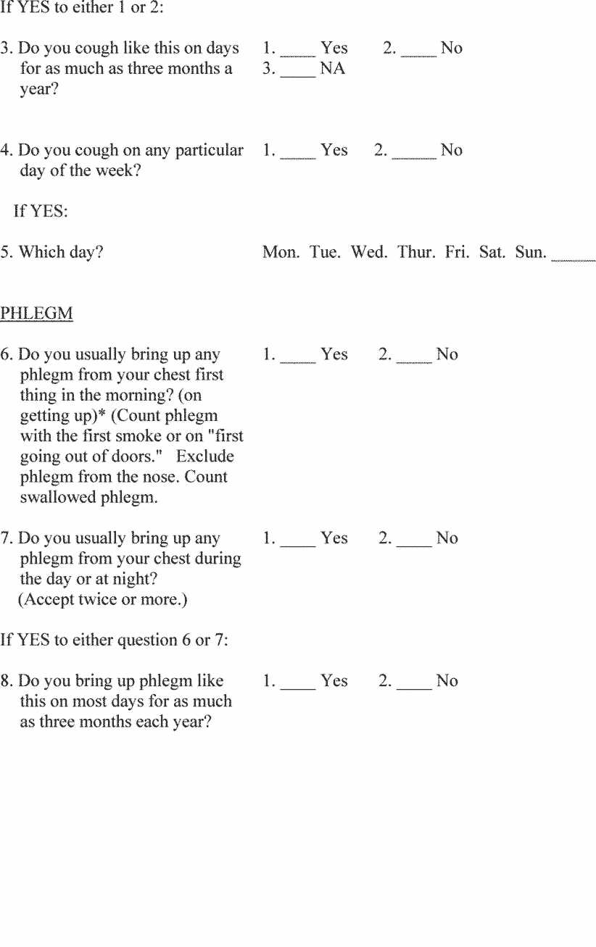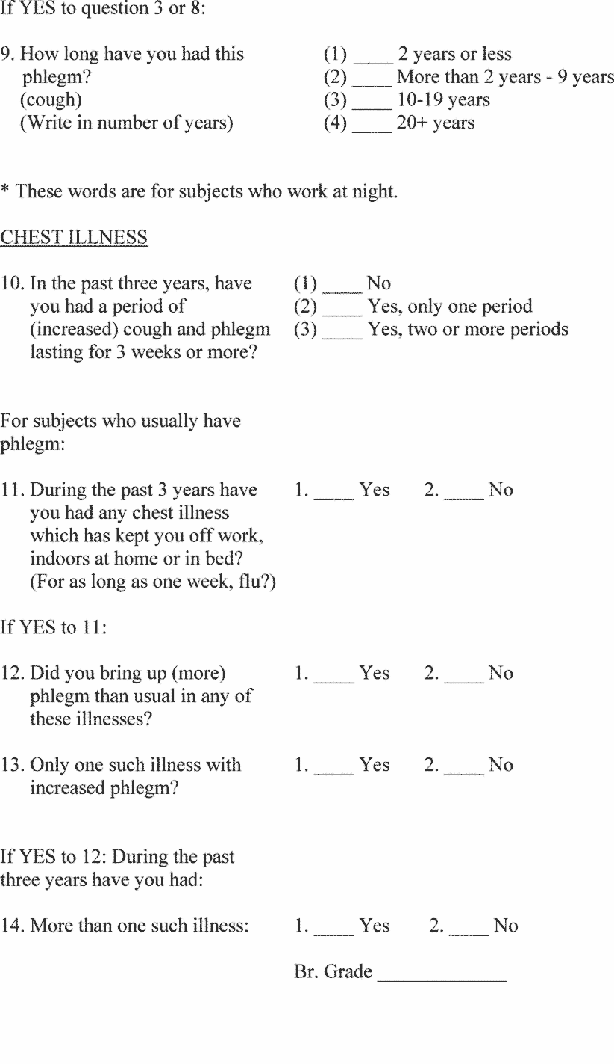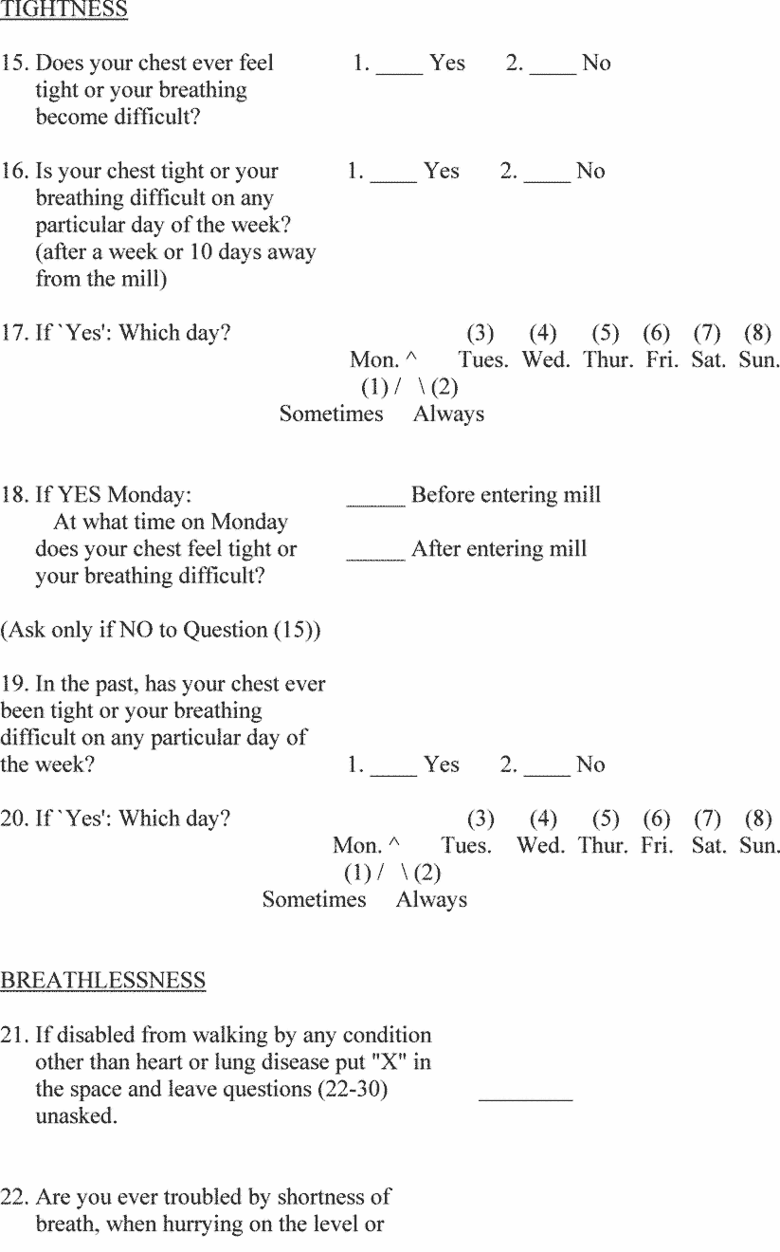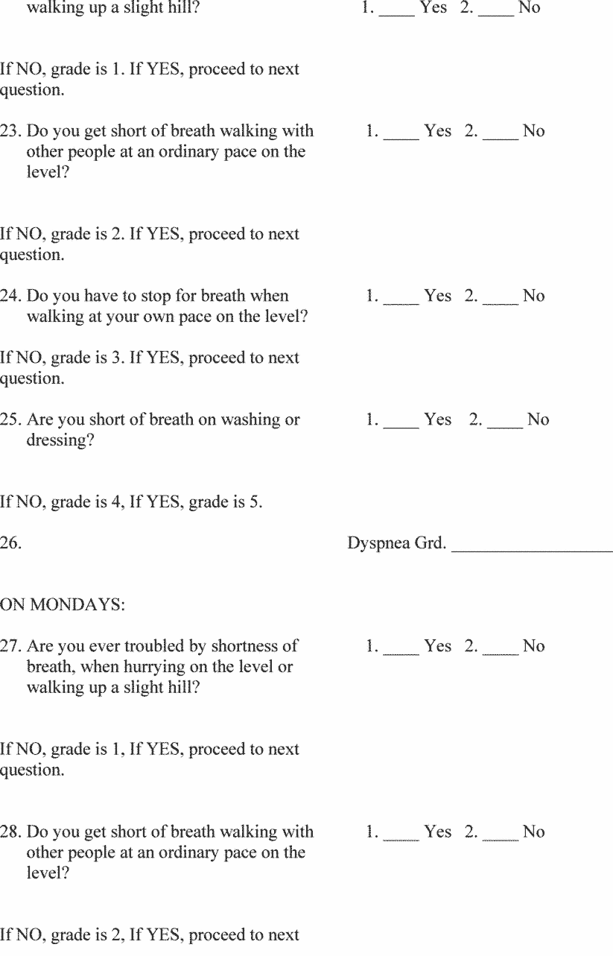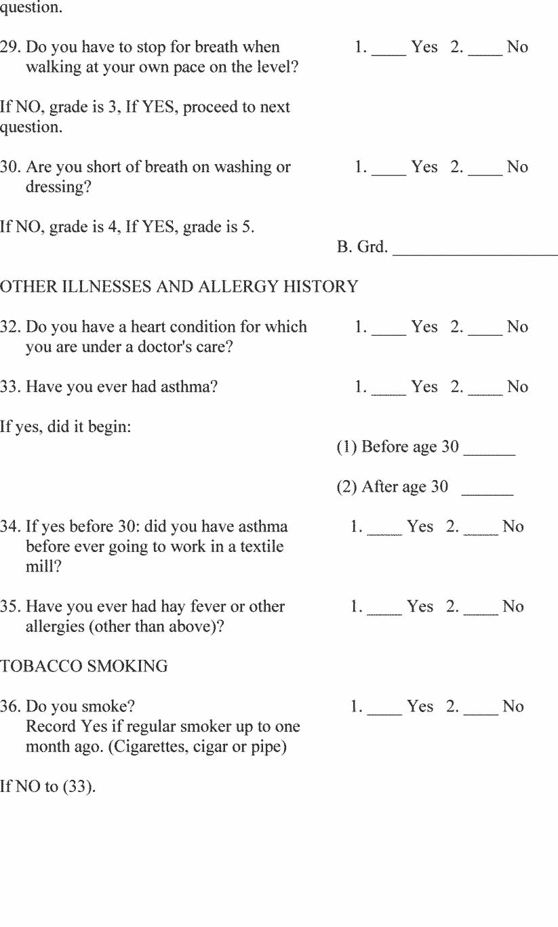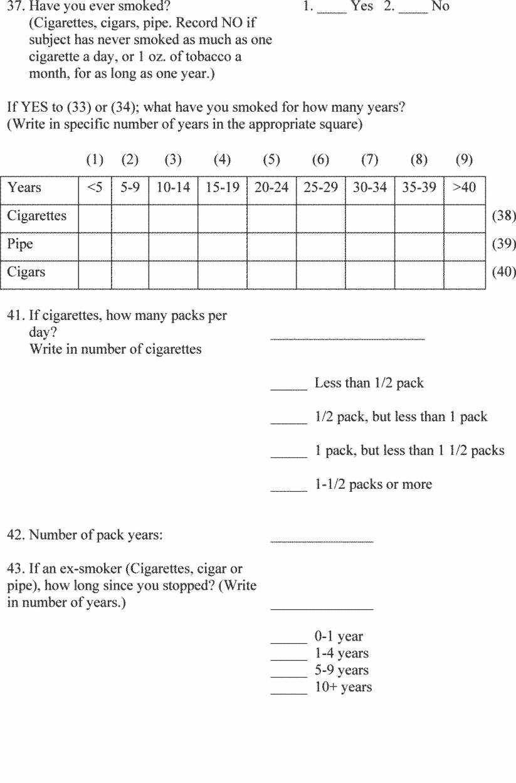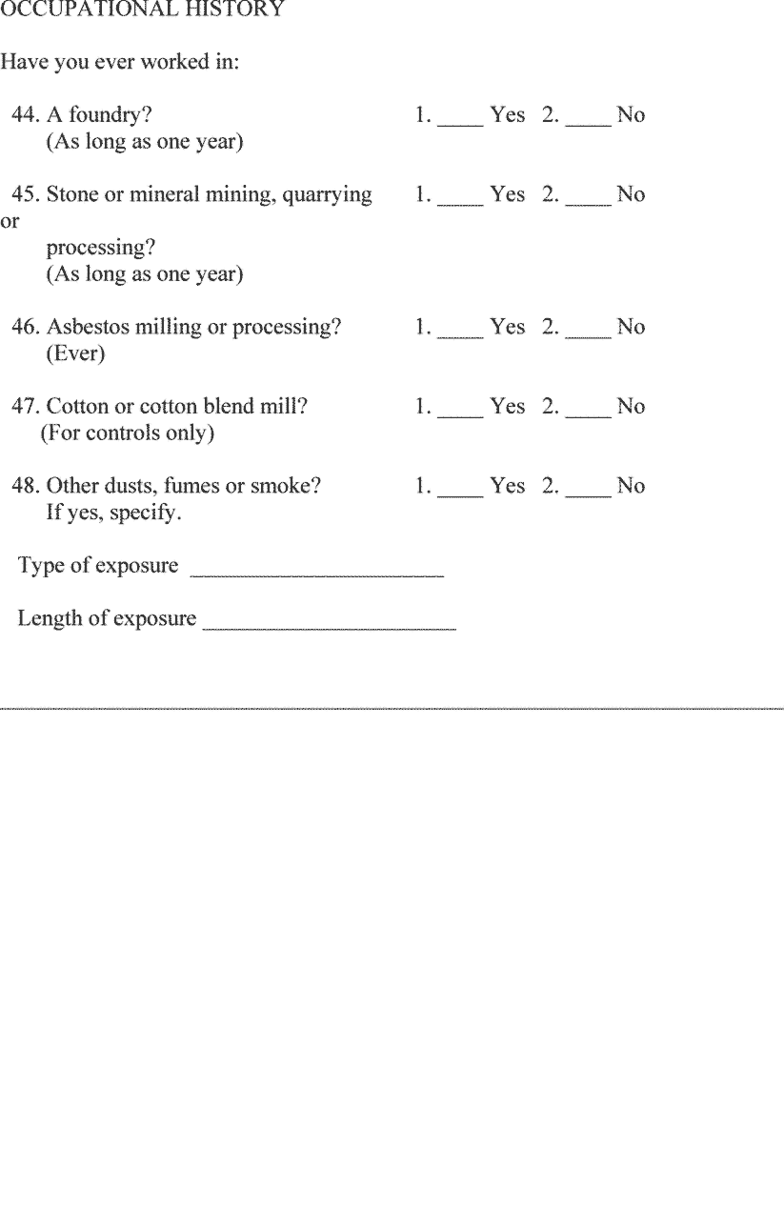
Appendix B-III to § 1910.1043—Abbreviated Respiratory Questionnaire
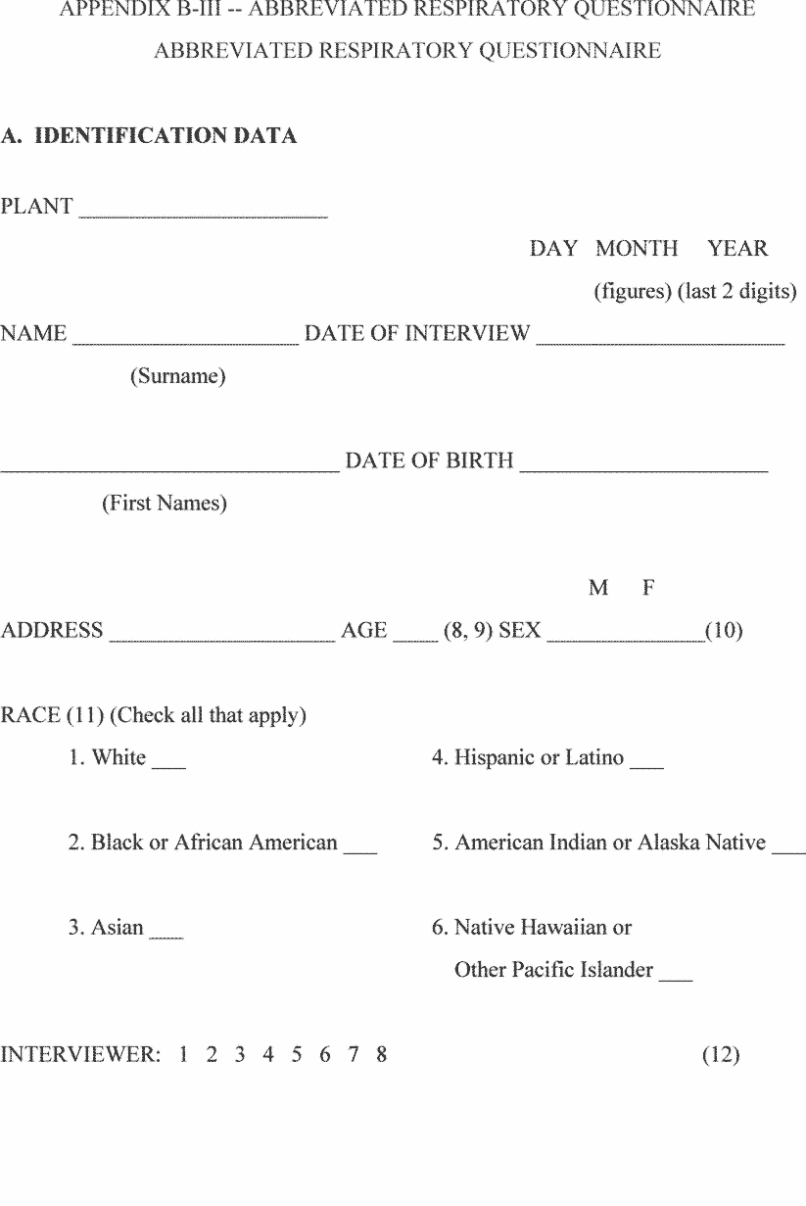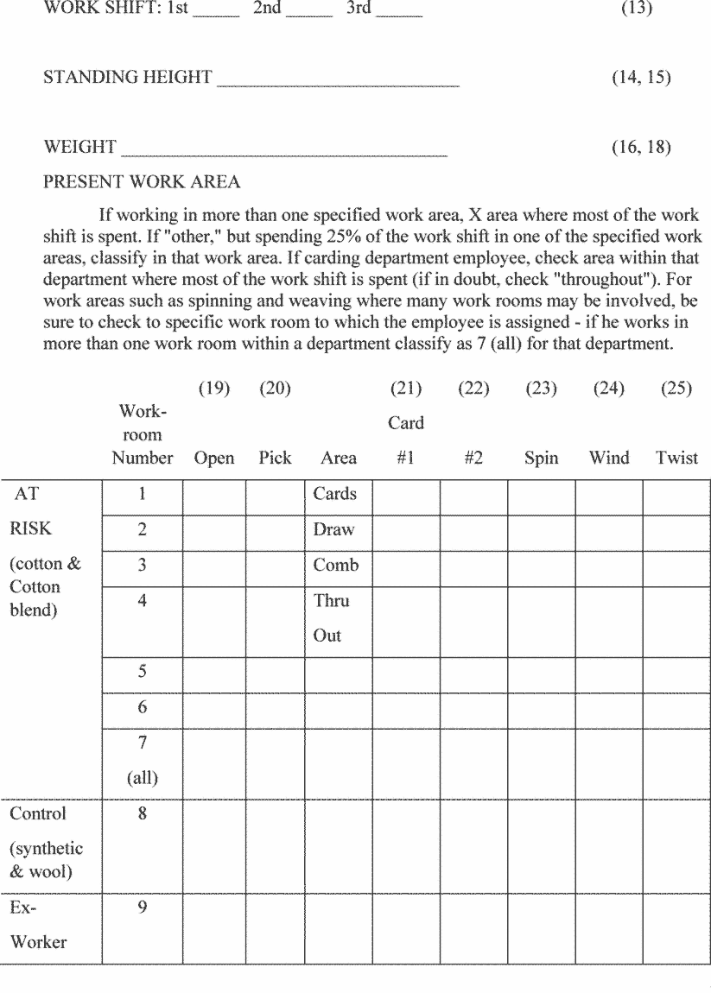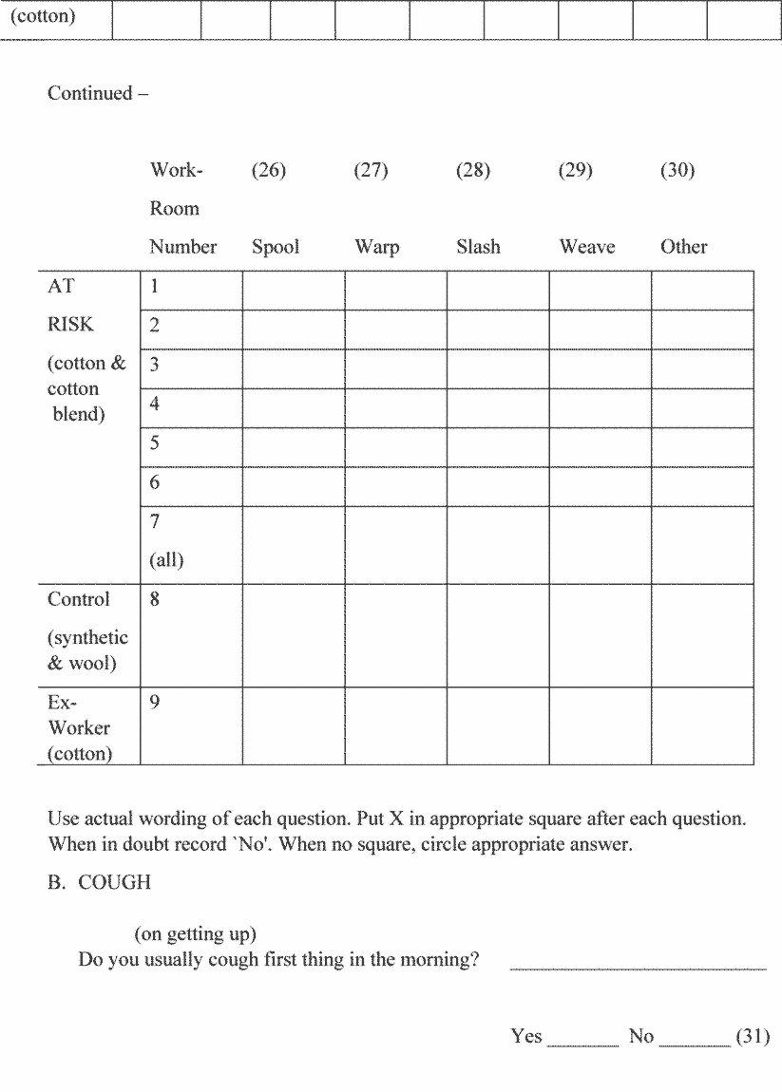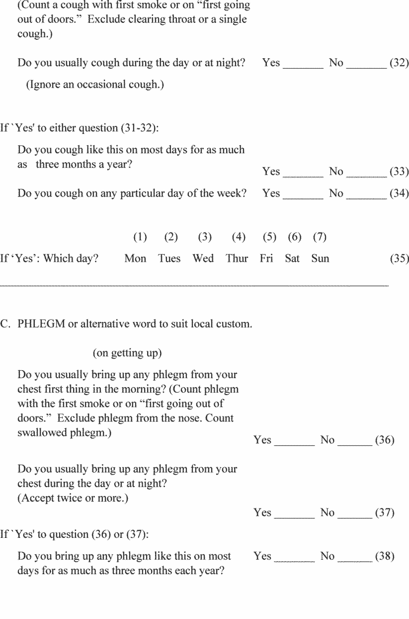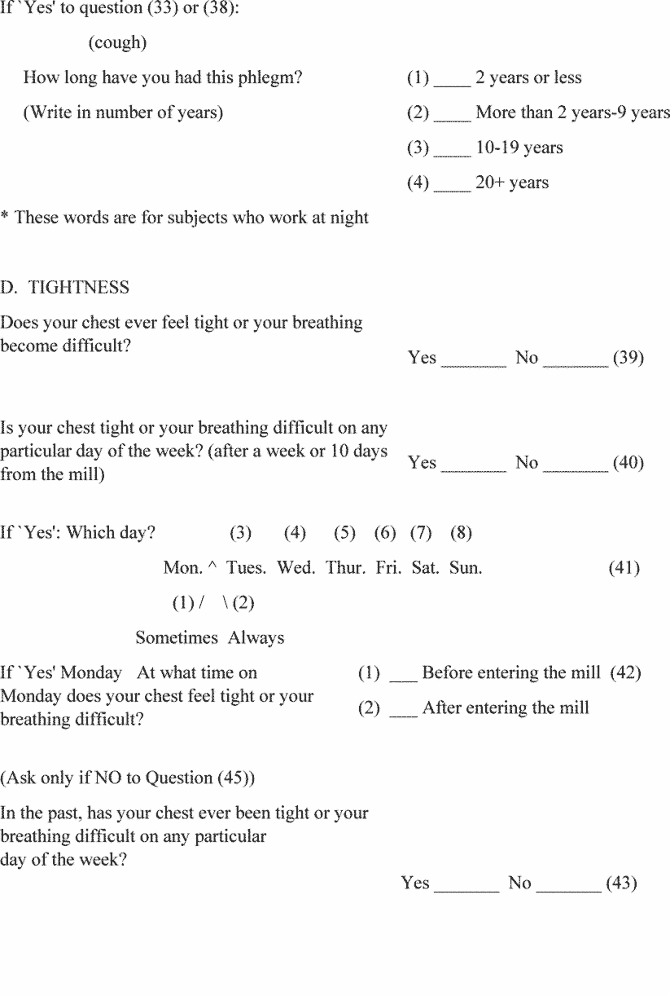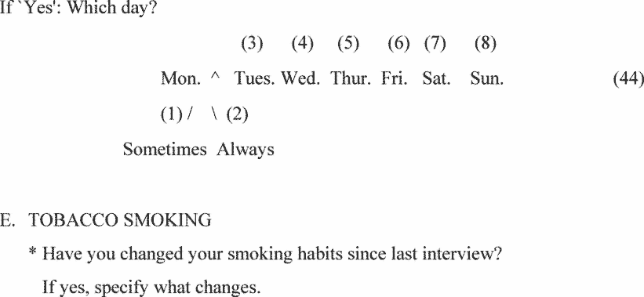
d. Data quality with emphasis on repeatability.
e. Actual use of the equipment under supervised conditions.
f. Measurement of tracings and calculations of results.
[43 FR 27394, June 23, 1978; 43 FR 35035, Aug. 8, 1978, as amended at 45 FR 67340, Oct. 10, 1980; 50 FR 51173, Dec. 13, 1985; 51 FR 24325, July 3, 1986; 54 FR 24334, June 7, 1989; 61 FR 5508, Feb. 13, 1996; 63 FR 1290, Jan. 8, 1998; 65 FR 76567, Dec. 7, 2000; 70 FR 1142, Jan. 5, 2005; 71 FR 16672, 16673, Apr. 3, 2006; 71 FR 50189, Aug. 24, 2006; 73 FR 75586, Dec. 12, 2008; 76 FR 33609, June 8, 2011; 77 FR 17782, Mar. 26, 2012; 84 FR 21490, May 14, 2019]

