**Description of Non-Substantive Changes to VA Form 40-1330UP, Claim for Commemorative Urn or Plaque For Veterans’ Cremains Not Interred (OMB # 2900-0937)**

The Department of Veterans Affairs (VA) National Cemetery Administration (NCA) is updating existing VA Form 40-1330UP, Claim for Commemorative Urn or Plaque For Veterans’ Cremains Not Interred to implement changes proposed by the NCA program office.

This form expires on May 31, 2027.  Per the VA Clearance Officer’s request, NCA has drafted this change document that explains NCA is finalizing changes to the General Information Sheet on the form, and will also make additional technical, non-substantive text edits not affecting the burden numbers (respondents, responses, and time).

Additionally, NCA is making the following non-substantive text edits to the General Information Sheet on the form that do not affect burden hours:

**Page 1:**

**BENEFIT PROVIDED:**

a. Replace the language and add a photo in the following:

Current Instructions: **COMMEMORATIVE URN:** a container that signifies the deceased individual’s status as a veteran in which the individual’s cremated remains

Replace with:

**COMMEMORATIVE URN:** The Walnut urn is 7.125” high, 7.25” wide and 9.25” in length with an interior capacity of approximately 280 cubic inches. There is a 5-inch etched emblem of a folded flag with the words Veteran and their branch of service on front of the urn. A black plate is affixed to the top of the urn with brass inscription of the Veteran’s name, date of birth and date of death.

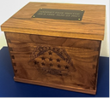

b. Replace the language and add a photo in the following:

Current Instructions: **COMMEMORATIVE PLAQUE:** a commemorative plaque means a tablet that signifies the deceased individual’s status as a veteran.

Replace with:

**COMMEMORATIVE PLAQUE:** The walnut plaque is 10 inches long, 8 inches wide and 3/4 of an inch thick.  There is a 5-inch etched emblem of a folded flag with the words Veteran and their branch of service. Below the emblem is a black plate with brass inscription with the Veteran’s name, date of birth and date of death. There is a notched keyhole to allow the plaque to hang on a wall.

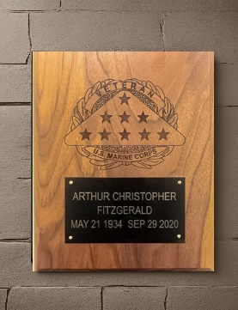

c. Bold 1st statement in **WHO CAN BE COMMEMORATED BY AN URN OR PLAQUE** paragraph:

Current statement: A deceased Veteran who has been cremated with no portion of the remains interred* at any location at the time of application,

Replace with:

**A deceased Veteran who has been cremated with no portion of the remains interred* at any location at the time of application,**

d. Bold additional statement in **WHO CAN BE COMMEMORATED BY AN URN OR PLAQUE** paragraph:

Current statement: whose remains have been cremated and is NOT interred at any location.

Replace with:

**whose remains have been cremated and is NOT interred at any location.**

Add bolded sentence to **TRANSPORTATION AND DELIVERY OF URN OR PLAQUE:**

e. Current Instructions: VA will ship the commemorative urn or plaque without charge to the applicant designated in block 10a of the claim. The applicant must

Replace with:

VA will ship the commemorative urn or plaque without charge to the applicant designated in block 10a of the claim. **VA will not deliver an urn or plaque to a Post Office box.** The applicant must

Please see the attached form with proposed changes.



VA will update the date of the form once OMB approval of the revised form is received.