**Supporting Statement – PART A**

**35% EXEMPTION REQUEST FROM 85/15 REPORTING REQUIREMENT**

**OMB Control Number 2900-0896**

|  |
| --- |
| Summary of Changes from Previously Approved Collection  ○ 35% Exemption Request From 85/15 Reporting Requirement.   * There are no changes to the form during this submission other than updating the respondent burden paragraph based on the newly received template format and changing the first word of the title from the word “Application” to the word “Request”. * The form is fillable and available electronically. * At this time, the form continues to be submitted to VA via email. * The burden has increased since the inception and initial approval of this relatively new collection. Based on the data collection received for calendar years 2022 and 2023 there has been an increase in the number of average annual 35% exemption request instruments received. The Program Office did not start receiving the instruments until after November 2021. This information collection request has therefore been entered into ROCIS as a “Revision” due to the increase in burden hours. * One anonymous comment received during the 60-day comment period. |

**A. Justification:**

1. **Explain the circumstances that make the collection of information necessary. Identify legal or administrative requirements that necessitate the collection of information.**

The Department of Veterans Affairs (VA) is authorized to pay education benefits to Veterans and other eligible persons pursuing approved programs of education under chapters 30, 32, 33, and 35 of title 38 U.S.C., and chapter 1606 of title 10, U.S.C. As part of the benefits authorization process, Code of Federal Regulations (CFR) title 38 Section 21.4201 places restrictions on enrollment based on the percentage of students receiving financial support in any approved program. Except as otherwise provided by regulation, VA shall not approve an [enrollment](https://www.law.cornell.edu/definitions/index.php?width=840&height=800&iframe=true&def_id=3afee38aaf8ee638868154c9da65c5a2&term_occur=999&term_src=Title%3A38%3AChapter%3AI%3APart%3A21%3ASubpart%3AD%3ASubjgrp%3A234%3A21.4201) in any course for an eligible Veteran, not already enrolled, for any period during which more than 85 percent of the students enrolled in the course are having all or part of their tuition, fees or other charges paid for them by the educational institution or by VA under title 38, U.S.C., or under title 10, U.S.C. This is known as the 85/15 Rule and is applicable to Institutions of Higher Learning (IHLs) and Non-College Degree postsecondary schools.

The requirements apply to all courses, not otherwise exempt, or waived, offered by all educational institutions, regardless of whether the institution is degree-granting, proprietary profit, proprietary nonprofit, eleemosynary, public and/or tax-supported. Schools are required to submit information necessary to determine if their programs of training are approved for the payment of VA educational assistance. This specified information is submitted either to VA or to the State Approving Agency (SAA) having jurisdiction over that school.

This regulation includes a provision that permits an exemption from routine reporting of this data for schools that assert that the number of VA beneficiary students in all programs approved for GI Bill never exceeds 35% of the total enrollment at the educational institution. If approved, such non-accredited schools must still monitor and collect the data, but are exempt from routinely reporting it to VA.

1. **Indicate how, by whom, and for what purposes the information is to be used; indicate actual use the agency has made of the information received from current collection.**

The VA uses data from this information collection to determine that non-receipt of the routine reporting of 85/15 data is authorized by non-accredited schools. Non-accredited schools with an approved exemption are required to provide the complete 85/15 data during regular, periodic compliance survey reviews by VA to ensure no more than 85% of students in any approved program are students in receipt of financial support from the educational institution or by VA under title 38, U.S.C., or under title 10, U.S.C. Without this information, VA might pay benefits in error.

1. **Describe whether, and to what extent, the collection of information involves the use of automated, electronic, mechanical, or other technological collection techniques or other forms of information technology, e.g., permitting electronic submission of responses, and the basis for the decision for adopting this means of collection. Also describe any consideration of using information technology to reduce burden.**

Information technology is being used to reduce the burden to the extent currently possible. This form is available as a fillable PDF document and is submitted to VA via email. Most schools utilize financial aid software packages that allow VA beneficiary data to be sorted/reported when appropriately categorized. This allows the school to readily identify affected VA students among the total student population in receipt of financial aid.

1. **Describe efforts to identify duplication. Show specifically why any similar information already available cannot be used or modified for use for the purposes described in Item 2 above.**

The information obtained through this collection is unique and is not already available for use or adaptation from another cleared source.

1. **If the collection of information impacts small businesses or other small entities, describe any methods used to minimize burden.**

This information collection does not impose a significant economic impact on a substantial number of small businesses or entities.

1. **Describe the consequences to Federal program or policy activities if the collection is not conducted or is conducted less frequently as well as any technical or legal obstacles to reducing burden.**

There are no consequences to Federal program or policy activities without this collection other than directly violating 38 CFR Section 21.4201.

1. **Explain any special circumstances that would cause an information collection to be conducted more often than quarterly or require respondents to prepare written responses to a collection of information in fewer than 30 days after receipt of it; submit more than an original and two copies of any document; retain records, other than health, medical, government contract, grant-in-aid, or tax records for more than three years; in connection with a statistical survey that is not designed to produce valid and reliable results that can be generalized to the universe of study and require the use of a statistical data classification that has not been reviewed and approved by OMB.**

This collection of information does not require collection to be conducted in a manner inconsistent with the guidelines delineated in 5 CFR 1320.5(d)(2).

1. **If applicable, provide a copy and identify the date and page number of publication in the Federal Register of the sponsor’s notice, required by 5 CFR 1320.8(d), soliciting comments on the information collection prior to submission to OMB. Summarize public comments received in response to that notice and describe actions taken by the sponsor in responses to these comments. Specifically address comments received on cost and hour burden.**

A 60-Day Federal Register Notice (FRN) for the collection published on Friday, September 13, 2024. The 60-Day FRN citation is Volume 89, FRN Page(s) 75059-75060. One anonymous comment was received during the 60-Day Comment Period.

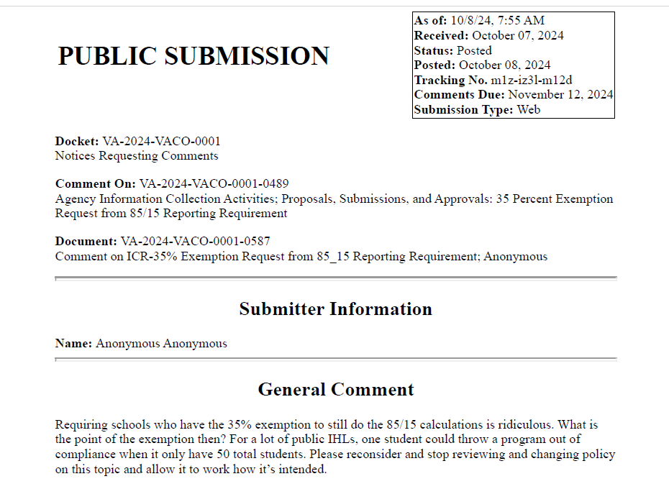

**VA Response:** VA agrees with the anonymous commenter and have therefore updated the Supporting Statement-A and 30-day FRN to reflect the change that the 85/15 calculations are still required for non-accredited schools.

A 30-Day Federal Register Notice (FRN) for the collection published on Friday, November, 22, 2024. The 30-Day FRN citation is Volume 89, FRN Page(s) 92739-92740.

1. **Explain any decision to provide any payment or gift to respondents, other than remuneration of contractors or grantees.**

No payments or gifts are being offered to respondents as an Incentive to participate in the collection.

1. **Describe any assurance of privacy, to the extent permitted by law, provided to respondents and the basis for the assurance in statute, regulation, or agency policy.**

Our assurance of confidentiality is covered by 38 U.S.C. 5701 and our System of Records, Compensation, Pension, Education and Veteran Readiness and Employment Records – VA (58VA21/22/28), which are contained in the Privacy Act Issuances, 2012 Compilation.

1. **Provide additional justification for any questions of a sensitive nature (Information that, with a reasonable degree of medical certainty, is likely to have a serious adverse effect on an individual's mental or physical health if revealed to him or her), such as sexual behavior and attitudes, religious beliefs, and other matters that are commonly considered private; include specific uses to be made of the information, the explanation to be given to persons from whom the information is requested, and any steps to be taken to obtain their consent.**

No questions considered sensitive are being asked in this collection.

1. **Estimate of the hour burden of the collection of information. If this request**

**for approval covers more than one form, provide separate hour burden estimates for each form and aggregate the hour burdens in Item 13 of OMB 83-I. Provide estimates of annual cost to respondents for the hour burdens for collections of information. The cost of contracting out or paying outside parties for information collection activities should not be included here. Instead, this cost should be included in Item 14 of the OMB 83-I.**

**Estimation of Respondent Burden:**

**VA Form 22-10216**

[35% Exemption Request From 85/15 Reporting Requirement].

There was a total of 5,645 collections of the “35% Exemption Request From 85/15 Reporting Requirement” instruments received for calendar years 2022 and 2023, resulting in an average annual receipt of 2,822 responses. The result calculates to a total of 1,411 burden hours.

1. Number of Respondents: 2,822.
2. Frequency of Response: Annually.
3. Annual Burden Hours: 1,411 (2,822 X 30 minutes / 60 minutes).
4. Estimated Completion Time: 30 minutes.
5. The respondent population for VA Form 22-10216 is comprised of School Certifying Officials who are otherwise required to periodically report 85/15 information to the VA. This form exempts the routine reporting to VA only, not collection of the information. VBA cannot make further assumptions about the population of respondents because of the variability of factors such as educational background and wage potential of respondents. Therefore, VBA used general wage data for **“All Occupations**” to estimate the respondents’ costs associated with completing the information collection.

The Bureau of Labor Statistics gathers information on full-time wage and salary workers. According to the latest available BLS data, the median weekly earnings of full-time wage and salary workers is $1,259.20. Assuming a forty (40) hour work week, the median hourly wage is $31.48 based on the BLS wage code of "00-000-0000 for "All Occupations." This information was taken from the following website <https://www.bls.gov/oes/current/oes_nat.htm>., May 2023.

Legally, respondents may not pay a person or business for assistance in completing the information collection and a person or business may not accept payment for assisting a respondent in completing the information collection. Therefore, there are no expected overhead costs for completing the information collection. VBA estimates the total cost to all respondents to be $44,418.28 (1,411 burden hours X $31.48 per hour).

1. **Provide an estimate of the total annual cost burden to respondents or record-keepers resulting from the collection of information. (Do not include the cost of any hour burden shown in Items 12 and 14).**

There are no annualized costs to respondents other than the labor burden

costs addressed in Section 12 of this document to complete this collection.

1. **Provide estimates of annual cost to the Federal Government. Also, provide a description of the method used to estimate cost, which should include quantification of hours, operation expenses (such as equipment, overhead, printing, and support staff), and any other expense that would not have been incurred without this collection of information. Agencies also may aggregate cost estimates from Items 12, 13, and 14 in a single table.**

**Estimated Labor Cost to the Federal Government: $55,593.40.**

[35% Exemption Request From 85/15 Reporting Requirement, VA Form

22-10216].

|  |  |  |  |  |  |  |
| --- | --- | --- | --- | --- | --- | --- |
| Grade | Step | Burden Time | Hourly Rate | Cost Per Response | Number of Responses | Total |
| GS-11 | 05 | 30 min | $39.40 | $19.70 | 2,822 | $ 55,593.40 |
| Overhead at 100% Salary | | | | | | $ 55,593.40 |
| Overhead charges are 100% of salary and are the same as the wage listed above; and the amount is included in the total. | | | | | |  |
| Processing / Analyzing Charges | | | | | | $ 55,593.40 |
| Printing and Production Cost | | | | | | $ 0.00 |
| **Total Cost to Government** | | | | | | **$ 55,593.40** |

**Note:** The hourly wage information above is based on the hourly 2024 General Schedule (Base) Pay. <https://www.opm.gov/policy-data-oversight/pay-leave/salaries-wages/salary-tables/24Tables/html/RUS_h.aspx>.

The processing time estimates above were based on the actual amount of time employees of the grade level spent to process to completion a VA Form 22-10216, received from an approved IHL or NCD.

1. **Explain the reason for any burden hour changes since the last submission.**

The burden has increased since the inception and initial approval of this relatively new collection. Based on the data collection received for calendar years 2022 and 2023 there has been a slight increase in the number of average annual 35% exemption request instruments received. The Program Office did not start receiving the instruments until after November 2021.

1. **For collections of information whose results will be published, outline plans for tabulation and publication. Address any complex analytical techniques that will be used. Provide the time schedule for the entire project, including beginning and ending dates of the collection of information, completion of report, publication dates, and other actions.**

The results of this information collection will not be published.

1. **If seeking approval to not display the expiration date for OMB approval of the information collection, explain the reasons that display would be inappropriate.**

We are not seeking approval to omit the display of the expiration date of the OMB approval on the collection instrument.

1. **Explain each exception to the certification statement identified in Item 19, “Certification for Paperwork Reduction Act Submissions,” of OMB 83-I.**

We are not requesting any exemptions to the provisions stated in 5 CFR 1320.9.