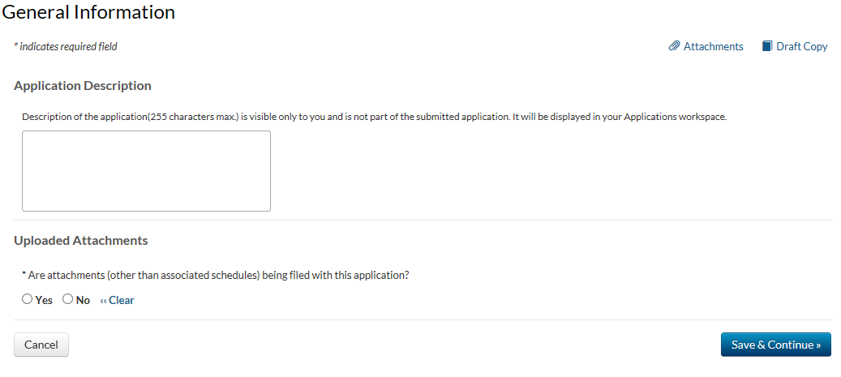

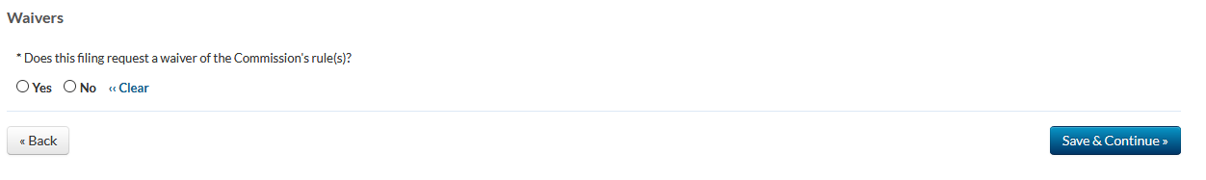

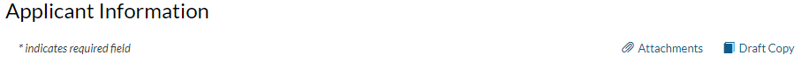
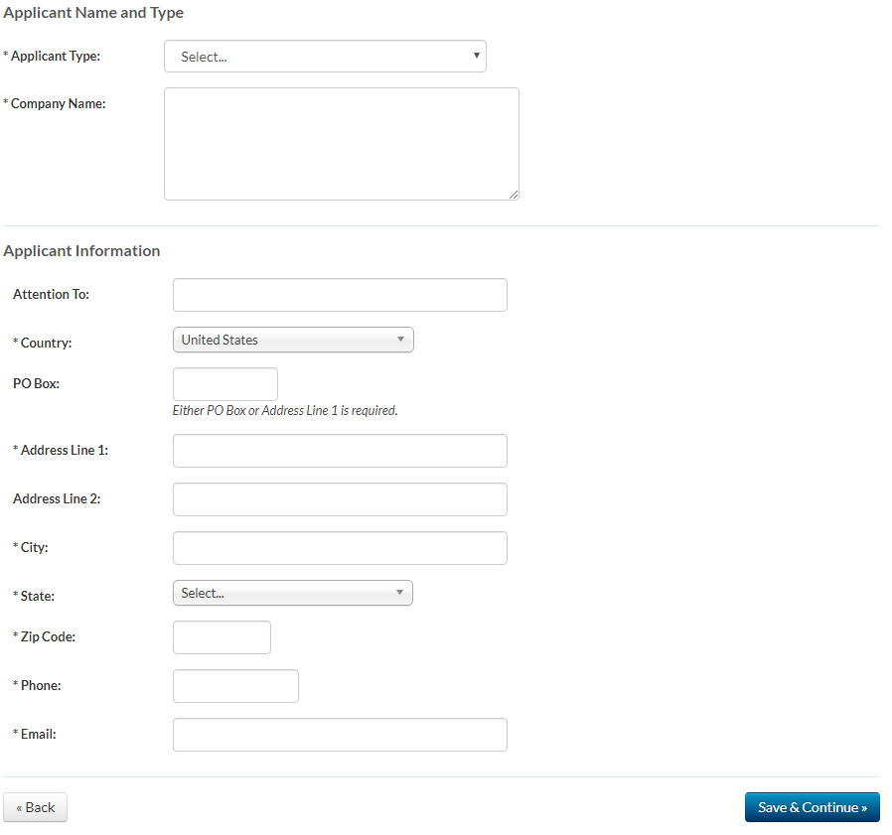

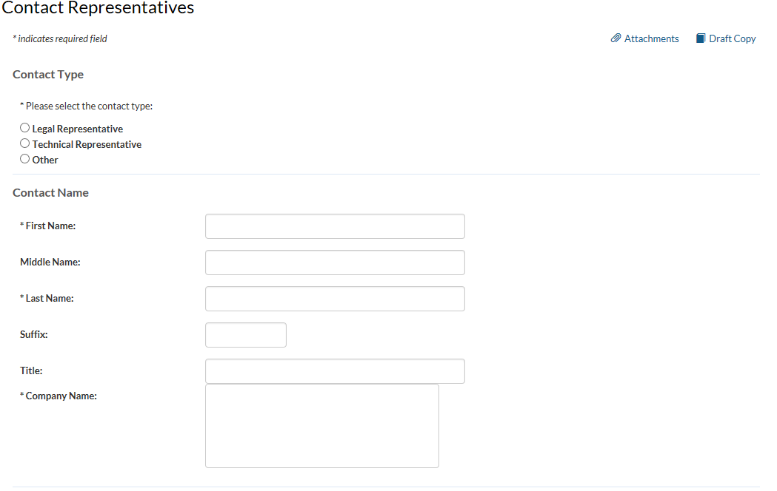
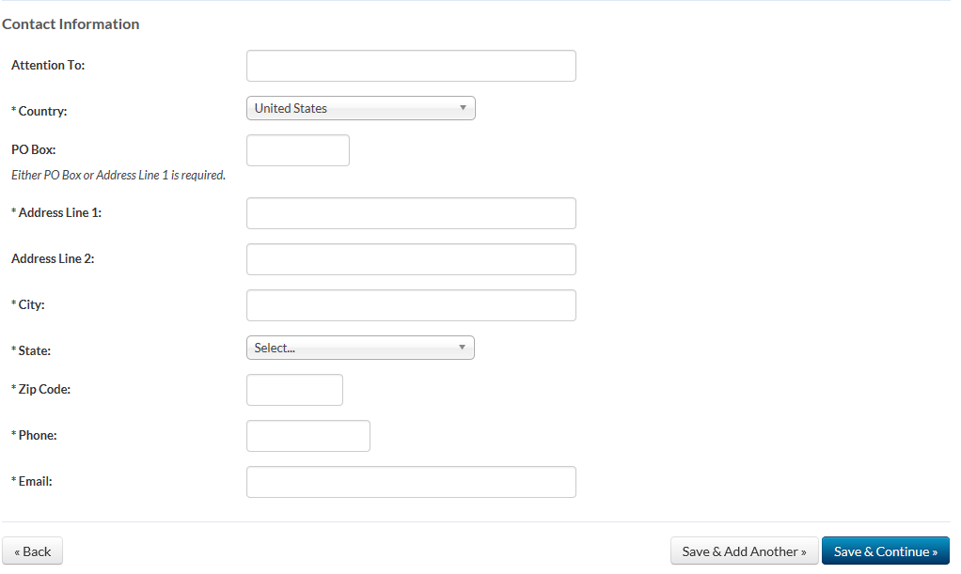

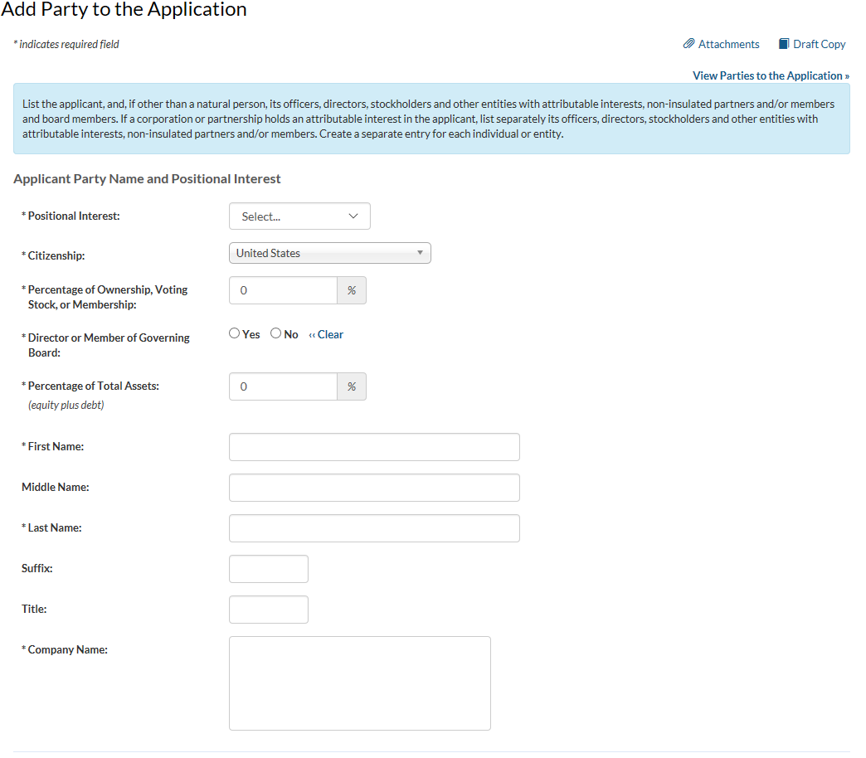
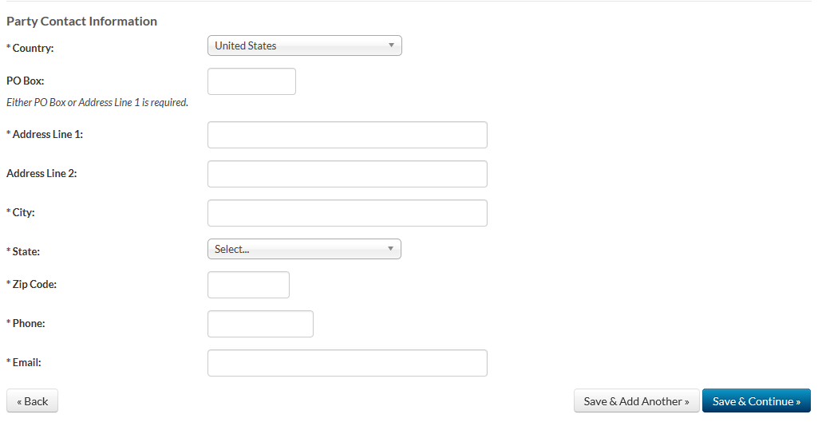
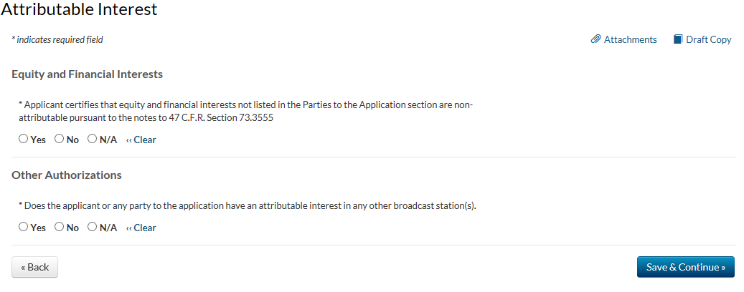
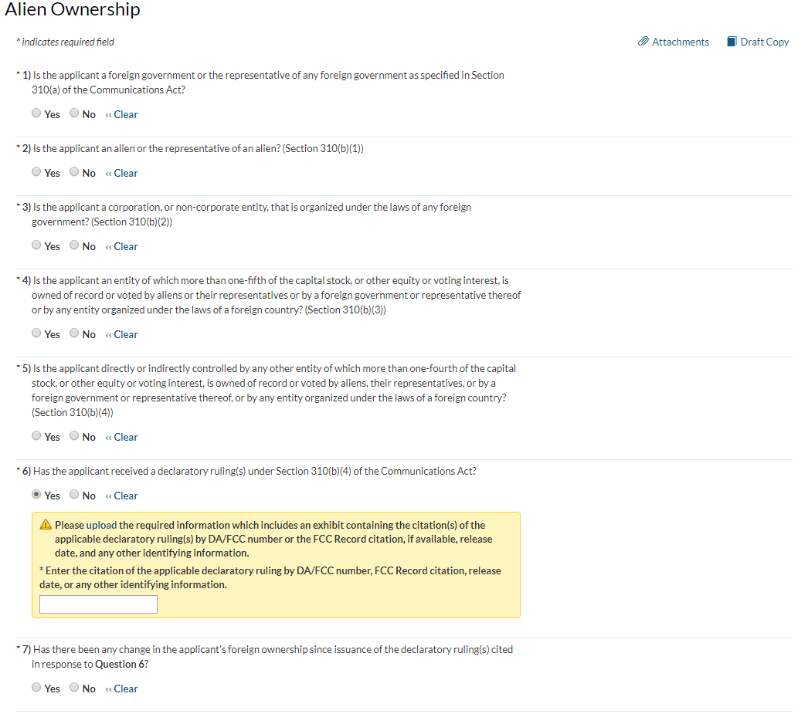
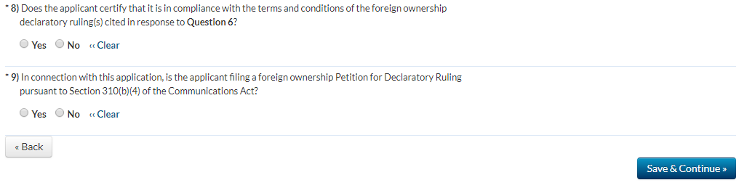
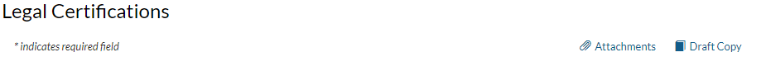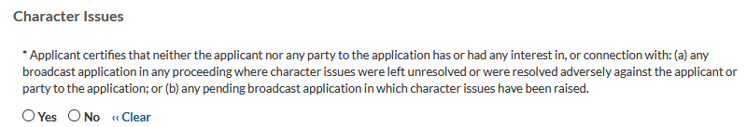

* Licensee certifies that, with respect to the licensee and each party to the application, no adverse finding has been made, nor has an adverse final action been taken by any court or administrative body in a civil or criminal proceeding brought under the provisions of any laws related to any of the following: any felony; mass media-related antitrust or unfair competition; fraudulent statements to another governmental unit; or discrimination. 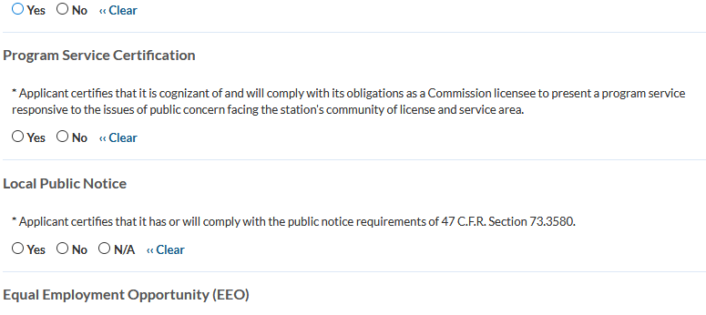
* If the applicant proposes to employ five or more full-time employees, applicant certifies that it is filing simultaneously with this application a Broadcast EEO Model Program Report.


Eligibility Certifications
*The applicant certifies that it is a:
O Nonprofit educational institution
O Governmental entity other than a school
O Nonprofit educational organization, other than as described above.
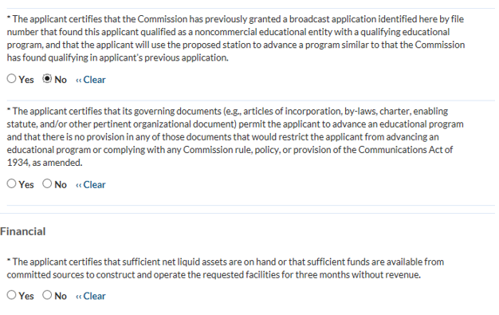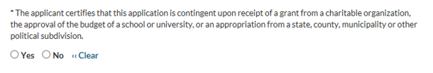
Fair Distribution of Service
*Applicant certifies that it provides a first aural (reception) service.

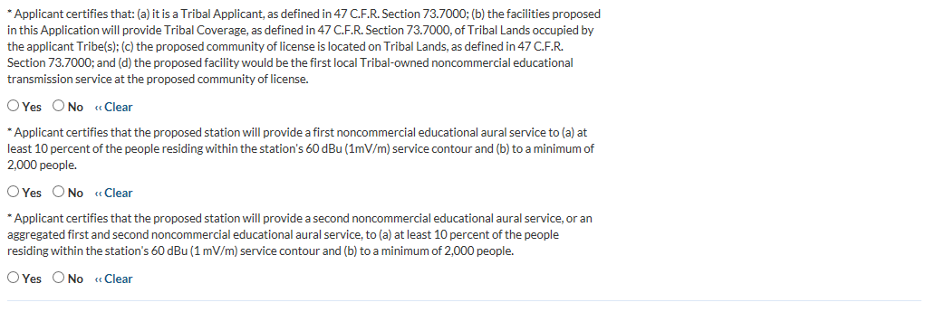
Maintenance of Comparative Qualifications
Applicant certifies that this application does not propose a modification to an authorization that was awarded on the basis of a preference for fair distribution of service pursuant to 47 U.S.C. Section 307(b).

Yes No « Clear

If ''No,'' answer a. and b. below.

- Applicant certifies that the proposed modification will not downgrade service to the area on which the Section 307(b) preference was based.
Yes No « Clear

- Applicant certifies that although it proposes to downgrade service to the area on which the Section 307(b) preference was based, either (1) any potential loss of first and/or second NCE service will be offset by at least first and, separately, combined first and second NCE service populations gains, or (2) the applicant has provided full service to that area for a period of four years of on-air operations.
Yes No « Clear

Applicant certifies that this application does not propose a modification to an authorized station that received a credit for superior technical parameters under the point system selection method in 47 C.F.R. Section 73.7003.

Yes No « Clear

If ''No,'' applicant must be able to answer ''Yes'' to a. below or provide an attachment that makes a compelling showing that the downgrade would be in the public interest.

- Applicant certifies that the population and area within the proposed service contour (60 dBu (FM)) are greater than or equivalent to those authorized.

Yes No « Clear

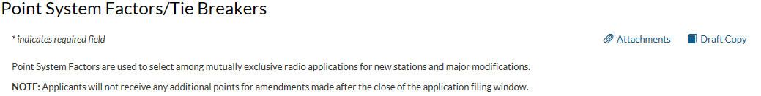
Established Local Applicant:

Applicant certifies that for at least the 24 months immediately prior to application, and continuing through the present, it qualifies as a local applicant pursuant to 47 CFR Section 73.7000, and that it has placed documentation of its qualifications as an established local applicant in the applicant’s public inspection file and has submitted to the Commission copies of the documentation.

Yes No « Clear

If the applicant certifies above that it qualifies for points as an “established local applicant,” applicant pledges to maintain localism characteristics during the period from grant of the construction permit until the station has achieved at least four years of on-air operations.

Yes No « Clear

Diversity of Ownership:
Applicant certifies (1) that the principal community (city grade) contour of the proposed station does not overlap the principal community contour of any other authorized station (comparing radio to radio and television to television, including non-fill-in translator stations) in which any party to the application has an attributable interest as defined in 47 CFR Section 73.3555, and (2) that it has placed documentation of its diversity qualifications in the applicant’s public inspection file and has submitted to the Commission copies of the documentation.

Yes No « Clear

Is the applicant's certification to the question above based on a pledge to divest an attributable broadcast interest or resign from an attributable positional interest?

Yes No « Clear

If “Yes,” applicant must upload an exhibit identifying the station authorization for which it will divest upon commencement of operation of the proposed full service station (i.e., upon its filing of a license application and receipt of program test authority).

If the applicant certifies above that it qualifies for points for “diversity of ownership,” applicant and any party to the application pledge to comply with the restrictions on station modifications and acquisitions, as defined in 47 CFR Section 73.7005, during the period from grant of the construction permit until the station has achieved at least four years of on-air operations.
Yes No « Clear

State-wide Network

Applicant certifies that (a) it has NOT claimed a credit for diversity of ownership above; (b) it is one of the three specific types of organizations described in 47 C.F.R. Section 73.7003(b)(3); and (c) it has placed documentation of its qualifications in a local public inspection file and has submitted to the Commission copies of the documentation.

Yes No « Clear

Technical Parameters

Applicant certifies that the numbers in the boxes below accurately reflect the new area and population that its proposal would serve with a 60 dBu (FM) or Grade B (TV) signal measured in accordance with the standard predicted contours in 47 C.F.R. Sections 73.313(c) (FM), 73.683(TV) and 73.622(e) and that it has documented the basis for its calculations in the local public inspection file and has submitted copies to the Commission. Major modification applicants should include new area proposed only (exclude any area already within the station's existing service area). (Points, if any, will be determined by FCC)

Yes No « Clear

New area served in square kilometers (excluding areas of water): _____________________________
Population served based on the most recent census block data from the United States: ____________

Tie Breakers
Existing Authorizations

By placing a number in the box, the applicant certifies that it and other parties to the application have, as of the date of filing and pursuant to 47 C.F.R. Section 73.3555, attributable interests in the stated number of relevant broadcast station authorizations. Radio applicants should count all attributable full service radio stations, AM and FM commercial and noncommercial, and FM translator stations other than fill-in stations or those identified in Point System Factors, Diversity of Ownership(b) above. TV applicants should count all attributable full service TV stations, commercial and noncommercial and TV translator stations other than fill-in stations or those identified in Point System Factors, Diversity of Ownership(b) above.

___________ (number of commercial and noncommercial licenses and construction permits)

Pending Applications

By placing a number in the box, the applicant certifies that it and other parties to the application have, as of the date of filing and pursuant to 47 C.F.R. Section 73.3555, attributable interests in the stated number of pending applications for new or major changes to relevant broadcast stations. Radio applicants should count all attributable full service radio stations, AM and FM, commercial and noncommercial, and FM translator stations other than fill-in stations or those identified in IV(2)(b) above. TV applicants should count all attributable full service TV stations, commercial and noncommercial, and TV translator stations other than fill-in stations or those identified in IV(2)(b) above.

__________ (number of pending commercial and noncommercial applications)

Prior NCE Applications

Applicant certifies that it applied for an NCE construction permit in a prior filing window and had its application accepted for filing and processed, but subsequently dismissed in favor of an applicant with superior points, or based on a tie-breaker preference.

Yes No « Clear

If yes, applicant certifies that (1) it has been in continuous existence from the date of the previous filing window until the present, and (2) it does not hold any NCE construction permit or license.

Yes No « Clear

Mandatory Time-Sharing Information

New station and major change applicants must complete the following questions.

This information will be used to effectuate the mandatory time sharing process. See 47 CFR Section 73.7003(c)(5).

Established Community Presence

Provide the date on which the applicant qualified as local. See 47 CFR Section 73.7000.

Date

Applicant certifies that it has remained local at all times since this date.

Yes No « Clear

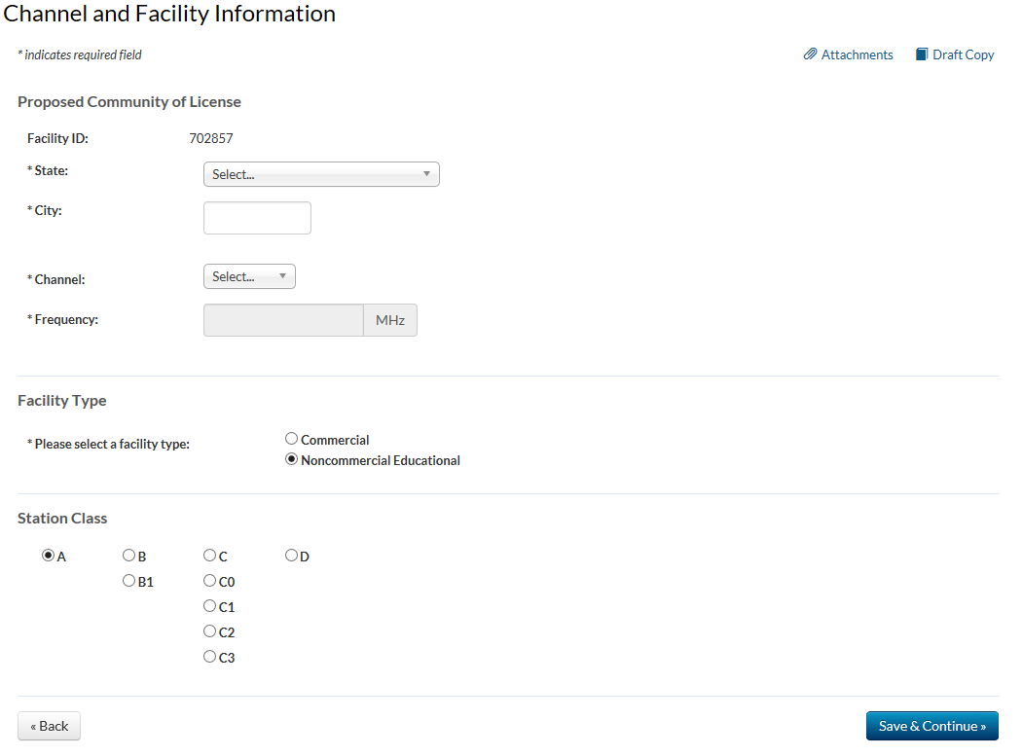

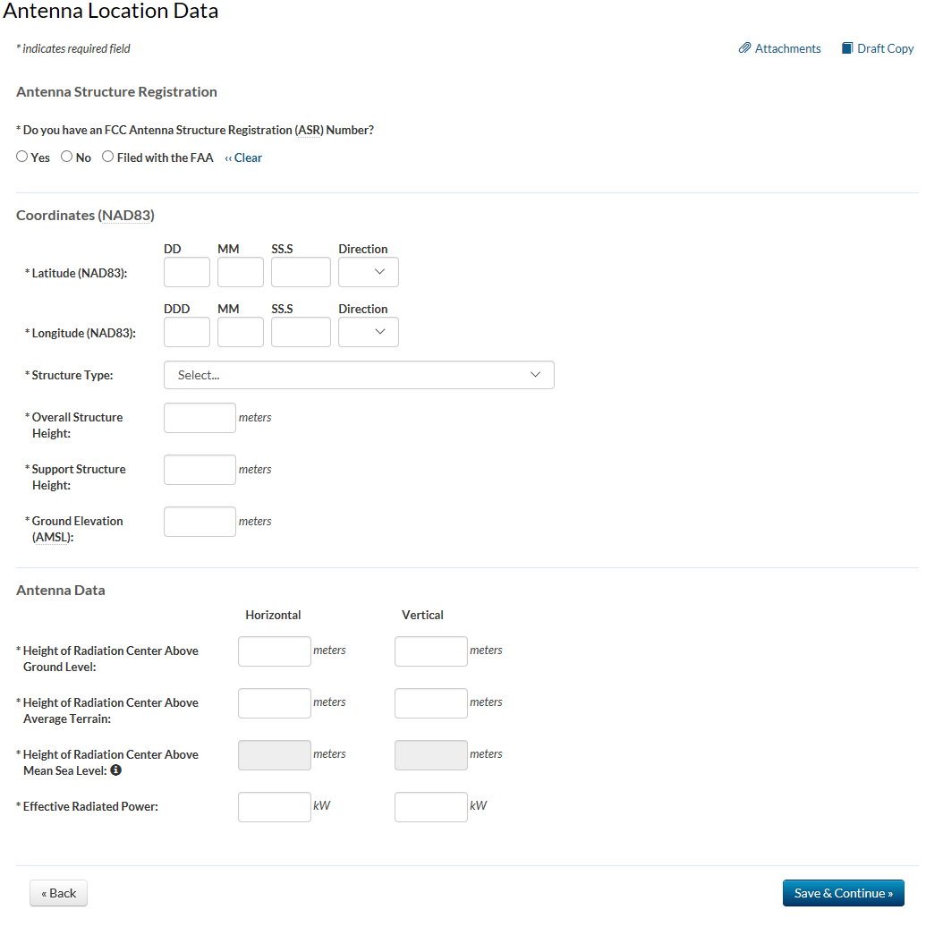
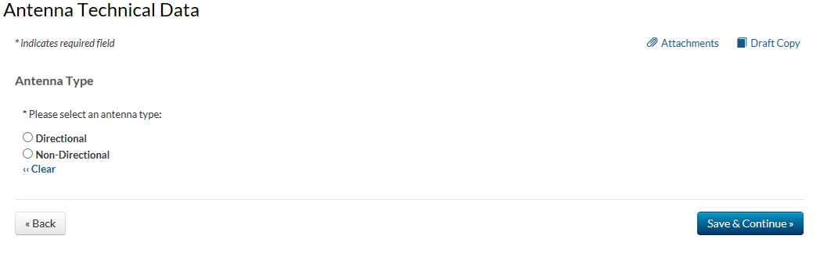
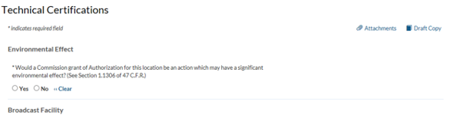
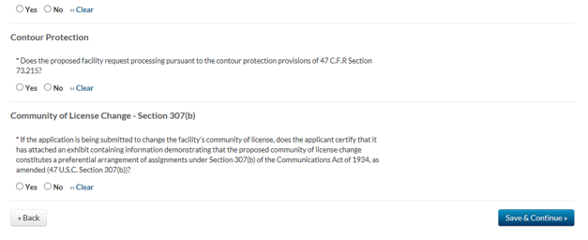
*Does the proposed facility comply with the applicable engineering standards and assigment requirements of 47 CFR Sections 73.203, 73.207, 73.213, 73.315, 73.509, 73.515, and 73.525?

Reasonable Site Assurance
Applicant certifies that it has reasonable assurance in good faith that the site or proposed structure at the location of its transmitting antenna will be available to the applicant for the applicant’s intended purpose.
⃝ Yes ⃝ No « Clear
If reasonable assurance is not based on applicant’s ownership of the proposed site or structure, applicant certifies that it has obtained such reasonable assurance by contacting the owner or person possessing control of the site or structure.
⃝ Yes ⃝ No « Clear
Please specify the name of the person contacted, the person’s telephone number, and whether the contact is the tower owner, agent, or authorized representative.
Name
Telephone Number
Is the contact: ⃝ Tower Owner ⃝ Agent ⃝ Authorized Representative « Clear

