**Screen shot explanations:**

Below you will find screenshots of five sections of the questionnaire – the cover page, section 1, section 2.D, section 2.E, and section 4. For section 2, specifically, we included screenshots of questions in which there are sub-items (see section 2.D1) and questions in which there are single items (see section 2.E) in the matrices. These are included to display how the survey was adapted and programmed based on the original template Word document to maximize clarity and consistency. We have also included a screenshot of the mobile view (see section 4) to show how it will appear for those taking the survey on their mobile device.

**Cover Page:**

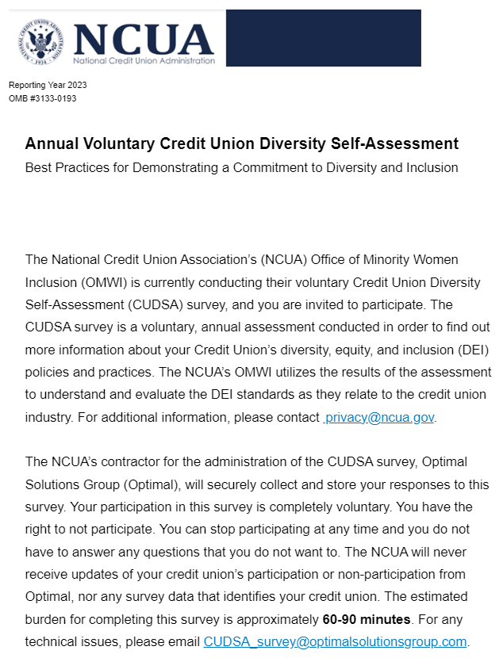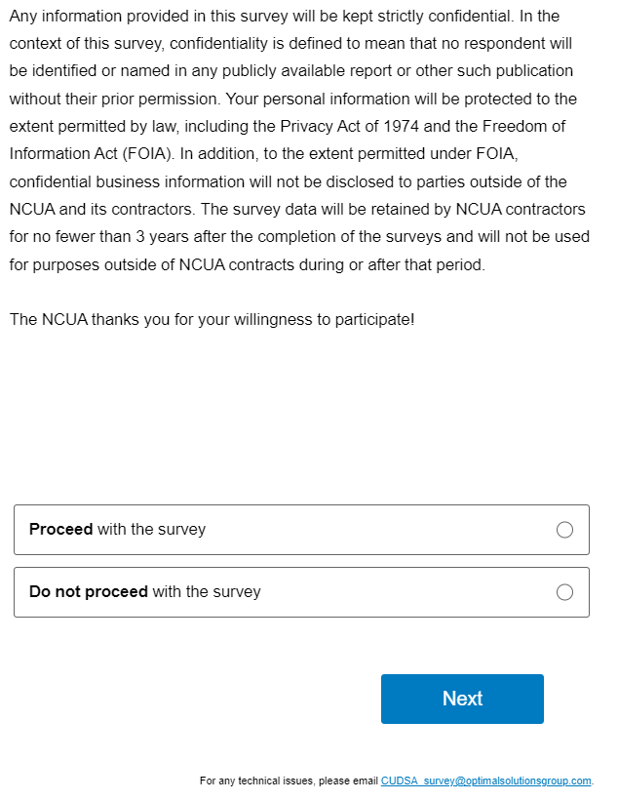

**Section 1 – Credit Union Information**

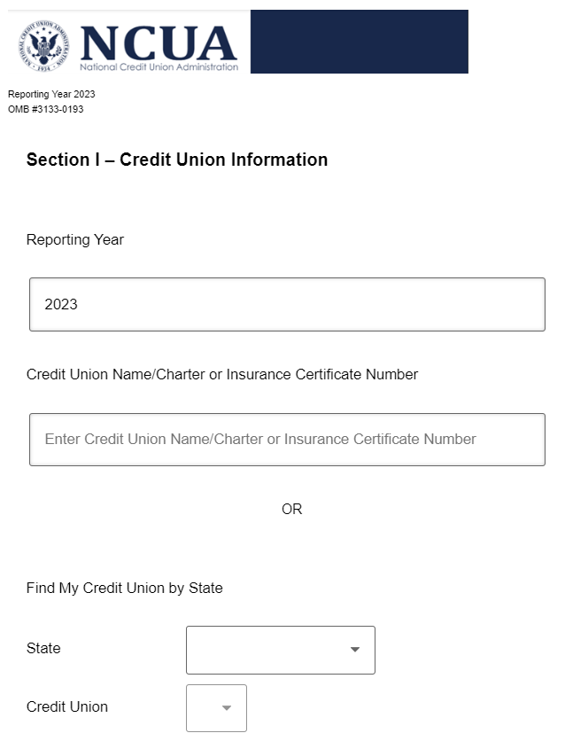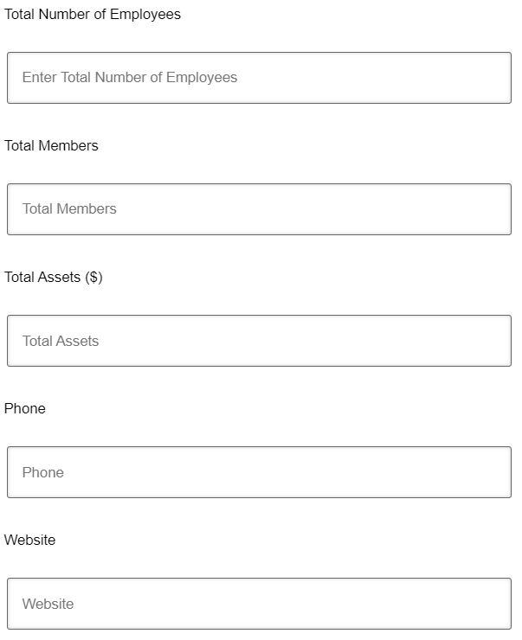

**Section 2 – Self-Assessment Part D1**

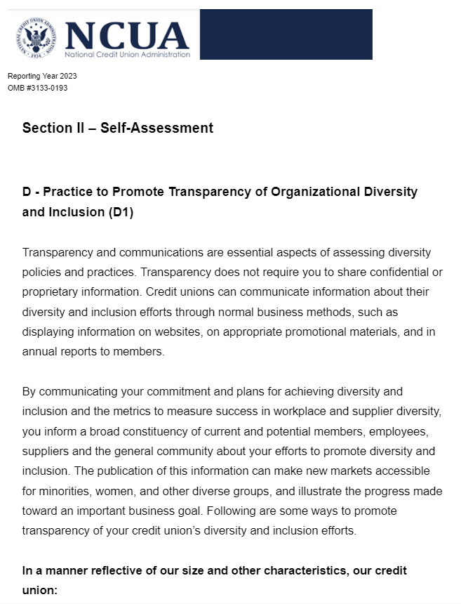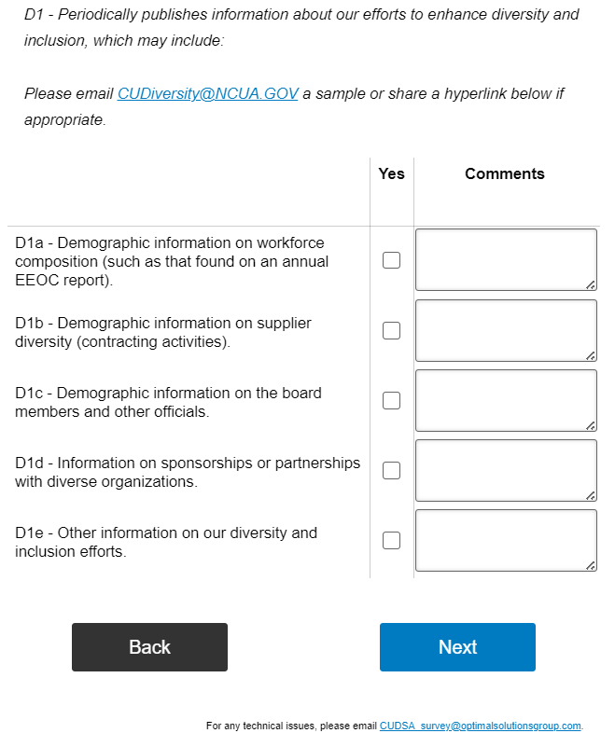

**Section 2 – Self-Assessment Part E**

**Mobile view of Section IV – Recommendations and Feedback**