Supporting Statement

EGG, CHICKEN, AND TURKEY SURVEYS

OMB No. 0535-0004

In an effort to increase the transparency of NASS's survey processes and provide information on the quality of its estimates, NASS publishes Methodology and Quality Measures Reports for some commodities. The Methodology and Quality Measures Reports are published at the same time or shortly after estimates are released.

This supporting statement incorporates data and methodology from the NASS Methodology and Quality Measures Publications located at https://www.nass.usda.gov/Publications/Methodology_and_Data_Quality/Chicken_Eggs/03_2024/cheggsqm.pdf

https://www.nass.usda.gov/Publications/Methodology_and_Data_Quality/Turkey_Raised/10_2023/tkrsqm23.pdf

Every five years NASS conducts a program review following the completion of the Census of Agriculture. NASS considered public input requested through a program review announcement released on Dec. 19, 2023 for these changes.

The poultry program changes are summarized in the following Agricultural Statistics Board Notice:

April 4, 2024 “NASS announces program changes following five-year review” at this link: https://www.nass.usda.gov/Newsroom/Notices/2024/04-04-2024.php.

A. JUSTIFICATION

1. Explain the circumstances that make the collection of information necessary. Identify any legal or administrative requirements that necessitate the collection. Attach a copy of the appropriate section of each statute and regulation mandating or authorizing the collection of information.

The primary functions of the National Agricultural Statistics Service (NASS) are to prepare and issue current official State and national estimates of crop and livestock production, disposition, and prices and to collect information on related environmental and economic factors. Thousands of farmers, ranchers, agribusinesses, and others voluntarily respond to nationwide surveys about their agricultural activities. Estimates of egg, chicken, and turkey production are an integral part of this program.

General authority for these data collection activities is granted under U.S. Code Title 7, Section 2204. This statue specifies that "The Secretary of Agriculture shall procure and preserve all information concerning agriculture which he can obtain ... by the collection of statistics ... and shall distribute them among agriculturists."

2. Indicate how, by whom, and for what purpose the information is to be used. Except for a new collection, indicate the actual use the agency has made of the information received from the current collection.

Summarized data that are published from the surveys included in this docket are needed by USDA economists and government policy makers to ensure the orderly marketing of broiler chickens, turkeys, and eggs. Statistics on these poultry products contribute to a comprehensive program of keeping the government and poultry industry abreast of changes.

The poultry reports are used by producers, processors, feed dealers, and others in the marketing and supply channels as a basis for their production and marketing decisions. Government agencies use these estimates to evaluate poultry product supplies. The Agricultural Marketing Service (AMS) uses statistics from these surveys as check data for their published statistics on daily and weekly slaughter, egg movements, and market conditions. AMS also uses NASS data in their decision-making process when buying poultry and eggs for the school lunch program. Similarly, the data are used by Department of Defense when buying poultry and eggs for the U.S. military. The Foreign Agricultural Service uses NASS data when designing market promotion programs and other export assistance programs. The Farm Service Agency uses poultry data in models to estimate feed use when designing grain programs.

These data are also used by the USDA Economic Research Service (ERS) and the World Agricultural Outlook Board (WAOB) to compute balance sheets for the Agricultural Situation and Outlook reports. Land Grant Universities use the data for research, especially poultry science departments. The data are used by the Food Safety and Inspection Service (FSIS) as check data for their slaughter data, to plan food inspections services, and in preparing their annual report to Congress. The data are used by the Animal and Plant Health Inspection Service (APHIS) to plan the scope of their work. Data are used by the American Egg Board to administer the marketing order assessment program. Poultry data are used by the Environmental Protection Agency (EPA), state governments, the Poultry Water Quality Consortium, and the Chesapeake Bay Foundation to inform decisions on environmental concerns. Many state, county, and township governments use poultry data for economic analysis and economic development programs and loans.

3. Describe whether, and to what extent, the collection of information involves the use of automated, electronic, mechanical, or other technological collection techniques or other forms of information technology, e.g., permitting electronic submission of responses, and the basis for the decision for adopting this means of collection. Also describe any consideration of using information technology to reduce burden.

Respondents can complete the Mink questionnaire by any of the following methods: Computer Assisted Self Interview (CASI), Computer Assisted Telephone Interview (CATI), FAX, or by paper/mail. NASS will utilize enumerators to do follow-up contacts either by phone or face to face interviews of non-respondents. In 2023, the response rate using Internet was 9 percent.

4. Describe efforts to identify duplication. Show specifically why any similar information already available cannot be used or modified for use for the purposes described in Item 2 above.

NASS collaborates with state agricultural agencies and land grant universities to conduct agricultural surveys. This eliminates data gathering by more than one agency. NASS constantly builds and maintains a list frame for sampling which contains egg, chicken, and turkey control data. The names, addresses, and telephone numbers of operations and individuals are continuously monitored to eliminate duplication in this frame. When possible, NASS will collect data from a centralized headquarters if that is how the respondents prefer to report.

5. If the collection of information impacts small businesses or other small entities (Item 5 of OMB Form 83-I), describe any methods used to minimize burden.

The information requested can be provided with a minimum of difficulty from normal operating records. Approximately 45 percent of the operations are small businesses (as defined in the Small Business Administration’s Table of Small Business Size Standards:

SBA Table of Size Standards

6. Describe the consequence to Federal program or policy activities if the collection is not conducted or is conducted less frequently, as well as any technical or legal obstacles to reducing burden.

Poultry and egg numbers can change rapidly because of relatively short reproductive cycles (unlike cattle and hogs, for example). Collecting information less frequently would erode our list frame, result in less precise knowledge of production levels in the poultry industry, and eliminate data needed to keep federal and state agencies, agribusiness suppliers, and other data users abreast of industry changes.

7. Explain any special circumstances that would cause an information collection to be conducted in a manner inconsistent with the general information guidelines in 5 CFR 1320.5.

There are no special circumstances associated with this survey.

8. Provide a copy and identify the date and page number of publication in the Federal Register of the agency's notice, required by 5 CFR 1320.8 (d), soliciting comments on the information collection prior to submission to OMB. Summarize public comments received in response to that notice and describe actions taken by the agency in response to these comments.

The Notice soliciting comments was published in the Federal Register on April 11, 2024 on pages 25560-25561. NASS only received one public comment and it was from Dr. Dennis Fixler at the Bureau of Economic Analysis in support of this renewal request.

Describe efforts to consult with persons outside the agency to obtain their views on the availability of data, frequency of collection, the clarity of instructions and recordkeeping, disclosure, or reporting format (if any), and on the data elements to be recorded, disclosed, or reported.

NASS personnel frequently meet with representatives from other government agencies such as the Agricultural Marketing Service and World Agricultural Outlook Board, as well as agricultural extension programs, cooperatives, and trade associations. Statisticians also maintain contacts with private agricultural groups by attending their meetings whenever possible. NASS holds data user meetings each year, as well, as part of an effort to obtain input from a cross-section of agricultural interests.

As an example of NASS consulting with industry groups, NASS normally has two headquarters representatives who participate in the International Production and Processing Expo (IPPE) in Atlanta each February. IPPE is the world's largest annual poultry, feed, and meat technology expositions. At the exposition, NASS commodity statisticians and management discuss the USDA NASS poultry program with poultry industry leaders, and gain feedback on the NASS statistical program and how industry trends and changes that can be captured in the data that NASS provides the public.

9. Explain any decision to provide any payment or gift to respondents.

There are no payments or gifts to respondents.

10. Describe any assurance of confidentiality provided to respondents and the basis for the assurance in statute, regulation, or agency policy.

Questionnaires include a statement that individual reports are confidential. U.S. Code Title 18, Section 1905; U.S. Code Title 7, Section 2276; and Title III of Pub. L. No. 115-435 (CIPSEA) provide for confidentiality of reported information. All employees of NASS and all enumerators hired and supervised under a cooperative agreement with the National Association of State Departments of Agriculture (NASDA) must read the regulations and sign a statement of compliance.

Additionally, NASS employees and NASS contractors comply with the OMB implementation guidance document, “Implementation Guidance for Confidential Information Protection and Statistical Efficiency Act of 2018, Title III of Pub. L. No. 115-435, codified in 44 U.S.C. Ch. 35” CIPSEA supports NASS’s pledge of confidentiality to all respondents and facilitates the agency’s efforts to reduce burden by supporting statistical activities of collaborative agencies through designation of NASS agents, subject to the limitations and penalties described in CIPSEA.

The following confidentiality pledge statement will appear on all NASS questionnaires.

The information you provide will be used for statistical purposes only. Your responses will be kept confidential and any person who willfully discloses ANY identifiable information about you or your operation is subject to a jail term, a fine, or both. This survey is conducted in accordance with the Confidential Information Protection and Statistical Efficiency Act of 2018, Title III of Pub. L. No. 115-435, codified in 44 U.S.C. Ch. 35 and other applicable Federal laws. For more information on how we protect your information please visit: https://www.nass.usda.gov/confidentiality. Response to this survey is voluntary.

11. Provide additional justification for any questions of a sensitive nature.

There are no questions of a sensitive nature.

12. Provide estimates of the hour burden of the collection of information. The statement should indicate the number of respondents, frequency of response, annual hour burden, and an explanation of how the burden was estimated. If this request for approval covers more than one form, provide separate hour burden estimates for each form and aggregate the hour burdens in Item 13 of OMB Form 83-I. Provide estimates of annualized cost to respondents for the hour burdens for collections of information, identifying and using appropriate wage rate categories.

The following table contains the estimated burden hours for the surveys included in this docket. Cost to the public for completing the questionnaire is assumed to be comparable to the hourly rate of those requesting the data. Average annual reporting time of 3,900 hours is multiplied by $42.75 per hour for a total annual cost to the public of $166,725.00.

NASS uses the Bureau of Labor Statistics’ Occupational Employment Statistics (most recently published on April 3, 2024 for the previous May) to estimate an hourly wage for the burden cost. The May 2023 mean wage for bookkeepers was $23.84. The mean wage for farm managers was $43.35. The mean wage for farm supervisors was $29.23. The mean wage of the three is $32.14. To calculate the fully loaded wage rate (includes allowances for Social Security, insurance, etc.) NASS will add 33% for a total of $42.75 per hour.

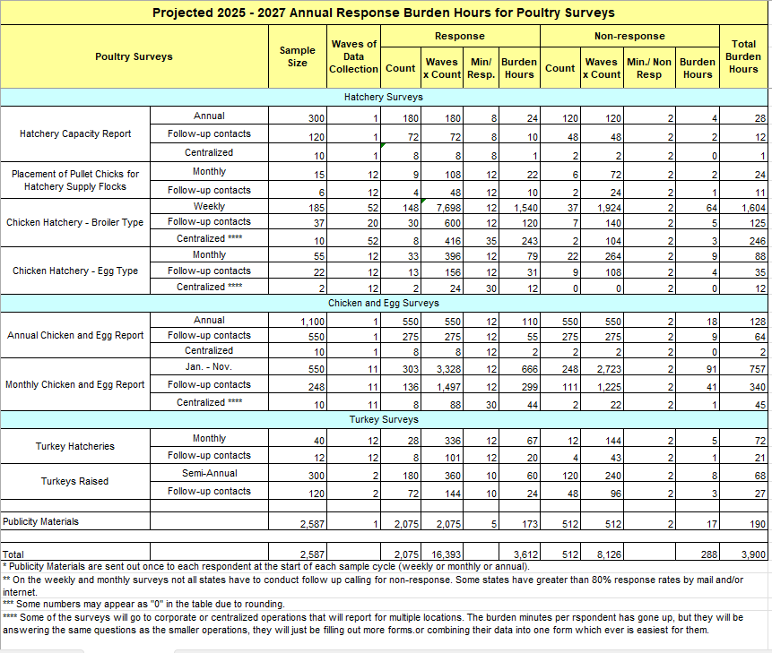
13. Provide estimates of the total annual cost burden to respondents or record keepers resulting from the collection of information, (do not include the cost of any hour burden shown in items 12 and 14). The cost estimates should be split into two components: (a) a total capital and start-up cost component annualized over its expected useful life; and (b) a total operation and maintenance and purchase of services component.

There are no capital/start-up or ongoing operation/maintenance costs associated with this information collection.

14. Provide estimates of annualized cost to the Federal government; provide a description of the method used to estimate cost which should include quantification of hours, operational expenses, and any other expense that would not have been incurred without this collection of information.

The total cost to the federal government for the poultry surveys is approximately $2,000,000. Most of the total cost goes to federal personnel wages and benefits; the remainder is for data collection, supplies, postage, computer processing, and similar items.

15. Explain the reasons for any program changes or adjustments reported in Items 13 or 14 of the OMB Form 83-I (reasons for changes in burden).

There was a decline in both the total number of responses and the total burden hours, with reductions of 882 and 72, respectively.

Minor adjustments have been made to the program since the previous approval, reflecting changes in the target population.

16. For collections of information whose results will be published, outline plans for tabulation and publication. Address any complex analytical techniques that will be used. Provide the time schedule for the entire project, including beginning and ending dates of the collection of information, completion of report, publication dates, and other actions.

Weekly broiler hatchery data are collected by NASS Regional Field Offices (RFOs) and Headquarters from questionnaires mailed each week. Data are for the full week, ending on Saturday. Any reports not received by the following Monday are followed up by telephone or personal interview. Each RFO summarizes the data and sends a report to NASS Headquarters in Washington, DC by Wednesday. After national information is summarized and reviewed by the statisticians in the Poultry & Specialty Commodities Section, it is released to the public the same day in the Broiler Hatchery report, as described in the Data Collection and Publication table below. The Broiler Hatchery report can be found at:

https://usda.library.cornell.edu/concern/publications/gm80hv35d

Monthly chicken hatchery, chicken and egg growers, and turkey hatchery survey data are collected by the RFOs from questionnaires mailed to respondents near the end of the reference month and returned early the following month. Survey data and state RFO statistician recommendations are sent to NASS Headquarters by the middle of the following month. Data are summarized and published about the 22nd in the monthly Chickens and Eggs:

https://usda.library.cornell.edu/concern/publications/fb494842n

or about the 15th in the monthly Turkey Hatchery:

https://usda.library.cornell.edu/concern/publications/k643b117x

The monthly Placement of Pullet Chicks for Hatchery Supply Flocks survey is conducted from the Poultry Section in NASS Headquarters. This specialized data is collected from the leading breeders who usually have facilities in several states. The data are collected at the national level only and are also published in the monthly Chickens and Eggs release.

Semi-Annual turkeys raised data are collected primarily by questionnaires mailed to producers on September 1 and on February 1. Telephone follow-up interviews are conducted of non-respondents in mid-September and mid-February to meet published release dates. The September data is published in the Turkeys Raised release at the end of September:

https://usda.library.cornell.edu/concern/publications/0g354f23n

The February data is published in the Poultry Production & Value annual summary in April:

https://usda.library.cornell.edu/concern/publications/m039k491c

Annual hatchery capacity, chicken hatchery, and chicken and egg grower’s data are collected primarily by questionnaires mailed in late December. Telephone follow-ups are completed in January to meet the various due dates. The annual publications are Hatchery Production:

https://usda.library.cornell.edu/concern/publications/9306sz28s

and the Chickens and Eggs Annual Summary:

https://usda.library.cornell.edu/concern/publications/1v53jw96n

These publications also include data from the monthly surveys.

Poultry data are also published in the Agricultural Prices Summary:

https://usda.library.cornell.edu/concern/publications/c821gj76b

and in the Cold Storage monthly and annual reports

https://usda.library.cornell.edu/concern/publications/pg15bd892

Data Collection and Publication
Survey | Data Collection |  |  | Publication
 | Timing | Survey Period | Reference Date | Date of Release | Name of Release
Hatchery Capacity | Annual | Jan | Jan 1st | Apr 15th -19th | Annual Hatchery Production
Placement of Pullet Chicks for Hatchery Supply Flocks | Monthly | 10th -22nd | Previous month | Monthly: around the 22nd of each month, and annually: mid-April | Monthly Chickens and Eggs and Annual Hatchery Production
Chicken Hatchery – Broiler Type | Weekly | Sat -Tues | Previous week ending on Saturday | Weekly: Wed. | Weekly Broiler Hatchery and Monthly Chickens and Eggs
Chicken Hatchery – Egg Type | Monthly | 1st -18th | Previous month | Around the 22nd | Monthly Chickens and Eggs
Chicken and Egg Report | Dec | 1st-15th | First of the month and previous month | Around the 22nd | Monthly Chickens and Eggs
 | Jan-Nov |  |  |  | Chicken and Eggs Annual Summary
 |  |  |  | April | Poultry Production and Values
Turkey Hatcheries | Monthly | 1st-12th | First of the month and previous month | Around the 15th | Monthly Turkey Hatchery
 |  |  |  | Mid-April | Annual Hatchery Production
Turkeys Raised | Semi-Annual | Feb. | Previous year | April | Poultry Production and Values
 |  | Sept | Current year | September | Turkeys Raised

17. If seeking approval to not display the expiration date for OMB approval of the information collection, explain the reasons that display would be inappropriate.

There is no request for approval of non-display of the expiration date.

18. Explain each exception to the certification statement identified in Item 19, “Certification for Paperwork Reduction Act Submissions” of OMB Form 83-I.

There are no exceptions to the certification statement.

September 2024

