Supporting Statement

**EGG, CHICKEN, AND TURKEY SURVEYS**

OMB No. 0535-0004

In an effort to increase the transparency of NASS's survey processes and provide information on the quality of its estimates, NASS publishes Methodology and Quality Measures Reports for some commodities. The Methodology and Quality Measures Reports are published at the same time or shortly after estimates are released.

This supporting statement incorporates data and methodology from the NASS Methodology and Quality Measures Publications located at <https://www.nass.usda.gov/Publications/Methodology_and_Data_Quality/Chicken_Eggs/03_2024/cheggsqm.pdf>

<https://www.nass.usda.gov/Publications/Methodology_and_Data_Quality/Turkey_Raised/10_2023/tkrsqm23.pdf>

Every five years NASS conducts a program review following the completion of the Census of Agriculture. NASS considered public input requested through a program review announcement [released on Dec. 19, 2023](https://www.nass.usda.gov/Newsroom/Notices/2023/12-19-2023.php) for these changes.

The poultry program changes are summarized in the following Agricultural Statistics Board Notice:

April 4, 2024 “NASS announces program changes following five-year review” at this link: <https://www.nass.usda.gov/Newsroom/Notices/2024/04-04-2024.php>

**B. COLLECTION OF INFORMATION EMPLOYING STATISTICAL METHODS**

**1. Describe (including a numerical estimate) the potential respondent universe and any sampling or other respondent selection method to be used. Data on the number of entities (e.g., establishments, State and local government units, households, or persons) in the universe covered by the collection and in the corresponding sample are to be provided in tabular form for the universe as a whole and for each of the strata in the proposed sample. Indicate expected response rates for the collection as a whole. If the collection has been conducted previously, include the actual response rate achieved during the last collection.**

NASS’ poultry surveys can be separated into three groups based on target population: hatchery surveys target operations that hatch chickens or turkeys; chicken surveys target operations that raise pullets for hatcheries, broilers for meat production and pullets and layers for egg production; and turkey surveys target operations that raise turkeys for meat or egg production. Recent poultry sample sizes, response rates, and coverage rates (where response rates were less than 80 percent) are shown in Table B1.

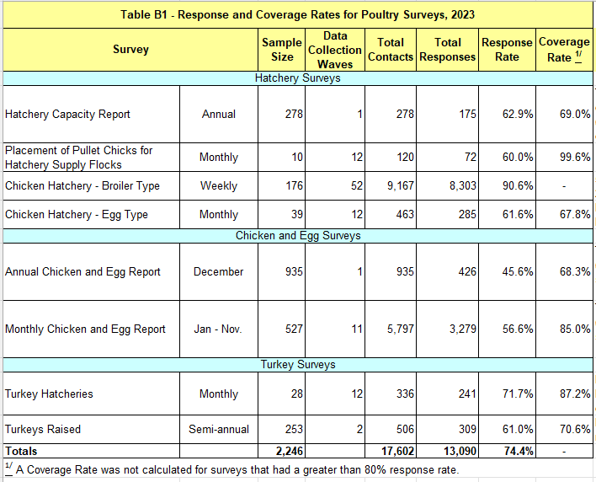

Hatchery Capacity Report – The Annual Hatchery Capacity survey is a census of all operations on NASS’s List Frame with a minimum hatch capacity of 1,000 birds (chicken and/or turkeys laying eggs).

Chicken Hatchery Surveys – The *Weekly* Chicken Hatchery survey is a census of all operations on NASS’s List Frame that hatch at least one million *broiler* chicks a year. The *Monthly* Chicken Hatchery survey is a census of all operations that hatch at least one million *egg layer* chicks a year.

Placement of Pullet Chicks for Hatchery Supply Flocks – The Monthly Pullet Placement survey is a census of operations on NASS’s List Frame that raise pullets for hatcheries.

Chicken and Egg Reports – The December Chicken and Egg survey is a census of all egg or broiler hatch flocks, table egg flocks or pullet-only operations on NASS’s List Frame that have at least 20,000 table egg layers, hatchery supply flocks, and/or 500 pullets, respectively. The January through November Monthly Chicken and Egg surveys are a census of all egg or broiler hatch flocks, table egg flocks or pullet-only operations on NASS’s List Frame that have at least 30,000 table egg layers, hatchery supply flocks, and/or 500 pullets.

Turkey Hatcheries Survey – The Monthly Turkey Hatchery Survey is a census of all operations on NASS’s List Frame that hatch at least 15,000 turkey chicks.

Turkeys Raised Survey – The Turkeys Raised sampling frame comprises all operations on NASS’s List Frame in program states that raise at least 1,000 turkeys annually or are Turkey contractors in program states; it is sampled at a 100% rate. The Turkey Raised survey is administered biannually.

**2. Describe the procedures for the collection of information including:**

**• statistical methodology for stratification and sample selection,**

**• estimation procedure,**

**• degree of accuracy needed for the purpose described in the justification,**

**• unusual problems requiring specialized sampling procedures**

Hatchery Capacity Report – Individual hatchery data are summed to State, regional, and US totals. The capacity survey gives an indication of what the maximum possible production could be and allows a measure of how close to capacity hatcheries are operating.

Placement of Pullet Chicks for Hatchery Supply Flocks – This monthly survey collects chicks hatched data on egg-type and broiler-type chicks intended for hatching flock replacements. It also includes chicks expected from eggs sold during the preceding month by primary breeders. The indications show the potential number of pullets available for addition to hatchery supply flocks several months before the pullets are moved into the flocks. Because the nationwide population of pullet placement breeders is relatively small and these companies typically have facilities in several states, this survey is conducted directly by NASS Headquarters and only US-level data is collected.

Chicken Hatchery Surveys – The hatchery surveys for chickens provide current data on the number of eggs set in incubators, the number of chicks hatched, and the number of chicks placed. Number of eggs set affects the forthcoming chick hatch. Number placed, in turn, correlates to the number of broilers produced. The number of egg-type chicks hatched ultimately affects the table egg layer inventory.

Chick placements are a reliable indicator of forthcoming broiler supplies. Broilers produced and processed lag chick placements by approximately 7 weeks, since the growing period for broilers is 6 to 7 weeks. Eggs set statistics, which also come from the weekly Hatchery Survey, provide an additional three weeks of lead time for marketers to adjust their marketing strategy. With broilers having a relatively short production period and the industry made up of large organizations with the capacity to over-produce, the weekly Hatchery Survey closely monitors forthcoming supplies and contributes to orderly marketing of broilers.

Hatcheries are asked to report the number of broiler chicks delivered to other states. This question alerts the regional field offices to cross-state movements so that chick placement can be correctly recorded to determine the state in which they were grown for value of production estimates.

Chicken and Egg Reports – The December survey establishes the sample for the monthly survey (January through November). Since the samples differ slightly, coverage for operations with less than 30,000 table egg layers is estimated each month based on Agricultural Census data and data reported in December.

Reports from egg flock operators allow NASS to estimate monthly numbers of layers on hand, rate of lay, and total egg production by type of flock (table egg flocks and hatching egg flocks). Estimates are made for layers (mature female chickens producing marketable eggs). Estimates of molting percentages are made for layers that are being force molted and those that have completed one or more forced molts. An estimate is also made for pullets (female chickens prior to laying the first marketable egg). Estimates of monthly egg production are based on the indicated daily rate of egg production on the first of the month. Rate of lay during the month is derived and multiplied by an estimate of the number of layers on hand during the month to estimate egg production for the month.

Rate of lay and number of layers provide a measure of the current status of the nation’s laying flock. Monthly laying rate, when correlated with historic data, provide a very reliable indicator of future rates of lay.

Turkey Hatcheries Survey –The data collected are eggs in incubators on the first of the month, the disposition of the poults hatched and poult placement information from the previous month. Only US-level estimates are published due to the limited number of states involved.

Turkeys Raised Survey – Turkeys raised preliminary estimates include young turkeys intended for meat production and breeder turkeys reaching maturity during the calendar year. The estimates exclude turkeys lost to disease or those destroyed. Placement of turkey poults from the monthly Turkey Hatchery Survey and indications from the September Turkeys Raised Survey provides the basis for the preliminary estimates published in September. Final estimates, published in April, use indications from the February Turkeys Raised Survey in addition to updated hatchery data. Other indications for the final estimates are obtained from monthly slaughter totals and check-off data provided by individual state turkey or poultry associations.

In general, for each survey all data are analyzed for unusual values. Data from each operation are compared to their own past operating profile and to trends from similar operations. Data for missing operations are estimated based on similar operations or historical data. NASS regional field offices prepare estimates by using a combination of survey indications and historic trends. Individual state and national estimates are reviewed by the Agricultural Statistics Board for reasonableness.

**3. Describe methods to maximize response rates and to deal with issues of non-response. The accuracy and reliability of information collected must be shown to be adequate for intended uses. For collections based on sampling a special justification must be provided for any collection that will not yield "reliable" data that can be generalized to the universe studied.**

NASS personnel frequently consult with trade associations and other agricultural groups to ensure that questionnaires are relevant to respondents and the requested data are easy to report. For example, as a result of a meeting with the United Egg Producers’ (UEP) “Information Sharing Committee,” NASS redesigned the monthly *Chicken and Egg Report* and the UEP published a story in their *United Voices Newsletter* explaining the importance of the data NASS collects and stating that they hope “all egg farmers will complete the survey on a monthly basis.”

Survey data are subject to non-sampling errors such as omissions and mistakes in reporting and in processing the data. Error is minimized by carefully reviewing all reported data for consistency and reasonableness.

Indications from the poultry surveys provide reliable estimates. The published chicken egg-producing States account for approximately 95 percent of the nation's total egg production. The major turkey-producing published States account for 88 percent of total US turkey production. The remaining turkey-producing States, published aggregately as other States, are modeled from the 2022 Census of Agriculture, thus allowing NASS to publish an estimate at the national level.

**4. Describe any tests of procedures or methods to be undertaken.**

Statisticians have frequent contact with egg, chicken, and turkey producers when collecting data and at the various association meetings. Procedures and methods are discussed with respondents and data users to seek improvements.

**5. Provide the name and telephone number of individuals consulted on statistical aspects of the design and the name of the agency unit, contractor(s), or other person(s) who will actually collect and/or analyze the information for the agency.**

Survey design and methodology are determined by the Summary, Estimation, and Disclosure Methodology Branch, Methodology Division; Branch Chief is Lindsay Drunasky. Lindsay’s email is [lindsay.drunasky@usda.gov](mailto:lindsay.drunasky@usda.gov) and phone number is (202) 690-8141.

Sample sizes for each State are determined by the Sampling, Editing, and Imputation Methodology Branch, Methods Division; Branch Chief is Andrew Dau. Andrew’s email is [andrew.dau@usda.gov](mailto:andrew.dau@usda.gov) and phone number is (202) 690-8141.

Data collection is carried out by NASS Field Offices; Eastern Field Operation’s Director is Jody McDaniel. Jody’s email is [jody.mcdaniel@usda.gov](mailto:jody.mcdaniel@usda.gov) and phone number is (202) 720-3638. Western Field Operation’s Director is King Whetstone. King’s email is [king.whetstone@usda.gov](mailto:king.whetstone@usda.gov). His phone number is (202) 720-9567.

The Census and Survey Division, Survey Administration Branch Chief is Suzanne Adams. Suzanne’s email is [suzanne.adams@usda.gov](mailto:suzanne.adams@usda.gov) and phone number is (202) 720-4028.

Statistics Division, Livestock Branch is responsible for national and regional summaries, analysis, and presentation of data to the Agricultural Statistics Board for final estimates, publication, and the Estimation Manual. The Livestock Branch Chief is Travis Averill. Travis’s email is [travis.averill@usda.gov](mailto:travis.averill@usda.gov) and phone number is (202) 692-0069.

September 2024