**United States Department of Agriculture**

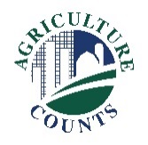

National Agricultural Statistics Service

October 27, 2023

**Why am I getting this letter?**

**What should I do next?**

Complete your survey in one of the following ways:

**Online** at [agcounts.usda.gov](http://www.agcounts.usda.gov) **Online reporting is fast and secure*.*** You just need your unique survey code on the enclosed form to begin.

By **mail or fax**. Complete the questionnaire and mail it back in the prepaid return envelope provided or fax it to 855-415-3687.

Enclosed is your Cost of Pollination Inquiry – November 2023. Your participation is important. Please complete the questionnaire at your earliest convenience.

You may receive an email reminder to complete your survey. If we do not receive your completed questionnaire by Tuesday, November 14, 2023, we will contact you for an interview.



**How will the data be used?**

The survey data help producers and beekeepers monitor and react to changes in production costs. Pollination expenditures are a necessary part of agriculture and are directly tied to the health of the honey bee industry.

We recommend you respond online. On the Respondent Portal, you can complete your surveys, track upcoming surveys, access data visualizations and reports of interest, link to other USDA agencies, and more.

The information you provide will be used for statistical purposes only. In accordance with federal law, your responses will be kept confidential and will not be disclosed in identifiable form. We will publish the data Friday, December 15, 2023, in the *Cost of Pollination* report at nass.usda.gov/publications and in NASS’s searchable database quickstats.nass.usda.gov.

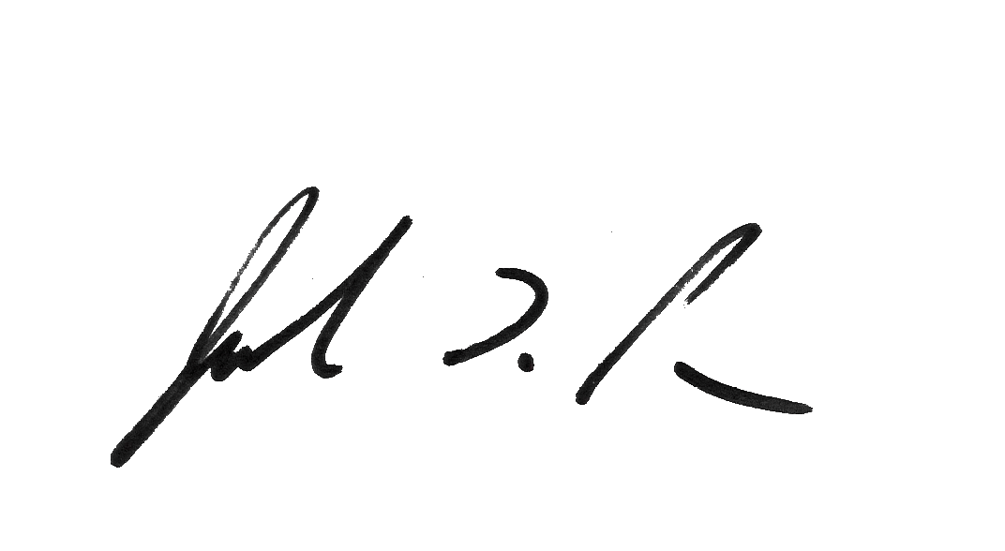Thank you for your participation and support of U.S. agriculture. For more information about this survey, visit [nass.usda.gov/go/bees/.](http://www.nass.usda.gov/go/bees/) If you need assistance, please contact us at 888-424-7828.

Sincerely,

Joseph L. Parsons

Chair, Agricultural Statistics Board

USDA National Agricultural Statistics Service

Enclosure