**Request for Nonsubstantive Change**

**ICR 0579-0297**

**May 10, 2024**

APHIS conducted a review of VS Form 1-36A, National Veterinary Accreditation Program Application Form, and requests approval for the following nonsubstantive changes.

The changes are the result of consolidating and modifying several blocks.

The changes do not affect response time or burden.

**Page 1 – Block 32 Certification Statement Updated**

CURRENT

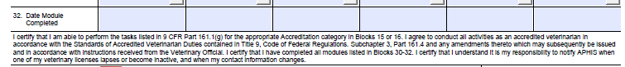

CHANGE TO

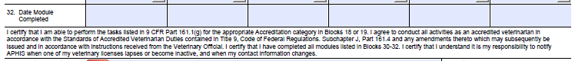

**Page 1 – Changed Veterinarian-in-Charge to Veterinary Official – inside RED boxes below.**

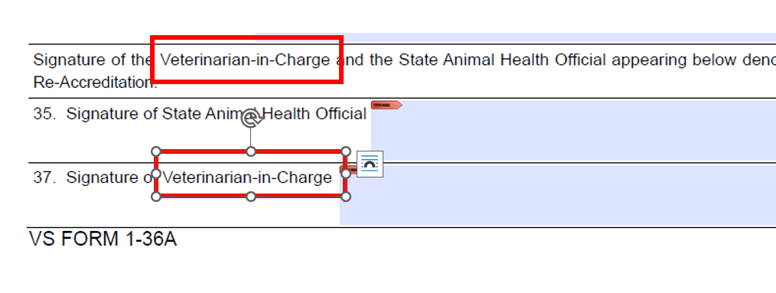

**Page 4 – Explanation of Codes – Changed 4 instances of (Blocks 15 & 16) to (Blocks 18 &19):**

