**Request for Nonsubstantive Change**

**ICR 0579-0297**

**September 4, 2024**

APHIS conducted a review of VS Form 1-36A, National Veterinary Accreditation Program Application Form, and requests approval for nonsubstantive changes.

The changes clarify the information being requested in the instructions on page 3 of 4.

The changes do not affect response time or burden.

**CURRENT – Page 3**

Instructions for Blocks 1, 2, 3, 4, 5, 6:

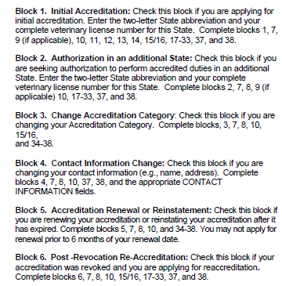

**CHANGE TO**

Instructions for Blocks 1, 2, 3, 4, 5, 6:

