File Name: SEC protocol doc 8.16.24 (updated 8.19.24)

**Social and Economic Survey of Hired Captains and Crew in U.S. South Atlantic, Gulf of Mexico, Puerto Rico, and U.S. Virgin Islands Commercial Fisheries**

**FREQUENTLY ASKED QUESTIONS (FAQS)**

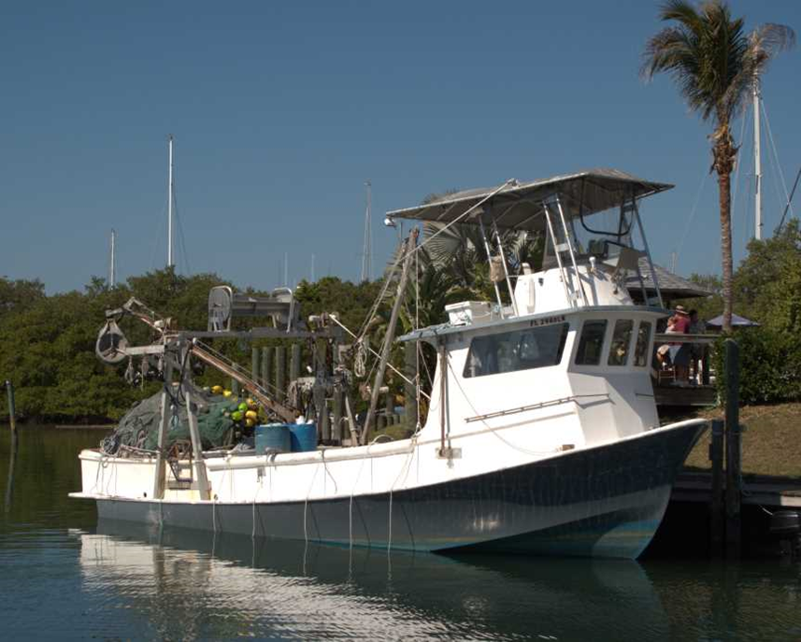

**Social Sciences Research Group**

**Southeast Fisheries Science Center**

**Miami, FL**

**socio**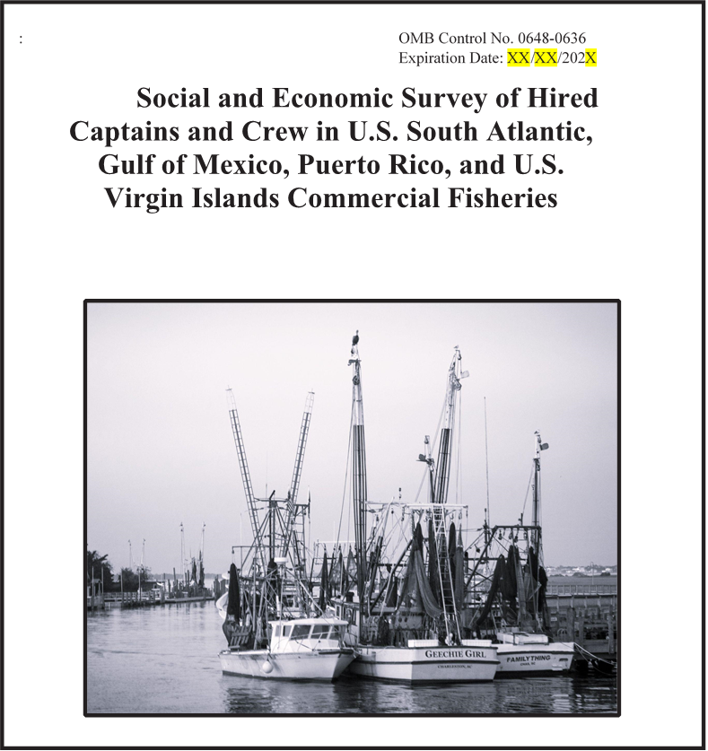

*Public reporting burden for this collection of information is estimated to average 20 minutes per response, including the time for reviewing instructions, searching existing data sources, gathering and maintaining the data needed, and completing and reviewing the collection of information. Send comments regarding this burden estimate or any other suggestions for reducing this burden to Matthew McPherson, 75 Virginia Beach Drive, Miami, Florida 33149 Email: matthew.mcpherson@noaa.gov*

**Notwithstanding any other provisions of the law, no person is required to respond to, nor shall any person be subjected to a penalty for failure to comply with, a collection of information subject to the requirements of the Paperwork Reduction Act, unless that collection of information displays a currently valid OMB Control Number.**

***Please tell us about your commercial fishing in the last year.***

***The information you provide will remain private and you will not be identified with your answers.***

1. **INTERVIEW INFORMATION**

**1.1 Interviewer’s Name: ______________________________________________________________**

**1.2 Date: ___________________________________________________________________________**

**1.3 Start time: ____________**

**1.4 End time: ____________**

**1.5 Location of Interview: _____________________________________________________________**

**1.6 Without asking, mark the gender of the person being interviewed: ___ Female ___ Male**

1. **INFORMATION ABOUT FISHING ACTIVITIES**

**2.1 Are you currently working as a hired captain or hired crew member, full time or part time, on one or more commercial fishing vessels?**

1. Yes

2. No (discontinue interview)

**2.2 How many years have you been involved in commercial fishing?**

Years (Interviewer instruction: round to nearest full year)

**2.3 How many different vessels did you work on in the past year?**

____________ Vessels

**2.4 How many different vessel owners or companies did you work for in the last year?**

___________Vessel owners

**2.5 How many years have you worked for the vessel owner or company that you have worked for the longest?**

____________ Years

**2.6 What was your position on commercial fishing vessels in the last year? (MARK ALL THAT APPLY).**

1. Captain _____

2. First mate/rig man _____

3. Deck hand/header _____

4. Other (please specify) ____________________________________

**2.7 Are you related by family ties (e.g. sibling, cousin, in-laws) to the owner of your primary vessel?**

1. Yes

2. No

**2.8 In the last year, did you also work as a hired crew member in the recreational for-hire fishing industry (charter boat/ head boat/ party boat/ fishing guide)?**

1. Yes

2. No

**2.9 What port did you primarily work out of in the last year?**

City __ County State_______________________

**2.10 Did you work in more than one commercial fishery last year?**

1. Yes

2. No

**2.11 In what commercial fisheries did you work during the past year?** (check all that apply)

**Federally-managed fisheries**

1. Shrimp
2. Reef Fish
3. King Mackerel
4. Spanish Mackerel
5. Dolphin
6. Shark
7. Swordfish
8. Tuna
9. Spiny Lobster
10. Snapper-Grouper, South Atlantic, incl. wreckfish
11. Golden Crab

**State-managed fisheries**

1. Stone Crab
2. Other Crabs
3. Oysters / Mollusks
4. Bait Fishery, including bait shrimp
5. Menhaden/Industrial Fisheries
6. Other _____________________________ (write in)
7. Other _____________________________ (write in)
8. Other _____________________________ (write in)

**2.12 Approximately how many days total did you spend working at sea in the past year? ___________**

(If they only worked in one fishery, skip to question 2.14)

**2.13 If you worked in more than one fishery, approximately how many days at sea did you spend working in each one of these fisheries in the past year?**

Primary fishery name: _______________________________ Days at sea per year: _________________

Second fishery name: _______________________________ Days at sea per year: _________________

Third fishery name: _________________________________ Days at sea per year: _________________

**2.14 In the last year, approximately how much did you earn from commercial fishing (please check the appropriate box)?**

| 1. Under $5000 |  |
| --- | --- |
| 2. $5,000 to $10,000 |  |
| 3. $10,000 to $20,000 |  |
| 4. $20,000 to $30,000 |  |
| 5. $30,000 to $40,000 |  |
| 6. $40,000 to $50,000 |  |
| 7. $50,000 to $75,000 |  |
| 8. $75,000 to $100,000 |  |
| 9 Over $100,000 |  |
| 10. Don’t know |  |
| 11. Refused |  |

**2.15 For your primary vessel, what is your pay based on?**

1. A share system: (earnings based on total proceeds from trip)
2. Daily or hourly rate
3. Annual or long-term contract
4. Other: _______________________________________

**2.16 On your primary vessel, with what type of contract were you employed?**

1. Independent contractor (receive 1099 MISC for taxes)
2. Full-time employee (receive W-2 for taxes)
3. Temporary/Seasonal worker (H2B visa)
4. Other: _____________________________________________
5. Don’t know or do not respond

**2.17 Do you regularly take catch home after a commercial fishing trip for your household?**

1. Yes

2. No

**2.18 As of today, how many years have you worked on your primary vessel in all positions?**

**__________**Years (round to nearest full year)

1. **ISSUES AND CHALLENGES**

**3.1 Please indicate the extent to which you agree or disagree with the following statements regarding the rules and regulations in your primary fishery. (CHECK ONE RESPONSE PER ITEM)**

|  | Strongly Disagree | Disagree | Neutral | Agree | Strongly Agree |
| --- | --- | --- | --- | --- | --- |
| 1. I am very familiar with the fishing regulations in my primary fishery | 1 | 2 | 3 | 4 | 5 |
| 1. I feel safe when fishing on my primary vessel | 1 | 2 | 3 | 4 | 5 |
| 1. The regulations in my primary fishery are too restrictive. | 1 | 2 | 3 | 4 | 5 |

**3.2 Would you advise a young person to enter the commercial fishing industry?**

1. YES

2. NO

3. UNSURE

**3.3 Would you still be a commercial fisherman if you had your life to live over?**

1. YES

2. NO

3. UNSURE

**3.4 How satisfied or dissatisfied are you with the following aspects of your fishing job? (CHECK ONE RESPONSE PER ITEM)**

|  |  | Very  Dissatisfied | Dissatisfied | Neutral | Satisfied | Very  Satisfied |
| --- | --- | --- | --- | --- | --- | --- |
| a. | Your earnings | 1 | 2 | 3 | 4 | 5 |
| b. | The predictability of your earnings | 1 | 2 | 3 | 4 | 5 |
| c. | Level of enjoyment | 1 | 2 | 3 | 4 | 5 |
| d. | Levels of Safety/Danger | 1 | 2 | 3 | 4 | 5 |
| e. | The amount of time spent away from home | 1 | 2 | 3 | 4 | 5 |
| f. | Physical nature of the job | 1 | 2 | 3 | 4 | 5 |
| g. | Impacts on your health | 1 | 2 | 3 | 4 | 5 |

1. **HOUSEHOLD CHARACTERISTICS AND CONTRIBUTIONS**

**4.1 Where is your *primary household* located?**

1. Country: USA: _______ Other (specify): _________________________________
2. City: ___________________________
3. County (if applicable): ___________________________________________
4. State/Municipality/Province: ______________________________________
5. Zip Code (if applicable): ________________________

**4.2** **How many people lived in your primary household over the past year, including yourself?**

________ Adults (18 and over) ________ Children under 18

**4.3** **Please list the three largest sources of your household’s overall income in the past year (e.g., commercial fishing, other employment, government assistance, or investment income), starting with the largest. Please consider all sources of income from everyone that lives in your household.**

1. Largest source of income ________________________________________________________
2. Second largest source of income __________________________________________________
3. Third largest source of income ___________________________________________________

**4.4 Approximately what percentage of your total household income in the past year came from commercial fishing activities?** _______%

**4.5 Did you have health insurance in the last year?**

1. Yes (CONTINUE)

2. No (SKIP TO QUESTION 5.1)

**4.6 Where did the insurance come from?**

1. Vessel owner

2. Spouse’s employer

3. Federal or state insurance program

4. Other: _____________________________

1. **PERSONAL AND DEMOGRAPHIC CHARACTERISTICS**

**5.1 Where were you born?**

1. U.S.
2. Outside U.S. Please specify: _____________________________________________________

**5.2 In what year were you born? ___________**

**5.3 What is your race and/or ethnicity? *Select all that apply and enter additional details in the spaces below****.*

* *.* American Indian or Alaska Native – *Enter, for example, Navajo Nation,*

*Blackfeet Tribe of the Blackfeet Indian Reservation of Montana, Native Village of*  *Barrow Inupiat Traditional Government, Nome Eskimo Community, Aztec, Maya, etc.*

* Asian – *Provide details below.*

¨ Chinese Asian Indian Filipino

¨ Vietnamese Korean Japanese

*Enter, for example, Pakistani, Hmong, Afghan, etc.*

* ¨ Black or African American – *Provide details below.*

¨ African American Jamaican Haitian

¨ Nigerian Ethiopian Somali

*Enter, for example, Trinidadian and Tobagonian, Ghanaian, Congolese, etc.*

* ¨ Hispanic or Latino – *Provide details below.*

¨ Mexican Puerto Rican Salvadoran

¨ Cuban Dominican Guatemalan

*Enter, for example, Colombian, Honduran, Spaniard, etc.*

* Middle Eastern or North African – *Provide details below.*

¨ Lebanese Iranian Egyptian

¨ Syrian Iraqi Israeli

*Enter, for example, Moroccan, Yemeni, Kurdish, etc.*

* Native Hawaiian or Pacific Islander – *Provide details below.*

¨ Native Hawaiian Samoan Chamorro

¨ Tongan Fijian Marshallese

*Enter, for example, Chuukese, Palauan, Tahitian, etc.*

* White – *Provide details below.*

¨ English German Irish

¨ Italian Polish Scottish

*Enter, for example, French, Swedish, Norwegian, etc.*

**5.4 What is the primary language you speak at home?**

1. English
2. Spanish
3. Vietnamese
4. Other: ______ _______

**5.5 What is the highest level of education you have completed?**

1. Did not complete high school

2. High school diploma/equivalency

3. Associate’s/ two-year degree or trade school

4. Bachelor’s/ four-year degree

5. Graduate degree

**5.6 Do you have any other formal qualifications, including licenses, certificates or training, related to your commercial fishing activities?**

1. Yes (Specify): ______________________________________________________________________________
2. No

**5.7 What is your current marital status?**

1. Never Married
2. Married or Living with Partner
3. Widowed
4. Divorced/Separated
5. **OTHER COMMENTS**

**6.1 Is there anything else you would like to tell us that you think fisheries managers should know about?**

**__________________________________________________________________________________________**

**____________________________________________________________________________________________________________________________________________________________________________________**

**__________________________________________________________________________________________**