Attachment 6e

2025-2026 Home Interview Hand Cards

Attachment 6e: 2025-2026 Home Interview Hand Cards

CARD HEQ1

Prescribed Medicines for Hepatitis B

Adefovir
Alinia
Baraclude
Descovy
Entecavir
Epivir
Epivir-HBV
Hepsera
Heptodin
Interferon/Peginterferon
Interferon Alpha
Intron A
Lamivudine
Levovir (cledvudine)
Nitazoxanide
Pegasys
Pegylated interferon
Roferon-A
Sebivo
Telbivudine
Tenofovir
Tyzeka
Vemlidy
Viread
Zeffix

CARD HEQ2

Prescribed Medicines for Hepatitis C

Alinia
Boceprevir
Copegus
Daklinza (Daclatasvir)
Epclusa
Harvoni
Incivek
Infergen
Interferon/Peginterferon
Intron A
Ledipasvir
Mayvret
Moderiba
Nitazoxanide
Olysio (simeprevir)
Pegasys
Peg-intron
Rebetol
Rebetron
Ribapak
Ribasphere
Ribatab
Ribavirin
Roferon-A
Sovaldi (sofosbuvir)
Technivie
Telaprevir
Victrelis
Viekira Pak
Viekira XR
Vosevi
Zepatier

CARD OSQ2
Prescribed Medicines for Osteoporosis

Fosamax, Alendronate
Boniva, Ibandronate
Actonel, Atelvia, Risedronate
Reclast, Zoledronic acid
Fortical, Miacalcin, Calcitonin
Evista, Raloxifene
Forteo, Teriparatide
Duavee, Bazedoxifene
Prolia, Denosumab

CARD AGQ2

Peanuts
Almonds
Walnuts
Cashews
Cow’s Milk
Eggs
Shrimp or Shellfish
Other Fish
Wheat
Soy
Sesame
Other Foods

CARD VIQ1

No difficulty
A little difficulty
Moderate difficulty
Extreme difficulty
Unable to do because of eyesight
Does not do this for other reasons

CARD VIQ2

No difficulty
A little difficulty
Moderate difficulty
Extreme difficulty
Unable to do because of eyesight
Does not do this for other reasons
Never drove

CARD AUQ1

GENETIC/HEREDITARY CAUSES

EAR INFECTIONS (INCLUDING FLUID IN EARS)

EAR DISEASES (OTOSCLEROSIS, MENIERES, TUMOR)

ILLNESS/INFECTIONS (MEASLES, MENINGITIS, MUMPS)

DRUGS/MEDICATIONS

HEAD OR NECK INJURY/TRAUMA

LOUD BRIEF EXPLOSIVE NOISE/SOUNDS

NOISE EXPOSURE, LONG-TERM (MACHINERY, ETC.)

AGING, GETTING OLDER

OTHER CAUSES

CARD AUQ2

Always
Usually
About half the time
Seldom
Never

CARD AUQ3

Speech-language
Reading
Hearing or listening skills
Intellectual disability
Movement or mobility difficulties
Other developmental or disability problems

CARD AUQ4

AUTISM, AUTISM SPECTRUM DISORDER, ASPERGER'S DISORDER OR PERVASIVE DEVELOPMENTAL DISORDER

ATTENTION DEFICIT/HYPERACTIVITY DISORDER (ADHD) OR ATTENTION-DEFICIT DISORDER (ADD)

ANXIETY
DEPRESSION

OBSESSIVE-COMPULSIVE DISORDER

INTELLECTUAL DISABLITY (INCLUDING DOWN SYNDROME, FETAL ALCOHOL SYNDROME, FRAGILE X SYNDROME)

NONE OF THESE

CARD AUQ6

LESS THAN 3 MONTHS

3 TO 11 MONTHS

1 TO 2 YEARS

3 TO 4 YEARS

5 TO 9 YEARS

10 TO 14 YEARS

15 OR MORE YEARS

CARD OHQ1

Went in on own for check-up, examination or cleaning

Was called in by the dentist for check-up, examination or cleaning

Something was wrong, bothering or hurting

Went for treatment of a condition that dentist discovered at earlier check-up or examination

Other

CARD OHQ2

Could not afford the cost

Did not want to spend the money

Insurance did not cover recommended procedures

Dental office is too far away

Dental office is not open at convenient times

Afraid or do not like dentists

Unable to take time off from work

Too busy

Did not think anything serious was wrong/expected dental problems to go away

Other

CARD OHQ3
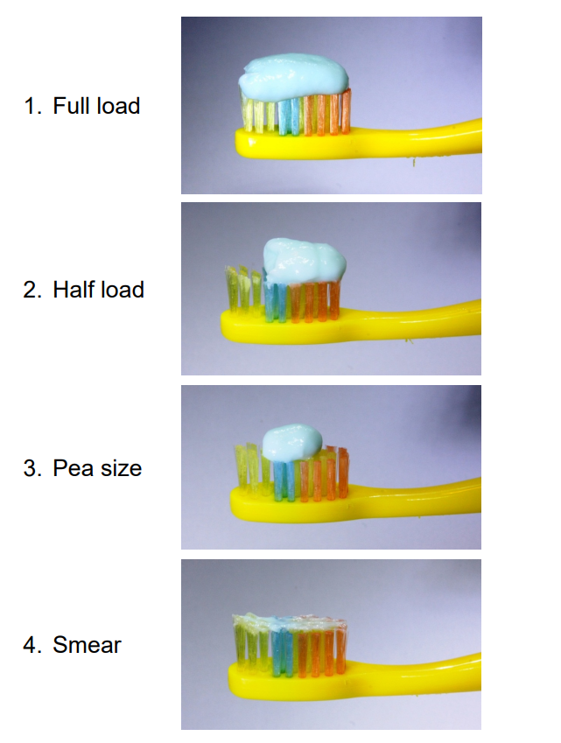

CARD OHQ4

Very often
Fairly often
Occasionally
Hardly ever
Never

CARD OHQ5

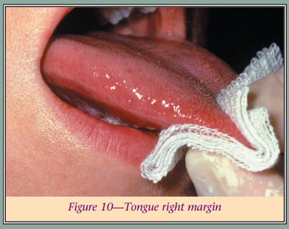

CARD OHQ6

Do not have access to tap water in my home
Do not like the taste of tap water
Do not think my tap water is clean to drink
Do not think my tap water is safe to drink
Other

CARD FNQ1

No difficulty
Some difficulty
A lot of difficulty
Cannot do at all

CARD FNQ2

Some difficulty
A lot of difficulty
Cannot do at all

CARD DBQ1

Never
1-3 Times in the last 7 days
4-6 Times in the last 7 days
1 Time per day
2 Or more times per day

CARD DBQ2
Examples of grain snacks for babies:

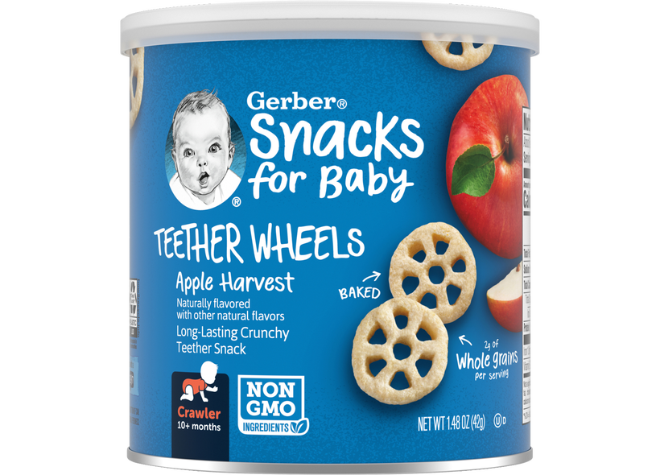



CARD DBQ3


Examples of infant cereal:
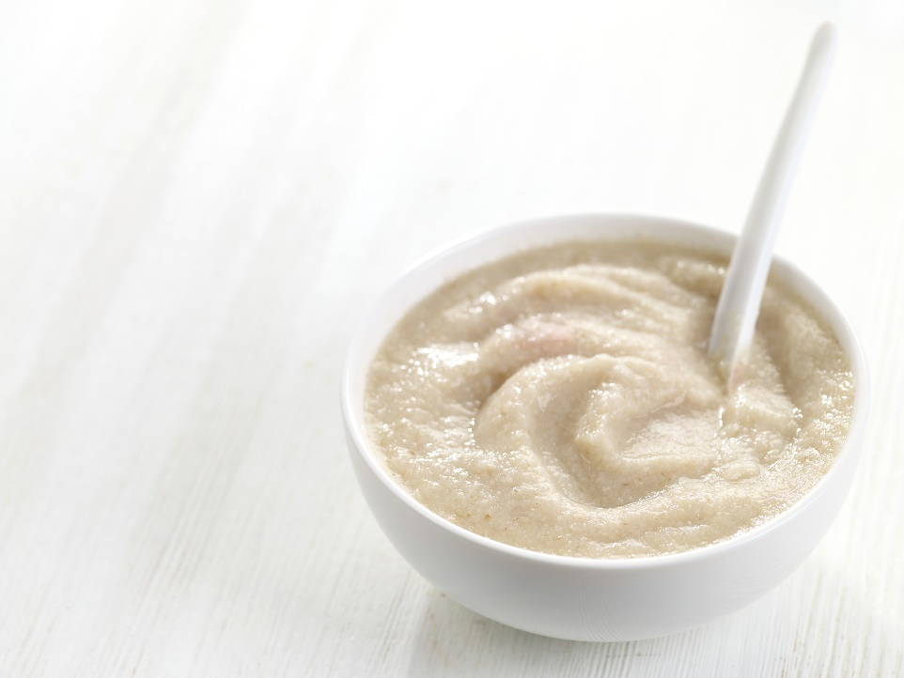

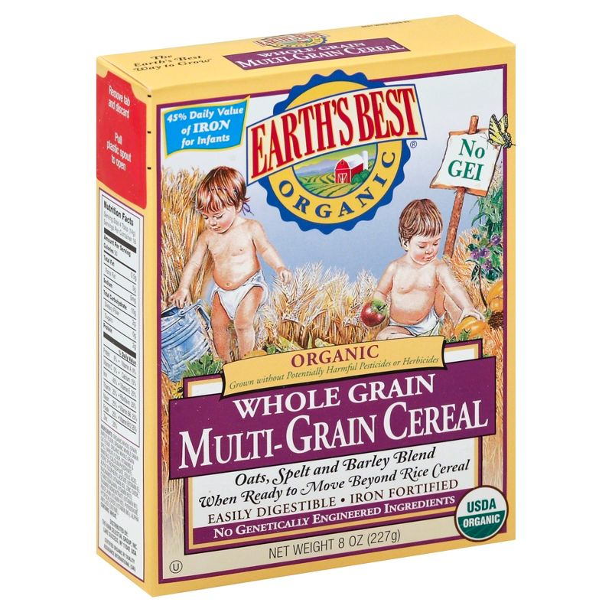
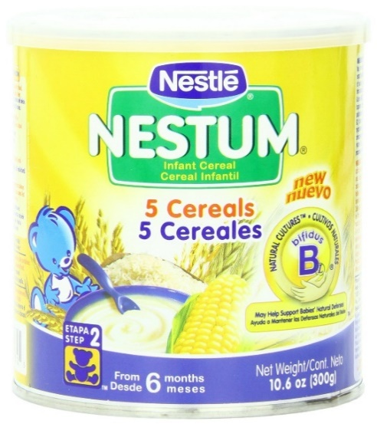

CARD DBQ1

Never
1-3 Times in the last 7 days
4-6 Times in the last 7 days
1 Time per day
2 Or more times per day

CARD DBQ4

Never
Rarely – less than once a week
Sometimes – once a week or more, but less than once a day

Often – once a day or more

CARD SMQ1
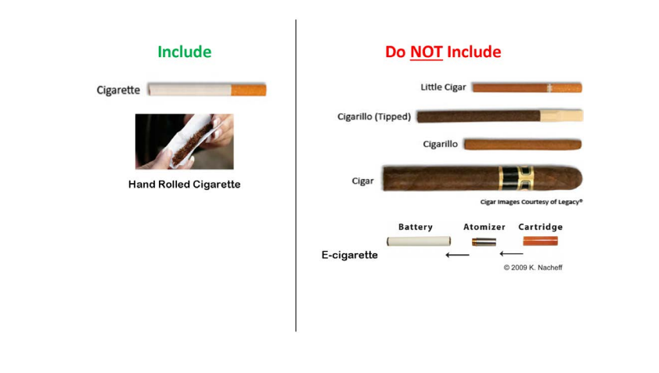

CARD COQ1

Change or loss of smell or taste
Changes in menstrual cycles
Chest pain
Cough
Depression and/or anxiety
Diarrhea
Difficulty breathing or shortness of breath
Difficulty thinking or concentrating (sometimes referred to as “brain fog”)
Difficulty with memory
Dizziness when you stand up (lightheadedness)
Fast-beating or pounding heart (also known as heart palpitations)
Fever
Headache
Joint or muscle pain
Pins-and-needles feelings
Rash
Sleep problems
Stomach pain
Symptoms that get worse after physical or mental effort (also known as “post-exertional malaise”)
Tiredness or fatigue that interferes with daily life
Other symptom

CARD DMQ1

Never attended/kindergarten only

Grade 1-11

12th grade, no diploma

High school graduate

GED or equivalent

Some college, no degree

Associate’s degree (Example: AA, AS)

Bachelor’s degree (Example: BA, AB, BS, BBA)

Master’s degree (Example: MA, MS, MEng, MEd, MBA)

Professional school degree (Example: MD, DDS, DVM, JD)

Doctoral degree (Example: PhD, EdD)

CARD DMQ2

MEXICAN
CARIBBEAN:
PUERTO RICAN
CUBAN
DOMINICAN
CENTRAL AMERICAN:
COSTA RICAN
GUATEMALAN
HONDURAN
NICARAGUAN
PANAMANIAN
SALVADORAN
OTHER CENTRAL AMERICAN
SOUTH AMERICAN:
ARGENTINEAN
BOLIVIAN
CHILEAN
COLOMBIAN
ECUADORIAN
PARAGUAYAN
PERUVIAN
URUGUAYAN
VENEZUELAN
OTHER SOUTH AMERICAN
OTHER HISPANIC OR LATINO:
FILIPINO
SPANIARD
SPANISH
SPANISH AMERICAN
HISPANO/HISPANA
HISPANIC/LATINO
OTHER HISPANIC/LATINO (SPECIFY)
CHICANA/CHICANO
REFUSED
DON’T KNOW

CARD ACQ2

English

SPANISH

Chinese

Japanese

Korean

Vietnamese

Other (SPECIFY)

CARD HIQ1

Private Health Insurance
Medicare
Medi-Gap
Medicaid
Children’s Health Insurance Program (CHIP)
Military Related Healthcare: Tricare (CHAMPUS)/VA Health Care/CAHMP-VA
Indian Health Service
State-Sponsored Health Plan
Other Government Program

CARD HIQ2

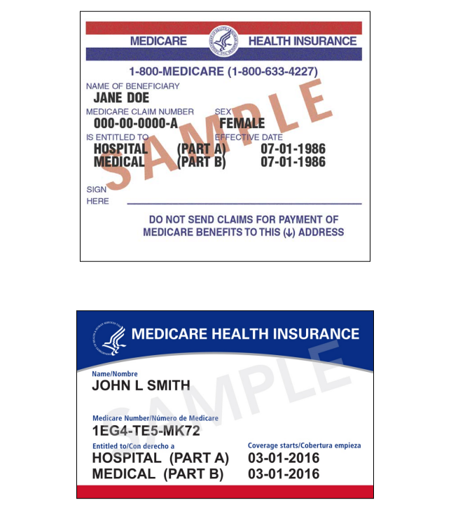

CARD HOQ1

A city water supply (also known as a public or community water system) through underground pipes to my home

An individual or private well

Rainwater routed into a tank or cistern on my property

A spring

Something else

CARD FSQ1

Often true
Sometimes true
Never true

CARD INQ

Income earned at a job or business

Retirement or Social Security

Disability, or survivor pension

Unemployment or worker's compensation

Veteran's Administration payments

Child support

Alimony

Interest income

Dividends from stocks or mutual funds

Income from rental properties, royalties, estates or trusts

CARD INQ1

U. $20,000 - $20,999
V. $21,000 - $21,999
W. $22,000 - $22,999
X. $23,000 - $23,999
Y. $24,000 - $24,999
Z. $25,000 - $25,999
AA. $26,000 - $26,999
BB. $27,000 - $27,999
CC. $28,000 - $28,999
DD. $29,000 - $29,999
EE. $30,000 - $30,999
FF. $31,000 - $31,999
GG. $32,000 - $32,999
HH. $33,000 - $33,999
II. $34,000 - $34,999
JJ. $35,000 - $39,999
KK. $40,000 - $44,999
LL. $45,000 - $49,999
MM. $50,000 - $54,999
NN. $55,000 - $59,999
OO. $60,000 - $64,999
PP. $65,000 - $69,999
QQ. $70,000 - $74,999
RR. $75,000 - $79,999
SS. $80,000 - $84,999
TT. $85,000 - $89,999
UU. $90,000 - $94,999
VV. $95,000 - $99,999
WW. $100,000 and over

CARD INQ2

A. Less than $1,000
B. $1,000 - $1,999
C. $2,000 - $2,999
D. $3,000 - $3,999
E. $4,000 - $4,999
F. $5,000 - $5,999
G. $6,000 - $6,999
H. $7,000 - $7,999
I. $8,000 - $8,999
J. $9,000 - $9,999
K. $10,000 - $10,999
L. $11,000 - $11,999
M. $12,000 - $12,999
N. $13,000 - $13,999
O. $14,000 - $14,999
P. $15,000 - $15,999
Q. $16,000 - $16,999
R. $17,000 - $17,999
S. $18,000 - $18,999
T. $19,000 - $19,999

CARD INQ3

Cash Checking accounts
Saving accounts
CDs (Certificates of deposit)
Retirement accounts (such as IRAs, 401K, etc.)
Stocks
Bonds
Mutual funds

CARD INQ4

A: $0 - $3,000
B: $3,001 - $5,000
C: $5,001 - $10,000
D: $10,001 - $15,000
E: $15,001 - $20,000

