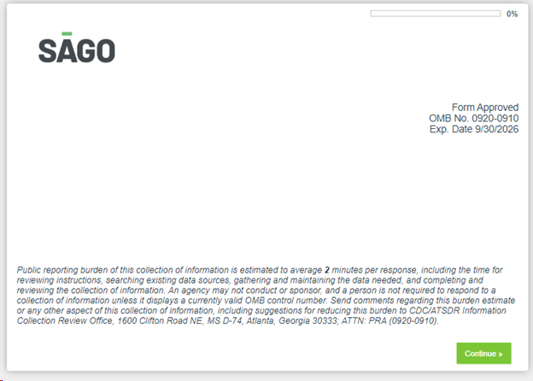

Screener pg. 1

Screener pg. 2

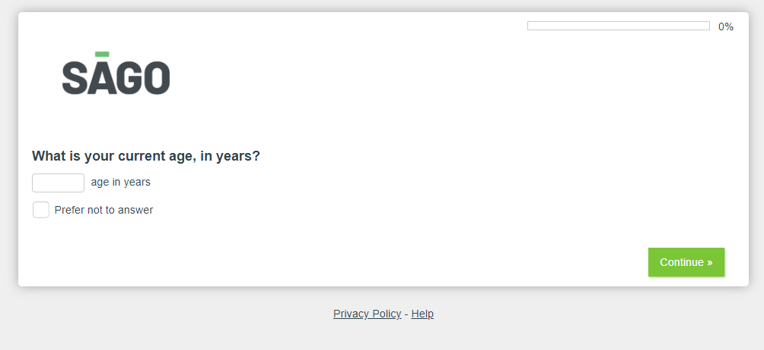

Screener pg. 2

Screener pg. 2

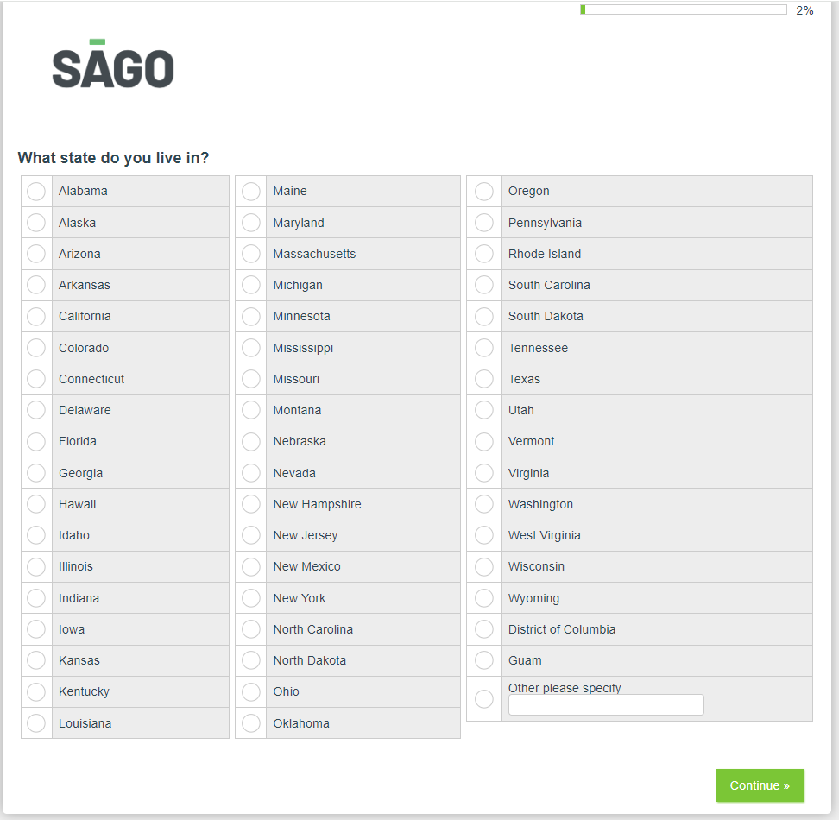

Screener pg. 3



Screener pg. 4

Screener pg. 4

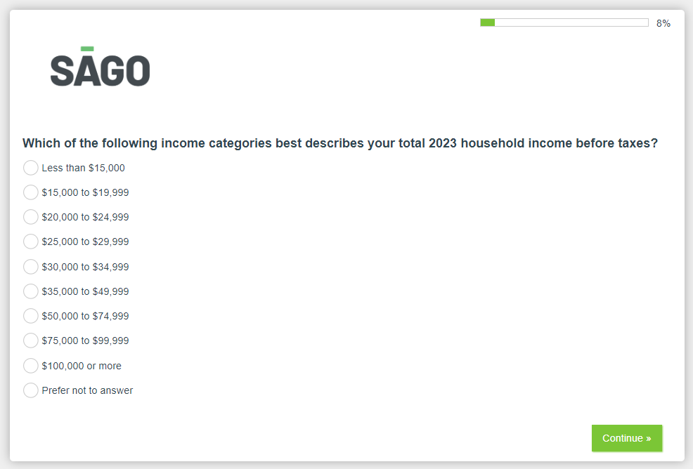

Screener pg. 4

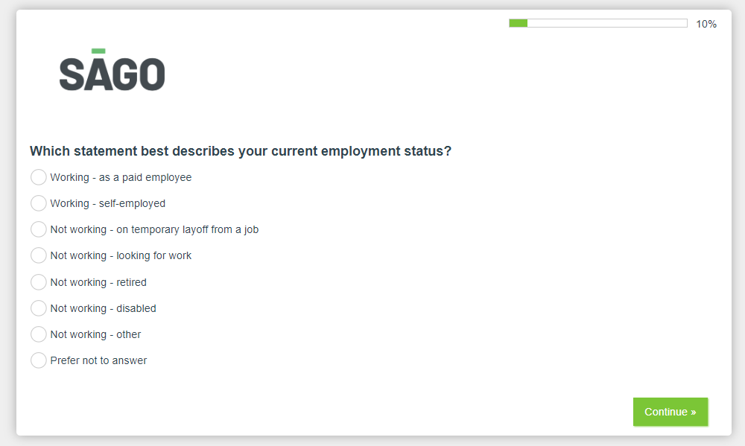

Screener pg. 4

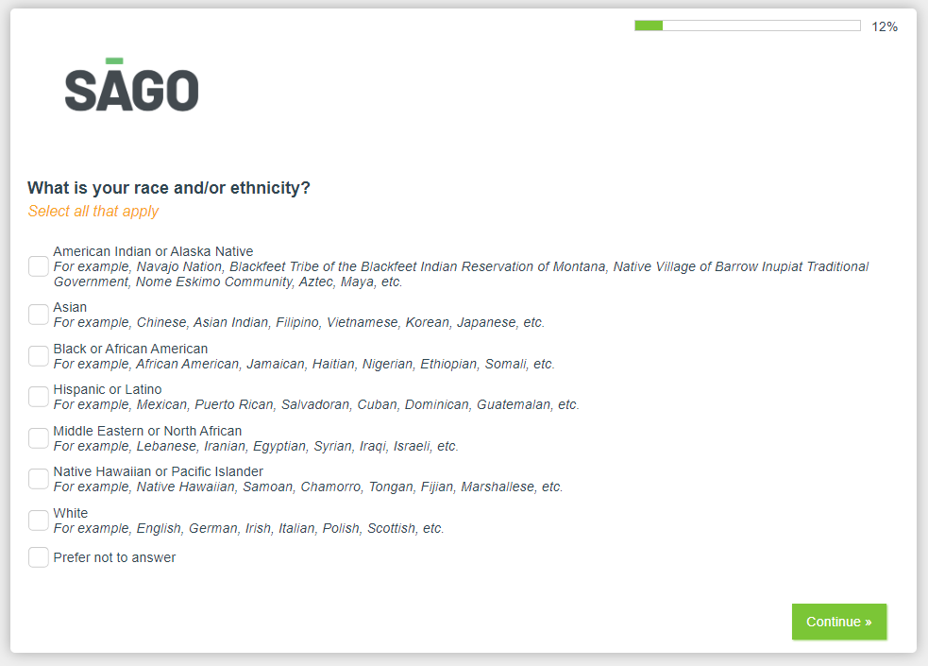

Screener pg. 5

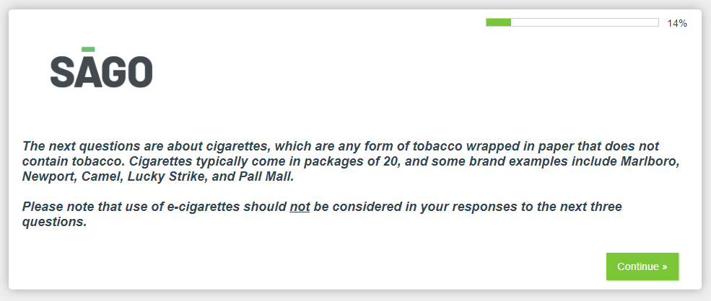

Screener pg. 5

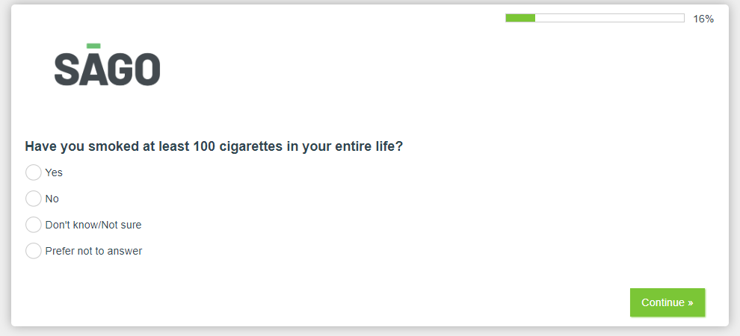

Screener pg. 5

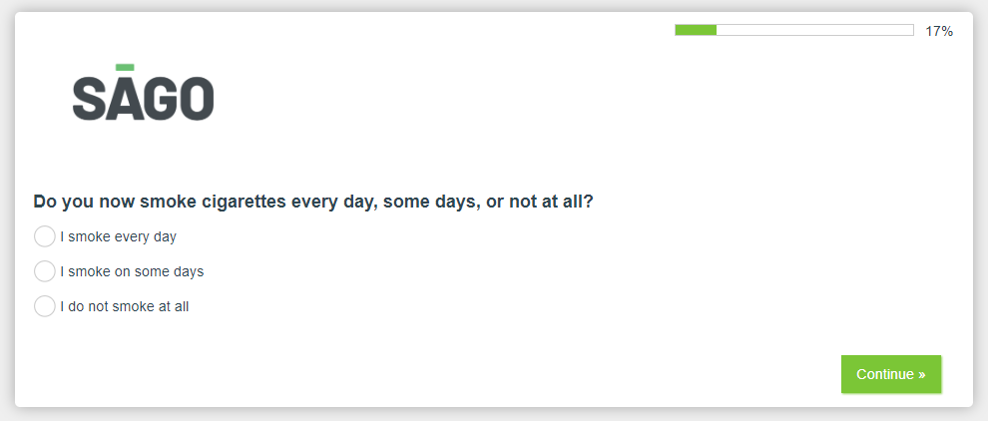

Screener pg. 5

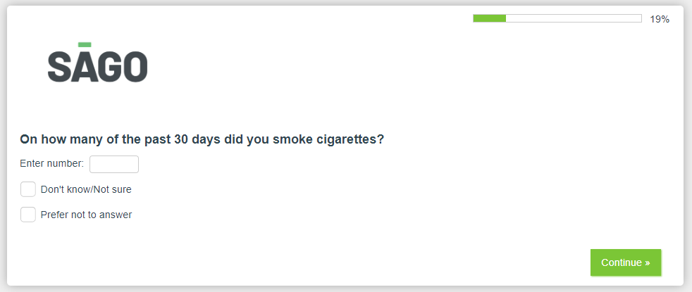

The next screenshot is only for those respondents who do not qualify for the survey

Questionnaire pg. 2

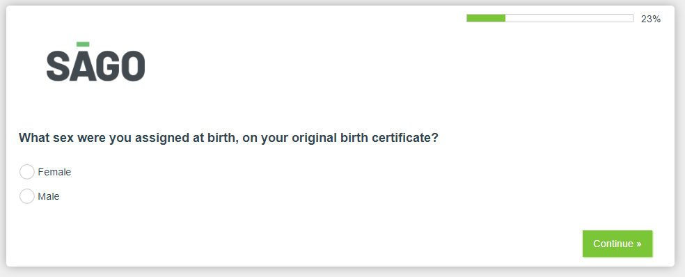

Questionnaire pg. 2

Questionnaire pg. 2

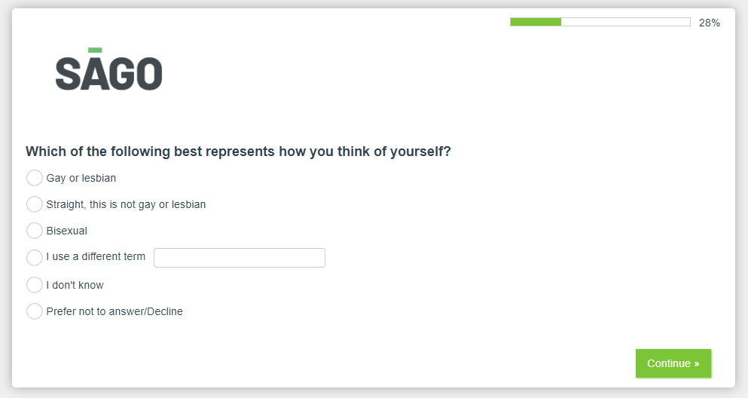

Questionnaire pg. 2

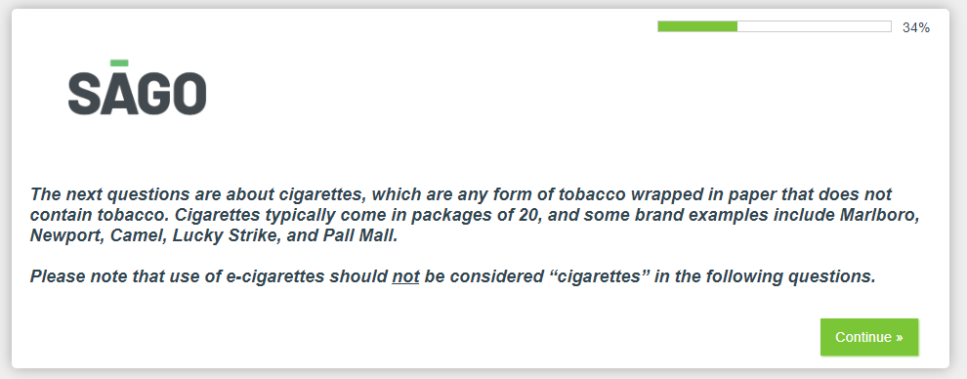

Questionnaire pg. 2

Questionnaire pg. 3

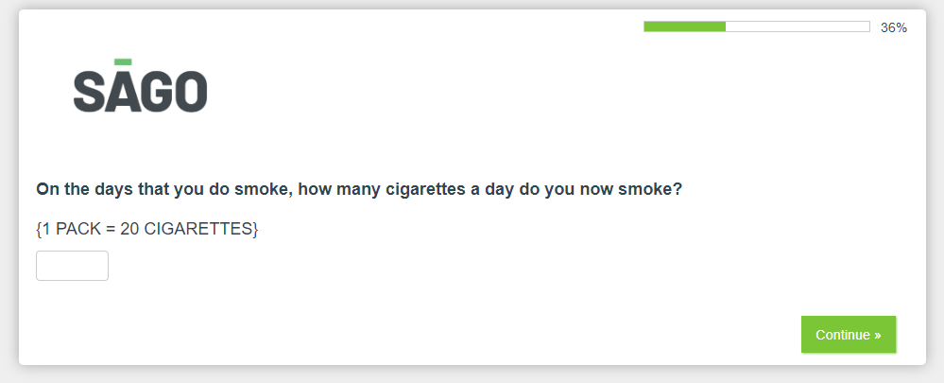

Questionnaire pg. 3

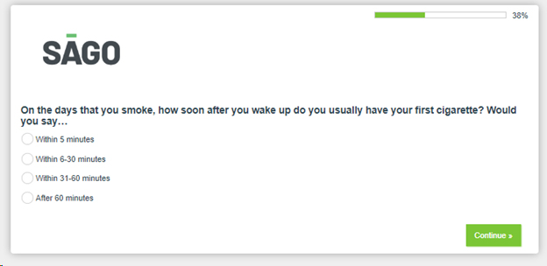

Questionnaire pg. 3

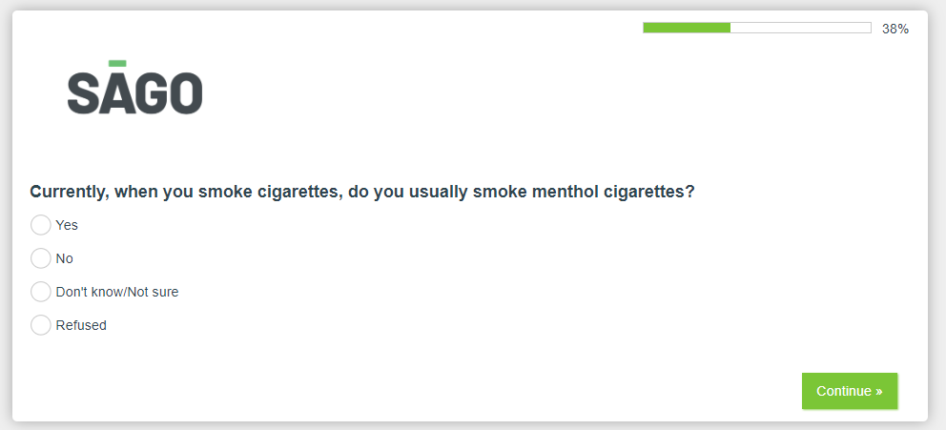

Questionnaire pg. 3

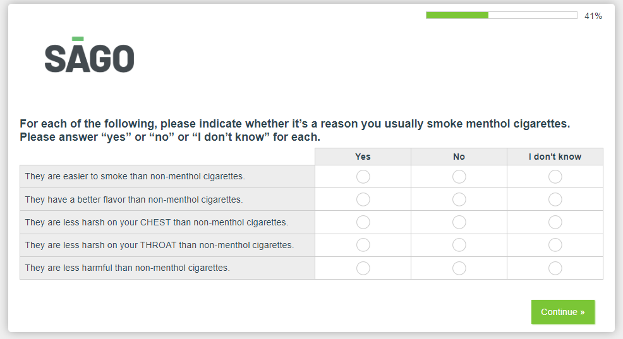

Questionnaire pg. 3

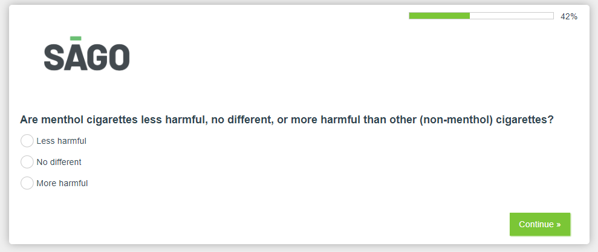

Questionnaire pg. 3

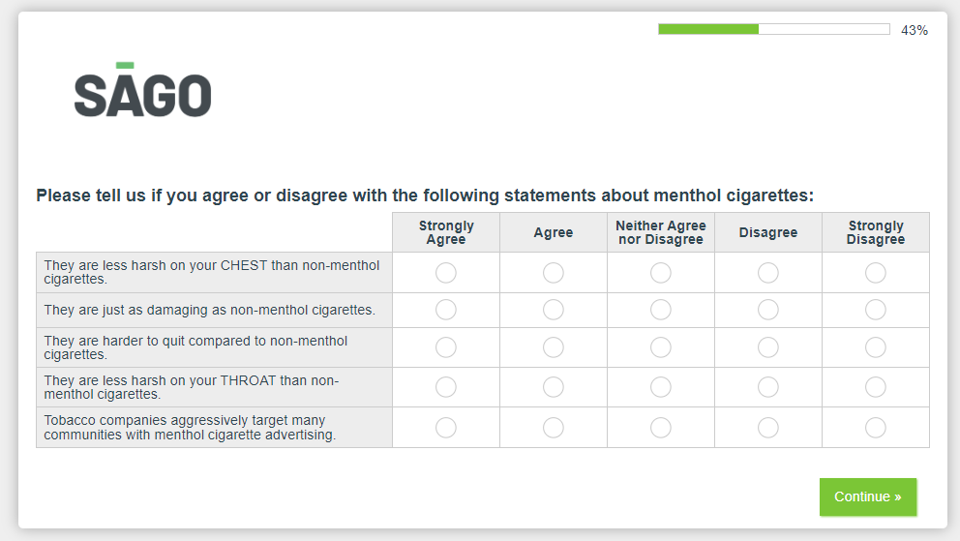

Questionnaire pg. 4

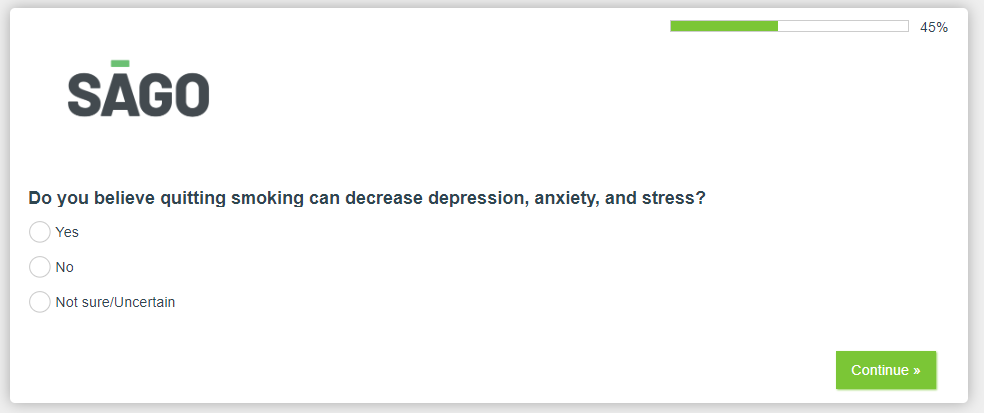

Questionnaire pg. 4

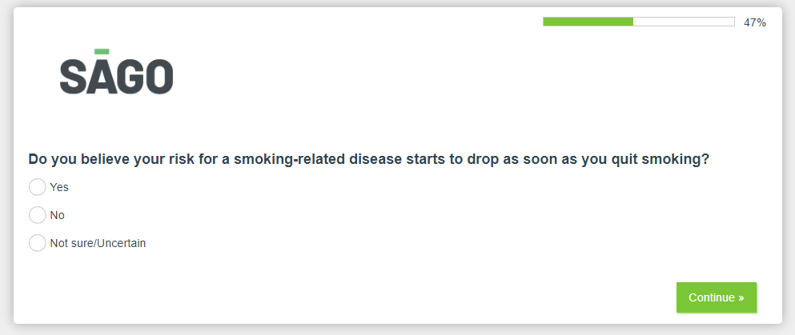

Questionnaire pg. 4

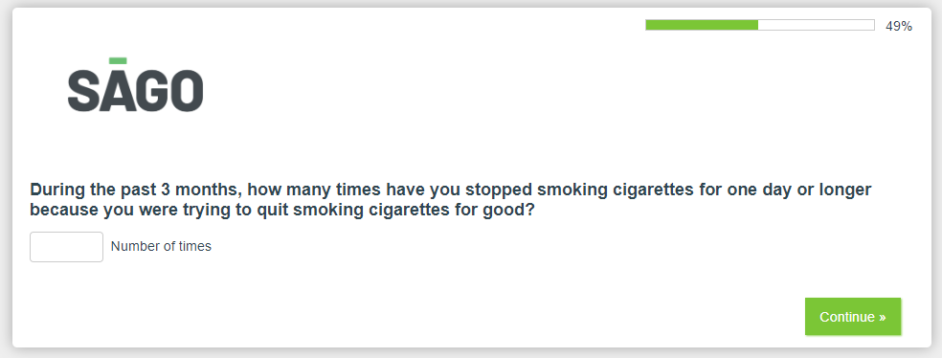

Questionnaire pg. 4

Questionnaire pg. 5

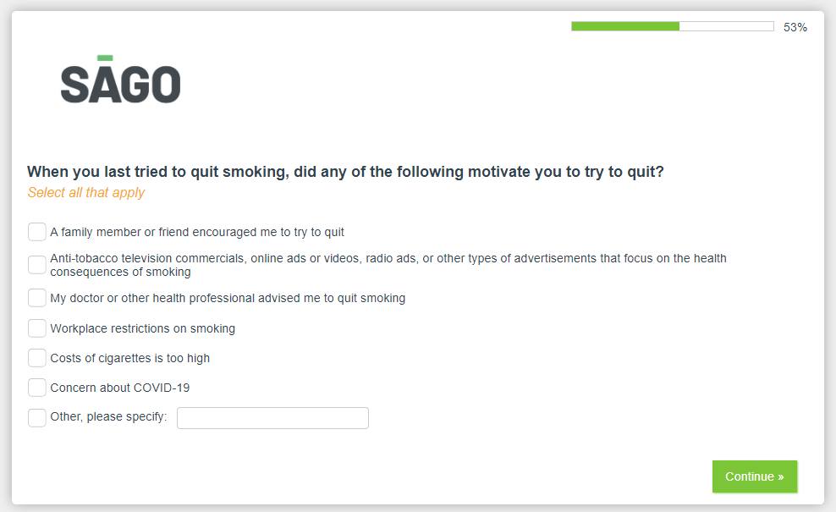

Questionnaire pg. 5

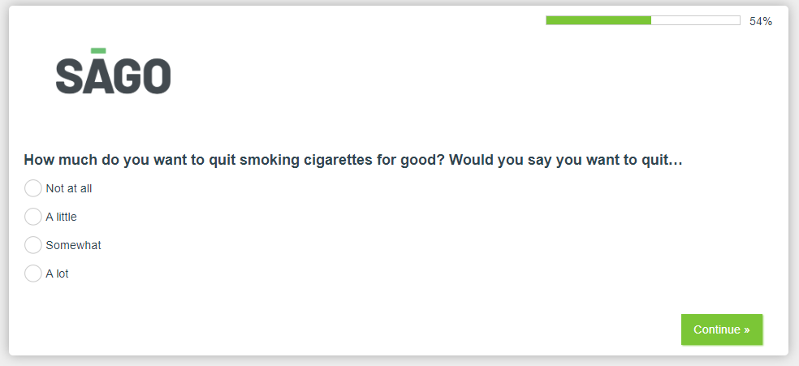

Questionnaire pg. 5

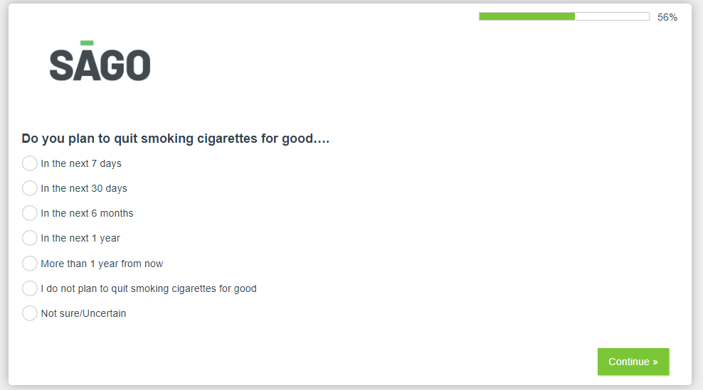

Questionnaire pg. 5

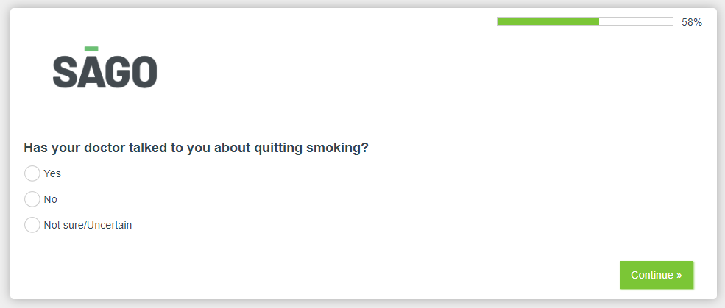

Questionnaire pg. 5

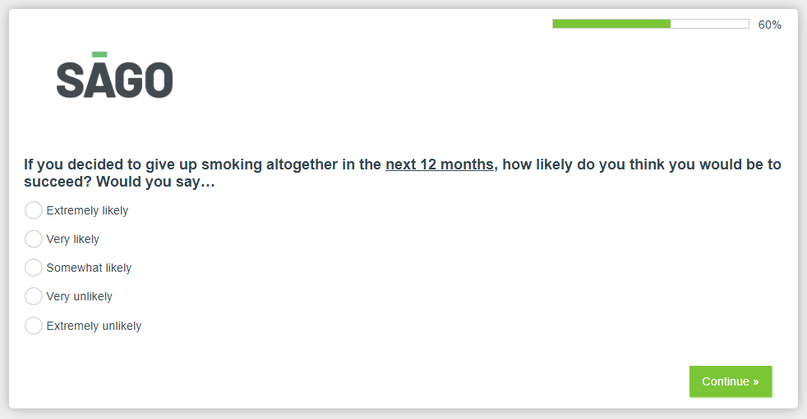

Questionnaire pg. 6

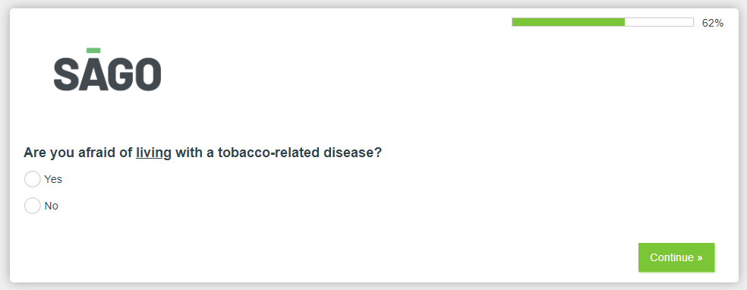

Questionnaire pg. 6

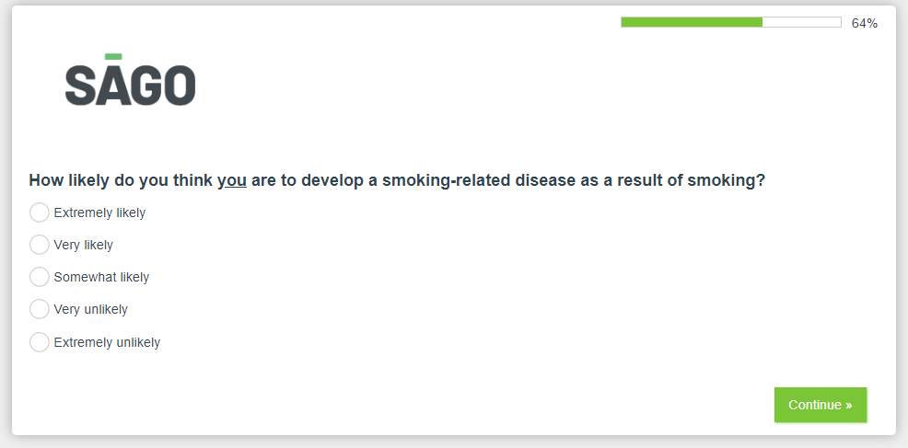

Questionnaire pg. 6



Questionnaire pg. 6

Questionnaire pg. 6

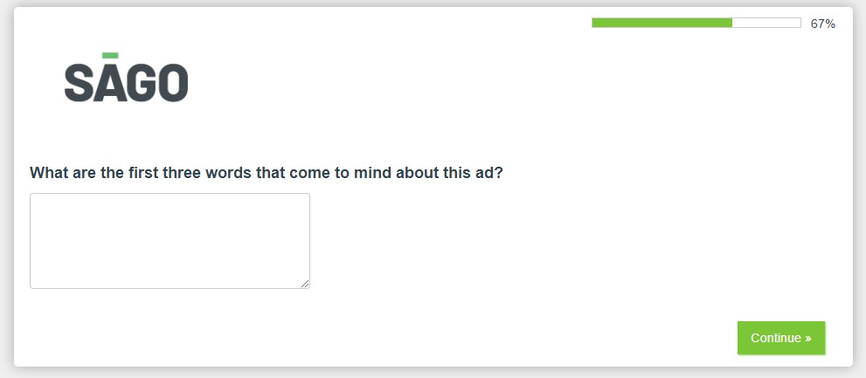

Questionnaire pg. 6

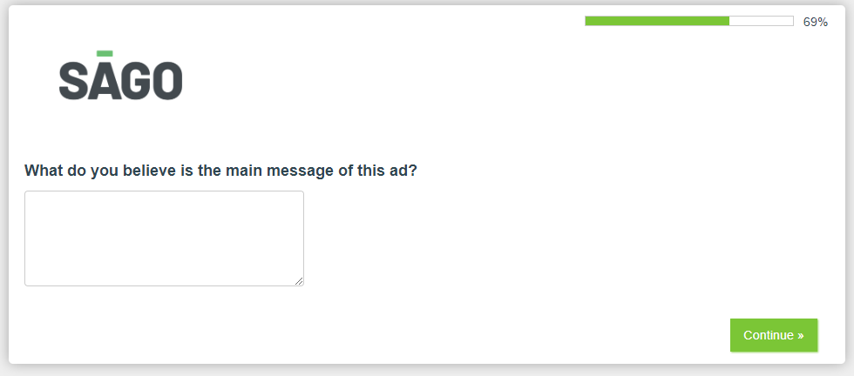

Questionnaire pg. 7

Questionnaire pg. 7

Questionnaire pg. 7

Questionnaire pg. 7

Questionnaire pg. 8

Questionnaire pg. 8

Questionnaire pg. 8

Questionnaire pg. 9

Questionnaire pg. 9

Questionnaire pg. 9

Questionnaire pg. 9

Questionnaire pg. 9

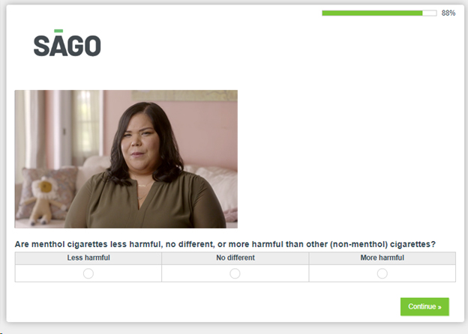

Questionnaire pg. 10

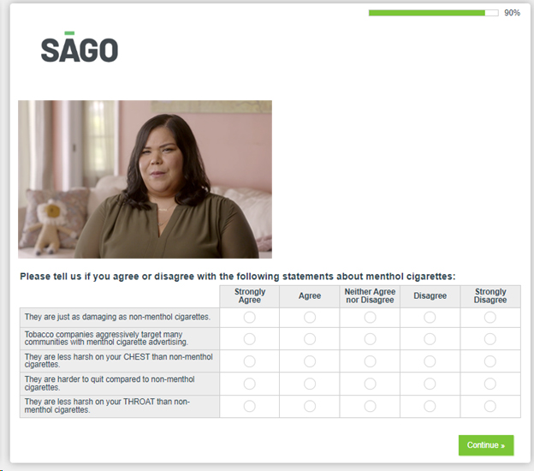

Questionnaire pg. 10

Questionnaire pg. 10

Questionnaire pg. 11

Questionnaire pg. 11

Questionnaire pg. 11

