Attachment 7
FCAS Vendor Portal Screen Shots
OMB No.: 0925-XXXX
Expiration Date: XX/XX/XXXX
Collection of this information is authorized by The Public Health Service Act, Section 411 (42 USC 285a). Rights of participants are protected by The Privacy Act of 1974. Participation is voluntary, however in order for NCI Office of Acquisitions (OA) to provide access to the Vendor Portal for use in uploading deliverables and invoices and responding to and submitting requests to NCI OA, Vendor Portal registration is required. The information collected will be kept private to the extent provided by law. Names and other identifiers will not appear in any report other than what is utilized by NCI OA and program staff for routine day-to-day contract administration. Information provided will be combined for all participants and reported as summaries. You are being contacted by email to complete this Vendor Portal Registration form and a voluntary survey so that NCI can provide your Vendor Firm with Vendor Portal access and improve the website. The information you provide will be included in a Privacy Act system of records, and will be used and may be disclosed for the purposes and routine uses described and published in the following System of Records Notices (SORN): 09-25-0216 Administration: NIH Electronic Discovery and 09-25-0118 Contracts: Professional Services Contractors https://www.hhs.gov/foia/privacy/sorns/nih-sorns.html.

Public reporting burden for this collection of information is estimated to average 1 minute per response, including the time for reviewing instructions, searching existing data sources, gathering and maintaining the data needed, and completing and reviewing the collection of information. An agency may not conduct or sponsor, and a person is not required to respond to, a collection of information unless it displays a currently valid OMB control number. Send comments regarding this burden estimate or any other aspect of this collection of information, including suggestions for reducing this burden to: NIH, Project Clearance Branch, 6705 Rockledge Drive, MSC 7974, Bethesda, MD 20892-7974, ATTN: PRA (0925-XXXX). Do not return the completed form to this address.

Editing Vendor User Account:
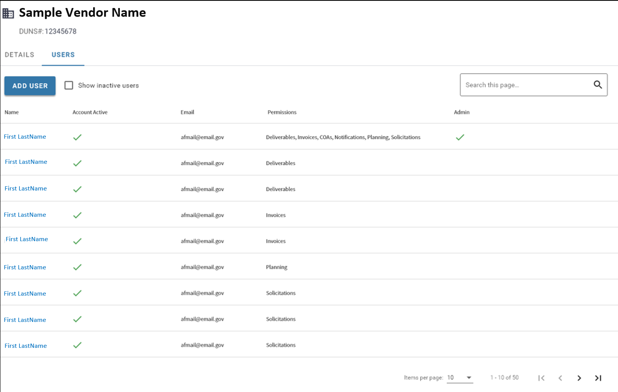

Data Field Information/Action Step:
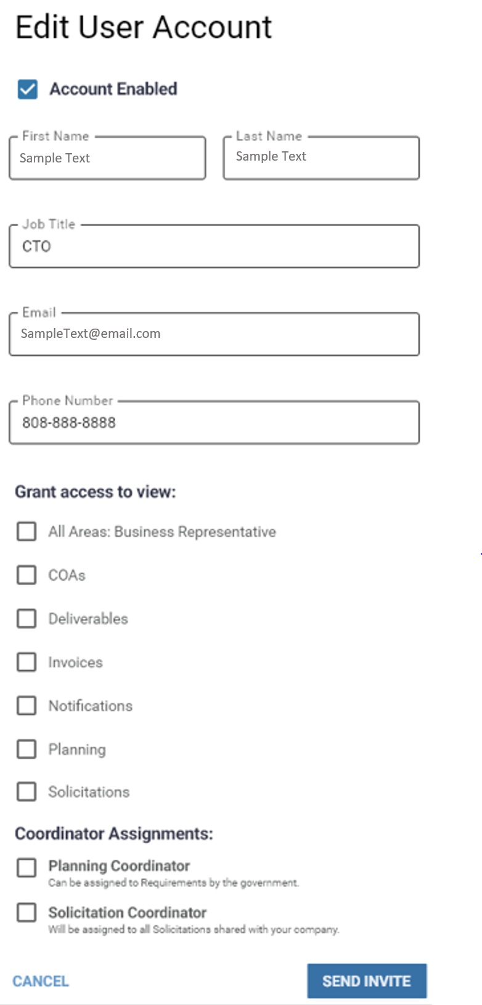
Contracting Officer Authorization (COA) Correspondence Processes:
View COA Correspondences within Contract:
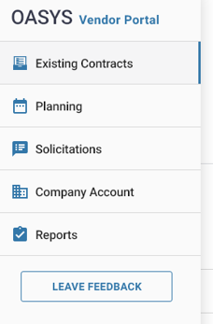

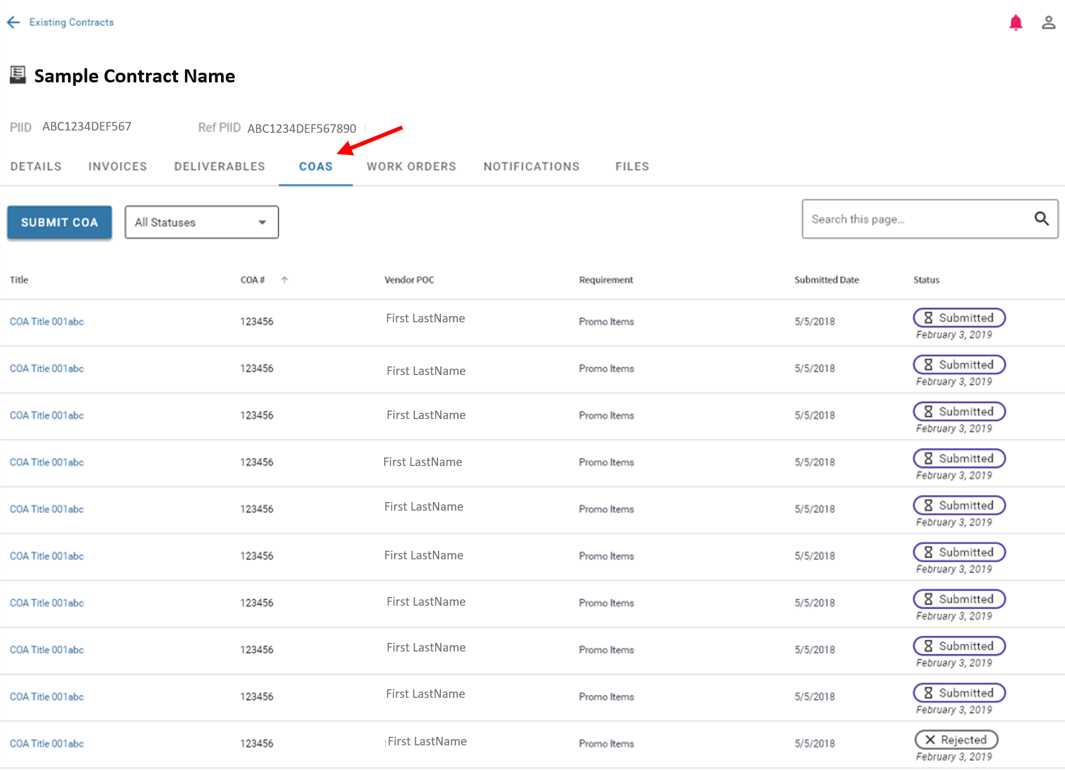

View Submitted COA Correspondence:
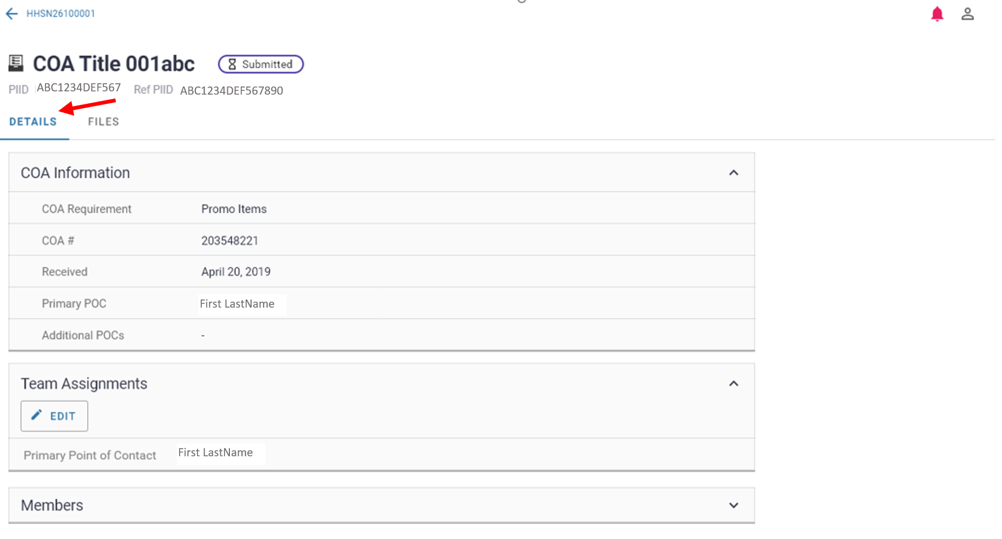
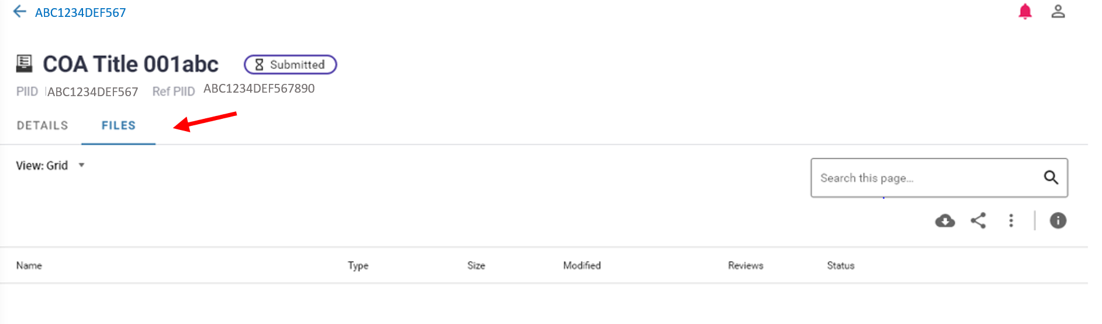
COA Submission:
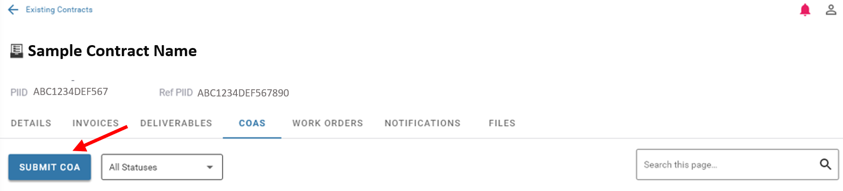

Data Field Information/Action Step:
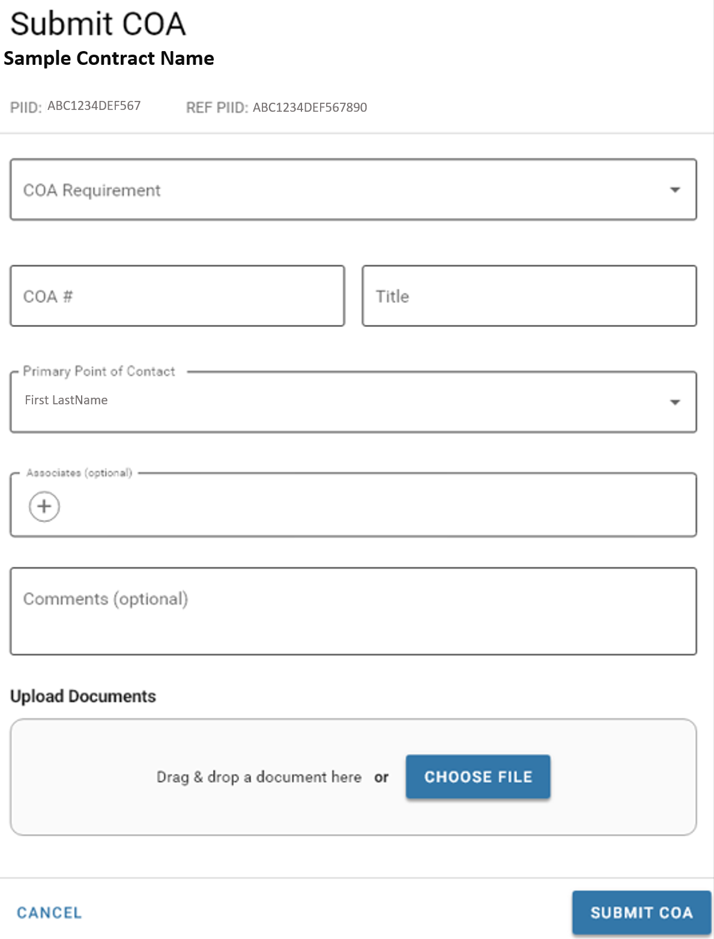

Deliverable Correspondence Processes:
View Deliverables Correspondences within Contract:
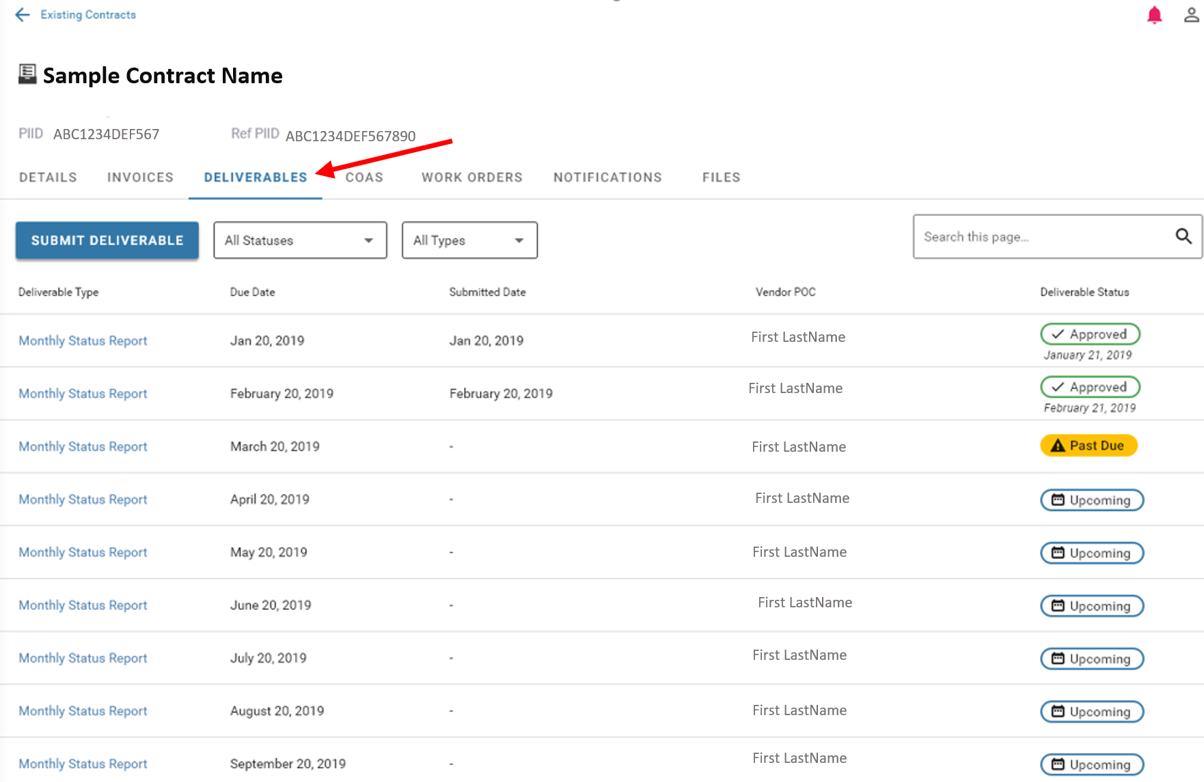
View Submitted Deliverable Correspondence:
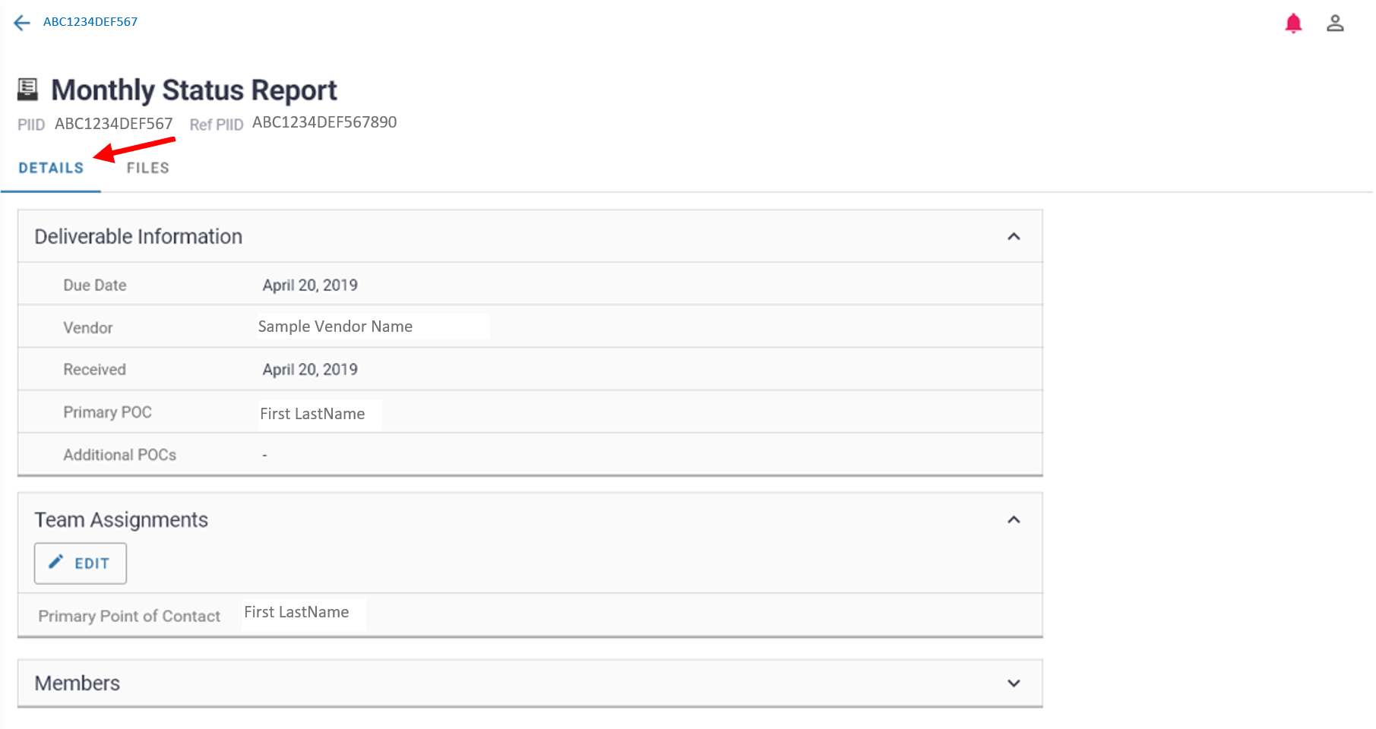

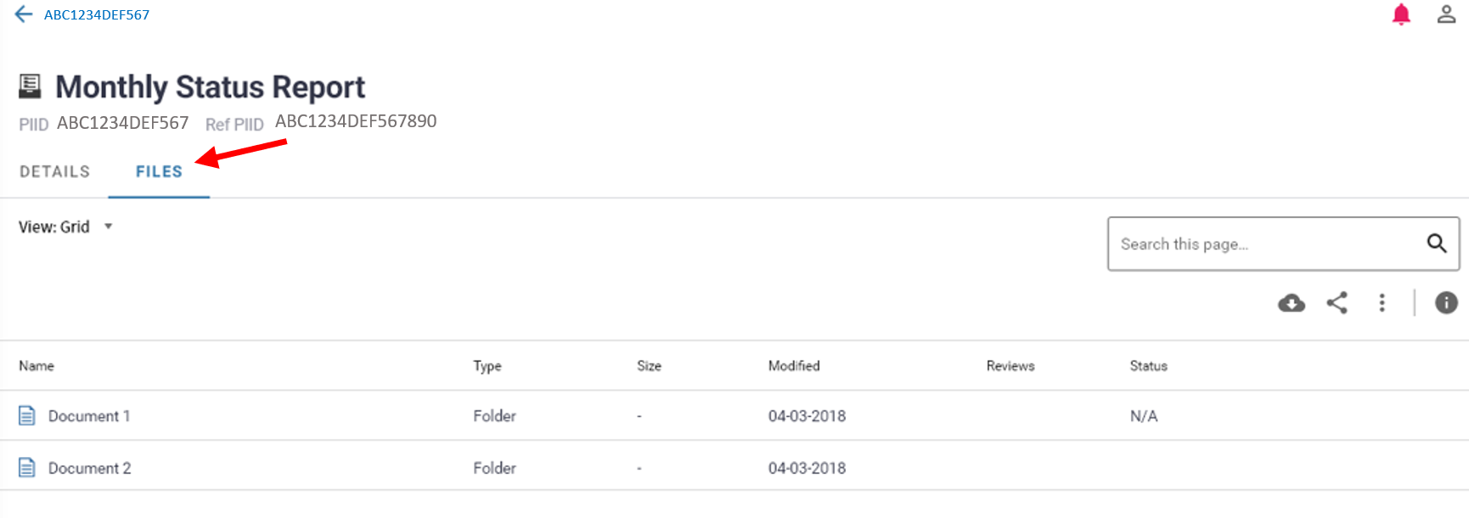
Deliverable Submission:
- Can submit deliverable by selecting the hyperlink within the deliverable schedule and click the ‘submit deliverable’ button on the pink action banner
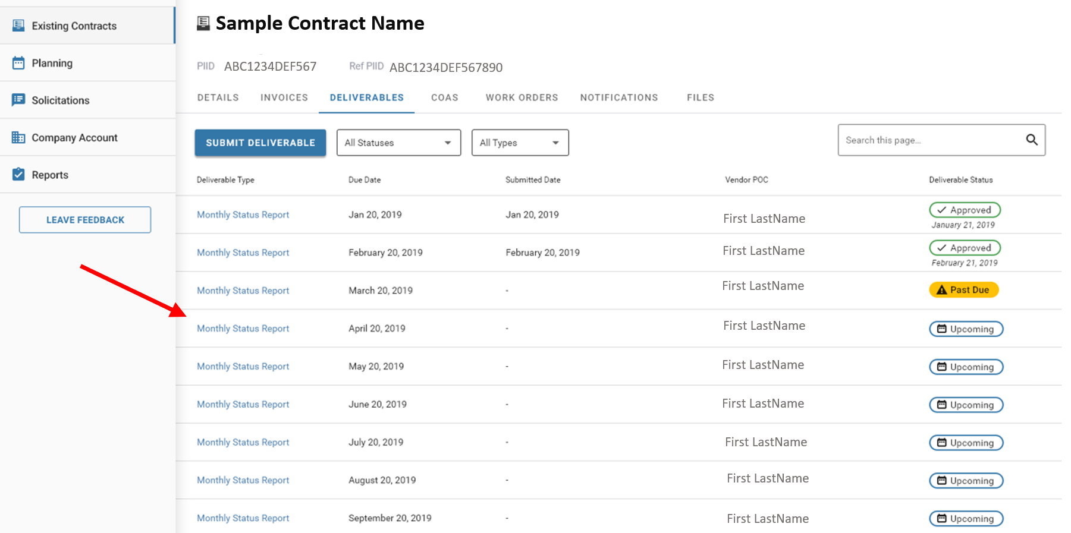
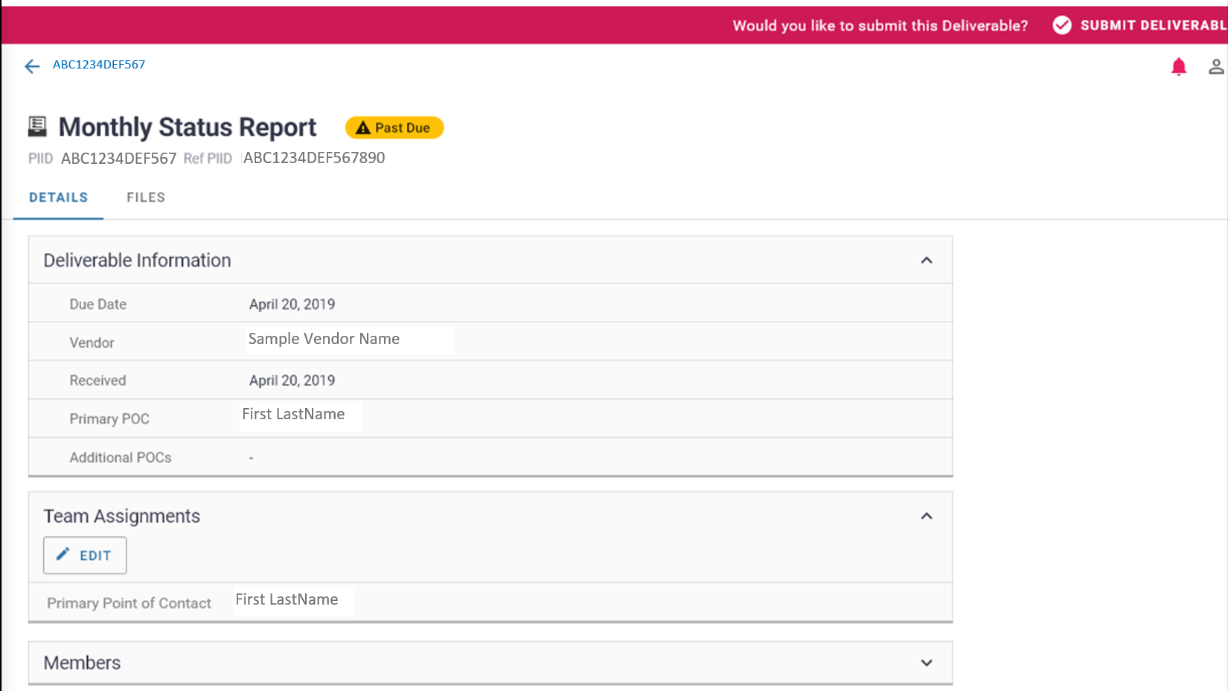

Data Field Information/Action Step:
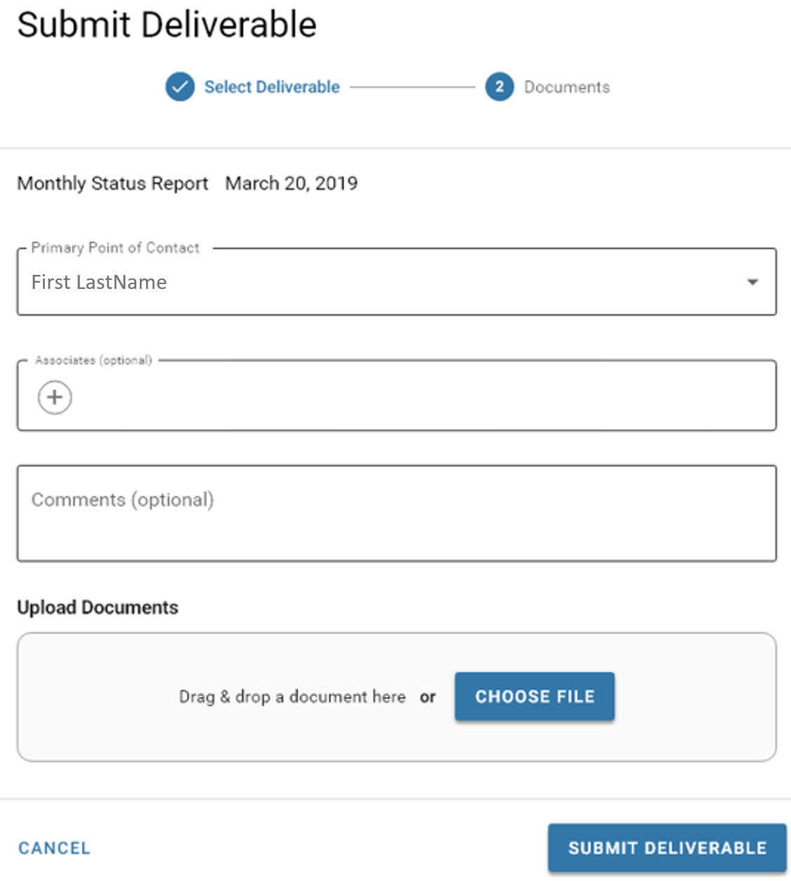

- Can submit deliverable by selecting the ‘submit deliverable’ button and a pop-up window appearing
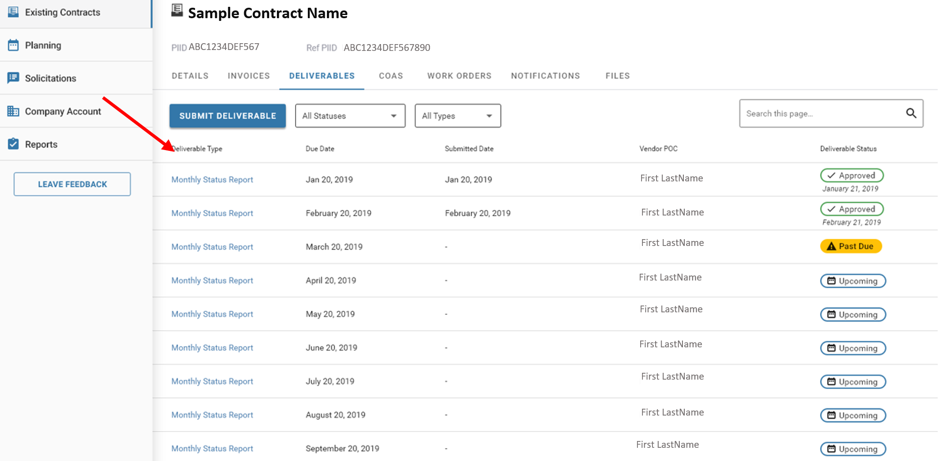
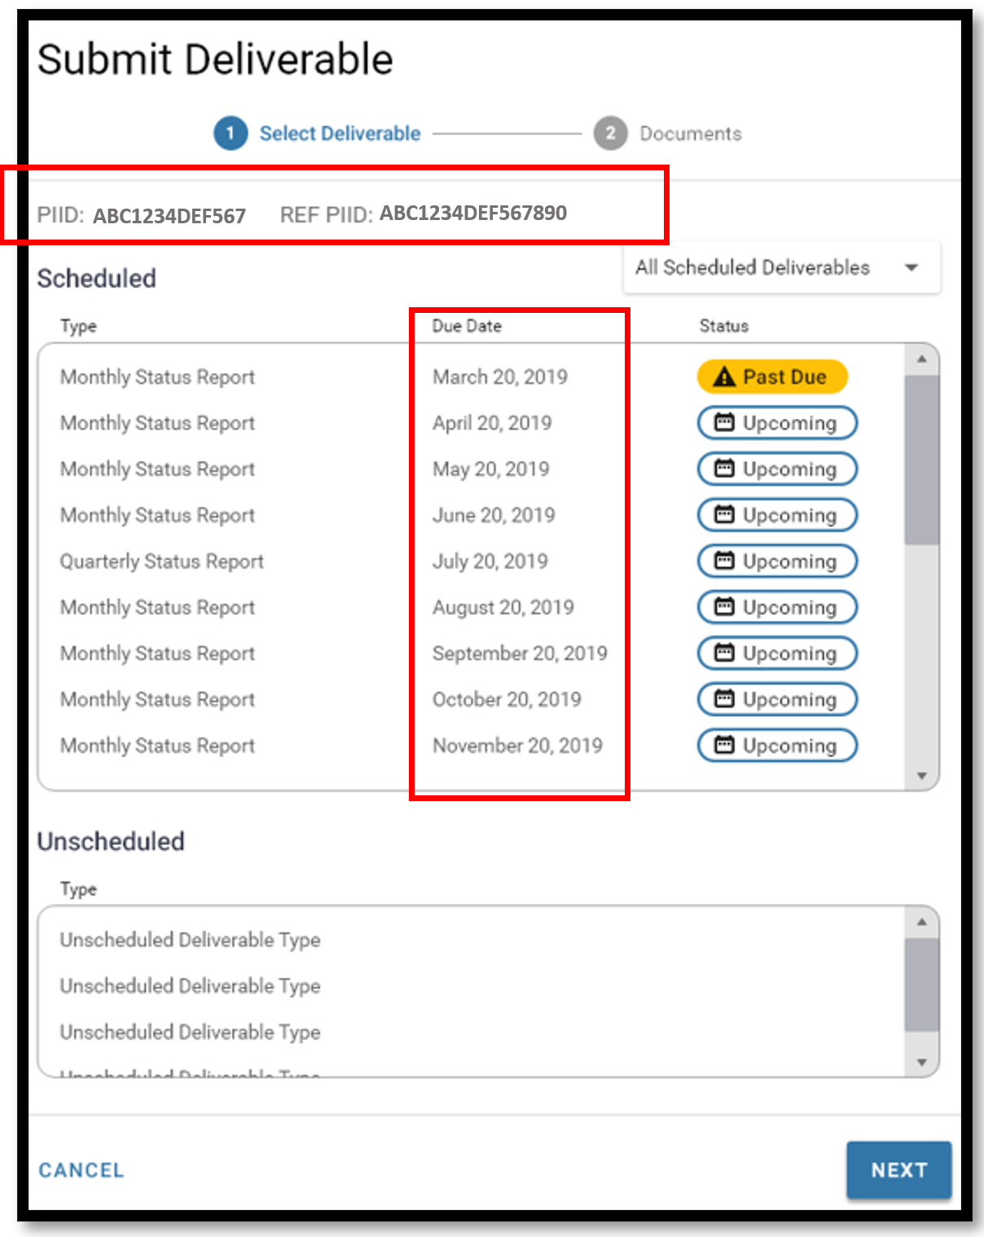
Ad hoc deliverables
Invoice Correspondence Processes:
View Invoice Correspondences within Contract:
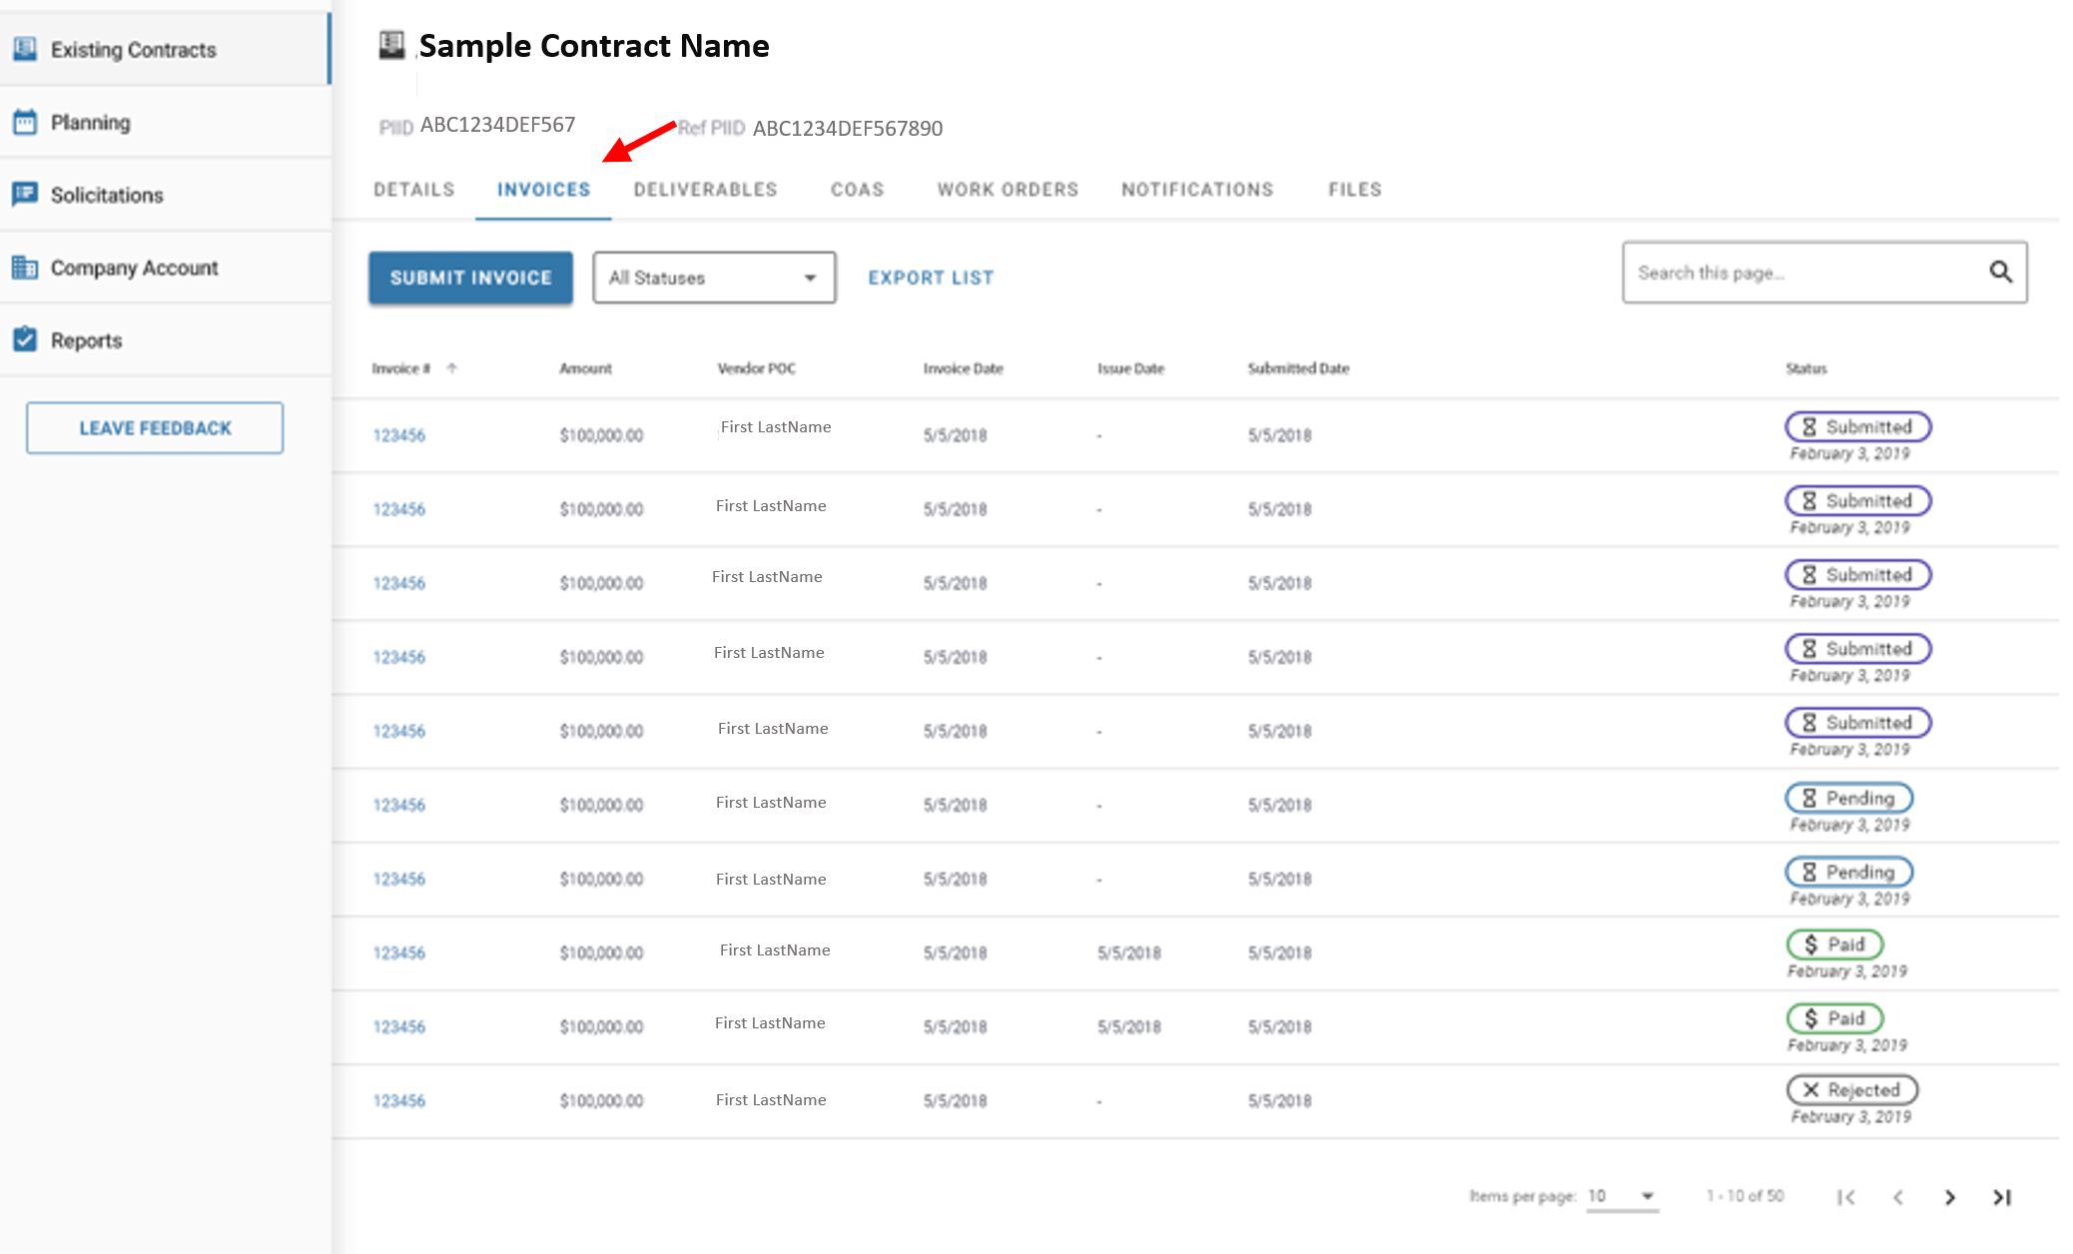

View Submitted Invoice Correspondence:
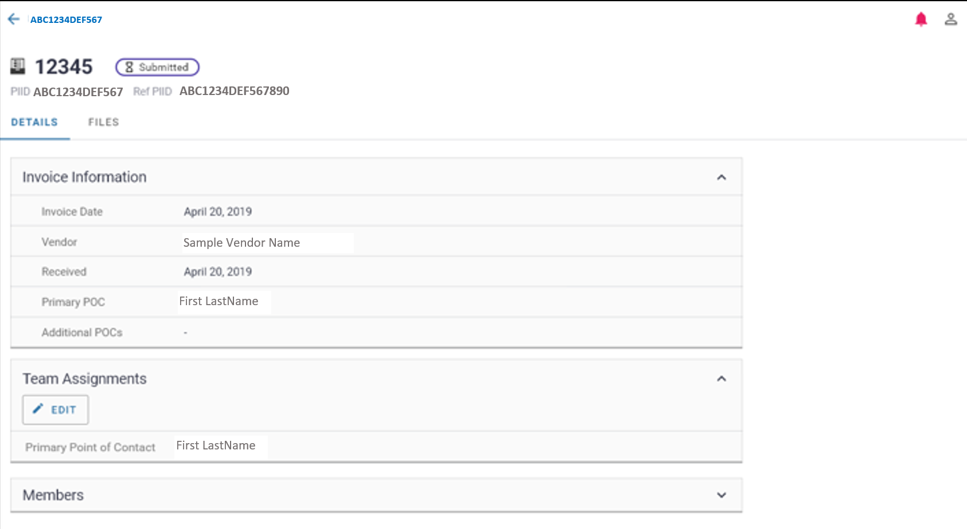
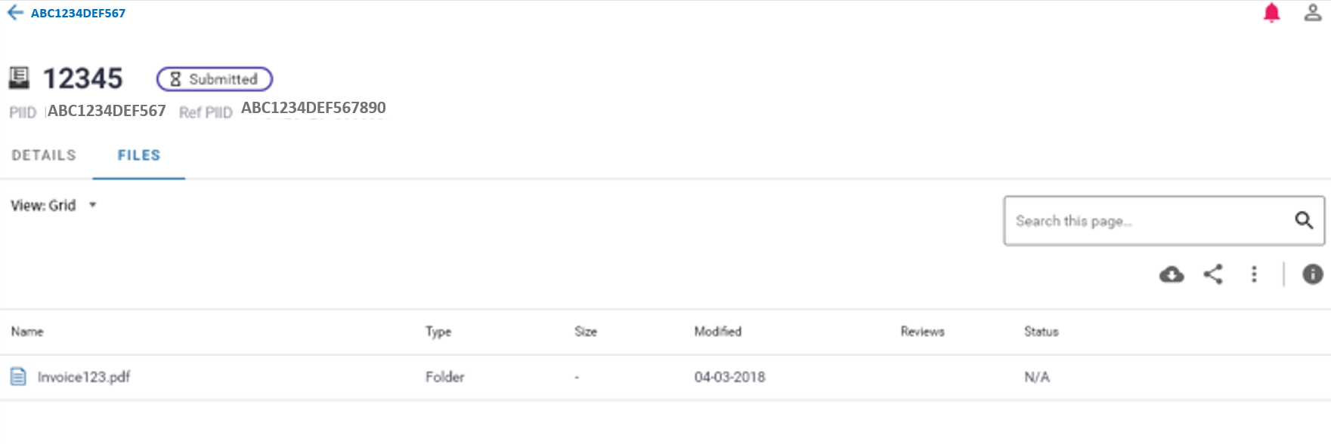
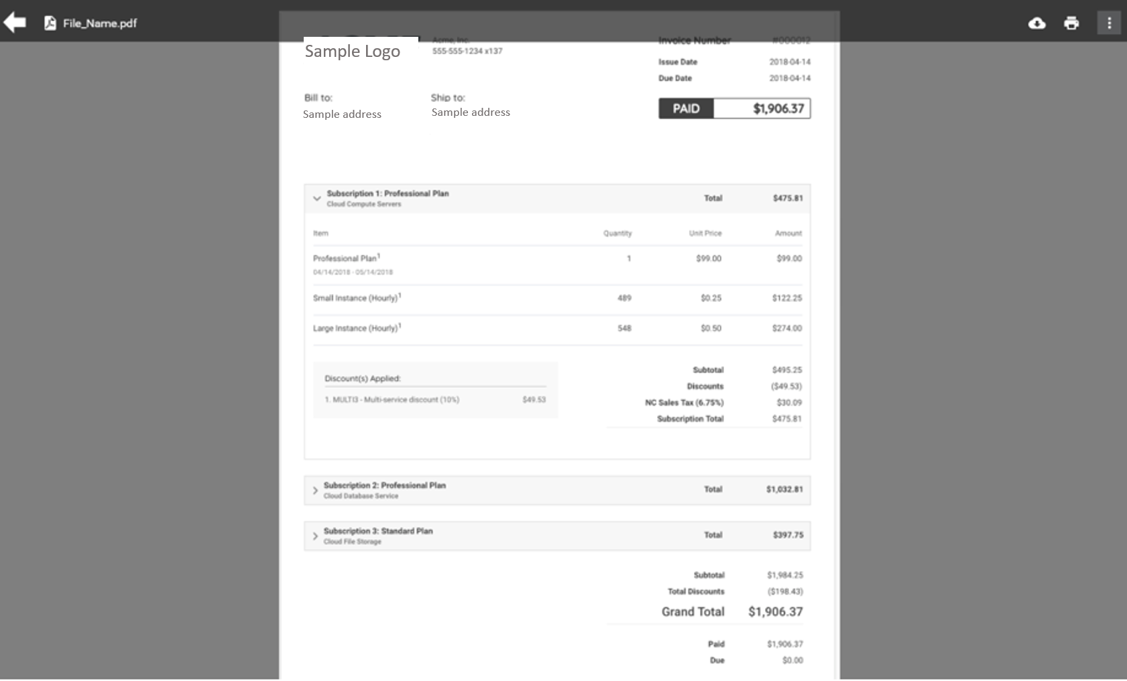
Invoice Submission: 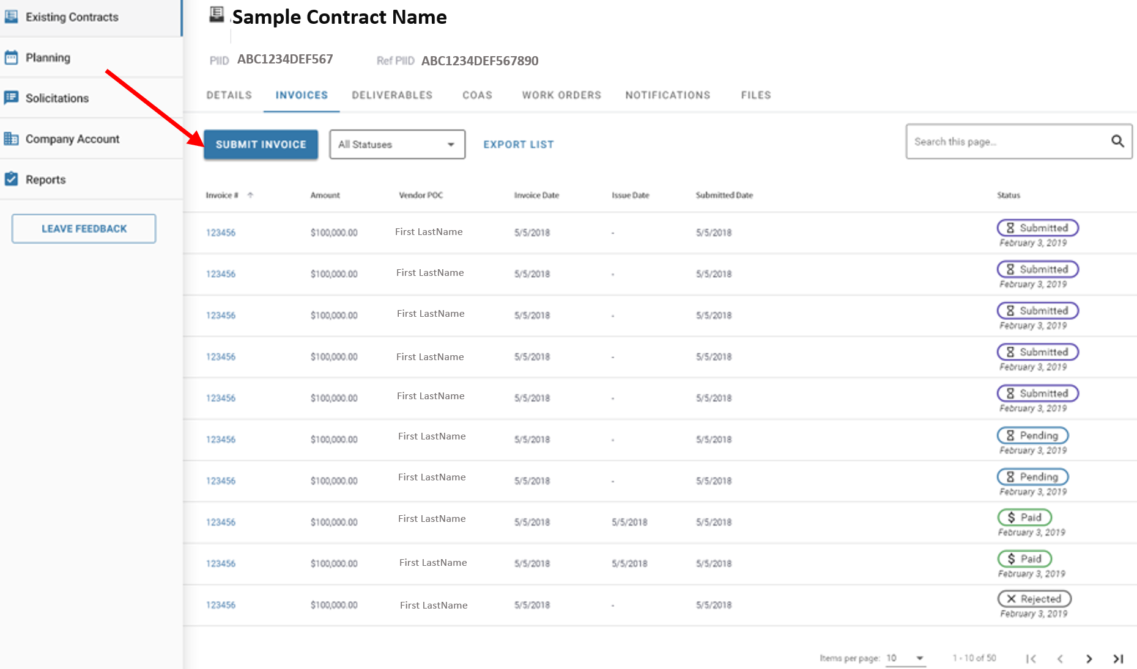
Data Field Information/Action Step:
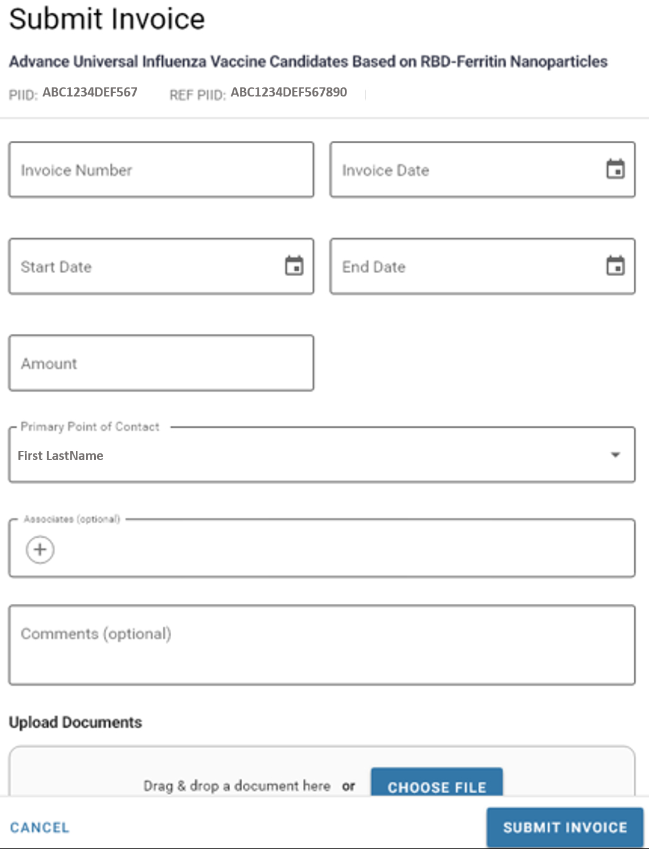
Notification Correspondence Processes:
View Notification Correspondences within Contract:
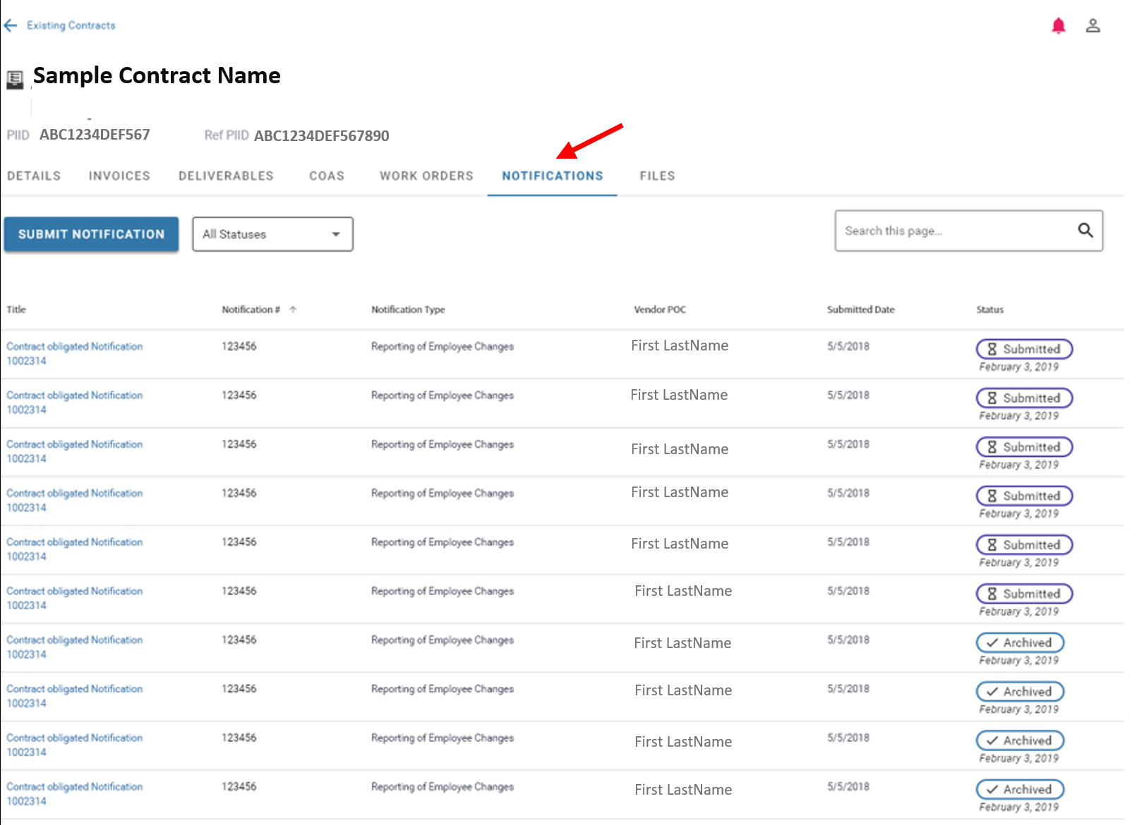
View Submitted Notification Correspondence:
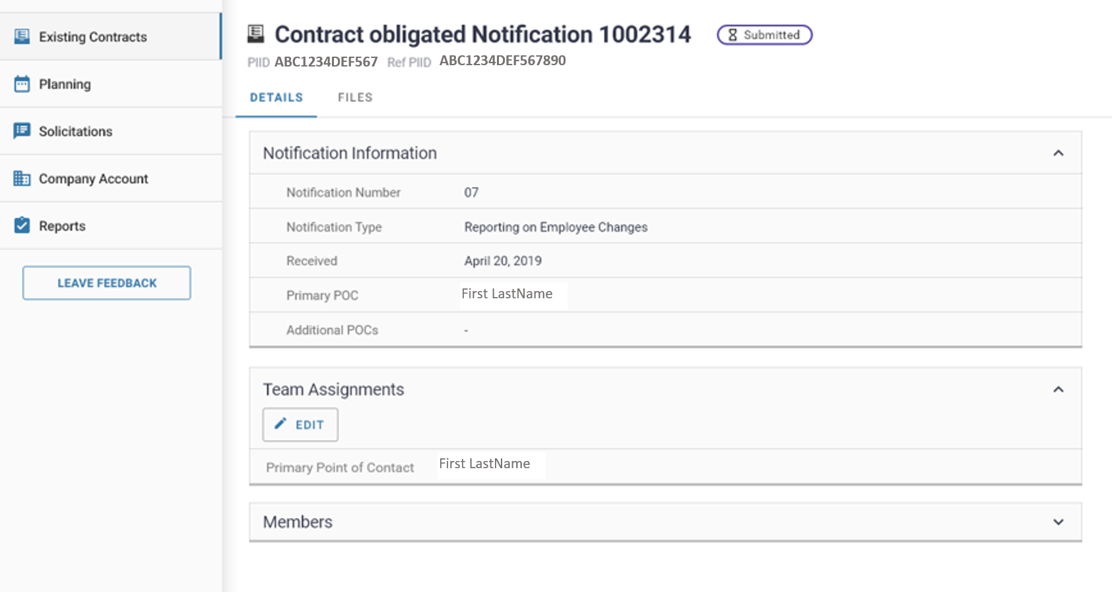
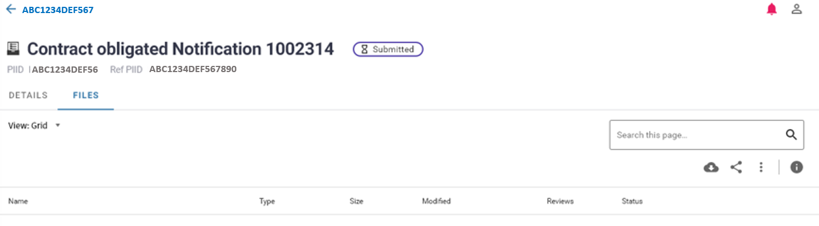
Notification Submission:
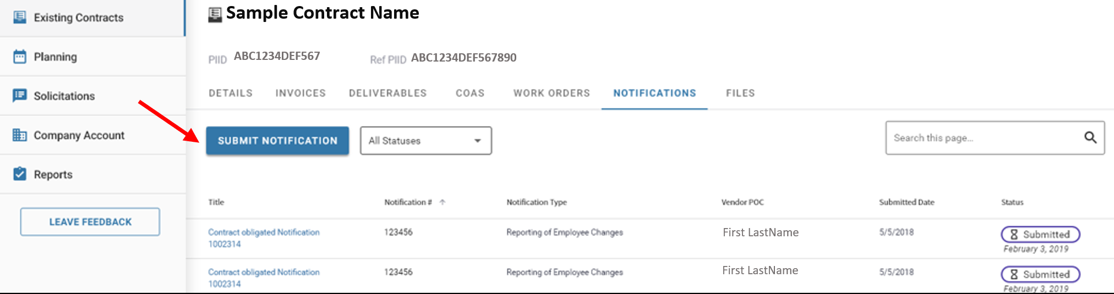
Data Field Information/Action Step:
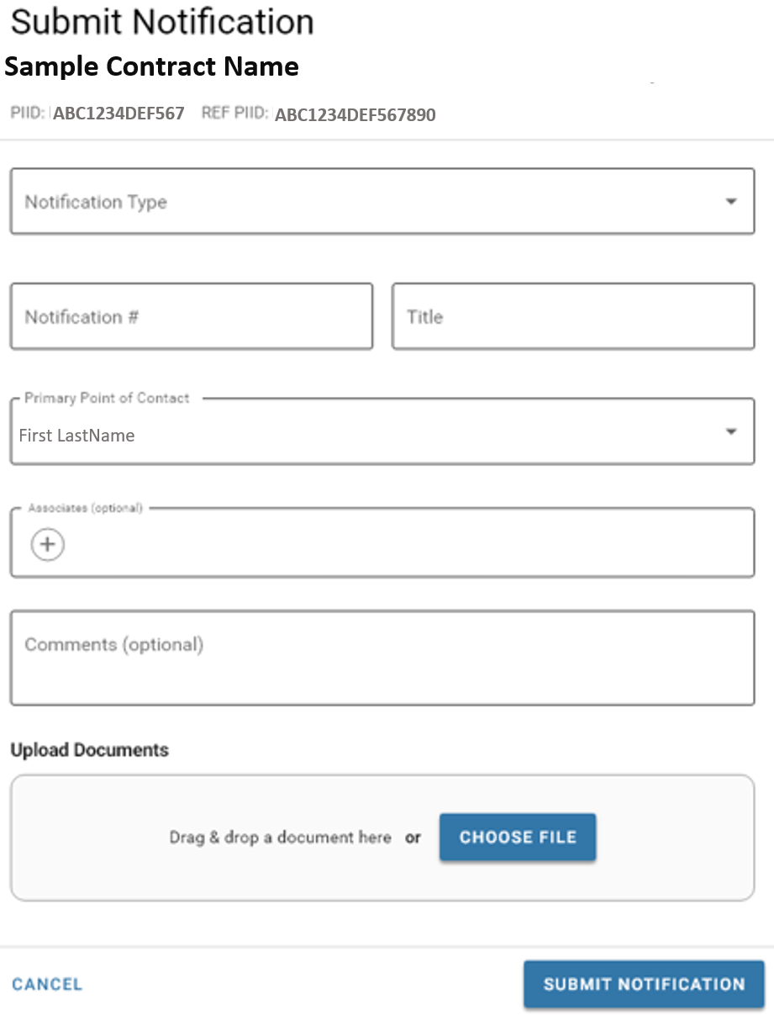

View/Update Contract Details and Assignments Processes:
View Contract Details:
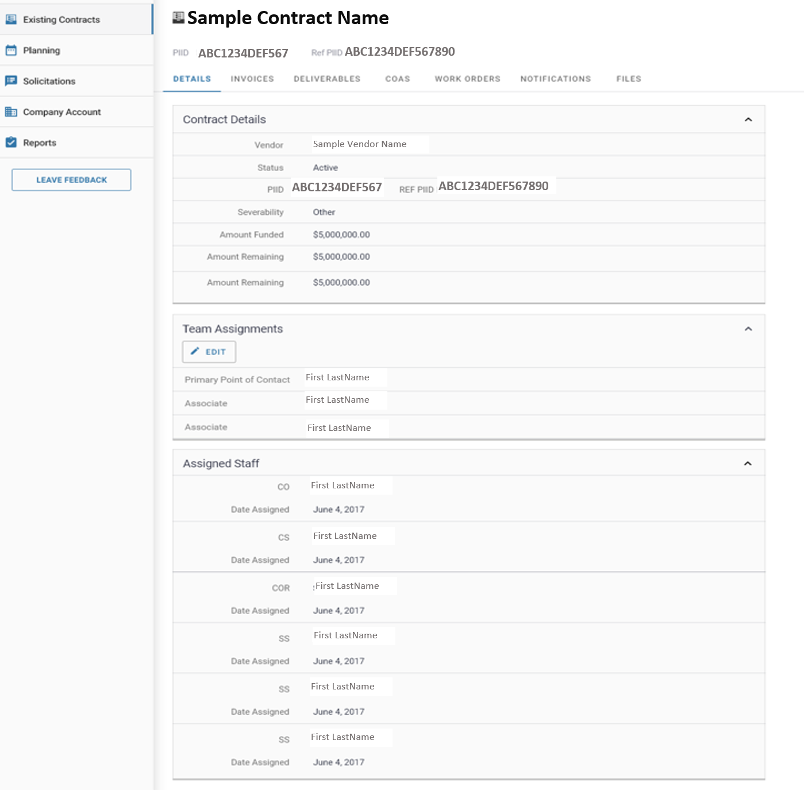

Edit Vendor Assigned Staff
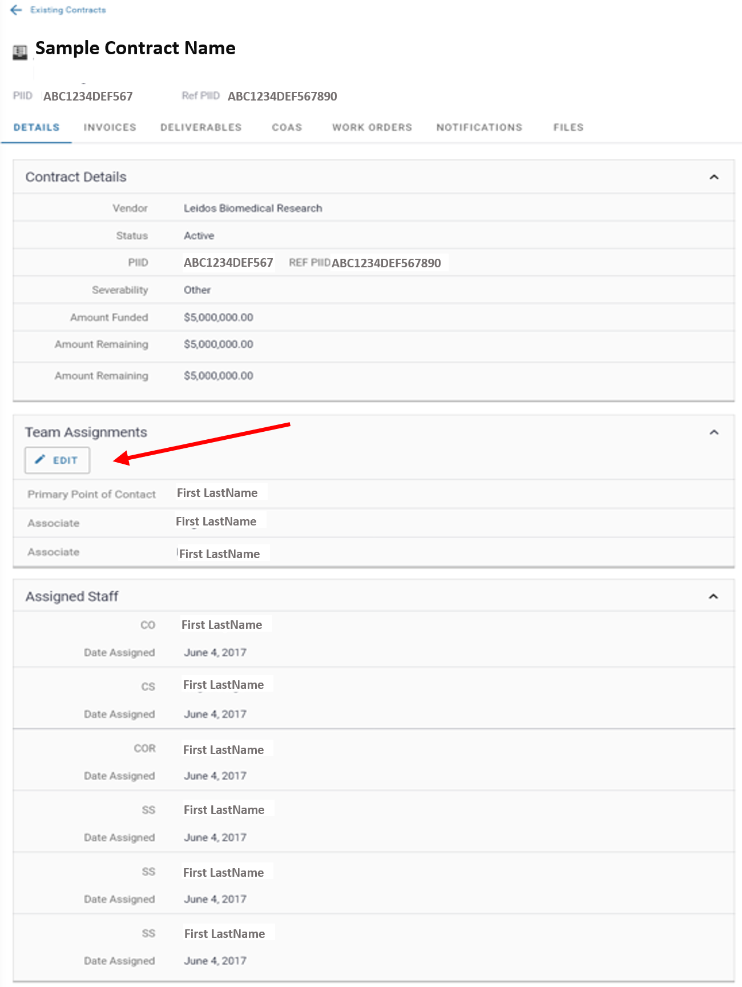
Data Field Information/Action Step:
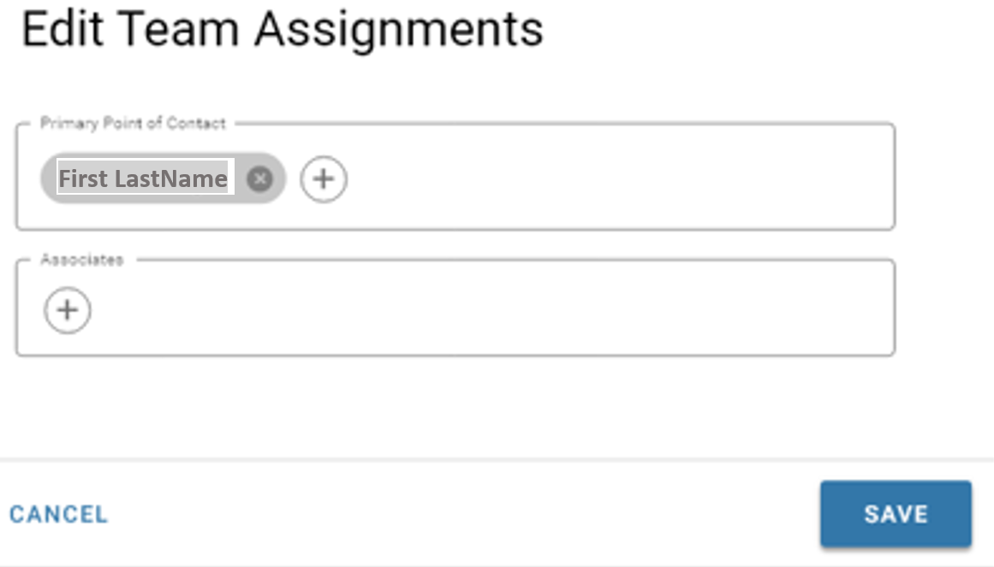

View Contract Files:
*Note only those marked as ‘visible to vendor’ will be displayed
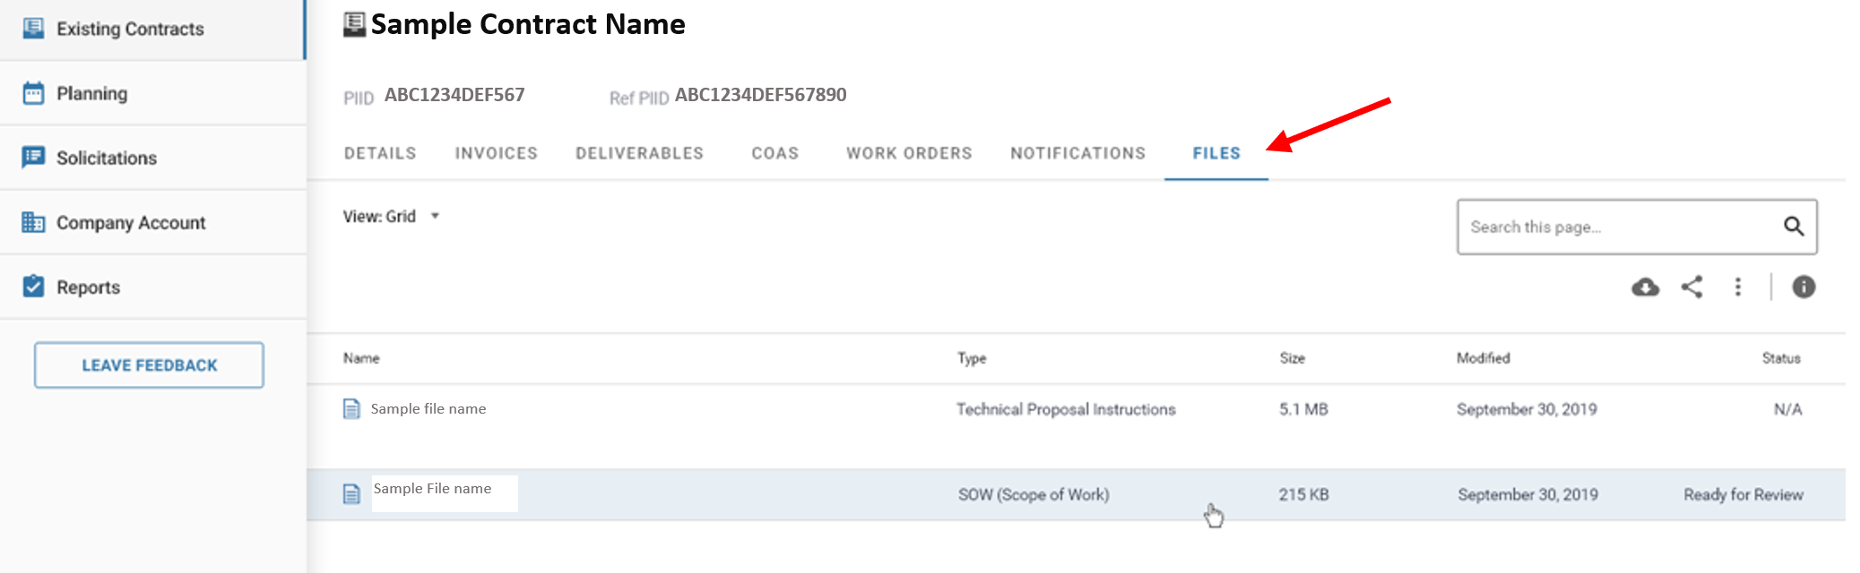
Submit Correspondences from Existing Contracts Overview Page:
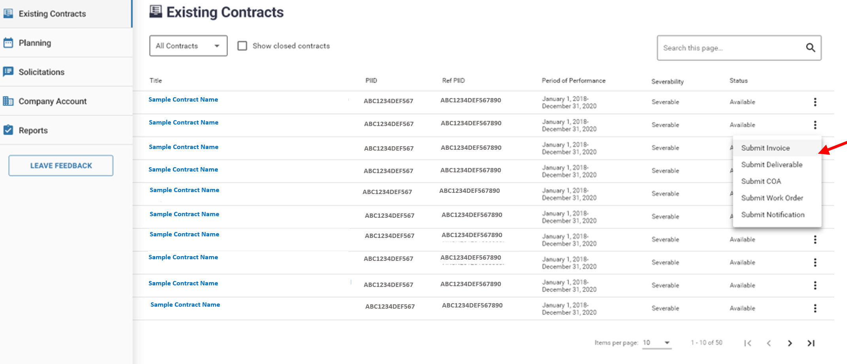

View/Manage Planning/Requirements Processes:
Planning Overview Page:
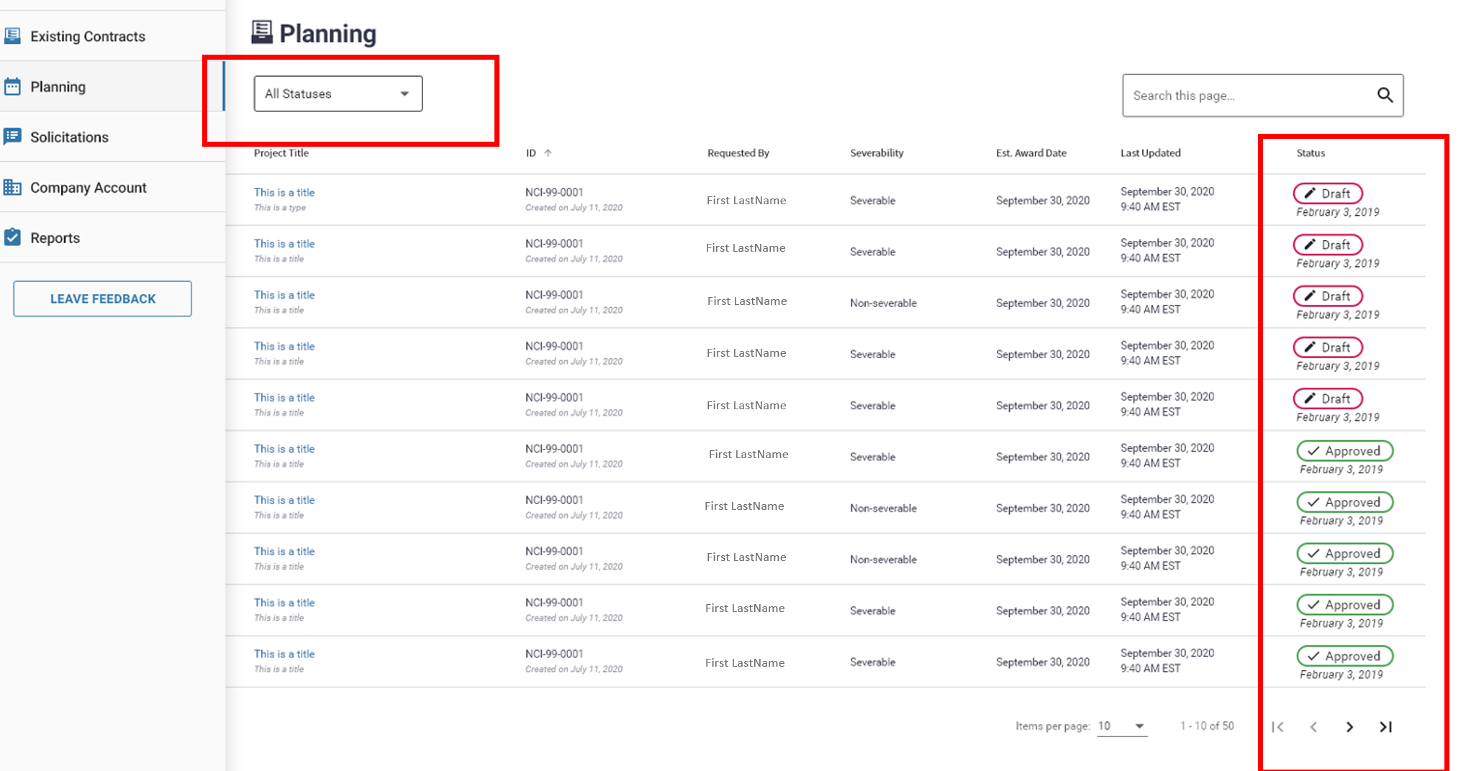
Requirement Details:
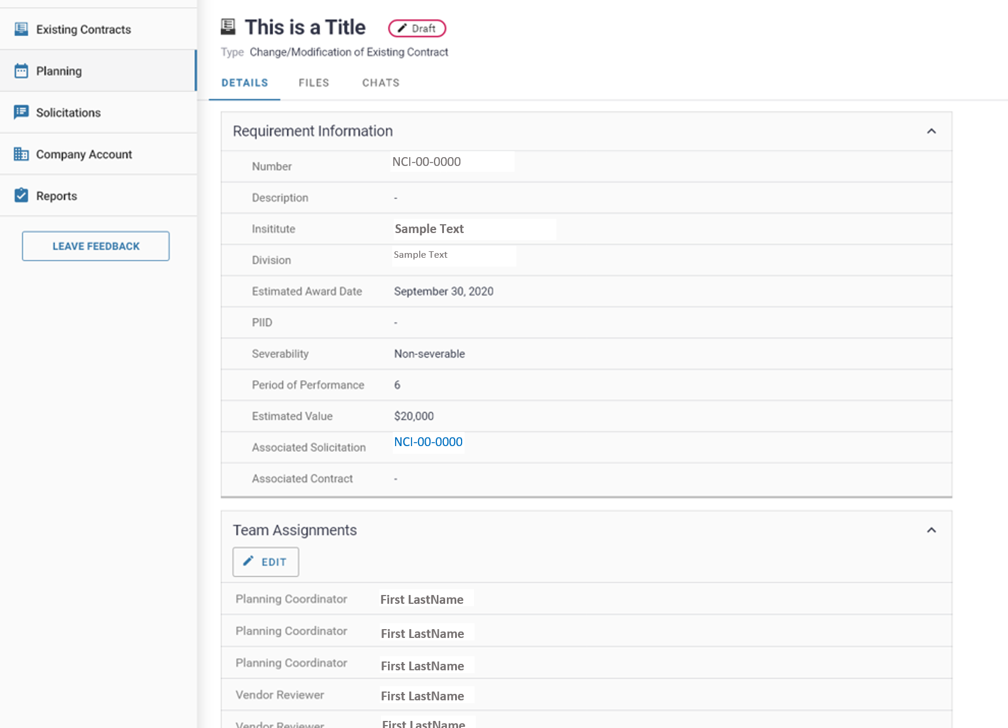

Edit Requirement Vendor Assignments:
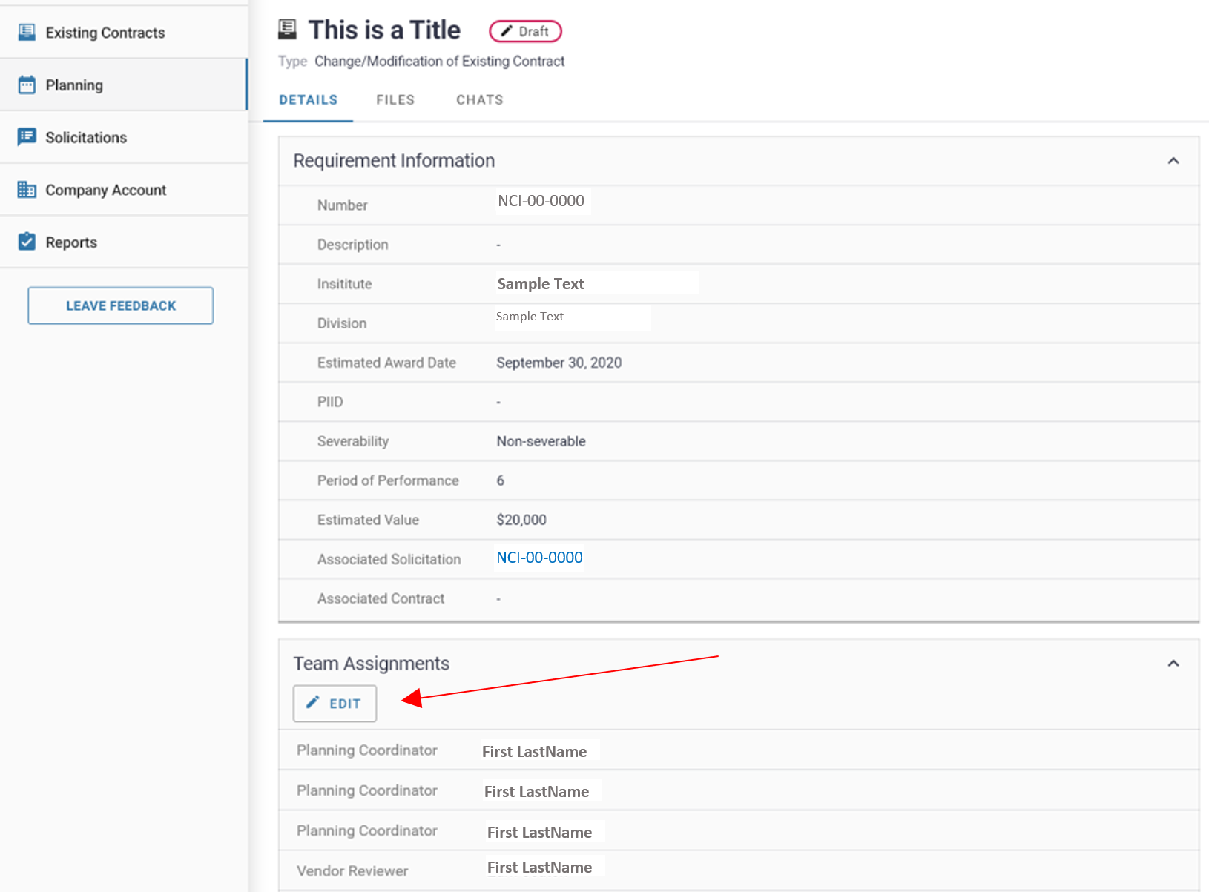
Data Field Information/Action Step:
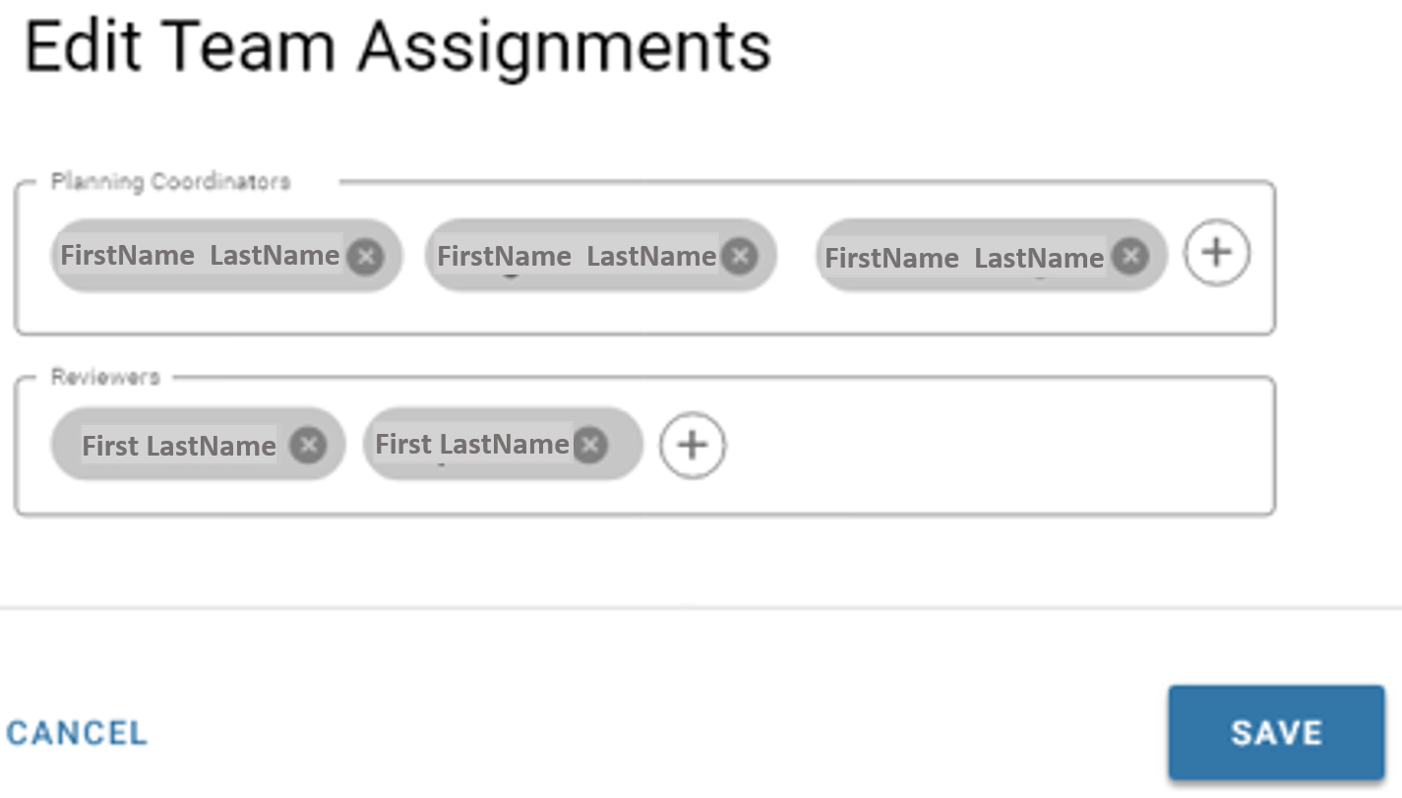

View Requirement Files:
*Note: Only visible to vendor files will be shown
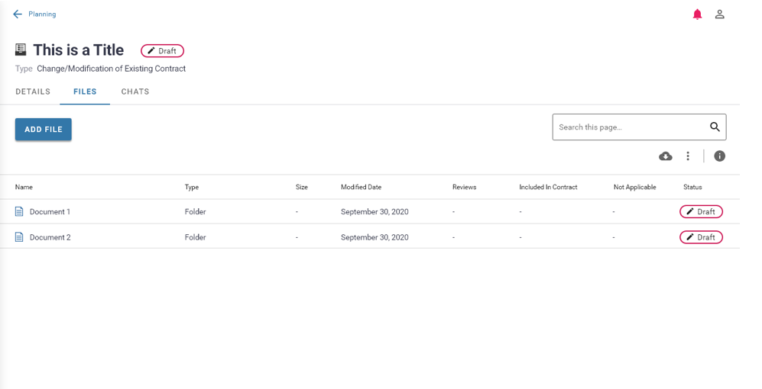

Add a Requirement File(s):
Data Field Information/Action Step:
*Note: Only Yellow Task Requirement Types will allow vendors the ability to add files
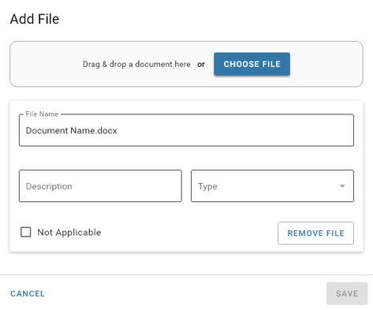

Chats within Requirement:
Data Field Information/Action Step:
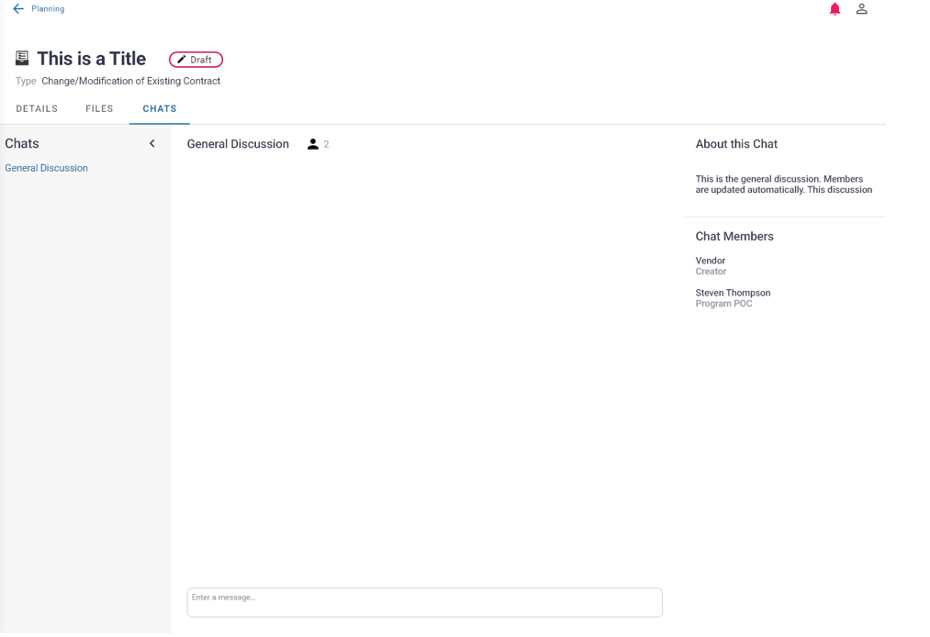

View/Manage Solicitations Processes:
Solicitations Overview Page:
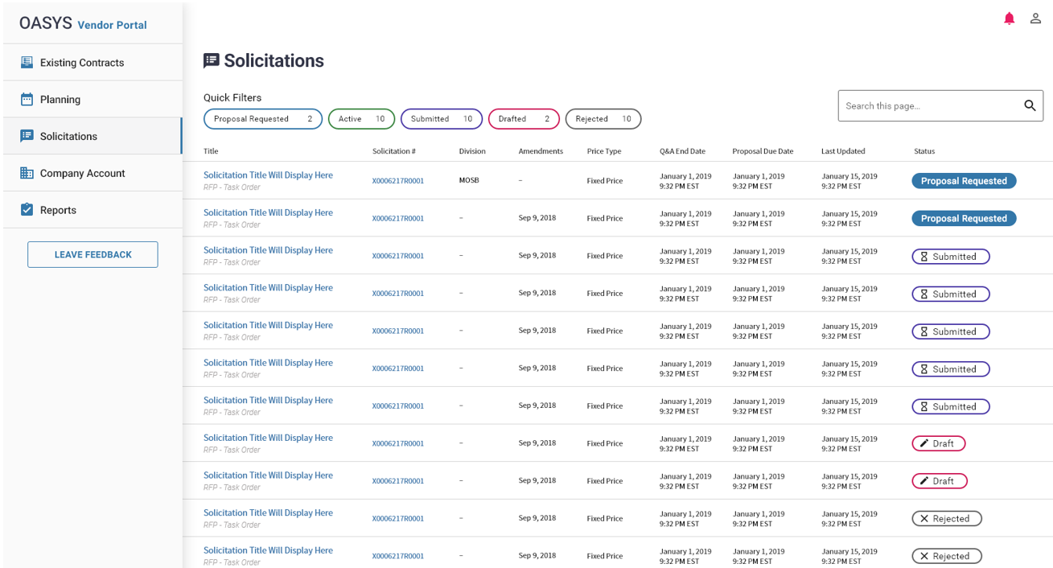
Active Solicitations Filter:
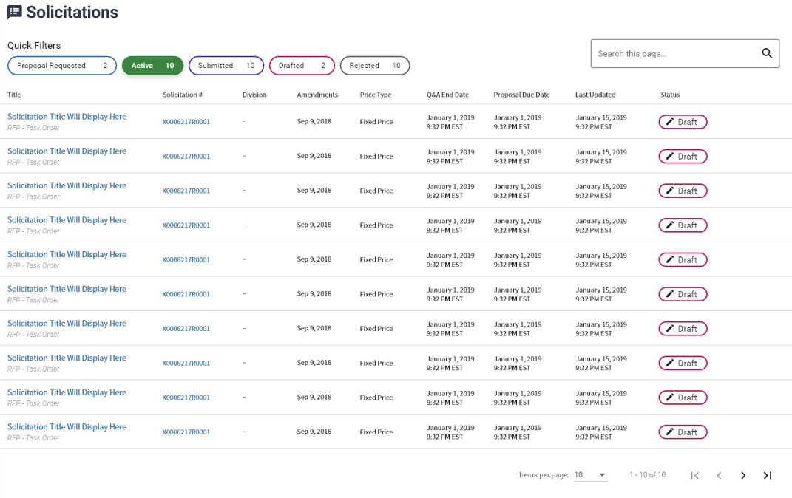
Drafted Solicitations Filter:
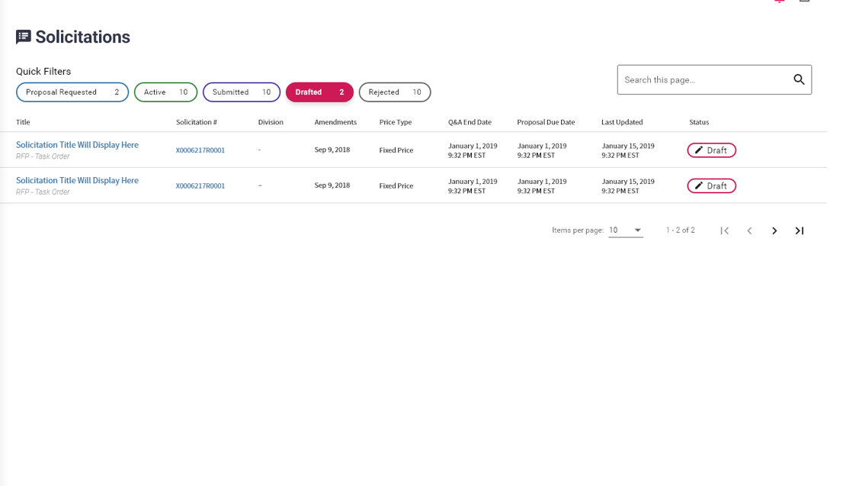
Rejected Solicitations Filter:
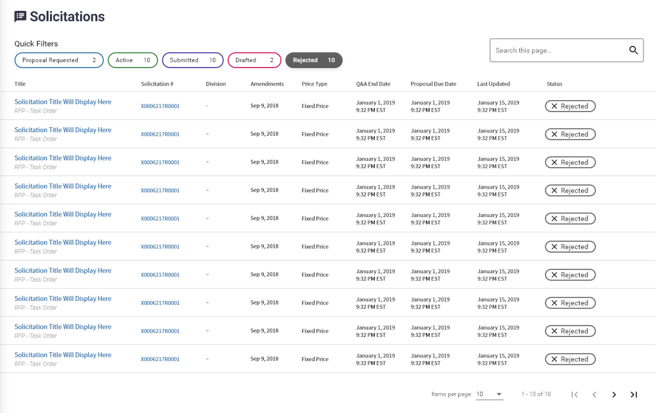
Proposal Requested Solicitations Filter:
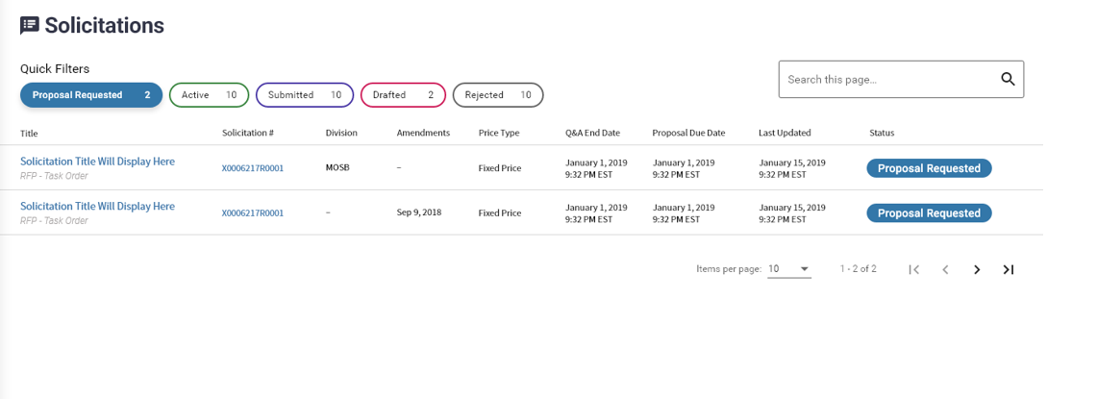
Submitted Solicitations Filter:
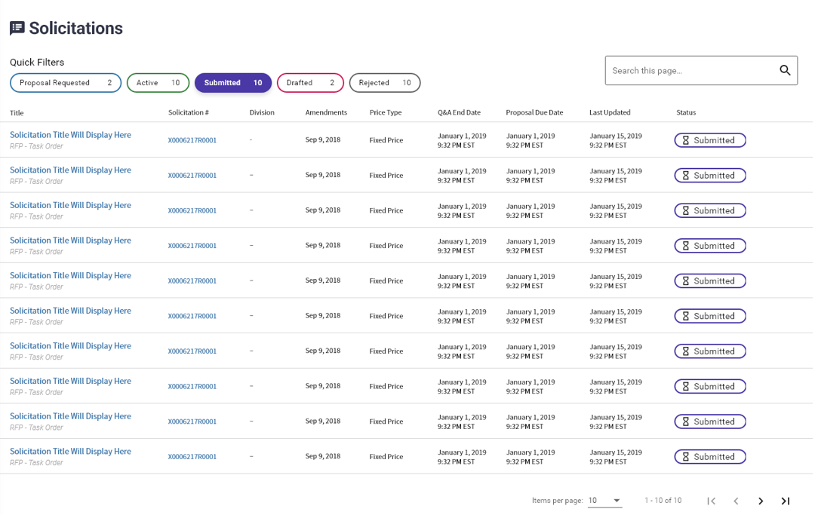

Solicitation Details:
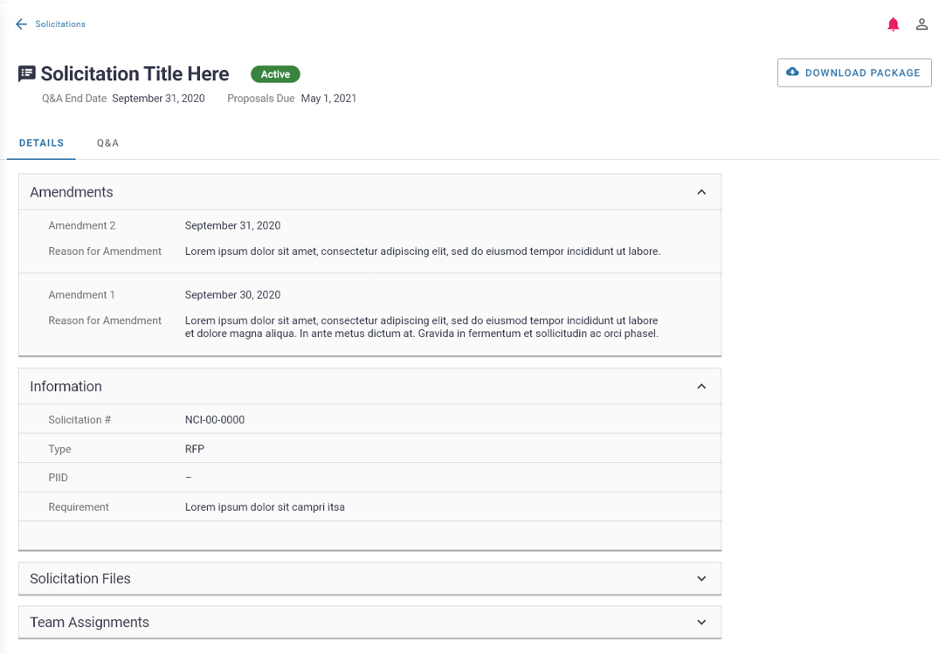
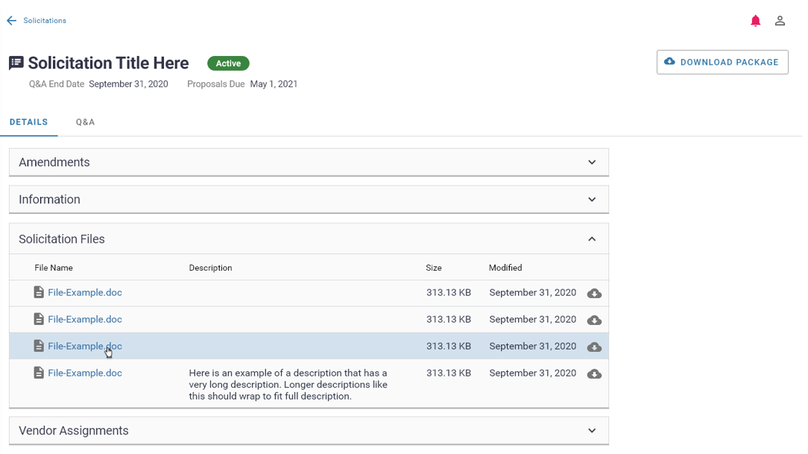

Editing Solicitation Vendor Assignments:
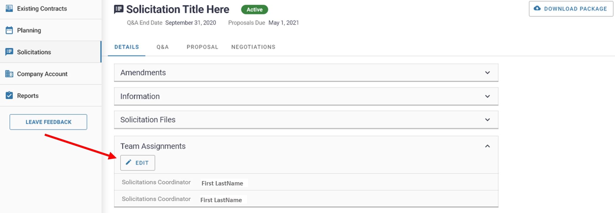
Data Field Information/Action Step:
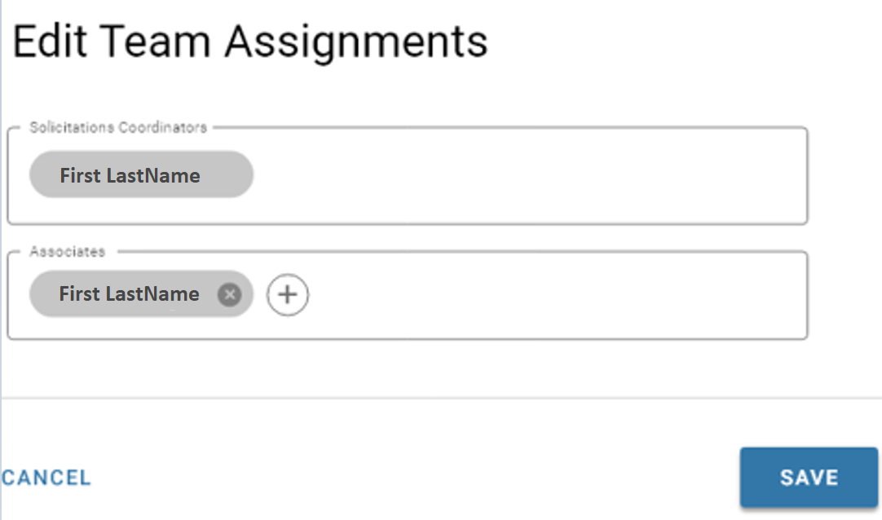

Submit Solicitation Question Process:
Ask a Question within Solicitation Q&A:
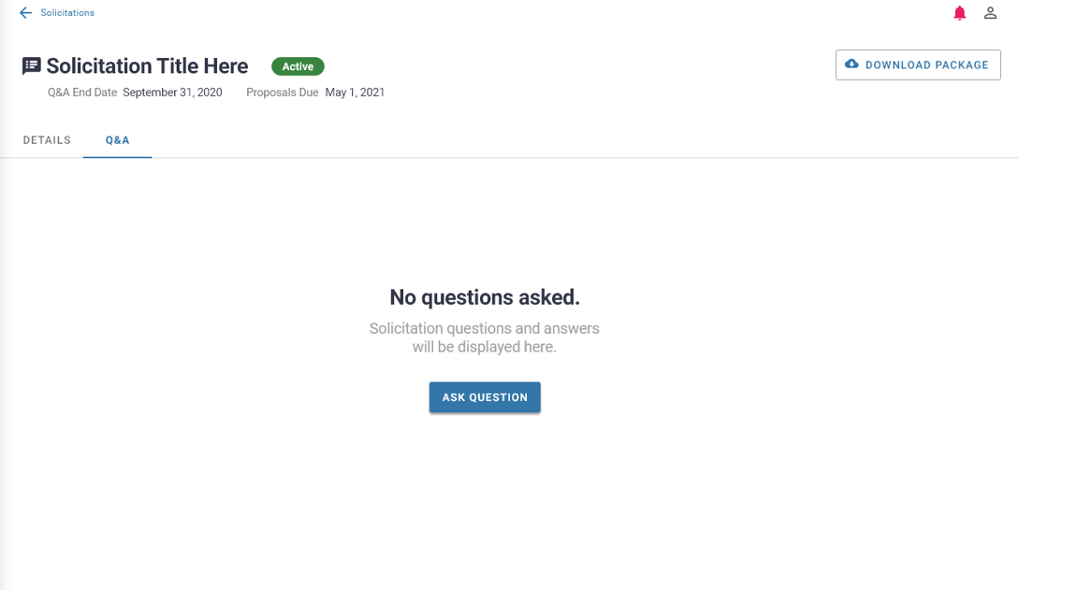

Data Field Information/Action Step:
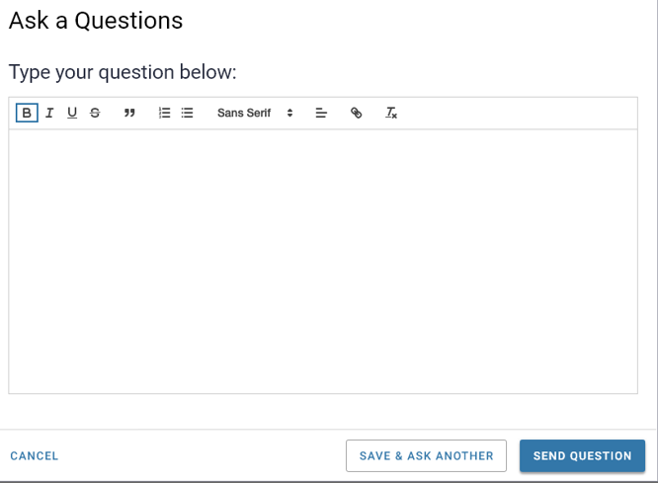
View all Q&A and edit Question:
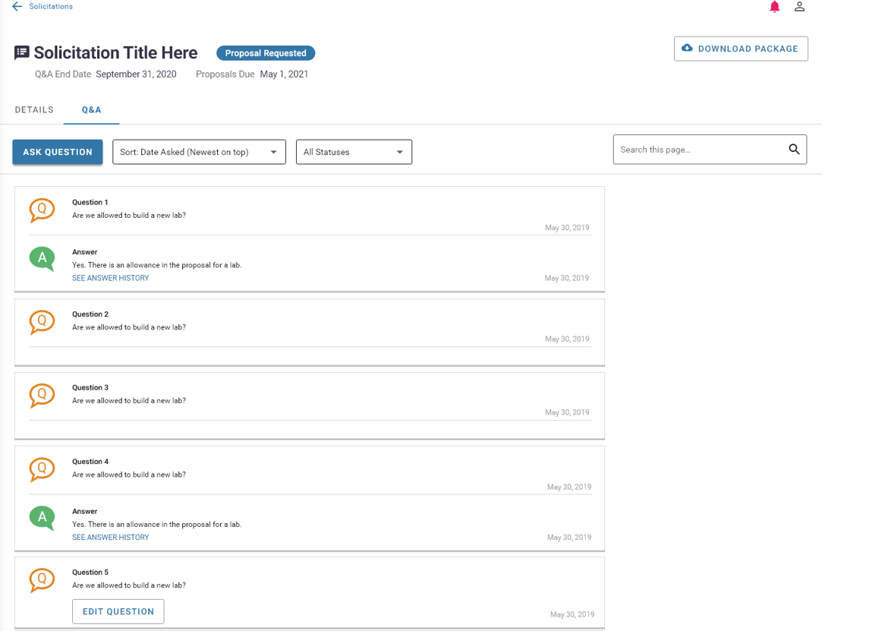

Submit Proposal Processes:
Submit Proposal:
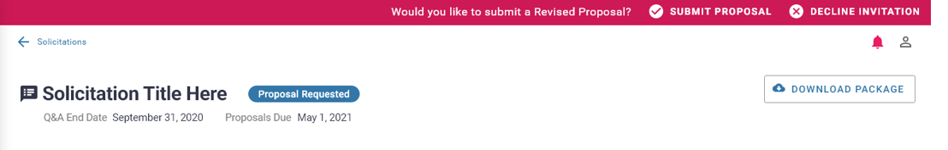

Data Field Information/Action Step:
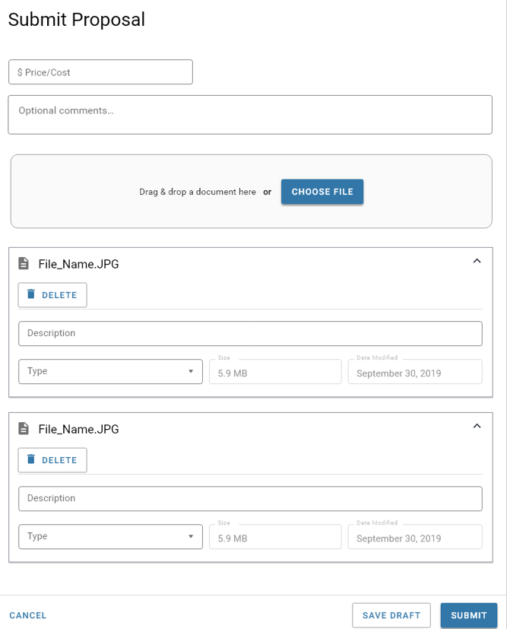
Data Field Information/Action Step:
Decline Initiation to Submit Proposal:
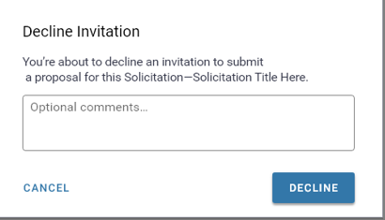
Proposals Submitted within Solicitation:
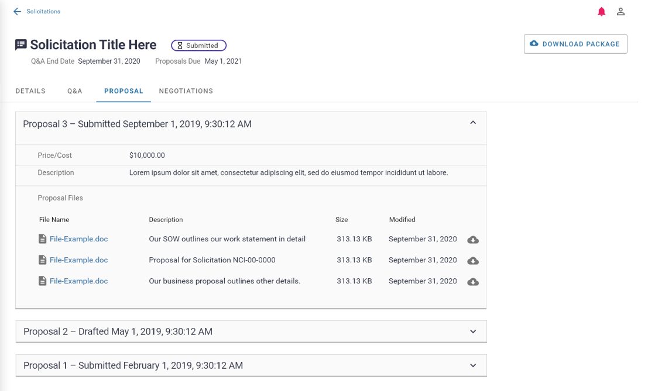

View Negotiations/Submit Response Processes:
Negotiations within Solicitation:
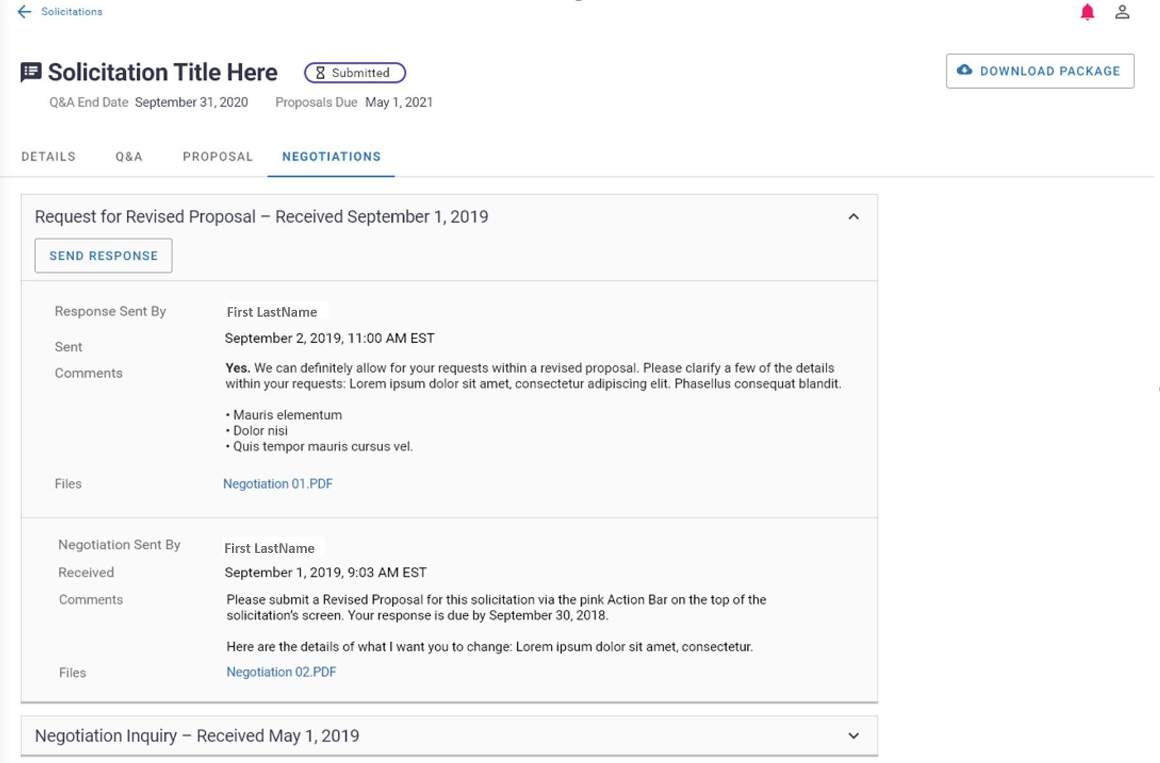
Data Field Information/Action Step:
Send a Negotiation Response:
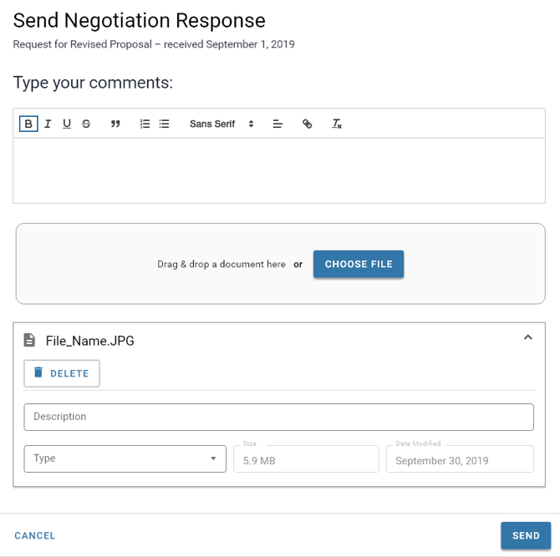
View Reports Process:
Reports within Vendor Portal:
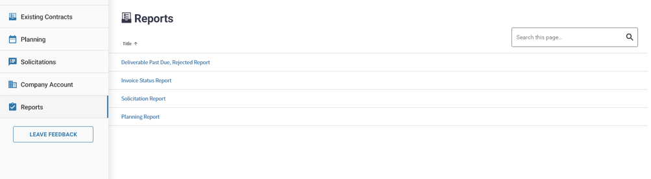
Invoice Status Report:
