Advocate Profile (Page 1)

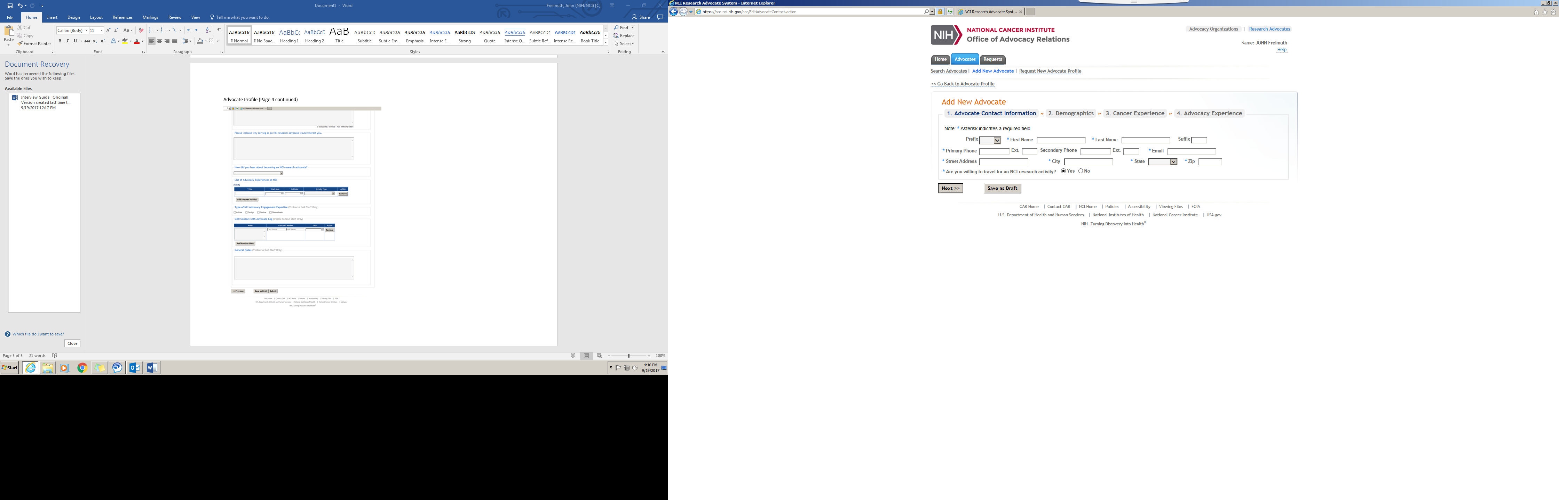

Advocate Profile (Page 2)

Advocate Profile (Page 3)

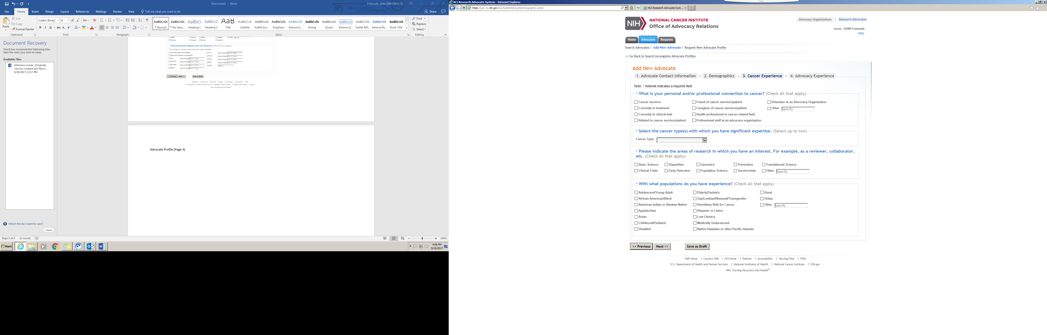

Advocate Profile (Page 4)

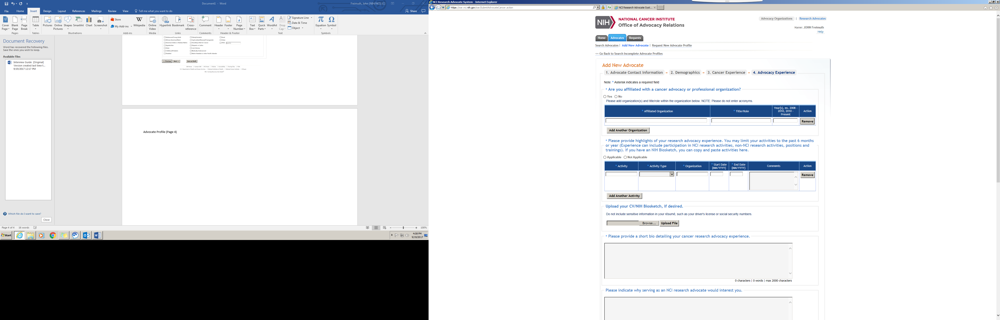

Advocate Profile (Page 4 continued)

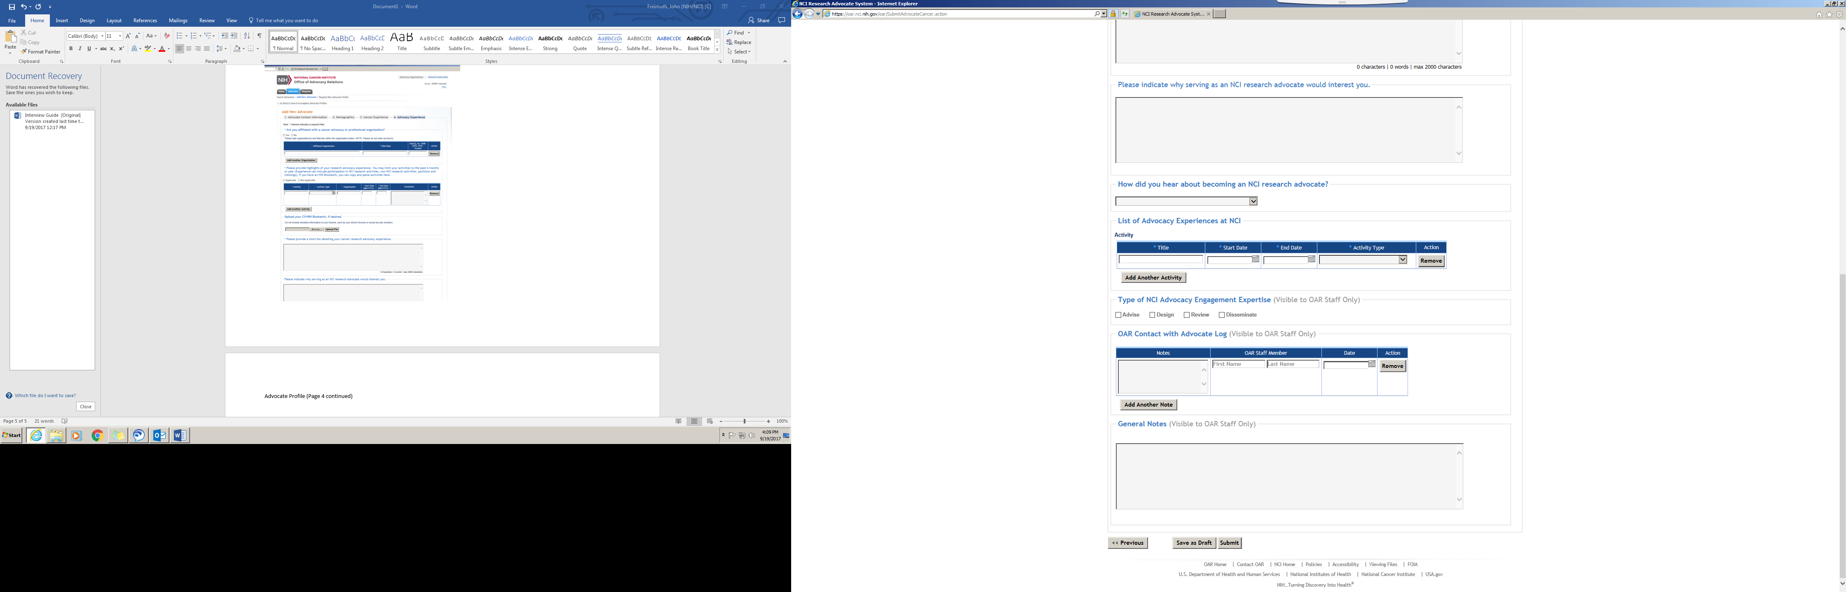

Program Staff Request (Page 1)

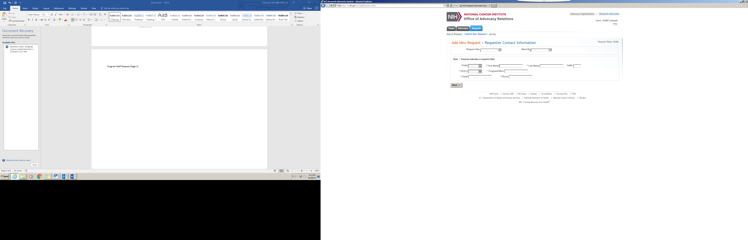

Program Staff Request (Page 2)

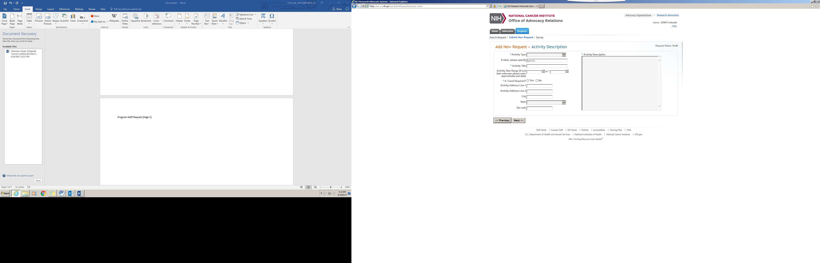

Program Staff Request (Page 3)

