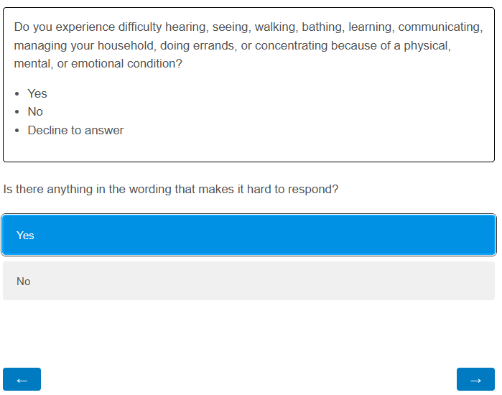

*[If text selected:]*

*[If no text selected:]*

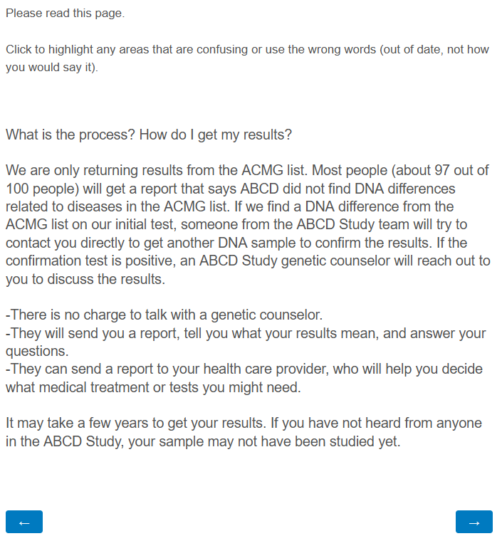

*[If text selected:]*

*[If no text selected:]*

*[If text selected:]*

*[If no text selected:]*

*[If text selected:]*

*[If no text selected:]*

*[If text selected:]*

*[If no text selected:]*

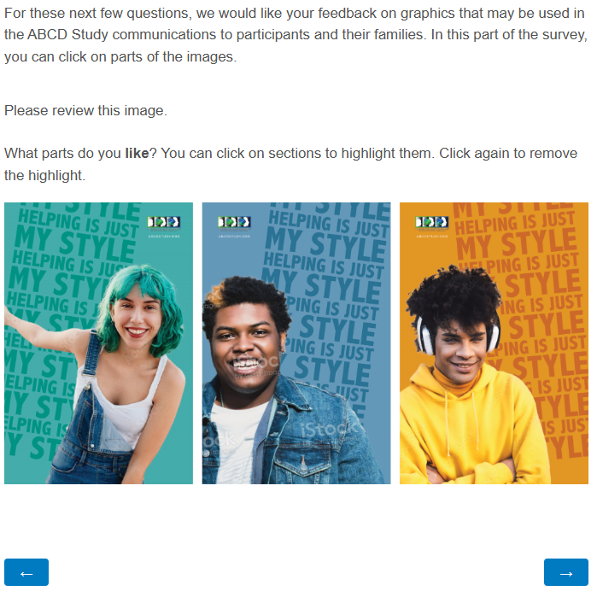

*[If any area selected:]*

*[If no areas selected:]*

*[If any area selected:]*

*[If no areas selected:]*

*[If any area selected:]*

*[If no areas selected:]*

*[If any area selected:]*

*[If no areas selected:]*

*[If any area selected:]*

*[If no areas selected:]*

*[If any area selected:]*

*[If no areas selected:]*

*[If any area selected:]*

*[If no areas selected:]*

*[If any area selected:]*

*[If no areas selected:]*

*[When additional or updated details on feedback team members are needed, this question can be updated:]*

