**Paperwork Reduction Act Statement:** The public reporting burden for this information collection has been estimated to average 30 minutes per response, including the time to review instructions and respond to questions. Send comments regarding this burden estimate or any other aspect of this collection of information, including suggestions for reducing this burden to NIH, Project Clearance Branch, 6705 Rockledge Drive, MSC 7974, Bethesda, MD 20892-7974, Attn: OMB-PRA 0925-0781

# Why Are We Asking These Questions?

Thank you for being part of the audience feedback teams to help the Adolescent Brain and Cognitive DevelopmentSM Study or ABCD Study®! (If you are joining us for the first time, welcome!) We are talking with parents and caregivers of teens to get their perspectives on parts of a research study with other parents and caregivers of teens. This activity is part of your participation in the feedback teams. We are asking for your help because we would like to hear the perspectives of parents and caregivers of teens from different backgrounds from all over the country. Your honest feedback will help the investigators ask questions in the best way possible.

You will be asked for your feedback on questions about health, life experiences, activities, and parts of your identities. Surveys will take no longer than 30 minutes to complete. You will have several days to complete the survey.

Parts of this activity are a little different from other surveys you may have taken. We are interested in your thoughts on *how the questions are written*, instead of your answers to the questions themselves. If something feels uncomfortable or confusing—we want to know. Please don’t worry about being polite or holding back. We value your feedback whether you agree or disagree, as we want to hear a wide range of opinions.

Your responses will be kept private. For open-ended questions, please do not enter any information that could identify you, such as your name or email address.

If you have questions, please email [PROJECT LEAD] at [PROJECT LEAD EMAIL.]

Would you like to participate in this activity?

Yes

No [Exit page]

# ABCD Study Background

Welcome! Thank you for participating in this exciting opportunity to contribute to research on teen health and development! We are so grateful for your commitment to this valuable project. Your role is to give feedback on questions we ask of participants in the Adolescent Brain Cognitive DevelopmentSM Study.

In the ABCD Study®, researchers will work with youth for 10 years starting at ages 9 and 10 to understand the different influences that affect brain development and general health. As part of the study, researchers will use questionnaires to ask youth about their physical and mental health; various life experiences such as playing sports, using social media, or trying drugs; and their family, school, and neighborhood environments, among other things.

The youth participating in the ABCD Study are as diverse as the United States. They come from 17 different states, from big cities and small towns, and from different economic backgrounds. The questions are asked of all participants regardless of their race, ethnicity, national origin, religion, sexual orientation, or gender identity. A large and diverse study like this makes it possible to investigate what contributes to differences in brain development, to understand what puts some people at risk for health problems, and to learn what makes some people able to recover from difficult experiences more easily than other people do.

Your feedback will help ensure the success of the ABCD Study in its quest to understand the many experiences that impact teen health and development and may help future generations of teens to live better, healthier lives.

# Feedback on Survey Questions

*[Instructions:]* We would like you to review some survey questions. This is a little different than other surveys you may have taken: we don’t need to know your answers to the questions. Instead, we want your feedback on how these questions are written.

|  |  |
| --- | --- |
| The following questions are about your family and household: ​ | |
| Is there another household in which the child spends a significant amount of time? ​ | * Yes ​ * No ​ * Declined to answer ​ |
| About how much time does the child spend at this other household? Approximately how many hours per week? ​ | ______ Hours/Week (168 hours = 1 week; 84 hours = half the week) ​   ​   * Refuse to answer ​ * Don't know ​ |
| Which of these categories best describes your TOTAL COMBINED FAMILY INCOME for the past 12 months? This should include income (before taxes and deductions) from all sources, wages, rent from properties, social security, disability and/or veteran's benefits, unemployment benefits, workman's compensation, help from relative (include child payments and alimony), and so on. ​ | * Less than $5,000 ​ * $5,000 through $11,999 ​ * $12,000 through $15,999 ​ * $16,000 through $24,999 ​ * $25,000 through $34,999 ​ * $35,000 through $49,999 ​ * $50,000 through $74,999 ​ * $75,000 through $99,999 ​ * $100,000 through $199,999 ​ * $200,000 and greater ​ * Refuse to answer ​ * Don't know ​ |

1. If you were answering this question, which scenario best describes your experience?

* I found an answer choice that completely matches how I would answer
* I could pick an answer choice that mostly matches, but not 100%
* I do NOT see an answer choice that matches how I would answer

1a.  *[If “I could pick…” or “I do NOT…”]* What makes it challenging to find a choice that matches? [Open-ended text box]

1. Were any choices missing from the response options?

* Yes
* No

2a. *[If “Yes”]* What response options should be added? [Open-ended text box.]

1. Is anything confusing or difficult to understand?

* Yes
* No

3a. *[If “Yes”]* What word or phrase would you want the question-writers to explain? You can click on any part of the text to highlight it. Click again to remove the highlight. [Select text highlight tool.]

1. Did any statements or phrases use the wrong words – out of date, not how you would say it?

* Yes
* No

4a. *[If “Yes”]* Which ones? You can click on any part of the text to highlight it. Click again to remove the highlight. [Select text highlight tool.]

4b. *[If “Yes”]* What changes would you make to those statements or phrases? [Open-ended text box]

1. Were any of these statements offensive?

* Yes
* No

5a. *[If “Yes”]* Which ones? [Select text highlight tool]

5b. *[If “Yes”]* Please share more about wh. [Open-ended text box]

|  | Yes | No | Don’t Know | Decline to Answer |
| --- | --- | --- | --- | --- |
| Are any firearms now kept in or around your home? |  |  |  |  |
| Are any of these firearms now loaded? |  |  |  |  |
| Are any of these loaded firearms also unlocked? |  |  |  |  |

1. Is there anything in the wording that makes it hard to respond?

* Yes
* No

6a. *[If “Yes”]* What in the wording would make it hard to respond? You can click on any part of the text to highlight it. Click again to remove the highlight. [Select text highlight tool.]

6b. *[If “Yes”]* Why does that make it hard to respond? [Open-ended text box]

1. Is anything confusing or difficult to understand?

* Yes
* No

7a. *[If “Yes”]* What word or phrase would you want the question-writers to explain? You can click on any part of the text to highlight it. Click again to remove the highlight. [Select text highlight tool.]

1. Did any statements or phrases use the wrong words – out of date, not how you would say it?

* Yes
* No

8a. *[If “Yes”]* Which ones? You can click on any part of the text to highlight it. Click again to remove the highlight. [Select text highlight tool.]

8b. *[If “Yes”]* What changes would you make to those statements or phrases? [Open-ended text box]

1. Are there any terms on this topic that are missing that should be included? [Open-ended text box]
2. These questions ask about some experiences, but this might not cover every experience. What else would you add? [Open-ended text box]

# Feedback on Study Materials and Instructions

These next few questions will ask you for your feedback on materials, instructions, or graphics used by the ABCD Study.

1. Please review this page. Click to highlight any areas that are confusing. To remove the highlight, click again. [Select text highlight tool.]

11a.  *[If any areas selected]* Tell us a little more about the area or areas you selected. What changes would be helpful? [Open-ended text box]

11b.  *[If no areas selected]* Do you have any comments or questions about this page? [Open-ended text box]

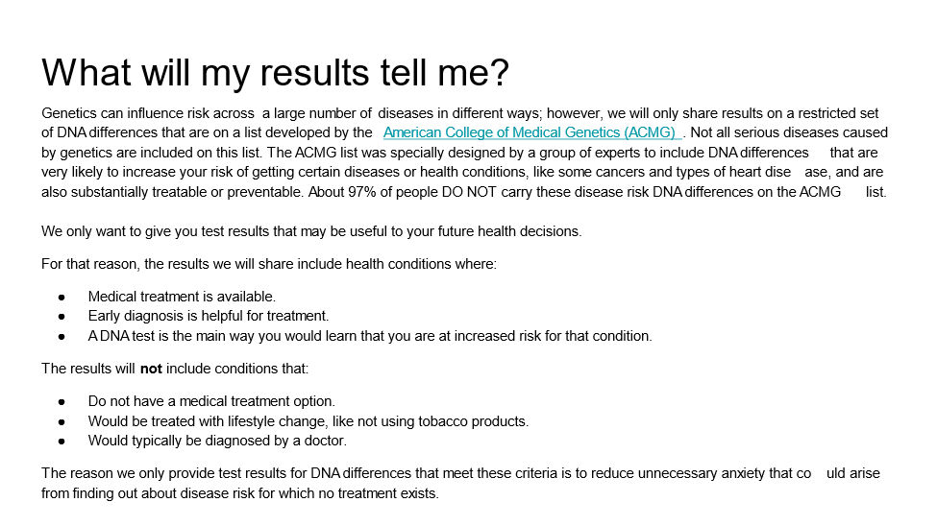

1. Please review this page. Click to highlight any areas that are confusing. To remove the highlight, click again. [Select text highlight tool.]

12a.  *[If any areas selected]* Tell us a little more about the area or areas you selected. What changes would be helpful? [Open-ended text box]

12b.  *[If no areas selected]* Do you have any comments or questions about this page? [Open-ended text box]

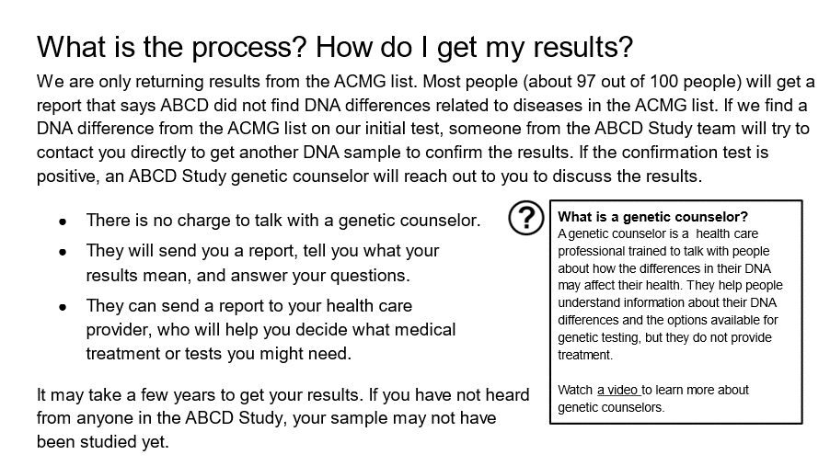

1. Please review this page. Click to highlight any areas that are confusing. To remove the highlight, click again. [Select text highlight tool.]

13a.  *[If any areas selected]* Tell us a little more about the area or areas you selected. What changes would be helpful? [Open-ended text box]

13b.  *[If no areas selected]* Do you have any comments or questions about this page? [Open-ended text box]

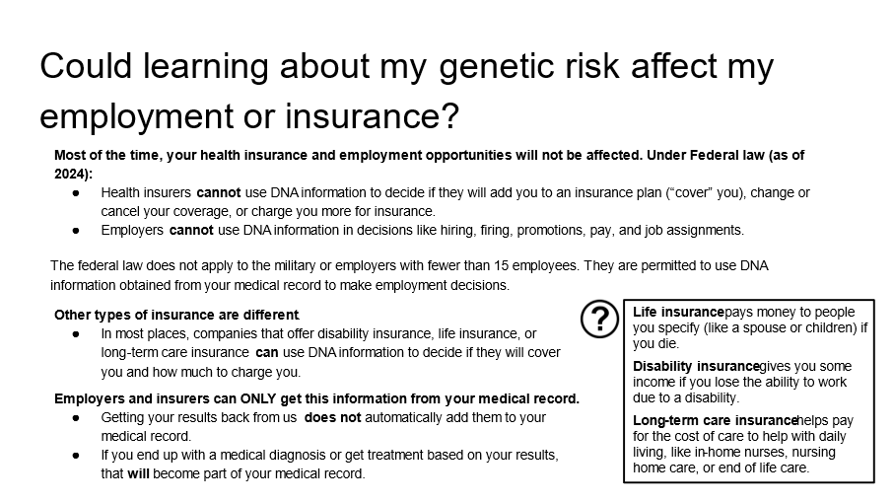

1. Please review this page. Click to highlight any areas that are confusing. To remove the highlight, click again. [Select text highlight tool.]

14a.  *[If any areas selected]* Tell us a little more about the area or areas you selected. What changes would be helpful? [Open-ended text box]

14b.  *[If no areas selected]* Do you have any comments or questions about this page? [Open-ended text box]

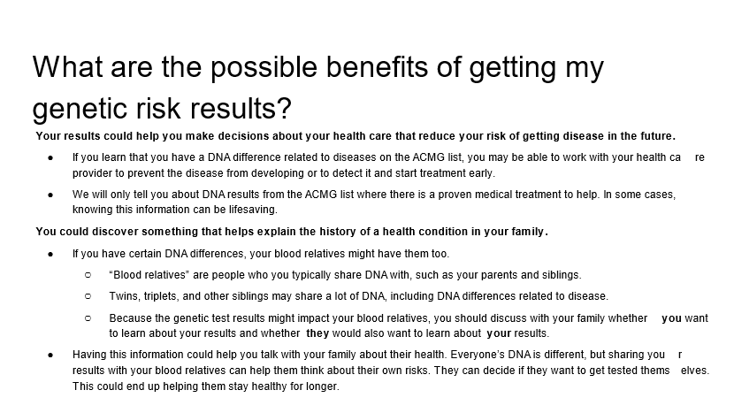

1. Please review this page. Click to highlight any areas that are confusing. To remove the highlight, click again. [Select text highlight tool.]

15a.  *[If any areas selected]* Tell us a little more about the area or areas you selected. What changes would be helpful? [Open-ended text box]

15b.  *[If no areas selected]* Do you have any comments or questions about this page? [Open-ended text box]

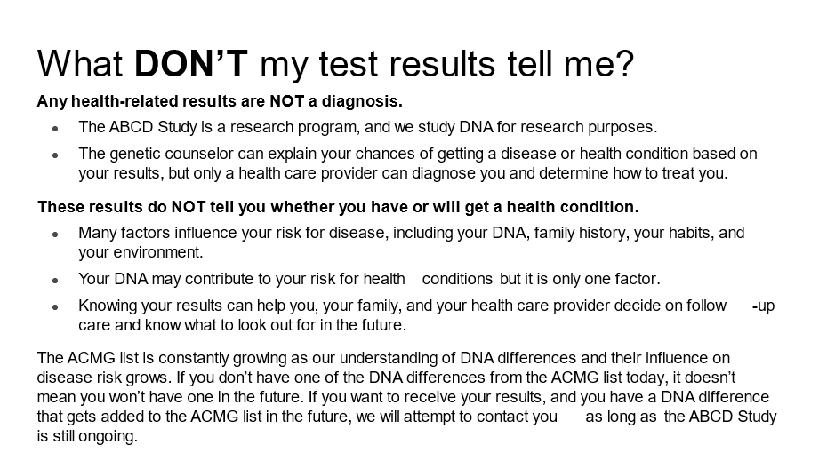

*[Instructions:]* For these next few questions, we would like your feedback on graphics that may be used in the ABCD Study communications to participants and their families. In this part of the survey, you can click on parts of the images.

1. Please review this image. What parts do you like? You can click on sections to highlight them. Click again to remove the highlight. [Select image section highlight tool]

16a.  *[If any areas selected]* Tell us a little more about the area or areas you selected. What do you like about them? [Open-ended text box]

16b.  *[If no areas selected]* Do you have any comments or questions about this image? [Open-ended text box]

1. What parts of the image do you dislike? You can click on sections to highlight them. Click again to remove the highlight. [Select image section highlight tool]

17a.  *[If any areas selected]* Tell us a little more about the area or areas you selected. What do you dislike about them? What changes would you make? [Open-ended text box]

17b.  *[If no areas selected]* Do you have any comments or questions about this image? [Open-ended text box]

1. Please review this image. What parts do you like? You can click on sections to highlight them. Click again to remove the highlight. [Select image section highlight tool]

18a.  *[If any areas selected]* Tell us a little more about the area or areas you selected. What do you like about them? [Open-ended text box]

18b.  *[If no areas selected]* Do you have any comments or questions about this image? [Open-ended text box]

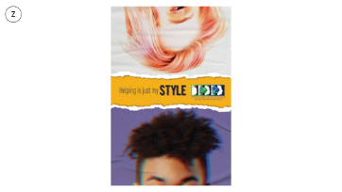

1. What parts of the image do you dislike? You can click on sections to highlight them. Click again to remove the highlight. [Select image section highlight tool]

19a.  *[If any areas selected]* Tell us a little more about the area or areas you selected. What do you dislike about them? What changes would you make? [Open-ended text box]

19b.  *[If no areas selected]* Do you have any comments or questions about this image? [Open-ended text box]



1. Please review this image. What parts do you like? You can click on sections to highlight them. Click again to remove the highlight. [Select image section highlight tool]

20a.  *[If any areas selected]* Tell us a little more about the area or areas you selected. What do you like about them? [Open-ended text box]

20b.  *[If no areas selected]* Do you have any comments or questions about this image? [Open-ended text box]

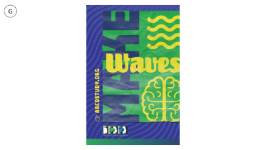

1. What parts of the image do you dislike? You can click on sections to highlight them. Click again to remove the highlight. [Select image section highlight tool]

21a.  *[If any areas selected]* Tell us a little more about the area or areas you selected. What do you dislike about them? What changes would you make? [Open-ended text box]

21b.  *[If no areas selected]* Do you have any comments or questions about this image? [Open-ended text box]



1. Please review this image. What parts do you like? You can click on sections to highlight them. Click again to remove the highlight. [Select image section highlight tool]

22a.  *[If any areas selected]* Tell us a little more about the area or areas you selected. What do you like about them? [Open-ended text box]

22b.  *[If no areas selected]* Do you have any comments or questions about this image? [Open-ended text box]

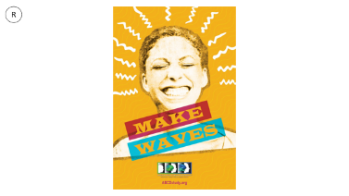

1. What parts of the image do you dislike? You can click on sections to highlight them. Click again to remove the highlight. [Select image section highlight tool]

23a.  *[If any areas selected]* Tell us a little more about the area or areas you selected. What do you dislike about them? What changes would you make? [Open-ended text box]

23b.  *[If no areas selected]* Do you have any comments or questions about this image? [Open-ended text box]



1. Which image is your favorite?

* *Image G*
* *Image Z*
* *Image R*
* *Image B*

1. Which image is your LEAST favorite?

* *Image G*
* *Image Z*
* *Image R*
* *Image B*

# Additional Participant Data

1. Which of the following describes your race or ethnicity? [choose one or more]

* American Indian or Alaska Native
* Asian
* Black or African American
* Hispanic or Latino
* Middle Eastern or North African
* Native Hawaiian or Other Pacific Islander
* White

# Participant ID

1. The study team gave you an ID number containing both a letter and number (such as Q4). Please enter your ID number here so you can get credit for completing this activity. [Open-ended text box]
2. Before we conclude, we wanted to offer one more space for you to share any additional thoughts about anything you saw in this activity. Remember, please don’t share your full name, contact information, or anything else that would connect you as an individual with your responses. [Open-ended text box]

# Thank You Page

Thank you for taking the time to complete this activity! The team greatly appreciates your feedback. What you shared today will help investigators ask questions in the best way possible to understand teens’ experiences and development.

We look forward to your participation in future feedback team activities. If you have additional feedback or questions about your feedback team participation, please contact [PROJECT LEAD] by email at [PROJECT LEAD EMAIL].

# Exit Page

We thank you for your time spent completing this activity. Your response has been recorded.