PAPERWORK REDUCTION ACT STATEMENT
Paperwork Reduction Act Statement: The public reporting burden for this information collection has been estimated to average 60 minutes per response, including the time to review instructions and respond to questions. Send comments regarding this burden estimate or any other aspect of this collection of information, including suggestions for reducing this burden to NIH, Project Clearance Branch, 6705 Rockledge Drive, MSC 7974, Bethesda, MD 20892-7974, Attn: OMB-PRA 0925-0781.

MODERATOR’S GUIDE

HOUSEKEEPING
Please note: Participants have been asked to log in a few minutes prior to the scheduled start time of the group discussion to begin on time. During this time, the moderator will ensure that each participant can see the shared screen, is in a private space with no other individuals present, and knows how to mute their microphone when not speaking.
Before we begin, can anyone NOT see the shared screen? If you cannot, please let me know now.

A few housekeeping items to review before joining today’s call:
- Our discussion will be recorded so that I can refer to the recording as needed for my report writing, and my colleague is also on the line to take notes. In addition, other project staff are on the line listening to today’s discussion. Does anyone object to this discussion being recorded? [Moderator to dismiss anyone who objects to the recording. Notetaker to press “record.”]
- We will use first names only during today’s discussion, and I will report all findings from our conversation in summary form, never connecting an individual comment with an individual name. This means that I will acknowledge that someone in this group made a comment but not anything about who you are (like your name, town, or school).
- To maintain everyone’s privacy, please do not share any specific comments other participants say during the discussion with anyone. You can talk about your experience participating in this project, but please do not share anything someone else says about their identities or experiences.
- We will use the findings from today’s discussion only to inform the development of questions asked in the Adolescent Brain Cognitive DevelopmentSM Study, also called the ABCD Study®.
- Please mute your microphone when you are not speaking to minimize background noise.
- Please put your smartphone or tablet on Do Not Disturb mode while we are in this discussion. I want to make the most of our time together.

In terms of your feedback:
- There are no right or wrong answers to any of the questions I will be asking. Please be honest.
- If something feels uncomfortable or unclear, we want to know. Please don’t worry about being polite, or holding back. I didn’t write anything you’ll see on the screen.
- It is valuable for me to hear all points of view, so please talk respectfully, one at a time, and let other participants finish what they’re saying before speaking.
- You are not required to answer every question. You can “pass” if any question makes you uncomfortable. You are also free to stop participating at any time.

BACKGROUND
Good [evening/afternoon]. Thank you for taking the time to participate in this discussion. My name is [XXXX], I use [XXXX] pronouns, and I am going to facilitate our conversation.

- I am a trained moderator with IQ Solutions, a company that is holding these discussions to help the National Institute on Drug Abuse (or NIDA).
- NIDA manages the Adolescent Brain Cognitive Development (ABCD) Study—the largest long-term study of brain development and child health in the United States.
- We're looking for your feedback on some of the questions, graphics, and instructions that will be asked of other people in the study later this year.
- When we ask for your feedback on questions, we don't need to know what your answers to the questions would be—just your reactions to how the questions are written.
- We want to make sure the questions or instructions don't leave anyone confused, uncomfortable, offended, or feeling like their experiences aren't included.

PARTICIPANT INTRODUCTIONS
Thank you all for joining our discussion today. I am now going to go around the virtual “table” and call your first name. Please introduce yourself briefly by letting us know:
- The name that you would like me to use during this discussion—remember, no last names—and the pronouns you use, if you would like.
- Something you are looking forward to this school year.

Okay, let’s get started on our questions.

FEEDBACK ON SURVEY QUESTIONS
We would like to get your feedback on some survey questions that the ABCD Study would like to use later this year. Thank you for the feedback you shared in the pre-discussion survey! In this part of the discussion, we want to ask some more questions to make sure the questions are written in the best way possible.
[Stimuli description:] This question asks about difficulties someone might experience with doing activities.
Do you experience difficulty hearing, seeing, walking, bathing, learning, communicating, managing your household, doing errands, or concentrating because of a physical, mental, or emotional condition?
- Yes
- No
- Decline to answer

- In your own words, what do you think this question is asking about?

- How would you think about answering this question? As a reminder, I don’t need to know your answer—rather, I want to hear you talk me through how you would get to the answer.
[Probe on definitions, examples, confusing areas]

- What other questions are important to ask on this topic?

[Stimuli description:] Here is another version of the question.
Do you experience difficulty in doing certain activities and interacting with the world around you because of a physical, mental, emotional, or behavioral condition?
- Yes
- No
- Decline to answer

- How would you think about answering this question?
[Probe on definitions, examples, confusing areas]

FEEDBACK ON STUDY MATERIALS
Now I’m going to switch topics a bit. I would like your feedback on some materials or instructions that will be used in the ABCD Study later this year.
[Stimuli description:] I’d like to get your feedback on some of the pages from a consent form for getting results from a genetic test for health risks. You might remember seeing the consent form during the discussion in the spring. Some of these pages were revised based on what youth and parents in the feedback teams shared in the last discussions—if you participated, thank you for your feedback. I would like to get your feedback on some of those pages today.
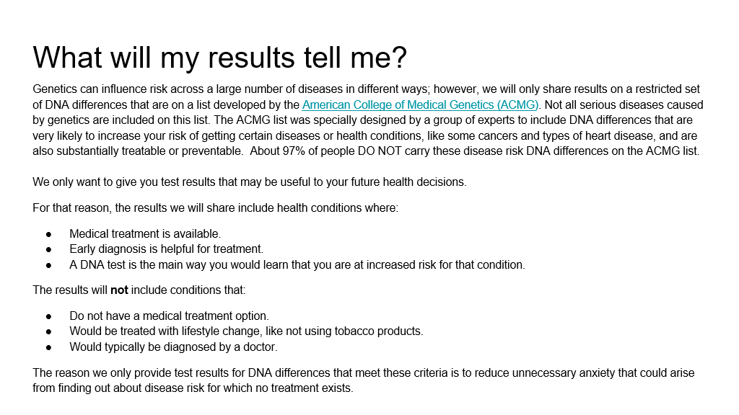
- What did you find surprising on this page?

- What, if anything, did you find confusing on this page?

- How would you summarize this page in your own words?

- What questions do you have after reading this page?
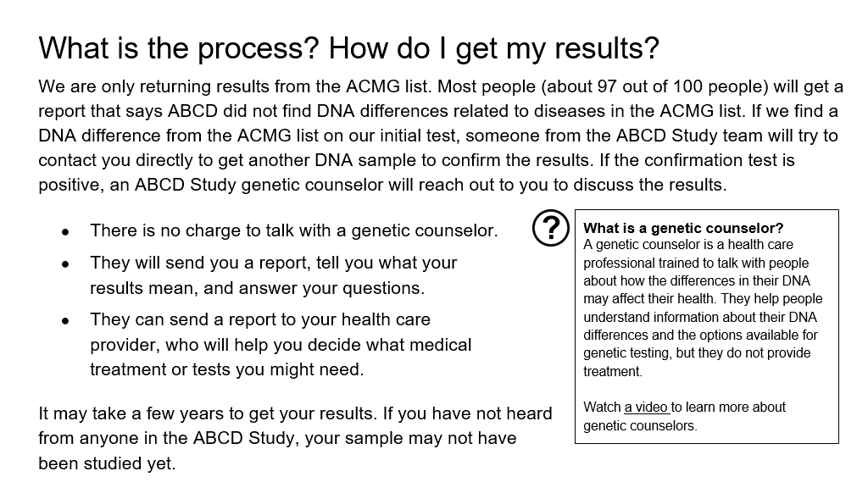
- What did you find surprising on this page?

- What, if anything, did you find confusing on this page?

- How would you summarize this page in your own words?

- What questions do you have after reading this page?
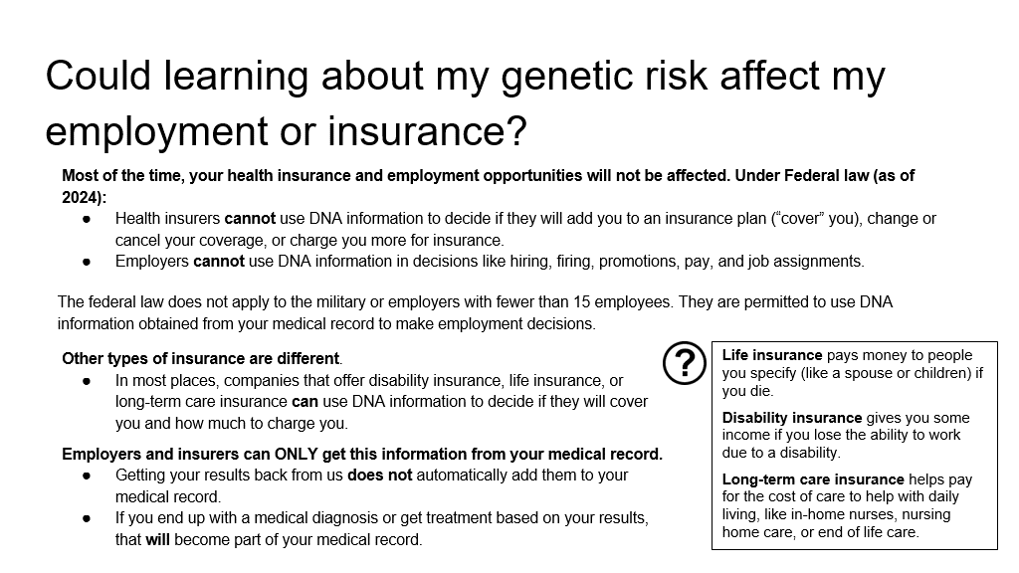
- What did you find surprising on this page?

- What, if anything, did you find confusing on this page?

- How would you summarize this page in your own words?

- What questions do you have after reading this page?
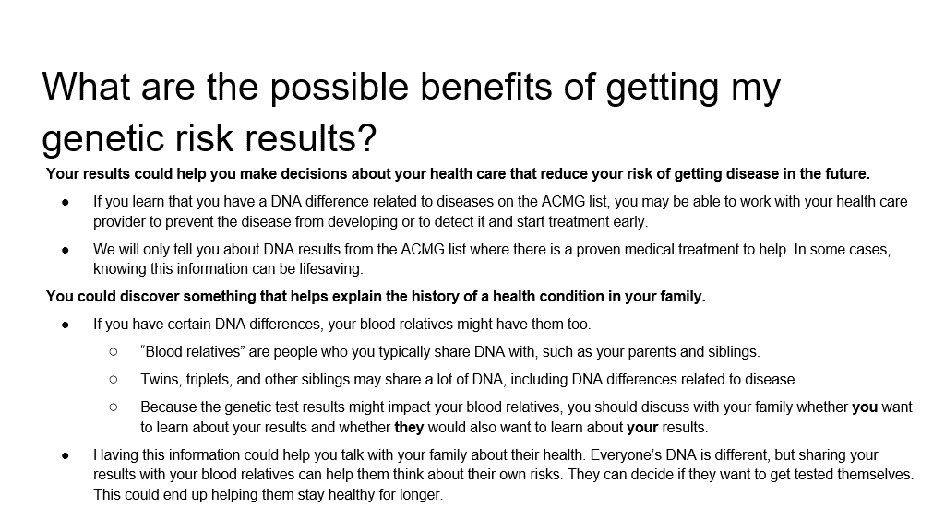
- What did you find surprising on this page?

- What, if anything, did you find confusing on this page?

- How would you summarize this page in your own words?

- What questions do you have after reading this page?

FEEDBACK ON LIFE EXPERIENCES
For this part of the discussion, we are interested in your experiences with certain topics that the questions writers may want to include in the ABCD Study.

[Stimuli description:] One topic important to the ABCD Study is mental health. The question writers want to make sure they are asking questions about mental health that are up-to-date and relevant.
- What are the most important mental health topics that the ABCD Study should be asking people your age about?

- How do people your age get mental health services or treatments?

[Stimuli description:] The ABCD Study would like to give the people participating in the study some options for providing feedback on being part of the study.

- Can you tell me about a time you gave feedback to a company, a business, or an organization? Just to clarify: we’re looking for an experience outside of being part of our audience feedback team.

CONCLUSION AND OBSERVER QUESTIONS
I have one last question:

- What is one thing you read or heard about in this discussion that was new to you?

Now I’d like to ask the observers if they have any additional questions or need clarification on any of the issues we’ve discussed. [Moderator will review any questions from observers via a private communication channel and pose those to the participants, as time allows.]

Thank you so much for taking the time today to discuss these topics as a group. The sponsors of this project will appreciate your honest feedback and reactions.

