PAPERWORK REDUCTION ACT STATEMENT
Paperwork Reduction Act Statement: The public reporting burden for this information collection has been estimated to average 30 minutes per response, including the time to review instructions and respond to questions. Send comments regarding this burden estimate or any other aspect of this collection of information, including suggestions for reducing this burden to NIH, Project Clearance Branch, 6705 Rockledge Drive, MSC 7974, Bethesda, MD 20892-7974, Attn: OMB-PRA 0925-0781.

MODERATOR’S GUIDE

HOUSEKEEPING
Please note: Participants have been asked to log in 5 to 10 minutes prior to the start of the discussion. During this time, the moderator will ensure that each participant can see the shared screen, is in a private space with no other individuals present, and knows how to mute their microphone when not speaking.
Before we begin, I just want to make sure that you’re able to see the shared screen and are able to minimize background noise (either by using headphones or being in a quiet room).

A few housekeeping items to review:
- Our discussion will be recorded so that I can refer to the recording as needed for my report writing, and my colleague is also on the line to take notes. In addition, other project staff are on the line listening to today’s discussion. Are you okay with this discussion being recorded? [Moderator to dismiss anyone who objects to the recording. Notetaker to press “record.”]
- We will use the findings from today’s discussion only to inform the development of questions asked in the Adolescent Brain Cognitive DevelopmentSM Study, also called the ABCD Study®.
- Please put your smartphone or tablet on Do Not Disturb mode while we are in this discussion. I want to make the most of our time together.

In terms of your feedback:
- There are no right or wrong answers to any of the questions I will be asking. Please be honest.
- If something feels uncomfortable or unclear, we want to know. Please don’t worry about being polite, or holding back. I didn’t write any of the questions we’re going to be looking at together.
- You are not required to answer every question. You can “pass” if any question makes you uncomfortable. You are also free to stop participating at any time.

BACKGROUND
Good [evening/afternoon]. Thank you for taking the time to participate in this discussion. My name is [XXXX], and I am going to facilitate our conversation.

- I am a trained moderator with IQ Solutions, a company that is holding these discussions to help the National Institute on Drug Abuse (or NIDA).
- NIDA manages the Adolescent Brain Cognitive Development (ABCD) Study—the largest long-term study of brain development and child health in the United States.
- We're looking for your feedback on some materials the Study uses to give people an idea of research activities related that are part of the ABCD Study.
- We want to make sure any questions/instructions don't leave anyone confused, uncomfortable, offended, or feeling like their experiences aren't included.

INTRODUCTION
For our first question:
- What is one thing you are looking forward to this [season]?

FEEDBACK ON SURVEY QUESTIONS
I would like to get your feedback on some survey questions that the ABCD Study would like to use later this year. I don’t need to know what your answers would be to these questions. Instead, I am interested in hearing your feedback on how these questions are written.
Do you experience difficulty hearing, seeing, walking, bathing, learning, communicating, managing your household, doing errands, or concentrating because of a physical, mental, or emotional condition?
- Yes
- No
- Decline to answer

- In your own words, what do you think this question is asking about?

- How would you think about answering this question? As a reminder, I don’t need to know your answer—rather, I want to hear you talk me through how you would get to the answer.
[Probe on definitions, examples, confusing areas]

- What other questions are important to ask on this topic?

[Stimuli description:] One topic important to the ABCD Study is mental health. The question writers want to make sure they are asking questions about mental health that are up-to-date and relevant.
- What are the most important mental health topics that the ABCD Study should be asking older teens and young adults about?

- How do teens and young adults get mental health services or treatments?

FEEDBACK ON STUDY MATERIALS
Now I’m going to switch topics a bit. In the survey activity you completed before this discussion, we asked you to look at some materials or instructions that will be used in the ABCD Study later this year.

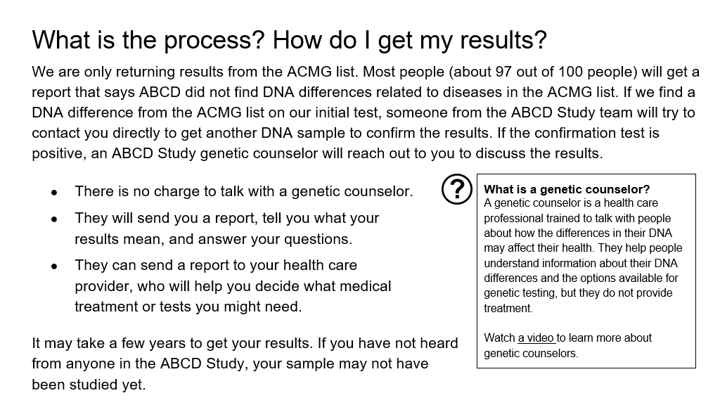
- What did you find surprising on this page?

- What, if anything, did you find confusing on this page?

- How would you summarize this page in your own words?

- What questions do you have after reading this page?

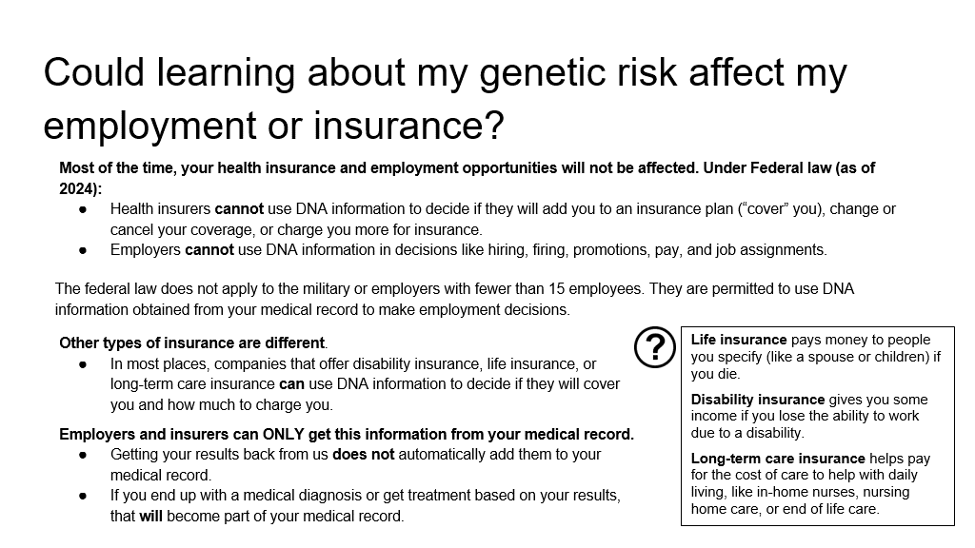

- What did you find surprising on this page?

- What, if anything, did you find confusing on this page?

- How would you summarize this page in your own words?

- What questions do you have after reading this page?

[Stimulus Description:] Now I would like to ask about giving feedback. The ABCD Study would like to give the people participating in the study some options for providing feedback on being part of the study.

- Can you tell me about a time you gave feedback to a company, a business, or an organization? Just to clarify: we’re looking for an experience outside of being part of our audience feedback team.

CONCLUSION AND OBSERVER QUESTIONS
I have one last question:

- What is one thing you read or heard about in this discussion that was new to you?

Now I’d like to ask the observers if they have any additional questions or need clarification on any of the issues we’ve discussed. [Moderator will review any questions from observers via a private communication channel and pose those to the participants, as time allows.]

Thank you so much for taking the time today to discuss these topics with me. The sponsors of this project appreciate your honest feedback and reactions.

