PAPERWORK REDUCTION ACT STATEMENT
Paperwork Reduction Act Statement: The public reporting burden for this information collection has been estimated to average 15 minutes per response, including the time to review instructions and respond to questions. Send comments regarding this burden estimate or any other aspect of this collection of information, including suggestions for reducing this burden to NIH, Project Clearance Branch, 6705 Rockledge Drive, MSC 7974, Bethesda, MD 20892-7974, Attn: OMB-PRA 0925-0781.

Instructions
Thank you for being part of our feedback team! We understand your time is important, so we want you to read through the materials before your scheduled interview, to make the most of the discussion time. Please read over the following visuals to get familiar with them before your session.
We look forward to hearing your feedback during your scheduled interview!

Draft Visual Consent Form

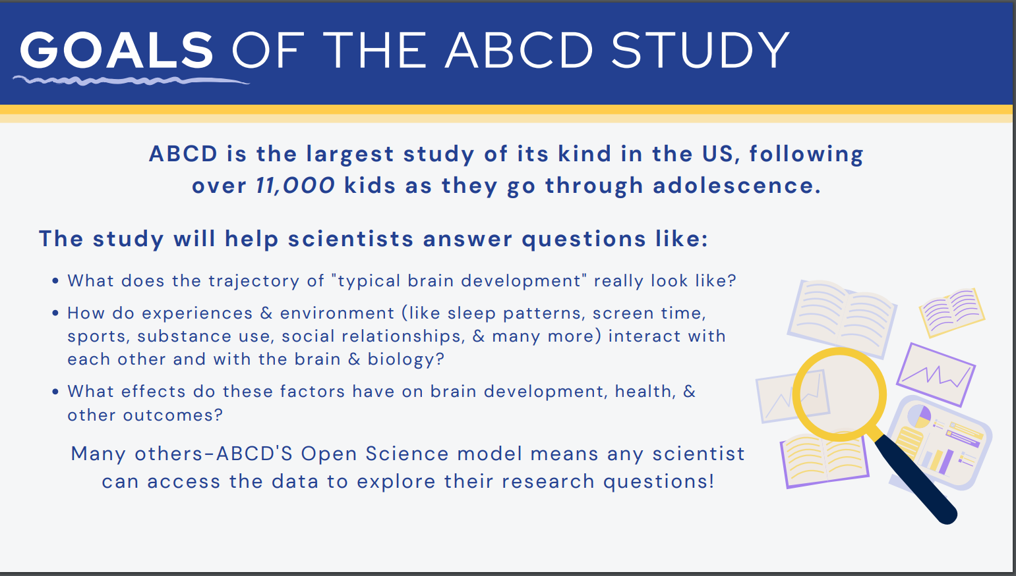
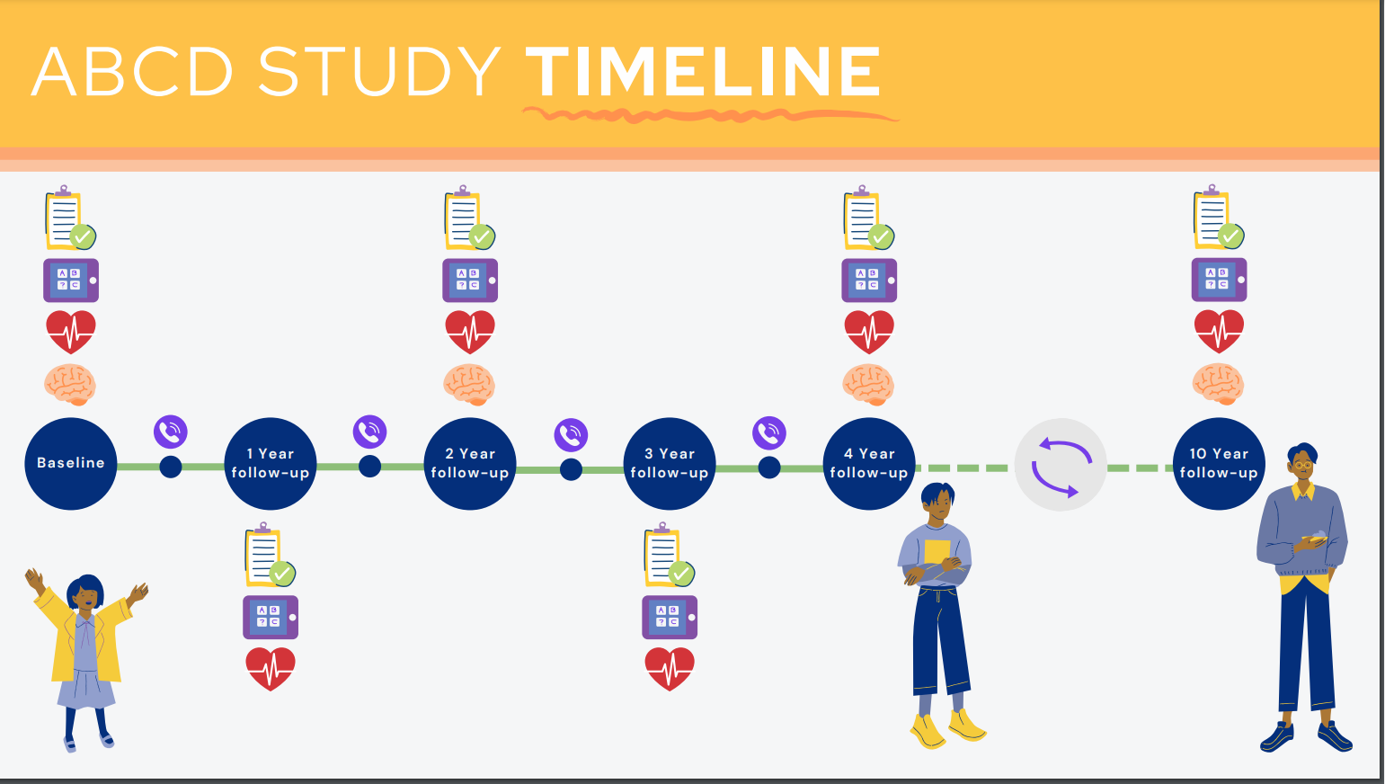
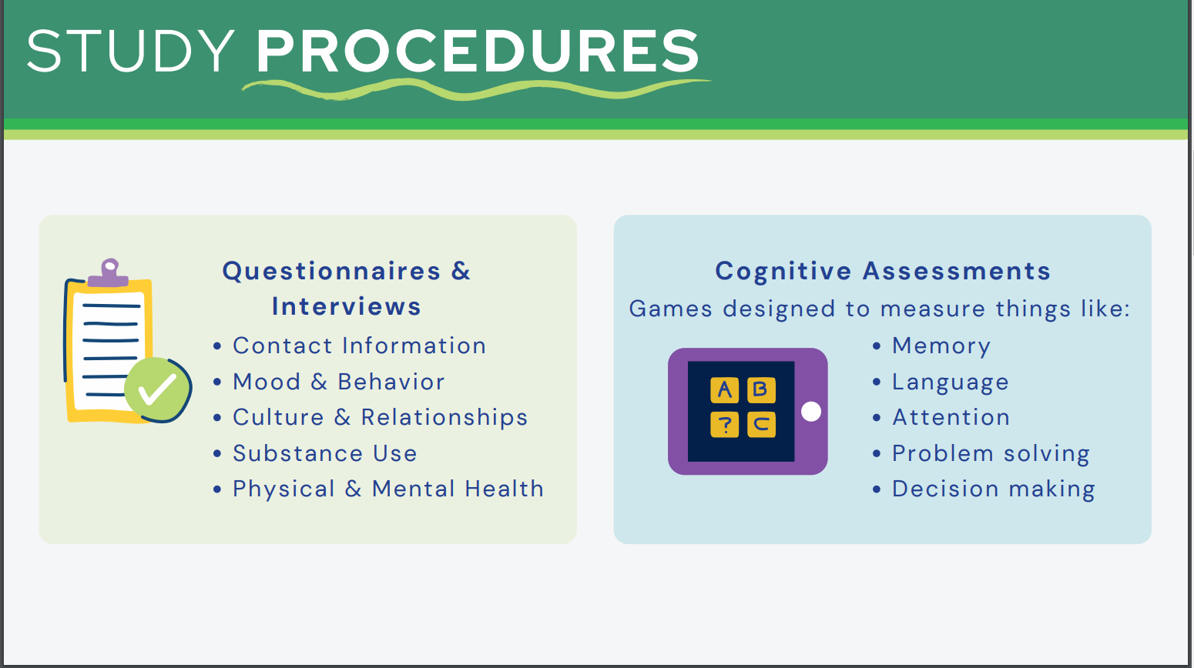
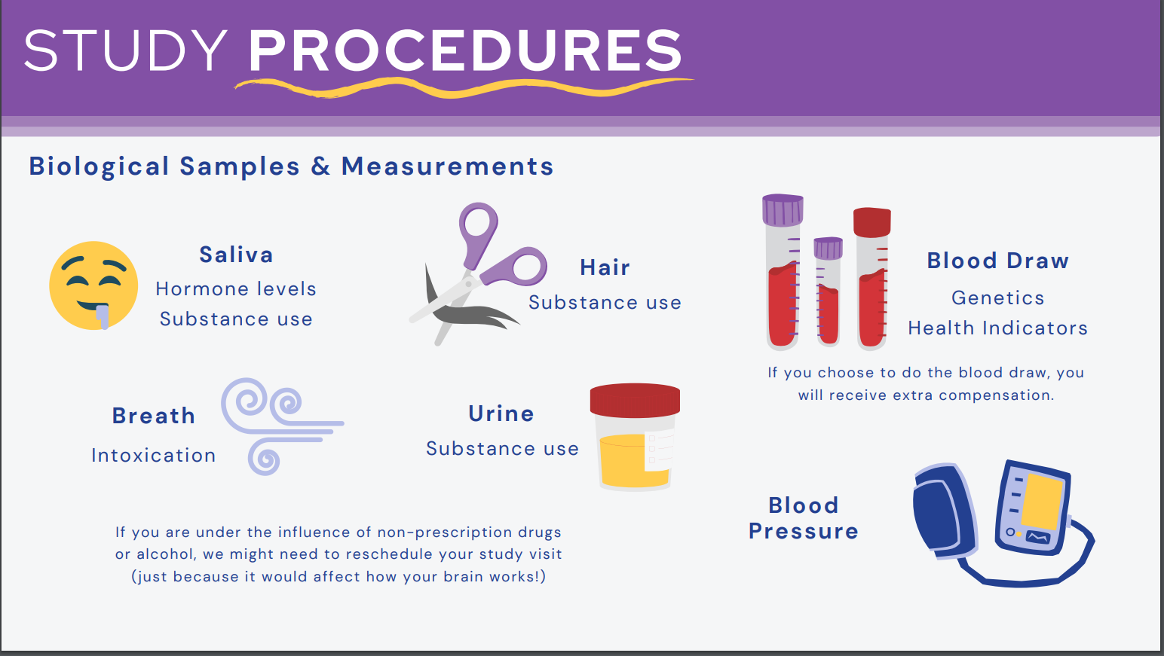
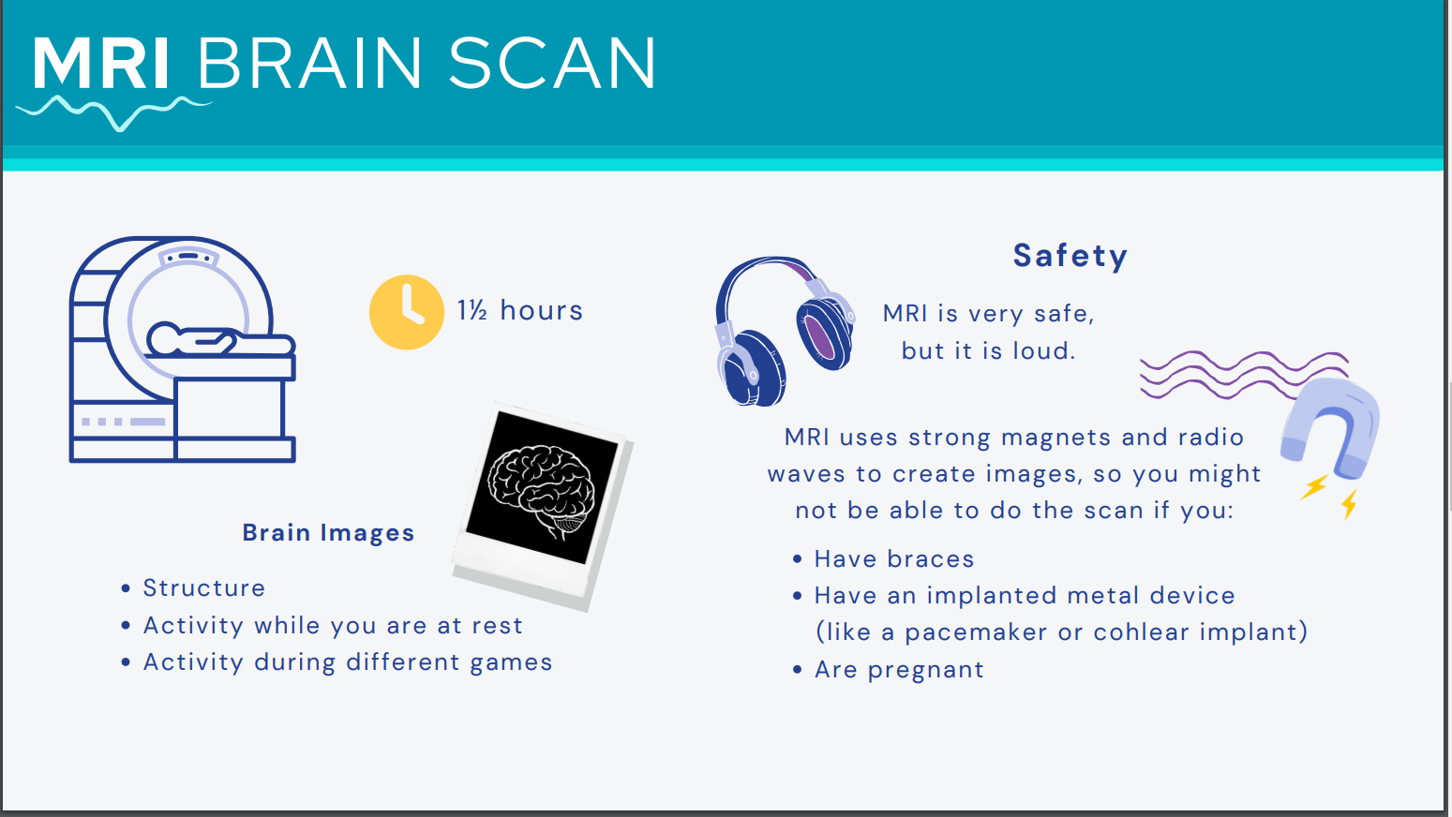
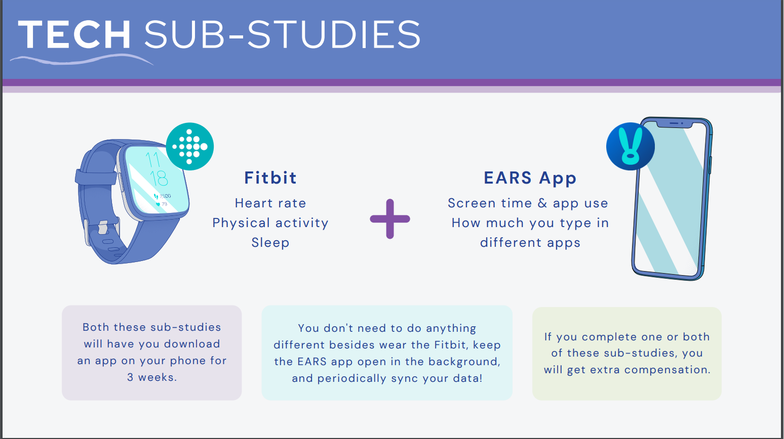
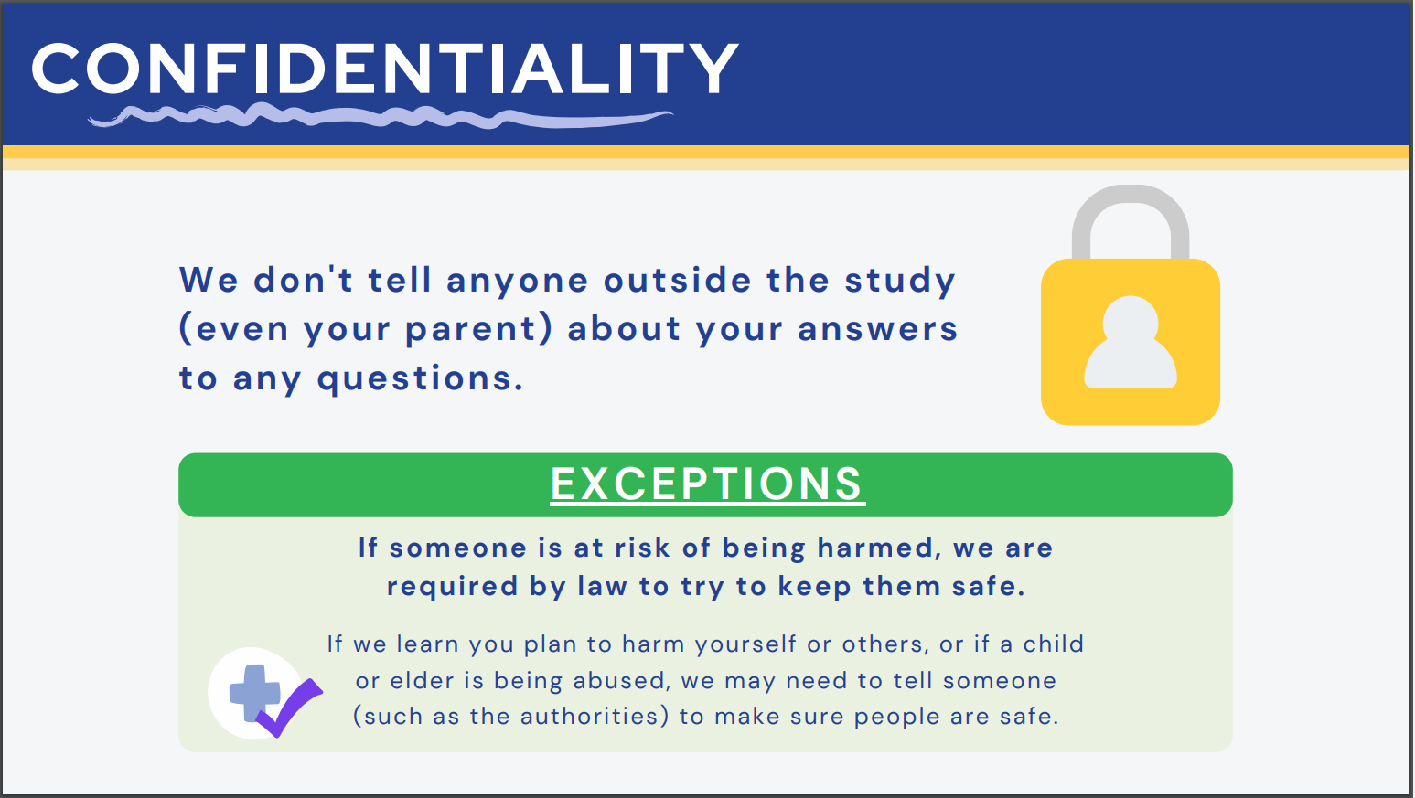

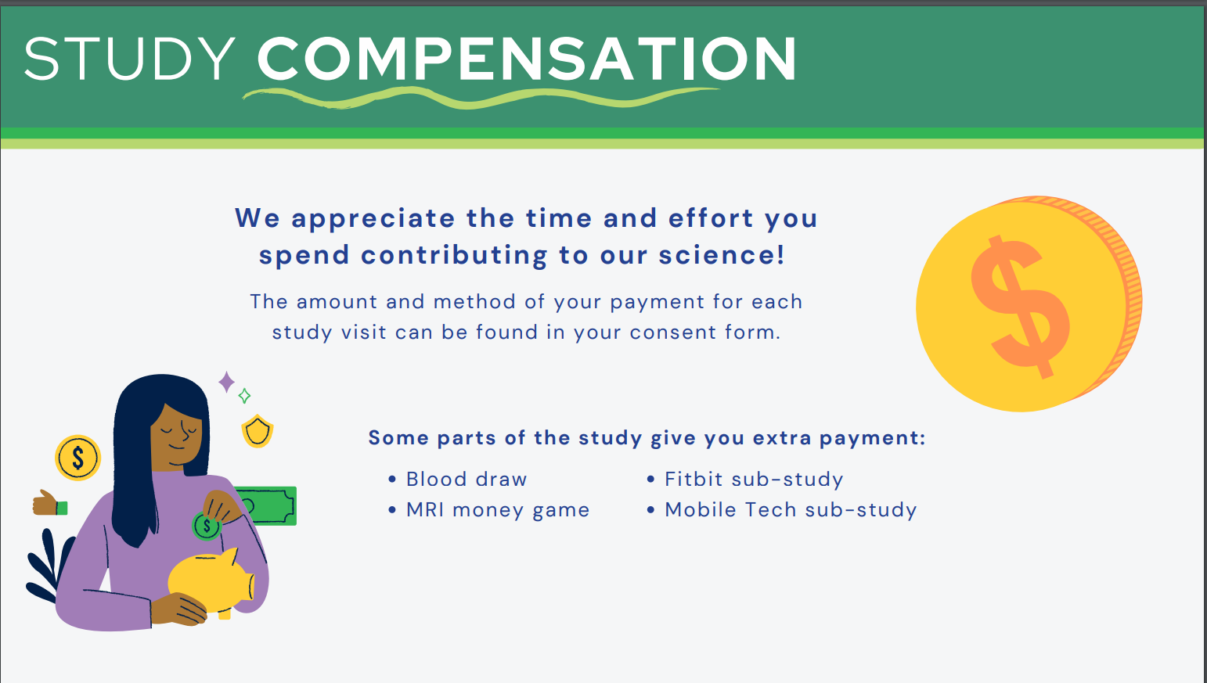

Draft Consent Form to Get Hereditary Disease Risk Results

