PAPERWORK REDUCTION ACT STATEMENT
Paperwork Reduction Act Statement: The public reporting burden for this information collection has been estimated to average 60 minutes per response, including the time to review instructions and respond to questions. Send comments regarding this burden estimate or any other aspect of this collection of information, including suggestions for reducing this burden to NIH, Project Clearance Branch, 6705 Rockledge Drive, MSC 7974, Bethesda, MD 20892-7974, Attn: OMB-PRA 0925-0781.

BACKGROUND AND INSTRUCTIONS
Thank you for participating in this online bulletin board discussion! We’re interested in your thoughts and opinions on some materials that have been created for the Adolescent Brain and Cognitive DevelopmentSM Study or ABCD Study®—the largest long-term study of brain development and child health in the United States.
Over the next two days, we want to get your feedback on anything that isn’t clear, anything that might be offensive, or anything that might make someone feel like their life experiences aren’t included. We will post some starting questions, but a moderator will also respond to your answers with some follow-up questions for you. You can also respond to other people’s comments, and they can respond to yours.
Before you get started, here are some “ground rules” for the discussion:
- Your total time spent on this Bulletin Board Forum will be approximately 60 minutes (across two days). It is up to you how you spend your time answering questions, but we encourage you to check in on Day 1 and Day 2 to respond to any follow-up questions from our moderator and to see what others have posted.
- After you answer each question, you will be able to see how others answered the same question. You will be able to react to comments from other participants in the Bulletin Board Forum as well as interact with the moderator.
- We want to hear all opinions and perspectives—there are no right or wrong answers to these questions. Please be respectful of all opinions and perspectives.
- This activity can be completed on a computer (desktop or laptop) or using a smartphone/tablet, whichever you prefer. You can choose to type your answers or record a video.
- At the end of the discussion, we will download everyone’s feedback for the purposes of our report. If you choose to record video answers, these will be transcribed and the videos deleted after the close of the Bulletin Board Forum.
- All information and opinions you give us will be kept private. Your identity will not be shared with anyone outside of the feedback team or project staff. Please do not share any information which could be used to identify you or someone else, such as full names, the name of your town, or your school’s name.
- Project staff may read responses, but only the moderator and other people on the teen feedback team will be post and answer questions during our discussion.
- Your feedback will only be used to help make sure that materials for the ABCD Study® are designed in the best way possible. This means we may share some comments with people who work on the ABCD Study but without any information that could identify who you are.
Thank you for reading our “ground rules.” Now, let’s get started!

PARTICIPANT INTRODUCTIONS
Let’s start by introducing ourselves! Please share your name (first name only) and something you like to do for fun.
[SUBSEQUENT ACTIVITIES: If this is your first time joining a feedback team activity, please introduce yourself using your first name only (no last names). If you are returning feedback team member, welcome back! Please share your first name for any new members in this bulletin board activity.]

MATERIAL TESTING

The ABCD Study would like feedback on some graphic designs they plan to use for communicating with participants in the study. I am going to ask you some similar questions for each of these designs.
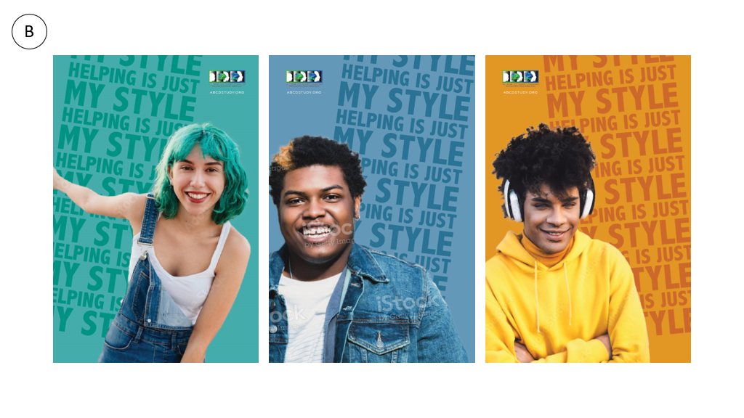
- What is one part of this image that grabbed your attention? Why? (Was it surprising, confusing, eye-catching, or something else?)

- How much would this image catch your attention if you saw it in person or online?

- How interested would you be in learning more after seeing this image?

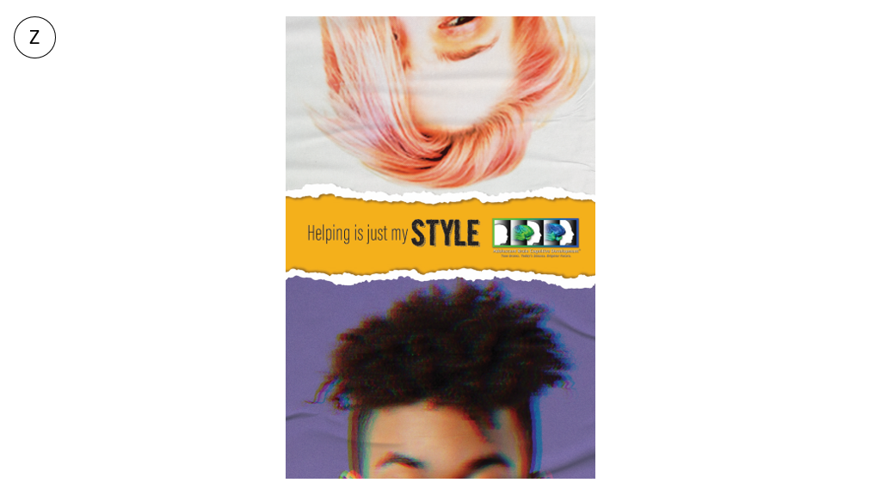
- What is one part of this image that grabbed your attention? Why? (Was it surprising, confusing, eye-catching, or something else?)

- How much would this image catch your attention if you saw it in person or online?

- How interested would you be in learning more after seeing this image?

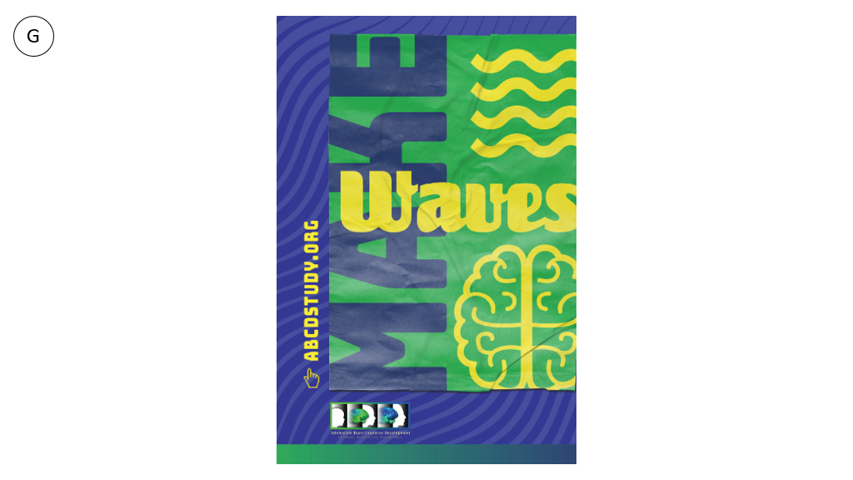
- What is one part of this image that grabbed your attention? Why? (Was it surprising, confusing, eye-catching, or something else?)

- How much would this image catch your attention if you saw it in person or online?

- How interested would you be in learning more after seeing this image?

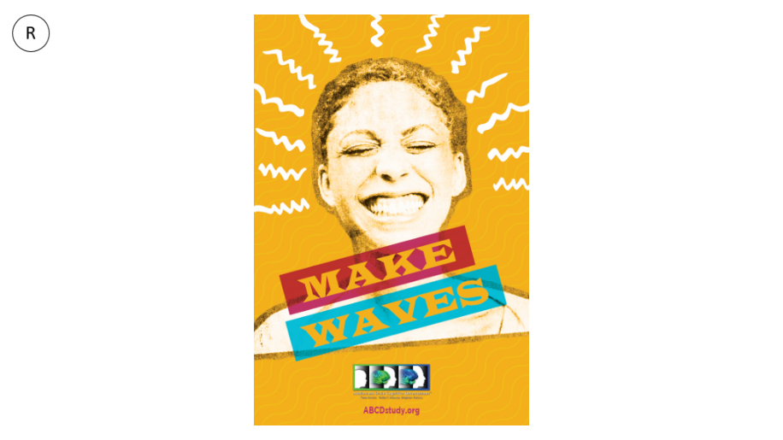
- What is one part of this image that grabbed your attention? Why? (Was it surprising, confusing, eye-catching, or something else?)

- How much would this image catch your attention if you saw it in person or online?

- How interested would you be in learning more after seeing this image?

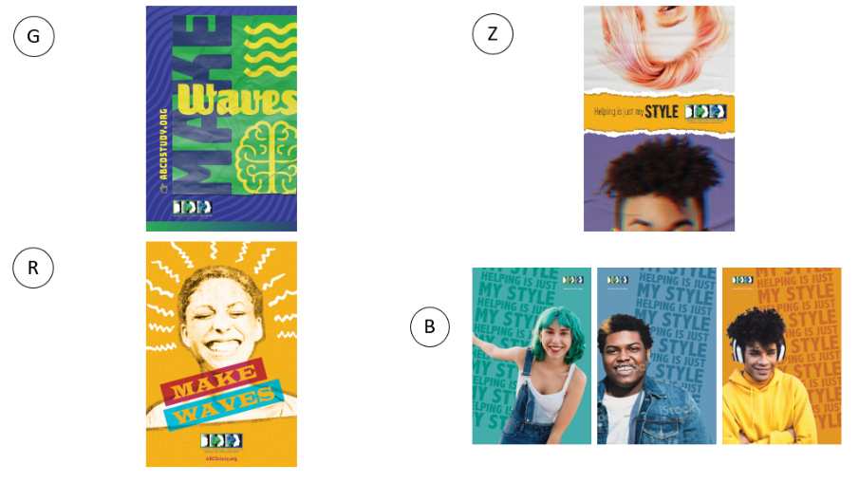

- Tell us what you like about your favorite design: what makes it your favorite?

- Which parts of the other designs (like colors, text or photos) do you like, even they’re not your overall favorite?

- What would you add to or take away from your favorite design (like colors, text, pictures) to improve it?

- Which designs would be better for something physical, like a poster or postcard? You can choose more than one.
- Image G
- Image Z
- Image R
- Image B

- Which designs would be better for something digital, like an email or social media post? You can choose more than one.
- Image G
- Image Z
- Image R
- Image B

FEEDBACK ON COMMUNICATION STRATEGIES
For these next questions, we want to hear your experiences with different kinds of communication – all the ways people watch, read, hear, or see information.
[Stimuli description] The researchers who run the ABCD Study are interested in feedback on the best ways to stay in touch with people in the study and to share updates or reminders.
- Thinking about a time where you wanted to get updates from someone like a company, an artist or creator, or a project you were interested in, how did you choose to get updates?
- Email or digital newsletters
- Social media accounts
- Text messages
- Phone calls
- Mail or physical newsletters
- Another way (Please specify)

  - Why would you use that way/those ways to get updates?

- Which ways of getting updates you would NEVER use?
- Email or digital newsletters
- Social media accounts
- Text messages
- Phone calls
- Mail or physical newsletters
- Another way (Please specify)

  - Why would you NEVER use that way/those ways to get updates?

- How does the type of content or person/organization factor into your choice?

- Which social media sources would use for this? Select all that apply.
- Facebook
- X (formerly Twitter)
- LinkedIn
- Instagram
- Pinterest
- TikTok
- Snapchat
- Reddit
- YouTube
- NextDoor
- WhatsApp
- Discord
- Threads
- Other (Please specify in the text box)
- I would not use social media to do this
- I do not use social media

  - Why would you use those sources?

- Which social media sources would you NEVER use for this? Select all that apply.
- Facebook
- X (formerly Twitter)
- LinkedIn
- Instagram
- Pinterest
- TikTok
- Snapchat
- Reddit
- YouTube
- NextDoor
- WhatsApp
- Discord
- Threads
- Other (Please specify in the text box)
- I do not use social media

- Why would you NEVER use that source/those sources?

[Stimuli description] Researchers from the ABCD Study are interested in sharing what they are learning about how teens’ brains work.
- Describe a recent health related article, post, video, or other kind of content that you thought was very well done. You can include a link in your answer.
- How did you find it?
- In your opinion, what made it good?
- What did you do after reading, listening to, or watching it?

- Which social media sources do you trust for health information? Select all that apply.
- Facebook
- X (formerly Twitter)
- LinkedIn
- Instagram
- Pinterest
- TikTok
- Snapchat
- Reddit
- YouTube
- NextDoor
- WhatsApp
- Discord
- Threads
- Other (Please specify in the text box)
- I do not use social media

- Why do you trust that source/those sources for this information?

- Which social media sources would you NEVER trust for health information? Select all that apply.
- Facebook
- X (formerly Twitter)
- LinkedIn
- Instagram
- Pinterest
- TikTok
- Snapchat
- Reddit
- YouTube
- NextDoor
- WhatsApp
- Discord
- Threads
- Other (Please specify in the text box)
- I do not use social media

- Why would NEVER trust those sources for health information?

WRAP UP
- If there is anything else you would like to share, you can use this question to share your thoughts.

CLOSE
Those are all the questions we have for you today. Thank you very much for sharing your thoughts and for being part of our feedback team!

